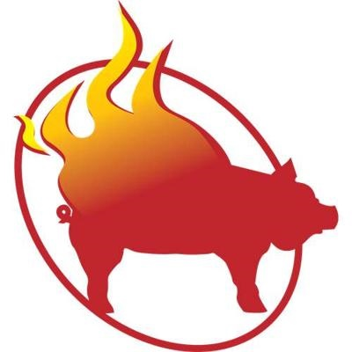

D & T BBQ
D & T BBQ LLC
950 Swan river rd
bigfork, mt 59911

Address Correction Required

Catering Requests
We offer all our standard business Meats: Pulled Pork, TriTip and Pork Ribs along with our Sides: Coleslaw, Potato Salad and Baked Beans at our standard rate. We can provide a quote on other meats (i.e. Chicken Leg & Thigh, Beef Brisket) and sides (i.e. Mixed Greens with Dressing, Corn on the Cob, Mashed Potatoes) upon request. We can also provide Drinks (Canned Soda, Iced Tea, and Fresh Squeezed Lemonade), Coffee Service or Dessert, pricing available upon request.

We look forward to being given the opportunity to provide a catering quote for your event. We appreciate the consideration.

Next steps to request a catering quote:
- Choose items from the Price List inside brochure.
- Complete the information in the Request Form. This will provide you with preliminary pricing, deposit requirements and has all the information we need to provide a quote.
- Send information to us via mail, email or online through our website’s request form.
If given this opportunity, we will take all of your concerns and requests into consideration as we develop your catering quote. We would like to assure you that our food and services would meet your high standards and suit your personal tastes and look forward to sharing our food and services with you and your guests

It’s All ‘bout My Rub
Telephone: 406-837-3442
Email: dtbbqllc@gmail.com
Website: www.dtbbq.com
Name
Street Address
City, St ZIP Code
1. Pulled Pork Sandwich, Per Person | 6.00
2. Chicken Leg & Thigh, Per Person  3. TriTip, Per Person | 6.00  8.00
4. Beef Brisket, Per Person | 9.00
5. Pork Ribs, Per Person  6. Multi-meat Options  - Pulled Pork & Chicken  - Pulled Pork OR Chicken with TriTip  - Pulled Pork OR Chicken with Brisket  - Pulled Pork OR Chicken with Ribs  - TriTip with Beef Brisket  - TriTip with Pork Ribs  - Beef Brisket with Pork Ribs  - Three Meats: Choose Pulled Pork or Chicken with Two other meats  7. Side Choices –  - Baked Beans  - Coleslaw  - Potato Salad  - Corn on the Cob  - Mashed Potatoes | 9.00  10.00  12.00  13.00  13.00  15.00  15.00  16.00  17.00  1.00 ea
7. Additional Side Choices –  - Mac and Cheese *  - Mixed Green Salad with Dressings | 2.00 ea
8. Appetizer: Bacon Wrapped Stuffed Jalapeno | 1.50 ea
9. Appetizer: Bacon Wrapped Prawn  10. Buffet Set Up, Chafing Dishes, Breakdown  - Buffet Service, meats only | 2.50 ea  125.00  150.00
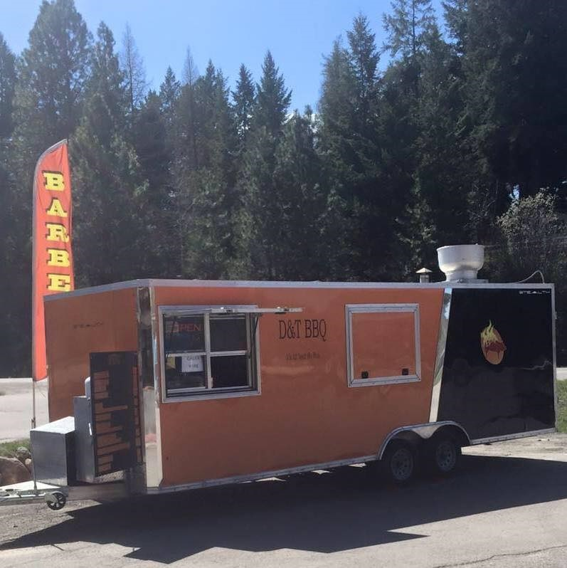

About Us
We are a family owned and operated Mobile Barbecue Trailer based in Bigfork, Montana. We travel throughout the Flathead Valley and sometimes beyond, to serve our customers.
We were founded in 2012 by April Wickwire after many years of hearing people say "You should open a restaurant" to her husband, David Wickwire. We decided to try something similar but more flexible and created D & T BBQ. The "D" standing for David, our oldest son and the "T" for Tyler our youngest son.
Running a barbecue business is an enjoyment for the whole family; GMA Dianne & Papa Dave are always ready to step in and help where needed.
You can find us –
Regular schedule; Whistling Andy’s, Kalispell Toyota or Ford, Gardner RV, National Flood Services and more.
At an organized event; Rebecca Farms, Thursday!Fest, NW Montana Fair, Whitewater Festival, Cabin Fever Days, Headwaters Country Jam, and many more.
Catering: as a drop off order or provided in a casual to formal setting.

Price List
Our menu is Gluten Free except for buns and items with *

request Form
Item # Description Qty. Price Subtotal
Order total:
Deposit (30 %):
Total:
Date/Time of Event
Event Location
Estimated # of Guests
Name
Address
Email
Phone
Exp. Date

D & T BBQ
950 Swan River RD
Bigfork, MT 59911
Phone: (406) 837-3442
www.dtbbq.com

E-mail: dtbbqllc@gmail.com

