caithnessmusic.com
02/08/13
Lyth Arts Centre Community Development
End of Year Report 2012/13
Introduction
Lyth Arts Centre’s community development programme has formed an integral part of the Centre’s work this year and our activities in this area have been well received and successful.
Thanks to the £7,500 Robertson Trust award for this period, we have been able to develop a musical outreach programme which has provided opportunities and positive experiences for ten of the most disadvantaged teenagers in Caithness. In doing so, we have also developed strong and lasting links with key staff members of our local Social Services.
Within the delivery of the main programme of events at Lyth Arts Centre this year, the Robertson Trust’s funding has enabled us to provide sponsored tickets to encourage carers and socially disadvantaged members of our community to attend mainstream events. The funding has allowed us to welcome 25 people who might otherwise have been unable to attend theatre and music events this year.
A total of 12 talented but geographically disadvantaged young Highland musicians have benefitted from working alongside professional musicians at exchange events at the Centre. Their places were subsidised using Robertson Trust funding.

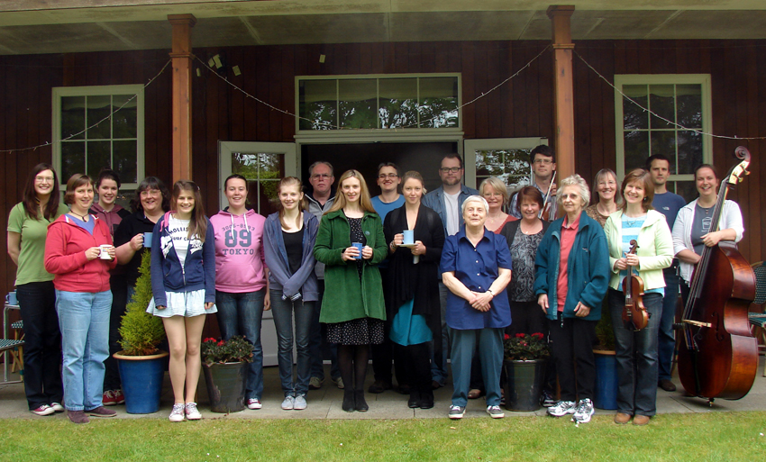
The Caithness Orchestra exchange event with the Sutherland Duo which included four places for young musicians subsidised by the Robertson Trust. (June 2013)

Planned Outcomes and Results
Outcome 1
To develop Lyth Arts Centre’s relationship with Social Services in order to identify young people living in Caithness who are disadvantaged and offer them the opportunity to participate in our Youth Music Exchange programme.
Target 1: Establish weekly music workshops throughout the year for up to 12 participants. These will lead towards specially tailored, 2 day, Youth Music Exchange events at Lyth Arts Centre which will be led by visiting music professionals.
Target 2: Acquire musical instruments and instrumental tutor books as required. Support for this will be sought from The Highland Region Music Service and matched funding will be applied for from the Caithness Music Association’s Henry Rosie Fund.
Target 3: Contract administrative and educational work for this project as appropriate.

We have established a strong relationship with Social Services over the year. Our weekly music workshops ran successfully between September 2012 and April 2013 at Airport House – a small school setting for disengaged teenagers. A total of 10 young people engaged with this programme over the course of the year. We offered the opportunity for pupils to play on trumpet, trombone, flute and/or alto sax at Airport House and, at the end of the project, offered the pupils the opportunity to visit Lyth Arts Centre for a day of workshops and work experience.
The level of disengagement from the education system demonstrated by many of the pupils was pronounced. For the majority of them, their default answer to any invitation to try something new was negative. Despite this, the pupils were all very friendly and as co-operative as their low self-esteem and difficult circumstances would allow. We are pleased to report that every pupil who attended Airport House during the project managed to engage with the visiting outreach workers and every single pupil did “have a go” on at least one musical instrument during the course of the project.
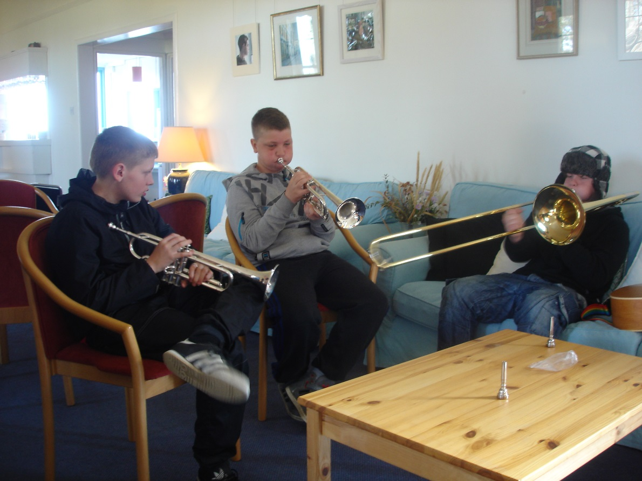
Koreen MacDougall, the manager of Airport House, warned us from the outset that group work would be very difficult to establish. We understood that many of the pupils have arrived at the House either as a result of being bullied at school or as a result of having been excluded for the offence of bullying. It was noticeable to us that all pupils visibly grew in self-confidence and happiness as they developed their new found musical skills.

Three Airport House pupils trying brass instruments.
We have successfully delivered Target 2 by purchasing instruments and books. Initially we had expected to have to cater for up to 12 musicians, but due to Airport House policy, we were unable to have more than six young people in the same room at once. For this reason, we purchased 6 instruments and extra mouthpieces so that instruments could be shared as required. This was much less expensive than our planned budget and so we have decided to postpone any application to the Henry Rosie Fund until 2013/14. We plan to use the benefit of this one-off funding opportunity to develop the project in a larger, primary school setting where many more instruments will be required. Support was sought from the Highland Council’s Music Service but they were unable to provide us with any instruments as they prioritise mainstream school attenders (within the Education Service) and had no instruments left for our participants (whose education is under the care of the Social Work Service – a different council department).
The group visit to Lyth Arts Centre was successfully delivered, although our initial plan to make this a music workshop with visiting professional musicians was unrealistic with this student group. Shy and uncooperative with strangers, they needed to be nurtured so they can establish a relationship with the outreach workers who then went on to deliver the workshops at Lyth. We decided that in order to make full use of this outing for all participants, we would include an element of “work experience” at the Arts Centre. The pupils were given the opportunity to learn about lighting, catering, box office work and craft sales as well as participating in the planned music workshops.
“I can wholeheartedly confirm that there were tangible benefits reaped from the Lyth Outreach Workers visiting Airport House to deliver music sessions to pupils weekly. The Outreach Workers took two very important steps to successfully deliver music sessions in Airport House – they built a relationship over the weeks and months with all pupils attending and staff; and they visited the pupils here, in their own comfort zone.”
- Koreen MacDougall, Manager of Airport House

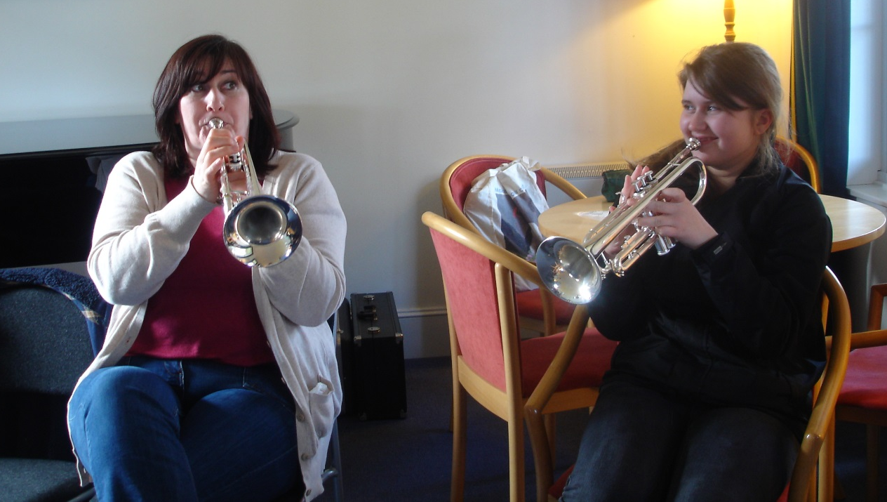
Airport House manager Koreen MacDougall learns trumpet alongside a pupil.

CASE STUDY 1 – the guitarist (Names have been altered to protect anonymity)
We witnessed a repeated pattern with one pupil, whose attendance rate was poor: Airport House staff would tell us on arrival that “Helen’s here today but she says she doesn’t want to do music.” We would informally engage with her and she would unfailingly, though reluctantly, change her mind and participate. Helen suffered with extremely poor self-esteem and often told us that she didn’t feel that she was worth teaching and that we were wasting our time on her.
She did try all of the instruments on offer during the early stages of the project and could have made progress on any one of them if she had wanted to. However, she shared with us that her heart's desire was to learn the guitar and listed several songs she’d like to be able to play. As a result, we worked with her every week on guitar for the rest of the project. We were delighted to discover that family support was in evidence because Helen received a guitar for Christmas and was obviously practising at home, teaching herself to play songs by her favourite artistes. With her active engagement in the project, her confidence grew and her attendance improved.
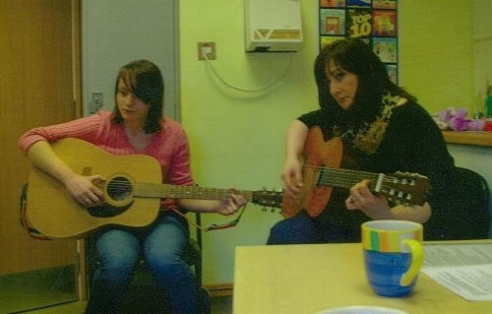
Helen at her final session, teaching guitar to
Airport House manager Koreen MacDougall

At the end of the project, we were able to provide her with a reference, an extract of which is below:

“Helen has chosen to learn the guitar and enjoyed 10 lessons during the project. During this short space of time she has become an accomplished guitarist. She has thoroughly learned 8 chords and now has the ability to look up and learn chords that she does not know. Encouraged by her lessons, she now has a guitar of her own.

Throughout the project she has always been friendly and well-mannered. She has been exceptionally quick to learn new skills and is obviously a very able individual.

We have enjoyed working with Helen and would be happy to provide a more detailed reference if required.”

CASE STUDY 2 – the shy songwriter (Names have been altered to protect anonymity)
Jenny was another pupil who benefited greatly from engagement with the project.
She was already an established guitarist but was painfully shy and had completely stopped attending her local high school, where she had been very unhappy. Staff told us that, at some stage in the future, they hoped Jenny would be able to gain some formal musical qualifications as she was obviously very talented and hardworking on the guitar. Her inability to attend school was a real barrier to her making progress in widening her musical horizons and developing her knowledge of music theory, history or analysis.
She tried out all of the four instruments on offer at the start of the project and decided that the sax was her favourite. Because of a background of parental support, we were able to allow her to take the sax home and she made excellent progress. We worked hard with her during her sessions to make links between her existing knowledge of guitar chords and tab and her new found skills of reading the music stave and her developing understanding of the theory of harmony and melody construction.
As she began to learn about how to read and write music, she confided in us that she had written some songs herself which she could sing but had not been able to put down on paper. We encouraged her by allowing her to use our music notation software to write down her own songs. She began to realise the benefits this had in being able to share her songs with other musicians who could read music and play her songs without having to hear them first. We opened a door for this shy songwriter and gave her the tools she needed to quietly continue her musical development at her own pace and on her own terms.
Below is an extract from the reference we gave to Jenny at the end of the project:

Already an accomplished guitar player and fluent reader of guitar tab, Jenny chose to learn to play the saxophone with us and rose to the challenge of learning to read standard music notation. It soon became clear that Jenny is a talented and hardworking musician and she was a pleasure to teach. After only ten lessons on the saxophone she was able to play a two octave chromatic scale and sight read a simple tune.

Towards the end of the project, we spent some time working on music theory with Jenny and she quickly learned the basics of how to use “Sibelius 7” music notation software to write music using both guitar tab and standard notation.

Jenny is a very creative person with the ability and desire to write her own music and lyrics. Our project has given her the tools she needs to continue to develop her skills in this area.

Jenny’s attendance has been good and she has always listened carefully, shown good understanding and worked hard during lessons.

We have enjoyed working with Jenny and would be happy to provide a more detailed reference if required.

Some of the participants in this project have now developed the potential to be able to participate fully in mainstream Lyth Arts Music Exchange events next year. We will certainly extend the invitation to them and use Robertson Trust funding (see outcome 3) to sponsor their attendance if a suitable Exchange event is programmed at Lyth during 2013/14.
All admin and tutoring for this outcome was delivered by caithnessmusic.com, a local social enterprise run by two professional musicians who have a background in education and in working with adults with additional needs.
In summary, we feel that delivery of Outcome One has made a significant difference to the lives of the ten young people who participated. We believe that a real connection has been made between Lyth Arts Centre, Airport House and the Social Work department’s Youth Action Team.
We have been encouraged by our success at Airport House to develop this project in 2013/14 to include a much larger number of younger children and keeping the emphasis on increasing self-confidence through inclusive engagement in group music-making.

Outcome 2
To increase the accessibility of all Lyth Arts Centre’s events, with a special focus on encouraging full-time carers and members of families who are socially disadvantaged to attend as audience members.
Target 1: Establish “VIP” sponsored community ticketing for all Lyth Arts Centre events, making a minimum of four seats available to individuals in need who will be identified through liaison with the social work department.
Target 2: Provide transport to events for “VIP” guests and chaperones as required.
Target 3: Contract administrative work for this project as appropriate.
We have been successful in widening the audience base for events at Lyth Arts Centre and have established links with both social work and several local charities.
Seats were made available for “VIP” guests and these were recruited through the Social Work department, Headway Highland, Stepping Stones (mental health support centre) and the North Highland Cancer Support and Information Centre. 25 VIPs have been welcomed at Lyth events this year. It was more difficult than expected to encourage take-up of these free tickets as the barriers to attendance are much more complex than simply financial. We have worked hard to overcome these social and emotional barriers, attending group meetings to introduce ourselves to potential VIPs and offering to chaperone individuals who would otherwise lack the self-confidence required to attend the theatre.
We would like to continue developing this work at Lyth Arts Centre over the coming 12 months, consolidating our links with the three participating charities and also widening our network to include other local support groups in order to provide as much benefit as is possible to our local community.
Transport, chaperoning and admin for this outcome was supplied by caithnessmusic.com

“Just wanted to thank you for a lovely evening at Lyth last night.
Samba Sene.were excellent, effortlessly creating a relaxed atmosphere where the music just.flowed through you! Everyone there just seemed to have such a great time, lovely to see such enthusiastic dancing from the audience.”
- Member of the “Headway” support group and
one of our first VIP guests in 2012.

Outcome 3
To increase opportunities for talented, geographically disadvantaged young musicians from across Highland Region to access facilities at Lyth Arts Centre.
Target 1: Continue to develop community work begun through Lyth exchanges with the Caithness Orchestra, the Caithness Big Band and the Sunday Night Band, and to incorporate other genres of music, such as folk or traditional music, into the programme of exchanges.

Target 2: Liaise with schools across Highland by developing our links with the Highland Region Music Service to ensure that some places on Lyth exchanges are made available as subsidised residential options for young people.

Target 3: Contract administrative and educational work for this project as appropriate.

Successful exchanges have taken place during this season with the Caithness Orchestra, the Sunday Night Band and the Caithness Big Band. We have been successful in recruiting 12 young people to participate in the exchange events which have taken place. We have not yet broadened the scope of exchange events to include folk or traditional music.
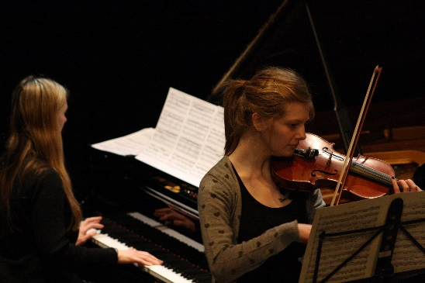
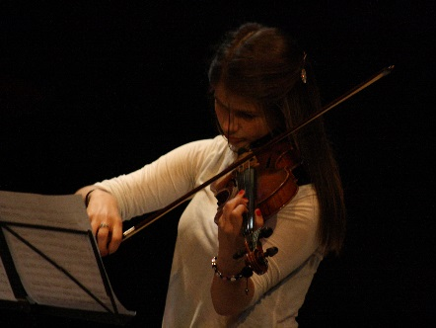
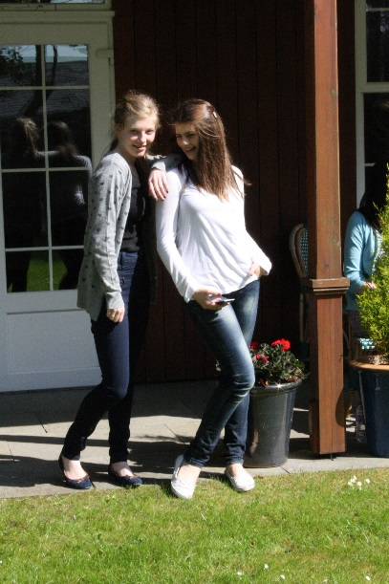
Teenage sisters Brianna and Cara, performing the Bach Double Violin Concerto with professional pianist Christina Lawrie of the Sutherland Duo, and relaxing on the veranda at Lyth Arts Centre.
“I’ve learned to look at what the feel and style of the music is and how to plan to play it.” Cara – Violin

Schools and instrumental tutors across Highland were informed of exchange opportunities, but due to timetabling difficulties and clashes with other major events in the Inverness area, we have not had as many young musicians from outwith Caithness as we had hoped. There is scope to develop this aspect of our work during 2013/14. Four young musicians benefitted from Robertson Trust support in order to attend the Sutherland Duo’s residency with the Caithness Orchestra, three young musicians joined the Tommy Smith jazz exchange and five young people joined in with the Sunday Night Band’s workshop with saxophonist Martin Kershaw.
Admin and some of the tutoring for this outcome was supplied by caithnessmusic.com
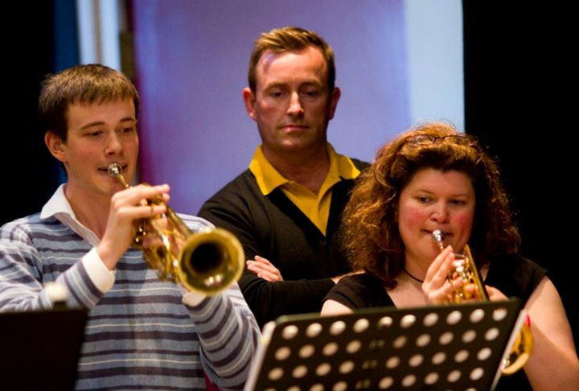

Young trumpeter Chris under the watchful eye of world class jazz saxophonist Tommy Smith.

