Friends of Bass Lake celebrate progress

April 22 event set

By **Seth Rowe**

[seth.rowe@ecm-inc.com](mailto:seth.rowe@ecm-inc.com)

**• Thursday, April 19, 2018 St. Louis Park sailor.mnsun.com**

As the Friends of Bass Lake group begins to reel in success in helping their namesake body of water

become more visitor friendly, the nonprofit plans to celebrate with fellow nature lovers.

Friends of Bass Lake will host Coffee in the Woods 1-3 p.m. on Earth Day, Sunday, April 22, on the northeast corner of the George Haun Trail that surrounds Bass Lake. Participants can learn about plans to restore native vegetation and improve water quality at Bass Lake.

The location will provide a focus on a woodsy but overgrown part of the shoreline area that Friends of Bass Lake plans to make more accessible to hikers. Volunteers have been removing buckthorn and other invasive species.

City crews have assisted with the cleanup. Friends of Bass Lake plans to add a path with woodchips that will form a loop from the George Haun Trail.

“It was overgrown and filled with rubble and garbage,” said Scott Carpenter, president of Friends of Bass Lake.

The group hired a consultant to help create a vision of what the area could become.

“The purpose is to give kids a nature area and residents the opportunity to get through there,” Carpenter said.

“It’ll be a woodland experience,” added Paul Adelmann, a board member of the group. “Kids will be able to go play in the woods.”

They plan to replace the buckthorn they have been removing with native plant species, including woodland flowering plants.

“It’s been a big effort of the last year,” Carpenter said. “The coffee is a big part of that. We’ll introduce people to the idea of the woods.”

Noting that the woodland area is owned by the city, Carpenter said, “This is actually parkland. It’s not wasteland. It’s not dumpland.”



**Scott Carpenter, president of Friends of Bass Lake,**

**marks a planned woodland trail near Bass Lake.**

**Water level work**

The group also advocated for a new drainage outlet structure for the lake, and the city responded by installing a structure in January. The new outlet will provide a more consistent water level and expand the areas of open water, according to Friends of Bass Lake.

The organization began about a decade ago out of concern about the water levels at Bass Lake, according to Carpenter. A wooden structure had washed out and failed to control the water level before it drained toward Bde Maka Ska, previously known as Lake Calhoun.

The new outlet could support a water level that is about 18 inches higher than the levels after the area has drained after precipitation, Carpenter said. “We’re super happy about it,” he said. “We’ve always monitored the depth of the lake. The reason it’s so important is wildlife, vegetation, and public use.”

Erick Francis, St. Louis Park’s water resources manager, said the previous outlet control structure had been about 50 years old and had not been functioning as designed.

“We replaced it with a new design that has a skimmer structure that will prevent floating debris from entering and going downstream,” Francis said. “It allows us to maintain the water levels in the lake a little bit better.”

The city also removed sediment that had accumulated near the outlet.

**Working with others**

The group obtained a permit from the Minnesota Department of Natural Resources to clear some of the cattails that are not native to Minnesota to provide room for a canoe or kayak access. No one will be water-skiing in Bass Lake, Carpenter said, but he showed a picture of children rafting on the preserve in the early 2000s before the water level dropped. The access point will allow paddle-boarders and others to reach open water farther out in Bass Lake.

While cutting cattails can be controversial, Carpenter said officials with the DNR were excited about the potential for public recreation on Bass Lake. He said the lower water levels had allowed hybrid cattails to invade areas they could not reach in the past. Removing them can help provide recreational and environmental benefits, Carpenter said.

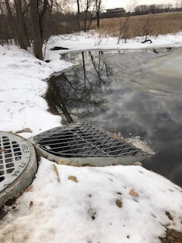

City officials supported the work.

“They’re a motivated group, and they got a permit to remove some vegetation to allow some better access to the preserve,” Francis said.

Engineering Director Debra Heiser added, “They

exemplify stewardship in a lot of ways. They are a very active group. They really want to contribute and really work on water quality in this basin.”

The group assisted the city in locating existing easements for a storm water pond upgrade near the northeast corner of Bass Lake, allowing storm water from private land to be filtered away from the area which the group hopes to make more accessible to the public.

While Friends of Bass Lake initially opposed the major storm water project at Carpenter Park due to the cost, the group later supported the work. The $1.7 million project included 10-foot-high concrete chambers designed to store water beneath a new skate park and a pretreatment manhole system designed to filter storm water before it runs into Bass Lake.

The project, which also included work to level playing fields on Carpenter Park and other upgrades,

provides storm water treatment for 42 acres on which

water had run toward Bass Lake untreated, Heiser said. Grants helped the city cover some of the costs for grading and drainage. The project will provide credit for storm water treatment in the development area near the planned Beltline light rail station. The project won an award from the Minnesota Erosion Control Association.

**Restoring a destination**

The group hopes all the work will help Bass Lake

gain recognition as a valuable destination in St. Louis

Park and beyond. Bass Lake originally had been about twice as large, Carpenter said, and part of the Chain of Lakes that include Lake Harriet, Bde Maka Ska, Lake of the Isles and Cedar Lake.

“It went all the way to City Hall,” Carpenter said. Adelmann added that Bass Lake once had a resort

on its shore.

However, the 29th Street Corridor train line divided Bass Lake from its peers in Minneapolis. Workers building the tracks dumped soil into Bass Lake, making the water body smaller and filling in areas. Bass Lake went on to become a dumping

**New control device for regulating lake depth.**

ground for decades.

“It was really on the wrong side of the railroad

tracks,” Carpenter said.

“We want to reconnect the Chain of Lakes. That really is a vision. We see Bass Lake as an amenity to the residents of St. Louis Park in the same way Lake Harriet, Calhoun and Isles are for people on the east side. Everybody goes over there, but we actually have this wonderful lake right here in St. Louis Park for the St. Louis Park residents.”

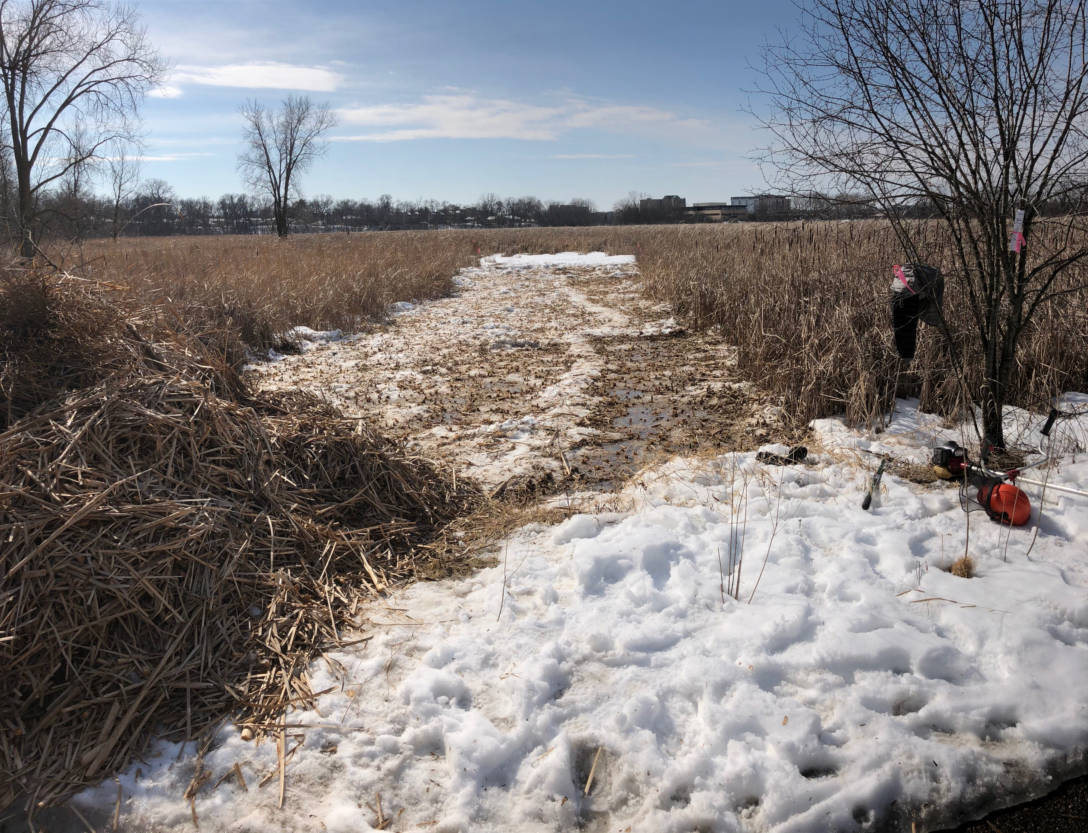

He compared Bass Lake to Westwood Hills Nature

Center, but on the east side of the community.

“This would be comparable to an Eastwood,” Carpenter said. “Bass Lake has the potential.”

He stressed the benefits for children.

“What we’re discovering is how important nature based play is, without structured play,” Carpenter said.

He and Adelmann pointed out that the neighborhoods near Bass Lake are changing as more apartment buildings are built and plans for development near the proposed Southwest Light Rail Transit line move ahead.

“Bass Lake will be even more important,” Adelman said. “You’re going to have more people in the neighborhood, and this will be a natural place people can go to.”

The trail around the lake already attracts thousands of visitors each year and has been used for charitable walks and events.

Carpenter said a past group several decades ago that tried to make changes at Bass Lake struggled to find success, and he said some advocates have had a troubled history in dealing with the city in the past. However, he praised several current officials and city departments for their efforts.

“We’ve been kind of a thorn in their side, but they’ve stepped forward on a number of these projects, and we look forward to building that relationship,” Carpenter said.

Adelmann thanked city officials and leaders of the Melrose Center located on the southwest side of Bass Lake, for their help.

“It’s a partnership now, and some good things are

happening,” Adelmann said.

Carpenter concluded, “The city is committed to this as well.”

Heiser said, “I can’t say enough about what a great

partner Friends of Bass Lake is. They’ve again risen

to the occasion and been incredible stewards of that basin. We really believe the city is committed to storm water and making storm water quality higher by putting in these kinds of projects and making sure we take care of our natural environment.”

Although the DNR technically classifies Bass Lake

as a wetland rather than a lake, Heiser said wetlands

are just as beautiful as lakes.

Friends of Bass Lake obtained a permit to remove hybrid cattails from a **section** of Bass Lake in preparation for a

dock and access point for canoes and kayaks. In January, St. Louis Park installed a new outlet for Bass Lake that helps control the water level.

“They provide habitat for birds and for all those critters– the deer, the amazing muskrat,” she said. “It’s an amazing habitat out there, and we’re very privileged to have such a large open space in the middle of our city.”

To learn more, log on to friendsofbasslake.com.