Registration Deadline: | March 11, 2020 | Competition Date: | March 21, 2020
Competition Director: | Laura Baxter | Contact Info: | laura@dancemapda.com
Venue: University of Maryland, Ritchie Coliseum |  |  | Time: Session 1: 9:30am  Session 2: 3:30 or 4pm.

School/Team Name
Division
Coach / Sponsor
Email |  | Phone
Two Additional Coaches Names

Small Qualified Routines Place an “X” Large Qualified Routines Place an “X” Non-Refundable Fees:
Pom |  |  | Pom |  |  | 1st Qualified Routine | $150
Jazz |  |  | Jazz |  |  | 2 Qualified Routines | $225
Lyrical |  |  | Lyrical |  |  | 3 Qualified Routines | $300
Kick |  |  | Kick |  |  | 4 Qualified Routines | $375
Prop |  |  | Prop |  |  | 5 or more Qualified | $450
Band Dance |  |  | Band Dance
Hip Hop |  |  | Hip Hop
Total Package |  |  | Total Package

Teams may enter up to 2 non-qualified routines. 1 non-qualified routine is $200, 2 non-qualified routines is $275. Type or print the dance category and group size.
Category |  | Group Size |  | Category |  | Group Size

Please Type or Print Jump off or Spin off Contestants Name and Grade.
 | Jump Off |  |  |  |  | Spin Off
 | Name | Grade |  |  |  | Name | Grade
1 |  |  | $15 |  | 1 |  |  | $15
2 |  |  | $15 |  | 2 |  |  | $15

2020 Discounts | Participated in four or more MAPDA Competitions | deduct | - $ 30.00
 | MAPDA Presidential Divisional High Scorers | deduct | - $ 100.00

Routine Payment Options and Deadlines:
On time Payment: Must be received by March 14
Payment Received after March 14 must include $25 late fee

School Check Payable to:
Mid Atlantic Pom & Dance Association
Mail Payment: MAPDA ~ Po Box 917, White Plains, MD 20695
Other options for payment: Paypal.me/MAPDA;
Cash App: $MAPDA
Qualified Routine Total | $
Non-Qualified Total | $
Less Discount | $
Routine Total | $
Jump Off / Spin Off Total | $
Pre-Order T-Shirt Total | $
Grand Total | $
Teams may elect to pay Jump/Spin off and T-shirts at team check–in. Routine payment must be received by stated deadline.

TEAM ROSTER
Please type or print team member names. Also identify officers, Captain, Co-Captain, etc. If you have a separate team roster file, you can send that instead.
OFFICERS

SQUAD MEMBERS

TEAM BIO FOR PROGRAM

Please also email a single picture of the team for the color programs by March 11. If a picture is not provided, you will not have anything on your page in the program!

Coaches / Sponsors Signature (1) |  | Coaches / Sponsors Signature (2)

MAPDA CHAMPIONSHIPS 2020
COMMEMORATIVE T-SHIRT

To guarantee your team members get a MAPDA 2020 Championship Commemorative T-Shirt it’s best to pre-order. There will be limited quantity the day of Championship. Please return this order form via email to laura@dancemapda.com by MARCH 11, 2020 to hold your shirts. Pre-ordered shirts will be given to the coach at check-in upon payment.
Please give accurate counts of t-shirts as your team will be responsible for payment.

Pre-order: $15.00 for each shirt

Payment can be sent in by March 14 or given at team check-in. If paying separately (not included with the registration fees) please send payment to:

MAPDA
P.O. Box 917
White Plains, MD 20695

Coach
Team

Size | Quantity |  | Size | Quantity
Youth Small |  |  | Adult Small
Youth Medium |  |  | Adult Medium
Youth Large |  |  | Adult Large
 |  |  | Adult X-Large
 |  |  | Adult 2XL
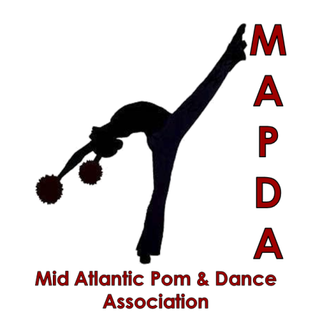
T-shirt Quantity
Total Payment  ($15.00 Each) | $

See MAPDA Rules and Regulations for Jump-Off/Spin-Off

