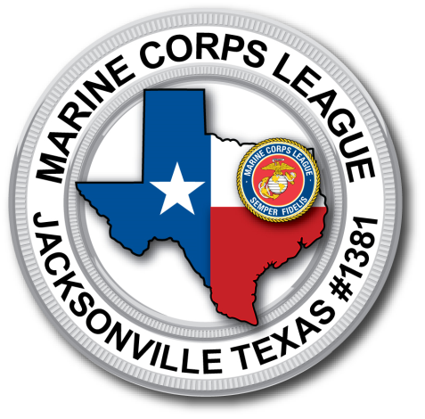
MArdet #1381
(Marine Disaster Emergency Team)
Updated Aug. 20th 2015

Contents Page
Mission Statement _____________________________ MS 01
Command Structure____________________________CS 01-11
Uniform Regulations____________________________UR 01-05
Gear and Weapon Regulations___________________GWR 01-02
Training & Member Handbook__________________

MArdet #1381
1/8 Golf Co.
(Marine Disaster Emergency Team)
Updated Aug. 20th 2015
Mardet mission Statement

Mission:
To provide supplies needed to Sustain life in a critical incident /disaster, to continue all training to be prepared to assist other agencies in any clime and place that abides by our Constitution and local Laws.
Members of the MARDET are Marine Corps League Members who join together for the purpose of preserving the traditions and promoting the interests of our local community, Texas, and the United States that they may effectively promote the ideals of American freedom and democracy, voluntarily aiding and rendering assistance to all Marines, law enforcement Officers, first responders and Citizens of our community.

Vision:
Proactively assist other agencies to protect and serve citizens of Texas and the United States.

Goals:
- Enhance Emergency Management.
- Further prevent loss of life, Injuries, and property damage.
- Maximize services to the public and assistance to other agencies.
- Optimize Emergency incident management.
- Protect public and State assets. MARDETHQ.MS080115 pg.MS 01

MArdet #1381
(Marine Disaster Emergency Team)-JUST AN IDEA-
Updated Aug. 20th 2015
MARDETHQ.CS080115
Command Structure

NOTE* Old School Marines work off of a rule of three. Each Marine has 3 things to worry about. This is a work in progress with the KISS concept. (Keep It Simple Stupid)

Fire Team - consist of at least 3 MARDET Members with a fire team leader.

Squad - consist of 3 fire teams lead by a Squad Leader.

Platoon – consist of 3 Squads

Company – consist of 3 Platoons lead by Commandant of Detachment

Battalion— currently we have 1 battalion for the State. We can add additional Battalions if needed.
Division - consist of one or more Companies.

MARDET – has 8 Divisions in the State of Texas based off of the MCL 8 dist.

MEU – (MarDet Expeditionary Unit) for special operations outside of County

MARDETHQ.CS080115 pg.CS 01

MARDET Division Map
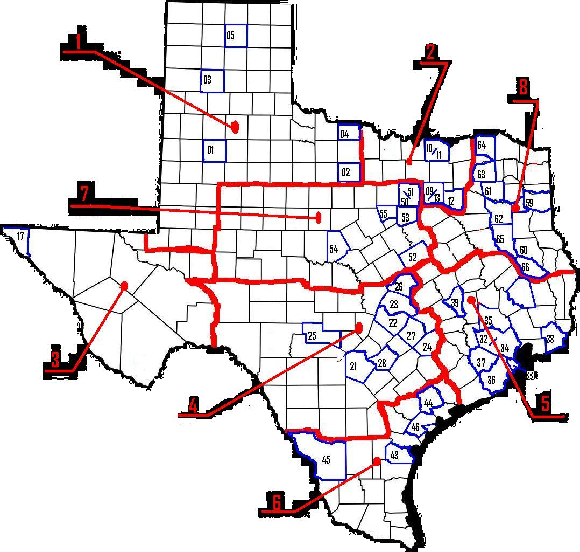

Work in progress nothing definate!!!

MARDETHQ.CS080115 pg.CS02

MARDET DIVISIONS
1st Battalion
DIV 1
Dist Vise -

Key Detachment/Web City County Social Media
1. - Alfa Co -------South Plains # 519---------Lubbock---------Lubbock County
2.- Bravo Co ----- North Texas # 862--------- Graham--------- Young County
3. - Charlie Co ----Roan Creek # 992-----------Amarillo-------Potter & Randall Counties
4. - Delta Co -----Red River Marines #997 -- Wichita Falls -- Wichita County
5. - Echo Co -------Hawthorne #1349-----------Stinnett ---------Hutchinson County------------Face Book
6. - Foxtrot Co ---Open
7. - Golf Co ---Open
8. - Hotel Co ---Open
DIV 2
Dist Vice -

9.- --Alfa Co ------- Big "D" #316 ----------------- Dallas ------Dallas County
10.- Bravo Co ----- Texoma #929 -------------------Dennison -- Grayson County
11.- Charlie Co --- LCpl Jacob R. Lugo #1300 -- Dennison -- Grayson County
12.- Delta Co ----- Terrell #1338 -----TFT----------Terrell ----- Kaufman County
13.-Echo Co------- Capt. John Yancy # 631--------Dallas ------ Dallas County
14.-Foxtrot Co--- Open
15.-Golf Co--- Open
16.-Hotel Co--- Open

DIV 3
Dist Vice -

17.-Alfa Co--- Dean Hawkins #323 ----------El Paso -----El Paso County
18.-Bravo Co--- Open
19.-Charlie Co--- Open
20.-Delta Co--- Open MARDETHQ.CS080115 pg.CS03
DIV 4
Dist Vice -
21.- Alfa Co ------ Alamo #315 -------------------- San Antonio --- Bexar County
22.- Bravo Co ----Cen-Tex #318---------------------Austin----------Travis County------------Face Book
23.- Charlie Co ---Williamson #1022-------------Georgetown-----Williamson County-----Face Book
24.- Delta Co ----Colorado Valley #1028---------La Grange-------Fayette County
25.- Echo Co -----Hill Country #1051--------------Kerrville--------Kerr County
26.- Foxtrot Co ---Lewis Wayne Qualls #1249----Temple---------Bell County
27.- Golf Co -----Lost Pines #1384------------------Bastrop---------Bastrop County
28.- Hotel Co -----Teufelshunde #1392---------New Braunfels--Guadalupe/Comal-----Face Book
29.- India Co ---Open
30.- Juliett Co ---Open
31.- Kilo Co ---Open
DIV 5
Dist Vice -
32.-Alfa Co---McLemore #324-------------------Houston---------Harris County
33.-Bravo Co---Galveston County #668------------Galveston--------Galveston County
34.-Charlie Co---AA Avalos #671-------------------Houston---------Harris County
35.-Delta Co---EASTEX #779---------------------Conroe----------Montgomery County
36.-Echo Co---Brazoria County #982--------------Angleton--------Brazoria County
37.-Foxtrot Co---Sgt J R Tijerina #1295--------------Katy-------------Fort Bend/Harris/Waller
38.-Golf Co---1st Sgt Joyce Venable #1382--------Port Arthur-------Jefferson County
39.-Hotel Co---Brazos Valley #1391----------------Bryan------------Brazos County
40.-India Co---Open
41.-Juliett Co---Open
42.-Kilo Co---Open
DIV 6
Dist Vice -
43.-Alfa Co-----Coastal Bend #430-----------------Corpus Christi-------San Patrico
44.-Bravo Co---Jack Ringel #540-------------------Victoria--------------Victoria
45.-Charlie Co---Larado #895-----------------------Larado---------------Webb
46.-Delta Co----Mike Loosemore #1167----------Woodsboro---------Refugio
47.-Echo Co---Open
48.-Foxtrot Co---Open
49.-Golf Co---Open
MARDETHQ.CS080115 pg.CS04
DIV 7
Dist Vise -
50.-Alfa Co------Tarrant County #731---------------Ft Worth-------------Tarrant County
51.-Bravo Co-----Bluebonnet #817-------------------Ft Worth--------------Denton
52.-Charlie Co---Heart of Texas #975----------------Waco-----------------McLennan
53.-Delta---------Longhorn #1069--------------------Crowley--------------Tarrant/Johnson
54.-Echo Co-----Pecan Valley #1170-----------------Brownwood-----------Brown
55.-Foxtrot Co---Comanche Peak #1297--------------Grandbury------------Hood------------Face Book---Twitter
56.-Golf Co---Open
57.-Hotel Co---Open
58.-India Co---Open
DIV 8
Dist Vise – Bill (Top) Hamby
P.O. Box 573
Jacksonville Texas 75766

59.- Alfa Co.---Longview #959----- -----------------Longview---------------Gregg/Harrison

60.-Brovo Co---Pineywoods #1189------------------Nacogdoches------------Nacogdoches

61.-Charlie Co---LCpl Shane L Goldman #1278------Mineola-----------------Wood

62.-Delta Co.---Rose City #1354--------------------------Tyler--------------------Smith

63.-Echo Co.---Hopkins County #1367-------------Sulfur Springs--------------Hopkins

64.-Foxtrot Co.---Sgt Jay Hoskins #1364----------------Paris---------------------Lamar

65.-Golf Co.---Jacksonville Texas #1381------------Jacksonville---------------Cherokee-------Face Book

66.-Hotel Co.---Lufkin #1362----------------------------Lufkin------------------Angelina

67.-India Co---Pending----------------------------Palestine----------------Anderson

68.-Juliett---Open
69.-Kilo Co---Open

MARDETHQ.CS080115 pg.CS05
Example:
8th Division

1st Bat. 8th MARDET Golf Co.1st Plt.

Golf Company. -Commandant

1st Squad leader-
1st Fire Team Leader - _____________
2nd Fire Team Leader - _____________
3rd Fire Team Leader - _____________
2nd Squad Leader -
1st Fire Team Leader - _____________
2nd Fire Team Leader - _____________
3rd Fire Team Leader - _____________
3rd Squad
1st Fire Team
2nd Fire Team
3rd Fire Team

MARDETHQ.CS080115 pg.CS06

MArdet #1381
(Marine Disaster Emergency Team)
Updated Aug. 20th 2015
MarDet Uniform Regulations - MARDET.UR.080115
MCL Commandant will set the uniform of the day/season/Mission.
The MarDet has 3 Duty uniforms -- O.D. Green, Woodland and 3 color Desert = "Field Utilities”.
If you earned certain badges, while on active duty, i.e. Jump wings, combat air crew, presidential badge or diving bell they are authorized for all uniforms (it is optional). Badges will need to be verified by your DD214
The new digital camouflage pattern “MARPAT” on any part of the Utility uniform is not authorized in the MARDET.
- Marines do not salute unless they are wearing a Cover.
- Marines do not wear covers indoors, unless they are "under arms", carrying a weapon or wearing a duty belt.
- Marines "blouse" their boots on all uniforms. That is, they roll the cuffs of their trousers back inside and tighten them over the boots with a cord or blousing cord.
  - Marines do not tuck trousers into the boots.
- Marines wear O.D. green Tee Shirts known as "skivvy shirt" or undershirts with all uniforms, No White Tee’s
- MARDET Marines do not wear any rank insignia. Only Team leaders for civilian communication.
- Marines when wearing The Utility /field / working uniforms, most commonly referred to as "Cammies", are not to be worn outside of training or duty assignment.
  - You may stop for gas and or emergency supplies at convenience gas stations. Unless under orders.
- Marines that earned the title of U.S. Marine may wear the EGA only, on left breast pocket and front of Cover.
  - No MARDET Marine will wear USMC on any uniform. (copyright issue)
  - All Marines are allowed to wear the MARDET patch (in development).
You can get all uniforms at TacticalGear.com except 8 point covers, they are at amazon.
3 color field jackets are hard to find.
MARDET.UR.080115 pg. UR01
Charlies are only required uniform at the present time.
MARDET Authorized Uniforms
Uniform | Description | Occasions for Wear | Leave/Liberty
Service “A”  Garrison Summer Uniform | O.D. green coat and trousers  O.D. green undershirt.  Eight point or boonie O.D. green cover  Belt Tan. Boots Tan.  O.D. green field jacket as needed  (badges optional) | Only when set as uniform of the day/event | no
Service “B”  Garrison  Winter  Uniform  “Optional” | O.D. Green sweater (Wooly Pulley)  w/green trousers. Eight point or boonie O.D. green cover. Belt tan Boots Tan.  O.D green field jacket as needed  (badges optional) | Only when set as uniform of the day/event | no
Service “C” | O.D. Green combat shirt.  O.D. Green Trousers, Eight point or boonie O.D. green cover. Belt kaki, Boots Tan. O. D. Green skivvy shirt.  O.D green field jacket as needed  (badges optional) | Only uniform required at the present time | no
Service “D”  Utility/Field  “Cammies”  Uniform | Woodland / 3 color desert coat and trousers. O.D. green undershirt. Eight point or boonie in woodland or 3 color desert.  Woodland combat shirt. Boots Tan.  Field Jacket same color as needed | Working/field uniform only (woodland during summer  3 color desert during winter season or as needed due to environment) MARDET HQ uniform of the day / operation. | No
“D1” | Woodland/Tan Combat Shirt
Physical Training Uniform  “PT GEAR” | Olive green undershirt, Woodland/3 color desert shorts, O.D. green sweatpants/shirt with a black MARDET logo on the upper left trouser leg and over the left breast of the sweatshirt. | Physical training (PT), field day, and limited leave and liberty occasions | Yes

MARDET.UR.080115 pg. UR02
Service “A” & “C” Primary Uniform O.D. Green
Propper cotton rip stop
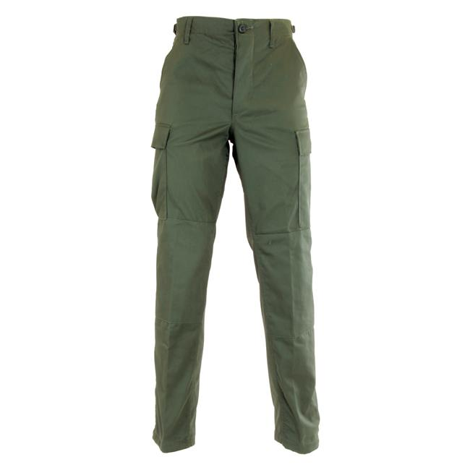
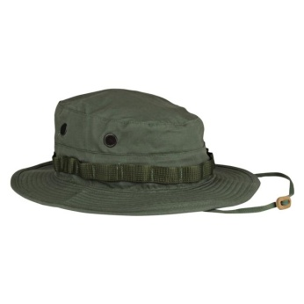
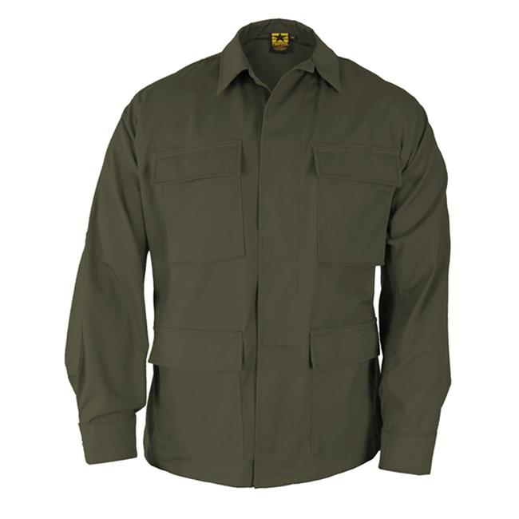
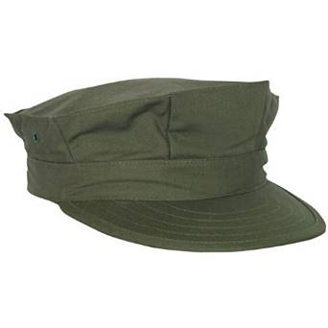
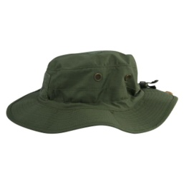

“A” Coat: $29.99 “A”B”C” Pants: $29.99 “C” Boonie: $9.99 “C” Boonie $12.97 “A””B” 8 point
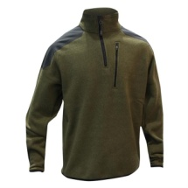
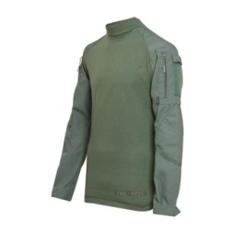
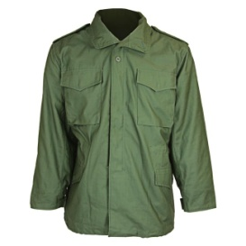
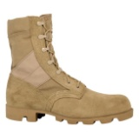
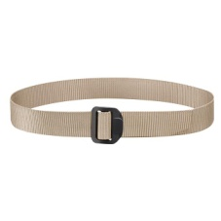

Field Jacket W/Liner Combat Shirt Kaki Belt $7.99 Boots Tan any stile “B”Sweater$89.00
“A”B”C” $82.99 “C” $49.95 ALL All $84 to $250
___________________________________________________________
Utility Field Cammies Service “D” Summer Woodland
Propper cotton rip stop
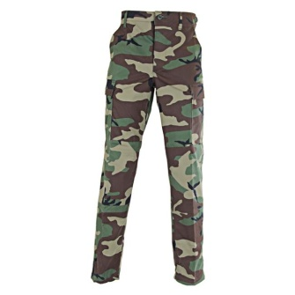
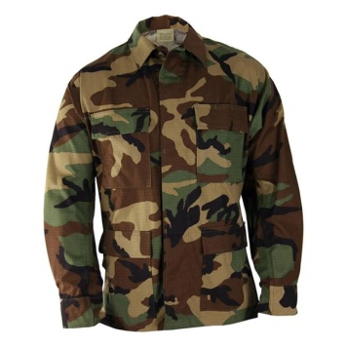
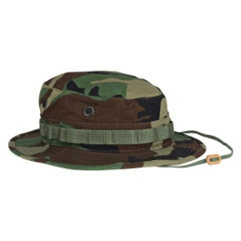
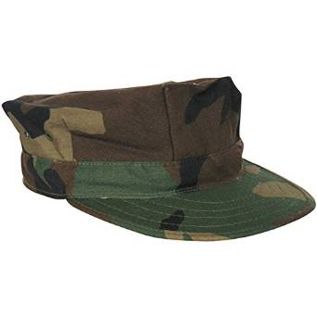

“D” Coat: $29.99 “D”&“D1” Pants: $29.99 “D1” Boonie: $9.99 “D” 8 point at Amazon
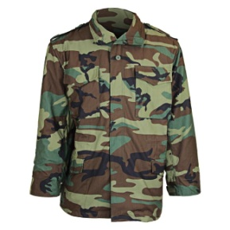
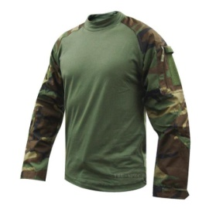
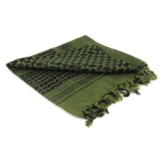
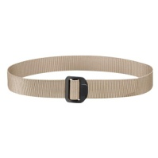

Field Jacket W/Liner Combat Shirt Kaki Belt $7.99 Condor Shemagh Boots Tan any stile
“D” & “D1”$82.99 “D1”$49.95 ALL As Needed OD/Blk $7.95 All $84 to $250

MARDET.UR.080115 pg. UR03
Utility field Cammies “D” winter 3 color desert
Propper cotton rip stop

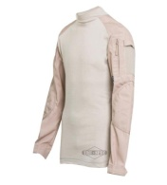
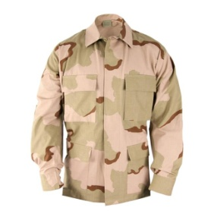
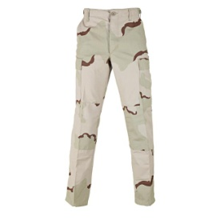
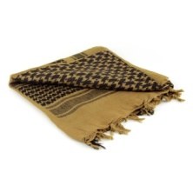
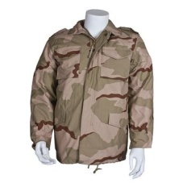

Field Jacket W/Liner Coat: $29.99 Pants: $29.99 Condor Shemagh Combat Shirt
Hard to find Tan/Blk $7.95 $49.95

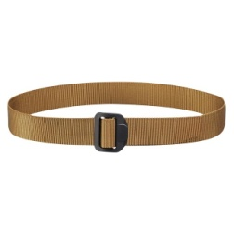
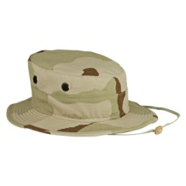
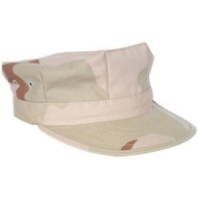

Kaki Belt $7.99 8 point at Amazon Boonie: $9.99 Boots Tan any stile
$84 to $250

Patches

Under construction!

MARDET.UR.080115 pg. UR04

MArdet #1381
(Marine Disaster Emergency Team)
Updated Aug. 20th 2015
Gear and Weapons Regulations MARDET.GWR.080115
Under construction
Digital Camo is authorized for all MarDet gear
WEAPONS
- All Firearms are to be concealed (if you have a CHL) NO OPEN CARRY OF ANY FIREARMS IN PUBLIC wile in MARDET UNIFORM until officially Deputized/Activated by County Sheriff or City Chief of Police. (even after Jan 1st 2016)
- MARDET Members are required to have a “GO BAG” (this will carry your weapons and tactical vest. And uniform)
- Primary Weapons are:
  - .45 acp, 9mm, Min of 20 rnds
  - 5.56 (223), 308, 30.06 Min of 100 rnds
  - 12 gage 20 rnds /bean bag rnds
  - K-Bar Knife or equivalent
  - Other wpns need to be authorized by Company CO

MARDET.GWR.080115 pg. GWR 01

GEAR
- Tactical vest 8. Folding Knife
- E-Tool 9. Safety Glasses Sun/clear
- Poncho w/liner 10.
- Gloves 11.
- Go Bag (accommodate wpn) 12.
- Camel bak (drinking water) 13.
- Small day back pack 14.

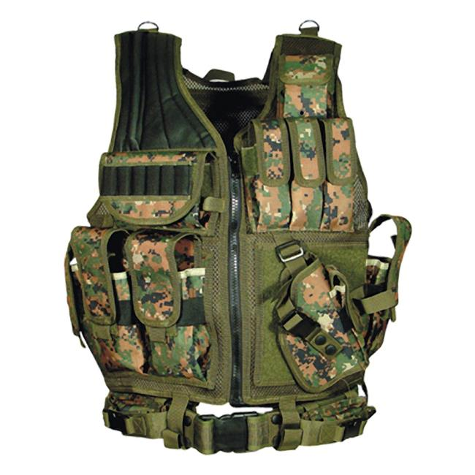
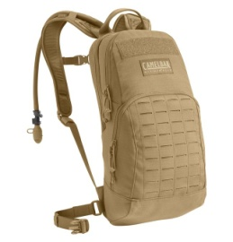
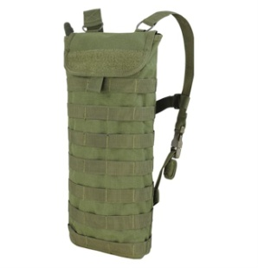

Leapers UTG 547 Law Enforcement Tactical Vest Hydration Carrier any size. Green, Tan or camo
Digital woodland $59.97 at tacticalgear.com from $28.99 to $200.00
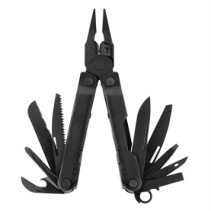

Leatherman, folding knife or equivalent
Starting at $30

MARDET.GWR.080115 pg. GWR 02

MArdet #1381
(Marine Disaster Emergency Team)
Updated Aug. 20th 2015
Training

- Crowd Control
- First Aid
- Food and Water Distribution
- Gun Control
- Radio Verbiage/Usage
- Deputized Member/ Legal Liability
- Local and Federal Agency’s
- City and County Law Enforcement
- Fire Department
- Water and Electric Co.
- Military
- Fema

MARDET
PROGRAM OPERATION
&
MEMBERS HANDBOOK
TABLE OF CONTENTS:
Section 1
MISSION STATEMENT
Vision
Motto
Level of authority
Section 2
OBJECTIVES
RESPONSIBILITIES
SELECTION PROCESS
EQUIPMENT
UNIFORMS
Section 3
Stakeholder
Analysis
Communication Planning
Evaluation
Budget
Data
Section 1
Mission
To provide supplies needed to sustain life in a critical incident / disasters, to continue all training to be prepared to assist other agencies in case of Terrorism foreign or domestic.
Vision:
Proactively assist other agencies to protect and serve citizens of Texas and the U S and State Constitution.

Level of authority:
must be approved by sponsor, Obtained approval by the Sheriff / Chief or his designee for implementation, staffing, equipment, training, program procedures and mission parameters.

Motto:
Semper fidelis
{always faithful}
OPERATING PROCEDURES
HANDBOOK
Section 2

SUBJECT | Marine Disaster Emergency Team #1381
DATE ISSUED |  |  |  |  |  |  |  | EFFECTIVE
09/5/2015 |  |  |  |  |  |  |  | DATE | 09/05/2015

PURPOSE:
To establish the mission and general duties of the MARDET
OBJECTIVES:
1. To Enhance Emergency Management.
2. Further prevent loss of life, injuries, and property damage during a critical incident.
3. Maximize service to the public and assistance to other agencies.
4. Optimize emergency incident management.
5. Protect public and state assets.

RESPONSIBILITIES
1. To work as a team with other agencies, keeping up with training, familiar
with area roads, mile markers and local resources. Keeping personal/unit
equipment up.

PROCEDU SELECTION PROCESS:
1. Apply with the appointed member by the Commandant of Detachment
2. Approval by Sheriff/Chief of his designee.
3. Must have a clean police record.

EQUIPTMENT:
1. All equipment for members must be purchased by members and must be authorized equipment. Any exceptions must be authorized in writing by the Commandant of Detachment or designee.

2. Vehicles and all accompanying equipment shall be distinctly marked as outlined the Commandant of Detachment of designee.

3. Inspections will be performed as directed by the Commandant of Detachment or designee.

4. Preventive Maintenance, cleaning and safety checks, shall be performed no less than once a month.

UNIFORMS:
1. Uniforms shall be worn in accordance with MARDET uniform policy, any exceptions must be authorized in writing by the Commandant of Detachment or designee.

2. MARDET units shall wear the below listed, approved equipment when operating in the field.
a) MARDET approved uniform

Members assigned as MARDET may provide escorts while on-duty under the following conditions:
1. When requested by incident commander.
2. When public safety will be compromised without such escort.

PUBLIC SAFETY PERFORMANCE OBJECTIVES
1. Mission tactics and strategies will be determined by the incident commander, if incident commander is unavailable the lead unit will handle, for faster response.

Stakeholder Analysis
Section 3
Customers | Their Expectations | Strategy
Citizens of Texas | Improve public safety, Work closely with allied agencies | Increase public safety By Rapid response.
Organizational | Their Expectations | Strategy
Commandant of Detachment or designee | Meet goals / objectives produce measurable results, enhance public image of MARDET. | Ensure Proper program management, specific mission parameters outlined.
Political | Their Expectations | Strategy

Stakeholder Analysis Strategy
How clear is their understanding of our work and our role? (Project)

The public’s understanding of the MARDET mission is clear.

How do they influence us?

Public opinion of MARDET influences funding and manpower increases which dictate effective performance.

What do we need from them?

Communicate who, what, why, and when consistently.

How important are they to our success?

Tremendously, the media has the ability to reach out to the whole community.

How can we win them to our side? What can they take back?

Our efforts will be forwarded to the public in real time. Together by communication and serve to the Public.

Stakeholder Communication Planning
Elevator or Hallway Speech
Audience Analysis
Who? | Priorities, Interests, Needs | What do you want them to know or do?
Sponsors  (Dept Chief) | Program implementation and budget authority | Know: Mission  Do: Approvals
Core Team  (Supervisor/Manager) | Equipment, training, data analysis, mission, tactics, strategy | Know: Expectations  Do: Equipment and logistics.
Extended Team  (Media) | Deployments, targeting a safer deployment to areas needed, tactics in our deployments. control by early warning. | Know: Data, intentions  Do: Inform public
Stakeholders  (Program membe |  | Know: Job Duties  Do: Perform duties as outlined by Command
Project Team

Roles and responsibilities | Skills and abilities knowledge needed | When Frequency | Name
Supervisor: program development, project management, data research/comparison, meetings | Strategy, tactics, schedules, personnel, equipment | n/a | Project Manager:
Manager: approvals, chain of command link | Guidance, support, influence, policy/procedures | Weekly | Core team:
Performance, feedback | Field Operational expertise | Daily | Extended team:  Team Members
Commander: Project/program implementation, mission, goals, objectives. | Authority | Monthly | Project support:
Project Budget Estimate Worksheet

Cost
Equipment
Hardware (vehicles)
Software
Project staff time
Other staff time
Consultants
Staff Development (training)
Overhead
Travel (fuel)
Hospitality
Consumables
Contingency (vehicle maintenance)

Data Collection Plan

What data do I need | How will I gather the data | How will I display my data
Current incident data comparison by month/day/beat/sector | Statistic gathered from Fire Department, area Law Enforcement and Weather Agencies | Spreadsheets/graphs
Equipment Costs | Budget declining balance spreadsheets | Spreadsheets
Monthly Activity | members End of month reports, | Spreadsheets

Project Evaluation Plan

Formative Evaluation | Evaluation Method | Success Measurement
Benchmarking: compare with other agencies | agencies, model what works | SOP completed
Process Evaluation | Evaluation Method | Success Measurement
How process operates | member feedback, data | Outlined, approved
Output Evaluation | Evaluation Method | Success Measurement
Counting results of process | Raw data | Accumulation graphed
Outcome Evaluation | Evaluation Method | Success Measurement
Reduction in injuries to Rescuers. | Continuous Data | Reduction graphed

Project Phases

Phase | Estimated elapsed time
Initiating: Program Policy, Procedures, Mission
Planning: Personnel / Equipment / Strategy / Media
Implementing: Equipment, Training, Data Collection, Tactics, Data Analysis, Reporting, Media
Closing: Project Report

Project Milestones or Events

Milestone | Estimated date
1) Start up = Mission, Implementation, personnel selection.
2) Development = Budget: Equipment allocation and personnel training {if any}
3) Mission Strategy = Data, SOP, Goals, Objectives, strategy, tactics, media exposure
4) Refinement = Mission, SOP, performance, scheduling

5) Evaluation = Data, Project report

Reviews and approvals needed

Interim Deliverable | Review by whom | Estimated date
SOP
Mission Statement
Equipment
Training Certifications
Enforcement Activity
Crash Analysis Results
Project Report

Project Progress Communication Plan

Who | Needs to know what | When/frequency | In what form
Sponsors: | Milestones | Monthly | email
Core Team: | Logistics | Weekly | In person/ email
Extended Team: | Unit deployments | Daily/weekly | PIO
Stakeholders: | Tactics, Strategy, Duty Assignments | Daily | In person

Action Planning
Action | Time | Start/Finish | Who | Resources
Refer to Gantt Chart

NOTES

