Angel Delight Valentine’s Event
Contact Retha Wegmiller, 580/542-2639 for information and reservations.
417 S. Washington, downtown Enid – angeldelight@att.net
Friday, February 13and Saturday, February 14
Seating begins at 6:00 p.m. Second seating at 8 p.m.
(Reservations Required - Tables of 2, 4 and 6 available - groups encouraged)
Complete evening $28.50 per person plus tax and gratuity.
($24.50 per person for parties of 4 or more.)
Hors d’oeuvres & Salad: – Served at your table.
•Mini-Savory Cheese Ball with Meats & Crackers •Hot Spinach Dip with Tortilla Chips
•Crisp Garden Salad (homemade Ranch) or Strawberry Salad (homemade Strawberry Balsamic Dressing)
Hot Buffet - (Choose some of each – or we’ll be glad to personally serve your entre’ selection.)
•Chicken Kiev, Seasoned Rice and Alfredo Sauce, Orange Honey Glazed Carrots
•French Onion Bacon Wrapped Sirloin, Mashed Potato Casserole, Green Bean Almandine
•Pork Loin, Sweet & Spicy Harvest Potato Medley, Vegetable, and hot fresh baked Rolls.
Dessert served at your table: – •Apple Crisp with Butter Rum Sauce and Vanilla Ice Cream
•Gourmet Cheese Cake (blueberry, cherry or chocolate/caramel/pecan toppings)
•Home-made Red Velvet Cake (Auntie Evelyn’s recipe) Or choose a little of each!

Treat your sweetheart to a taste of heaven!
French Onion Chopped Sirloin Dinner  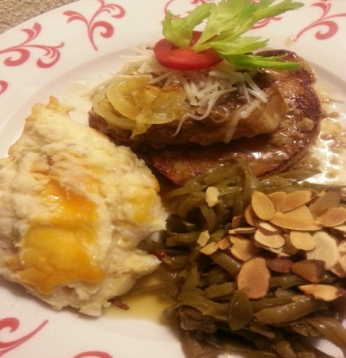 | Aunt Evelyn’s Red Velvet Cake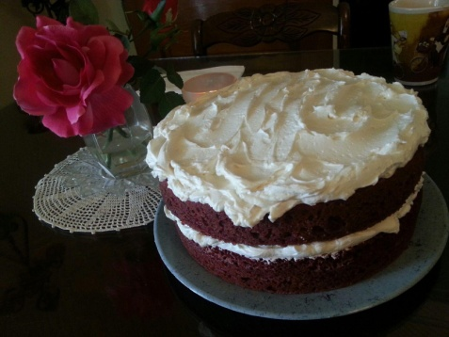 | Elegant Tea Room Setting  for Special Events  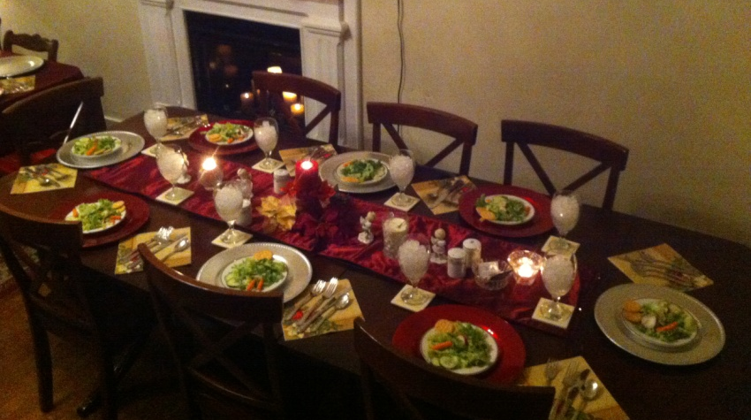
Fruit Bouquets $29-$59  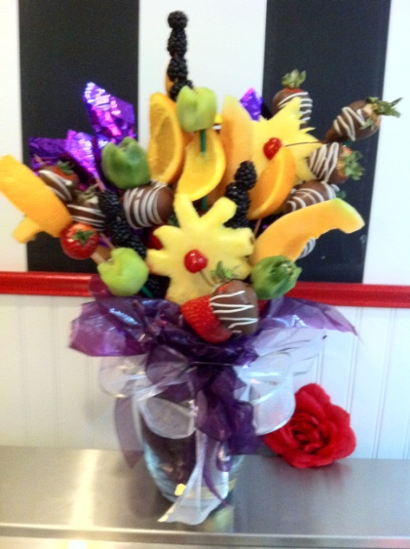 | Gift Boxed Toffee: $24.99 pound ½ Pound - $13.99 3 oz bag $4.99  4x4 Gold Box $6.99  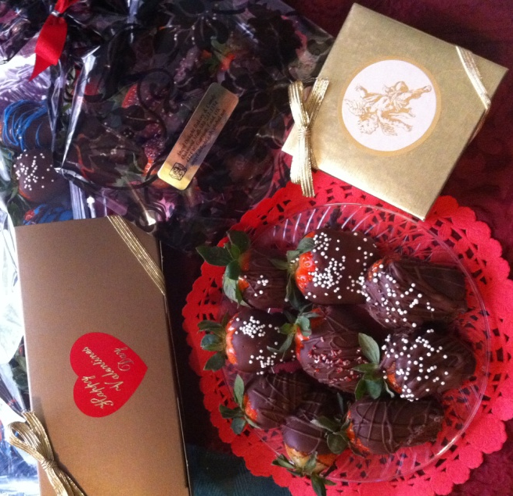 | Wine tasting by Rose Cohlmia, independent licensed wine maker  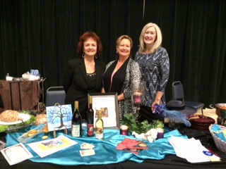  Iced & Hot Tea, Peach Tea, Coffee

