Risk Factors of Breast Cancer: Environmental Focus

Natalie S. Schulhof

May 8, 2017

George Mason University

**Introduction**

This paper focuses on risk factors of breast cancer; specifically environmental risk factors. Case studies and analysis are used to show scientific data on the topic. One case investigates environmental breast cancer risks in a high incidence area. Data is collected in a variety of ways for the first case. The second case is based upon adolescent behavior and investigates if younger age of exposure to certain environments and activities are correlated with an increased risk of breast cancer. Before discussing and analyzing cases, I will explain what cancer is and why it is especially important that we research its causes. Preventative measures and their challenges are noted as well.

**Background**

Breast cancer is caused by damage/mutation to DNA. It is a non-communicable disease. Although a lot of research has been done to find environmental contributors to breast cancer, “results have offered few opportunities for preventative actions” (Breast Cancer and the Environment, 1). In fact, 60%-70% of breast cancer patients do not have known risk factors (Risk Factors, 2016). It is very important that we continue to research causes and environmental contributors because if we are aware of risk factors, we can better protect ourselves. If we do not know risks factors, then we do not know which exposures to limit or which behaviors we should avoid. Of course, it is not certain that all women will change their environments and/or activities if they learn about increases to their breast cancer risk. However, research is still important from a public health perspective because- depending on what the risk factors are- there may be ways to reduce exposure.

**Health Implications**

Breast cancer is a disease triggered by mutations in a woman’s cells. Thus, a basic understanding of DNA and DNA mutations can help explain the biological pathway of what makes a cell cancerous. “Endogenous estrogen and other hormones are proposed as plausible biologic pathways by which breast carcinogenesis is influenced…” (Gannon, 2002). A few examples of such include high alcohol intake, menstruating at an early age, having a late first birth, low parity, null parity, late age menopause, little/no lactation, and excess bodyweight at time of menopause (Gannon, 2002). Risk factors are often associated with estrogen levels. Estrogen is known to be a cancer promoter because it increases the speed of cell turnover (Gannon, 2002). This can be a problem if there is rapid cell turnover if there is damage, a mutation, in the DNA. Presence of BRCA1 and BRCA2 genes can also increase breast cancer risk (Risk Factors, 2016). On the other hand, radiation exposure can itself disrupt the cell cycle to cause a direct mutation.

Regardless, it is important to understand that cancer is caused by damaged/mutated DNA. It is not a contagious diseased. Therefore, when we study its risk factors we need to consider how those environmental risk factors affect DNA because DNA is ultimately what causes breast cancer. Attached in the appendix is a picture of the cell cycle. Cell health is a major health implication related to breast cancer.

**Methodology**

Pertaining to methodology, the best can do is find methods of prevention until there is a definite cure for breast cancer. Methods that should be practiced include limiting ionizing radiation exposure, alcohol consumption, excess postmenopausal weight, and combined hormone therapy with progestin and estrogen (Breast Cancer and the Environment, 2). These methods can be practiced in theory, but in reality, some women may not be able to limit those environmental factors. For example, if you have PCOS then it may be necessary that you take a combined estrogen and progestin pill. Weight gain is also something that not all women are in control of because of limited mobility, genetics, access to only certain foods, etc.

**Case 1: The Long Island Breast Cancer Study Project: Description of a Multi-Institutional Collaboration to Identify Environmental Risk Factors for Breast Cancer**

In the following paragraphs I will refer to this case with the acronym “LIBCSP” for simplicity. LIBCSP is a population-based case-control study that took place in Long Island, NY. LIBCSP. In this high incidence area, there are approximately 2,000 newly diagnosed and invasive breast cancer cases annually in the Nassau and Suffolk county regions (Gammon, 2002). The purpose of this study was to investigate if exposure to organochlorine compounds, such as DDT, polycyclic aromatic hydrocarbons (PAH), and polychlorinated buhenyls (PCBs) are associated with risk of breast cancer (Gammon, 2002). Testing was done using self-reports recorded by participants, blood samples, urine samples, and environmental home samples of soil, dust, and water (Gammon, 2002). It is noteworthy that testing was in a variety of mediums to all test for environmental exposures. With many different ways of testing, accuracy should be improved.

Although LIBSCP took place in the Long Island, NY area, it is important that to think about *why* there is a high incidence of breast cancer. Is it coincidence that women with a higher likelihood of developing breast cancer live in the same area? Or is the environment to blame? Perhaps there are multiple reasons? Immigrant women and her children experience incidence rates similar to their adopted country as opposed to their country of origin (Gannon, 2002). This information shows that even if the environment is not the only indicator of risk, it is definitely a contributing risk factor. Investigation on specific environmental risk factors such as diet, smoking, alcohol consumption, and ionizing radiation exposure to the chest area- ranging from moderate to high exposure are considered to be risk factors for breast cancer (Gannon, 2002).

Women who participated in LIBSCP were newly diagnosed with invasive or primary *in situ* breast cancer (Gannon, 2002). Researchers contacted physicians who then shared information about the study to their patients who were potential cases. 2,271 women were initially considered to be potential cases for this study (Gannon, 2002). After accounting for women who had poor health status in addition to their breast cancer diagnosis and determined eligibility by the physicians, 1,837 women became subjects in this case study (Gannon, 2002). Women who were controls came too from Suffolk and Nassau countries. They had no history of breast cancer, spoke English, and were within 5 years of age to the case study women (Gannon, 2002).

The results of the study confirmed that the following are breast cancer risk factors: parity, age of first birth, family history (sister and mother), and breastfeeding (Gannon, 2002). It is important for us to consider how these risk factors relate to environmental health. If we think of environment in broad terms- such as relating to cultural norms as opposed to only the physical environment- we can see how age of first birth, for example, relates to environmental health. In class we talked about how women in high-income countries tend to have fewer children and at an older age. As the study just proved, women who have their first birth at an older age have a higher chance of developing breast cancer. Considering the social environment, there is a connection between environmental health and the risk of obtaining breast cancer. Although, a risk factor such as family history is a biologic factor regardless of environment. Also, not all participants provided each of the different biologic, self-reporting, and environmental home samples. Hence, we must consider the incomplete sampling when analyzing results.

**Case 2: The Associations of Adolescent Cigarette Smoking, Alcoholic Beverage Consumption, Environmental Tobacco Smoke, and Ionizing Radiation with Subsequent Breast Cancer Risk (United States)**

The purpose of this case study is to investigate if adolescent exposures increase the likelihood of developing breast cancer later in life. The four adolescent exposures are alcoholic beverage consumption, cigarette smoking, environmental tobacco use (ETS), and ionizing radiation, which is used to monitor or treat medical conditions (Marcus, 2000). The Carolina Breast Cancer Study, referred to as CBCS, was the provider of data for this analysis (Marcus, 2000).

Researchers hypothesized that adolescent environmental exposures would correlate to an increased chance of breast cancer (Marcus, 2000). This hypothesis comes with context. Japanese women who were WWII survivors showed an increased breast cancer risk later in life (Marcus, 2000). These women were between 10 and 19 years old at the time of the atomic bomb detonations over Hiroshima and Nagasaki (Marcus 2000). Because of this information, it is logical to hypothesize that radiation exposure during adolescence could be associated with a greater risk of breast cancer. This would mean that adolescent breasts are particularly sensitive to carcinogenic insult; specifically exposures to ionizing radiation which can damage DNA (Marcus, 2000). I think that is important that researchers pay attention to history to realize patterns such as these. It makes more scientific research possible, which can hopefully be used to produce information to save lives.

Now I will discuss the methods used to carry out this study. CBCS is a “population-based, case-control study of breast cancer in a contiguous 24-county region of central and eastern North Carolina” (Marcus, 2000). Women who were cases ranged in age from 20 to 74 years old (Marcus, 2000). They were diagnosed with a first, invasive, primary breast cancer between May 1993 and May 1996 (Marcus, 2000). Randomized recruitment was used to find women for cases and controls (Marcus, 2000). Female nurses asked participants questions relating to their adolescent exposure (Marcus, 2000). Specifically, the question used to determine ETS exposure in this study asked if anyone in the participant’s home smoked before she was 18 year old and if so, for how long (Marcus, 2000).

Results showed that woman who began smoking cigarettes between ages 10 to 14 were at a greater breast cancer risk than women began smoking between ages 15 to 10 and women who had never smoked (Marcus, 2000). Women who were exposed to ETS in their homes before they were age 18 did not have a greater risk of breast cancer when compared to women who did not have ETS exposure (Marcus, 2000). Initial alcohol consumption between ages 10-15 and 16-19 was not proven to increase the risk of breast cancer (Marcus, 2000). A higher risk of breast cancer was found in women who were exposed to ionizing radiation for medical reasons between ages 10 and 19 (Marcus, 2000). Something that is particularly fascinating about this study is that adolescent ages are broken down into smaller brackets for deeper analysis. A challenge associated with adolescent exposure is recall bias. However, since cases and controls were both asked about adolescent exposures, it is very likely that differential such bias would not change results (Marcus, 2000). Also, it is difficult to determine at which age exposure is associated with highest risk of breast cancer (Marcus, 2000). This case studied adolescent exposure/behavior. Separating effects of adolescent and adult behavior is difficult when studying the effects of exposure (Marcus, 2000). Overall, I think this was an interesting study because it focused on environmental exposure at a younger age to see if that affected breast cancer risk in women.

**Analysis**

We can synthesize that there is not a clear-cut solution to limiting environmental risk factors associated with breast cancer. In part, this is because we are not fully aware of which environmental risks have the largest influence and at which age. Also, not all risks for breast cancer are environmental risks. Since there are personal factors that influence breast cancer risk, it is extremely difficult to determine which factors are a greater contributors to breast cancer.

**Conclusion**

This paper addresses what breast cancer is, personal risk factors, environmental risk factors, preventative options/challenges, and analysis of scientific case studies. Challenges with this topic include determining the strength of certain risk factors and thus determining how to limit dangerous environmental exposure. Even after we determine what the environmental risk factors are, it is difficult to tell what amount of exposure is considered dangerous. We also do not know at which ages women are most susceptible to environmental risk factors. I think more research should be conducted on this topic so that women can better protect themselves. Knowledge is power. Research for a cure is very important, too, especially since research shows that determining environmental risk exposures is difficult. On a personal note, I hope to see a cure for breast cancer. Not only from a public health perspective which I have learned about in class, but also from a personal perspective. My mother passed away from breast cancer about 8 years ago and I would like to dedicate this paper to her. Some women will defeat breast cancer, but breast cancer will never defeat women.

**Reference Page**

Gammon, M.D., Neugut, A.I., Santella, R.M. et al. Breast Cancer Res Treat (2002)

74:235

Institute of Medicine of the National Academies. (2011). *Breast Cancer and the*

*Environment: A Life Course Approach.* Washington, DC.: National Academy of Sciences.

Marcus, P.M., Newman, B., Millikan, R.C. et al. Cancer Causes Control (2000) 11:

271.

Panno, J. (2005). *Cancer : The Role of Genes, Lifestyle, and Environment*. New York,

NY: Facts on File, Inc.

Risk Factors. (2016). National Breast Cancer Foundation, Inc. Retrieved from

<http://www.nationalbreastcancer.org/breast-cancer-risk-factors>.

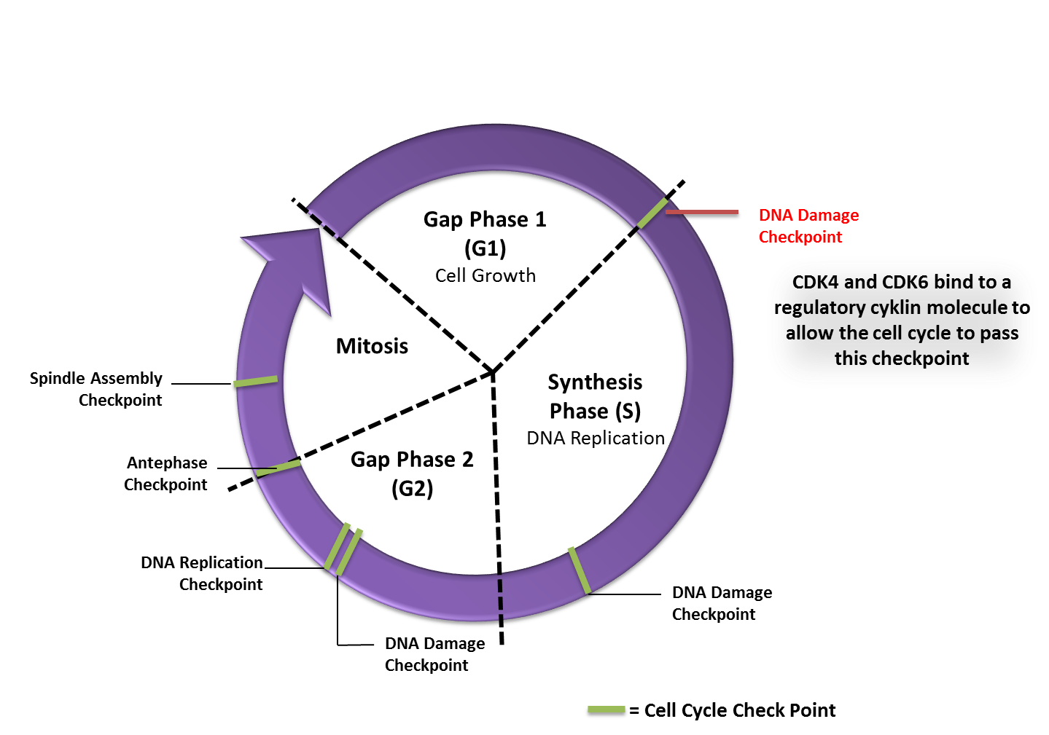

https://scooponcancer.wordpress.com/2014/04/07/new-pfizer-breast-cancer-drug-has-impressive-results/