**Safety of U.S. Produce**

**Madeline Ludwig**

**George Mason University**

**GCH 360**

**Introduction**

Produce is defined as “agricultural [products](http://www.merriam-webster.com/dictionary/products) and especially fresh fruits and vegetables as distinguished from grain and other staple crops” (Merriam-Webster). The produce section is usually found at the front of most grocery stores and considered the “most fresh” area. But are these grocery items fresh and from nature? Do they have layers of chemicals and pesticides? Are there genetically modified organisms (GMOs) mixed in? And are these chemicals and GMOs safe for us to consume? This paper will focus on pesticide usage, GMOs, and the overall safety of the United States’ produce.

**Pesticides on Produce**

Produce is meant to be a fresh, nutritious food staple, which is encouraged to be half of our plates by the USDA’s funded program, Choose My Plate. Fruits and vegetable are encouraged to be eaten because of their nutrients and health benefits. A few of these benefits for include that they are naturally low in fat, sodium, and calories, they include vitamins and minerals, help to maintain healthy blood sugar levels, help grow and repair body tissues, and reduce the risk for heart disease, diabetes, and kidney stones. (USDA, 2015)

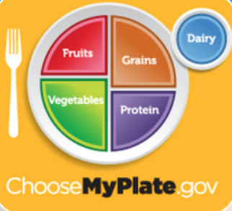

Pesticides are a concern for 85 percent of Americans. (Consumer Reports, 2015a) Pesticides are defined as “something used to kill, repel or control plant or animal life that is considered to be a pest to the growth of the fruit or vegetable.” (Best Food Facts, 2013) The Centers of Disease Control and Prevention (CDC) reports that on average 29 different pesticides are in American’s bodies.

The Food Quality Protection Act ensures that the EPA (Environmental Protection Agency) checks that the levels of pesticides are not harmful to children. Each year the Department of Agriculture completes tests to check pesticide residues on different produce sources. But in the latest report, they saw that most samples had pesticide residue but came in below the EPA’s tolerance levels, not raising any flags. The USDA checked different types of residue that individually did not exceed tolerance levels, but the mixture of pesticide residues and their effects are not tested or known about. (Consumer Reports, 2015a)

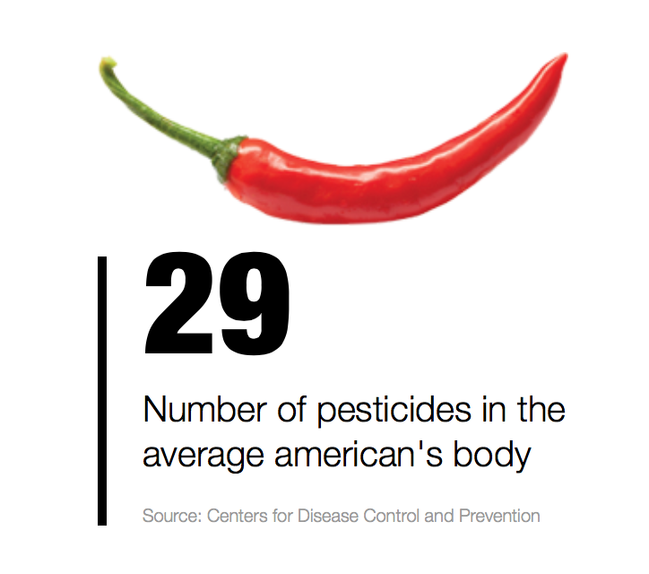

The USDA recorded some examples of the highest levels of pesticides that must be taken in by the body to produce significant health effects. A few of these examples include a woman consuming 529 servings of apples in one day, a child consuming 6,494 servings of potatoes in one day, a man consuming 2,640 serving in one day, a teenager consuming 888 servings of cherries in one day, all with no significant effects. (Best Food Facts, 2013)

Pesticide exposures can lead to chronic health problems, especially in cases of long exposure such as farmworkers. These health problems are increased risk of Alzheimer’s, Parkinson’s, cancers, depression, birth defects, and/or respiratory problems. Children are also at high risk for pesticide exposure. Children’s immune systems are not as strong as most adult’s which can lead to these toxins staying in their bodies longer. If pesticides can get to a child’s brain, they can and will slow down development.

**GMOs**

GMOs are genetically modified organisms, made to introduce “good genes” in organisms (like produce) that need to be changed for some reason or another. Scientists in labs harvest “good genes” and stick it into the organism they want to change. This is a process that happens in nature, but the science of GMOs dramatically speeds up the process of DNA changes. When this process occurs in nature, it is called evolution. In the US now, more than 90 percent of soybeans and about 80 percent of corn and cotton are GMOs. (Carroll, GMOs, 2014a)

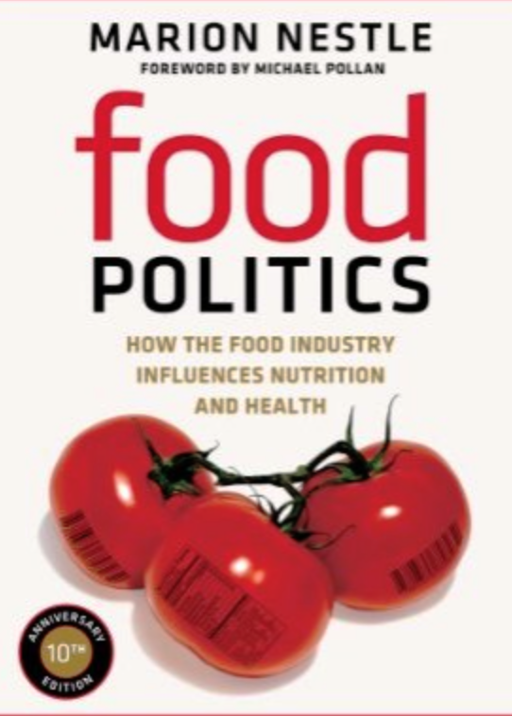

Many controversies have arisen over GMOs and their “hazards” to human health. Marion Nestle explains in her book *Safe Food: The Politics of Food Safety* there are two ways to approach food hazards in general, but it specifically applies to GM foods. The first approach is science based; “if the food is safe, it is acceptable.” From today’s scientists, they call GMOs acceptable and safe, so with this approach all critiques of GMOs are not valid. The second approach is value based; “even if GM foods are safe, they are not necessarily acceptable for reasons of precaution, ethics, religion, culture, or concerns about corporate control of the food supply.” This approach does not allow for just scientific research: it calls for reasoning of values. (Nestle, 2010)

**Case Study: “Eat the Peach, Not the Pesticide”**

Consumer Reports did a special report and risk guide titled “From Crop to Table: Pesticide Use in Produce.” They calculated the Dietary Risk Index (DRI) to measure the relative risks of different produce items and their levels of pesticide residue. They then matched the DRI levels with their risk category from ‘very high’ to ‘very low.’

In the report we see all types of produce rated on its risk scale, by country of production. For example, we see cantaloupe from Honduras and Mexico is at a ‘very low’ risk level, but from Costa Rica and Guatemala it is a ‘low’ risk level, and from the USA is a ‘high’ risk level. Another example, green beans are ranked ‘medium’ when from Guatemala, ‘high’ when from Mexico, and ‘very high’ from the USA. (Consumer Reports: Food Safety & Sustainability Center, 2015b)



**Case Study: GMOs**

Years of research on GMOs have been conducted and are still being conducted. Dr. Aaron Carroll makes videos to explain healthcare policy, medical research, and other health questions of “regular people.” In his video on GMOs he says “the European Union conducted its own research… let me quote from their report ‘The main conclusion to be drawn from the efforts of more than 130 research projects, covering a period of more than 25 years of research and involving more than 500 independent research groups, is that biotechnology, and in particular GMOs, are not per se more risky than e.g. conventional plant breeding technologies.’” He continues to add that the American Medical Association, the US National Academy of Sciences, the British Royal Society, and WHO all agree. (Carroll, GMOs, 2014a) His sources can be all be found here <http://theincidentaleconomist.com/wordpress/healthcare-triage-gmos/> (Carroll, Healthcare Triage: GMOs (sources), 2014b)

**Analysis**

The first case study on pesticides shows that pesticide residue does cause threats, shown through the Consumer Safety’s report, which includes the Dietary Risk Index on all types of produce. Consumer Reports shows which country’s products are less likely to risk to an individual. They also offer other solutions, as is when is buying organic most important. The second case study uses research from highly pronounced research organizations, such as the World Health Organization (WHO) that no scientific threat comes from genetically modifying organisms.

**Conclusion**

We can use Marion Nestle’s two approaches to conclude the safety of U.S. produce in relation to pesticides and GMOs. From Nestle’s scientific based approach, the research expressed by our government’s EPA that they do not test for multiple pesticides shows they do not feel those pesticides can cause any foreseeable harm. We also saw the USDA’s examples of how much one could eat of a produce product without significant effects. In accordance with GMOs, the European Union, the American Medical Association, the US National Academy of Sciences, the British Royal Society, and WHO do not consider them to be more risky than conventional plant breeding methods.

When we use Marion Nestle’s value approach, we come in question with people’s values on changing genes and speeding up processes of nature. Also, individual’s opinions on whether they place a significant seriousness and severity of consuming some pesticides with their produce. This is how the argument of the US’s safety of its produce occurred. Science has done their part and are continuing to do more, to continue to prove that GMOs do not harm us any more than conventional methods. This brings a final statement that the safety of U.S. produce lies in the values of the beholder, as long as they know of the true scientific research behind pesticides and GMOs.

# Works Cited

Best Food Facts. (2013, 10 28). *Are Fruits and Vegetables Sprayed with Pesicides Less Safe than Organic Produce?* Retrieved 12 8, 2015, from http://www.bestfoodfacts.org/food-for-thought/pesticides-on-produce

Carroll, A. (2014a, 6 9). GMOs. *Healthcare Triage* .

Carroll, A. (2014b, 6 9). *Healthcare Triage: GMOs (sources)*. Retrieved 12 8, 2015, from Incidental Economist: http://theincidentaleconomist.com/wordpress/healthcare-triage-gmos/

Consumer Reports. (2015a). *Pesticides in Produce*. Retrieved 12 8, 2015, from http://www.consumerreports.org/cro/health/natural-health/pesticides/index.htm

Consumer Reports: Food Safety & Sustainability Center. (2015b). *From Crop to Table: Pesticide Use in Produce.* Consumer Reports.

Merriam-Webster. *produce.* Merriam-Webster.

Nestle, M. (2010). *Safe Food: The Politics of Food Safety .* University of California Press.

USDA. (2015, 6 16). *Choose My Plate*. Retrieved 12 8, 2015, from http://www.choosemyplate.gov/vegetables-nutrients-health