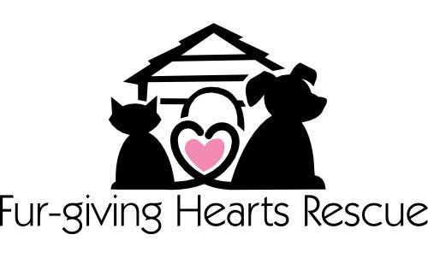
Volunteer Guidelines

- Volunteers are required to attend interviews, orientations, and training as the Fur-Giving Hearts Rescue deems necessary.
- Volunteers should be polite and helpful at all times.
- All people and animals are to be treated with respect and courtesy. Volunteers are required to adhere to the rules explained in the training as it pertains to animal handling.
- Volunteers should refer questions from the public regarding Fur-Giving Hearts Rescue policies to the staff only. Volunteers should maintain confidentiality in regards to FGHR clients and business.
- Volunteers must accept the guidance and decisions of the professional staff person responsible for volunteer activities.
- Volunteers are responsible for giving reasonable notice is required if unable to make a volunteer shift.
- For safety reasons, volunteers are required to wear appropriate attire when working with animals. Volunteers are required to purchase and wear an Fur-Giving Hearts Rescue t-shirt (approximately $15) during their volunteer shift.

Volunteer Signature:____________________________________________________
Date:________________________________________________________

REVISED 4/2014

