**Finding the ROI of Social Media**

*A Case Study of Healthcare Art Consulting*

by J. R. Atkins, MBA, and Marilyn Mathis, ABC

**Could your business benefit from social media?**

It’s a given. Social media (such as Facebook, Twitter, and LinkedIn) is affecting the culture almost as much as the invention of the PC. And, like the computer, social media morphed quickly from toy and stylish accessory to essential business tool. This case study provides not only the story one company that decided to measure social media outcomes, but also a blueprint for its future marketing and measurement.

[HealthcareArt Consulting](http://www.healthcareartconsulting.com/) (HAC) is a specialized health care consulting firm located in Dallas, TX, whose mission is to improve healing environments for patients and staff through the use of art and multisensory solutions. “We help heal people through visual stimulation,” says Chief Operations Officer Megan Lapham.  “We not only offer visual art on the walls of institutions, but also we provide *Art Helps Healing* Programs, dynamic digital art for patient rooms, and iArt tours for the iPhone. HAC provides research, education and knowledge to healthcare administrators, physicians and other health care leaders in order to select the best artistic solution for their healing environment.”

**LAPHAM**

Lapham initially looked for a way to connect directly with hospital executives when she began using LinkedIn, noticing she could build relationships with those in her target market. She also decided to connect with [J.R. Atkins, social media expert and speaker.](http://www.somethingdifferentcompanies.com/) (They were both Texas A&M graduates). “I asked him to speak to our management team about the business advantages of LinkedIn.” At the end of the workshop Lapham accepted the offer to hold a series of events on Social Media and engage with Atkins to help them promote their firm through Social Media. Atkins presented HAC with the potential of added value through “The Big 5 of Social Media”

* LinkedIn
* Facebook
* Twitter
* Blogging
* Video

Lapham and Atkins decided to present three seminars at HAC: Social Media Basics, Social Media and Legal issues and The ROI of Social Media. J.R. invited attorney [Kevan Benkowitz](http://www.kiblaw.com/) to address legal specifics and Babar Bhatti of Mutual Mind to address analytics in Social Media. The case study grew organically, much like networks do in emerging media, to encompass a dynamic measurement tool and measure the outcomes.

**Are you getting targeted results from social media contacts?**

**BHATTI**

Measurement is critical in any business endeavor. Babar Bhatti’s company, Mutual Mind, provides software to leverage the opportunities provided by social media into bottom-line results. Mutual Mind supplied the tools which Lapham used to create an ongoing measurement platform to track: Website traffic, activity on Social Media and campaign activity. In order to get immediate calculations, she used a value of $1 per connection, but as more information becomes available, that figure will be adjusted to represent more relevant value. For example, did that contact result in a contract with an entire hospital system? How much traffic did that posting on YouTube create, and what were the tangible results?

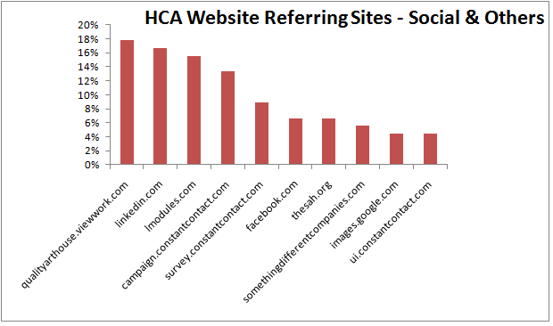

Says Bhatti, “First we have a discussion of the client’s presence, where they are in using the Web and social media. Then we can determine what technology is best for them in order to meet their business goals. We give them the tools and guidelines – to see how they can extend their reach. We give companies a platform so they can set up their campaign, monitoring, promoting, and including their insights about their efforts. It’s all in one – they can post from there as well. Everyone is trying to engage this larger community. We bring not only the metrics but the capability to integrate all this input.”

**Joining the conversation with your clients**

Lapham’s company had already begun to use social media. “We started with LinkedIn, and then joined Facebook which has built-in measurement. We wanted to venture on Twitter to join the “tweeting” revolution and micro conversations. And then we used our YouTube channel to distribute our videos. We started a blog many months before using social media but didn’t actively engage in conversation. Upon conducting research in our community, we found that our key clients were regularly blogging and so we should join this conversation platform online.”

“In our work, we can help reduce costs in the health care system by creating a better healing environment. For example, patients in ongoing cancer treatment may provide our firm insight into their healing journey through one-on-one interviews. We use information gathered to share their stories through video which can benefit future cancer patients and the health care organization. Therefore, social media is a beneficial marketing platform for our firm and our clients.”

“This study helped us put it all together. We track it weekly, and we will be looking at the ROI results quarterly.”

The company recently received a boost from Oprah Winfrey, when Shannon Kincaid, one of HAC’s artists, donated a painting to raise awareness of ovarian cancer. “We generated media response and Web conversations when [Kincaid presented it personally to Oprah](http://www.youtube.com/watch?v=nVGEALswAbw) during her visit to The State Fair of Texas (Dallas) in Fall 2009.”

Having an event like this is extraordinary. Measuring and tracking its ROI is, as they say on those commercials, “priceless.”

These results will be updated as the study goes forward.

Are you using social media in your business? Start the conversation with J.R. Atkins, social media Speaker, Strategist and Consultant at [www.somethingdifferentcompanies.com](http://www.somethingdifferentcompanies.com).

**ATKINS**

This article was prepared with the assistance of

Marilyn Mathis, ABC. Marilyn is a writer, editor

and strategic communications consultant. Contact her at [www.linkedin.com/in/marilynmmathis](http://www.linkedin.com/in/marilynmmathis).

**MATHIS**

# # #