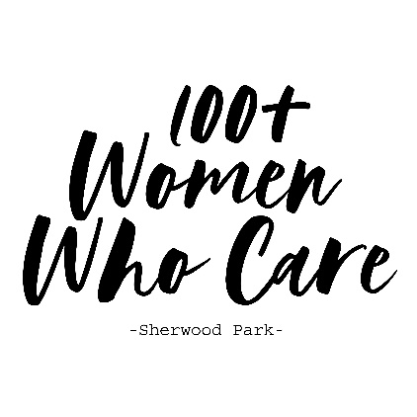
100+ Women Who Care – Sherwood Park
Registration & Commitment Form

Commitment: With my signature below, I am agreeing that the information I provide below is accurate and true. I am pledging to participate in 100+ Women Who Care – Sherwood Park, and I am making a personal commitment to contribute $200 in 2020 and $300 in each subsequent calendar year ($100 two and/or three times a year) to a local non-profit organizations serving Sherwood Park and area. I agree to donate two and/or three times a year to the non-profit organization selected by the group’s majority vote. If I am unable to attend a meeting, I will send my cheque (or cash) with another attending member to deliver on my behalf. I also acknowledge that photographs and videos taken at events and meetings may include my image and may be used in promotional materials for 100+ Women Who Care – Sherwood Park.

I understand my personal contact information is strictly confidential and I understand it will not be shared or distributed to an outside third party without my expressed consent. If 100+ Women Who Care – Sherwood Park chooses to publish a Membership Directory, I agree that my contact information be included in that directory. Yes____ No____

Member:
First Name_____________________ Address________________________ _
Last Name _____________________ City _________________________ PR ______ Postal ________
Phone Number ________________ Email Address _______________________________________
Date __________________________ Signature ____________________________________________

Completed Commitment Forms may be scanned and sent via e-mail to womenwhocare.shpk@gmail.com, or forms may be completed and turned in at a meeting.

Should you wish to discontinue membership at any time after your first year commitment, please send an e-mail to womenwhocare.shpk@gmail.com indicating your withdrawal.

