LASK Raffle Ticket Reward System!
We want to add a little enthusiasm & sparkle to January & February After School Club!
Every day until Wednesday 12th February 2014 (5weeks in total), LASK will be giving reward raffle tickets to the children who demonstrate the following:
- Good behaviour & being a good role model to his/her friends - (this includes please/thank-you and good behaviour during snack time).
- Sharing & turn taking with each other.
- Helping each other & the LASK staff in a positive way.
- Involving and welcoming other children into games & play.
- And any other kind/Good act the LASK staff feel deserves a ticket!
We think we will be giving away lots of tickets over the next few weeks!!!!
The Prizes
- A free day at LASK Holiday Club (Worth £18) *
- A free Morning at LASK Holiday Club (Worth £9)*
- A free Afternoon at LASK Holiday Club (Worth £9)*
- A Large sweetie gift bag-(see pic below)
- A medium Sweetie bag (see pic below)
- 3 sweetie cones- drew separately (See Pic below)
- All Children who receive more than 10 tickets will receive a recognition certificate for their efforts!

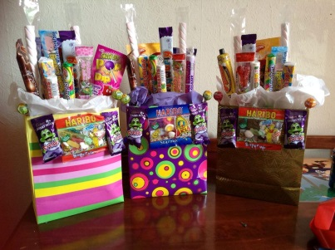
The draw will take place on Wednesday 12th February 2014- Good Luck!
The Rules on tickets:
- Staff must see/hear the act; unfortunately we cannot take other children’s ‘word’ for any kind act.
- Children will be given a ticket, and the counter ticket will be kept for the draw (so do not worry if you lose a ticket!)
- Tickets are unlimited! So you could get lots in one session!
- Tickets will not be offered if children attempt bribe staff- it must be a genuine act of goodness/kindness.
- We expect all children to ‘Try’ and kindly ask parents to support & encourage your child/ren to get as many raffle tickets as possible!

*Must be taken by 17th April 2014, you can top-up to a full day paying the difference. If any special days/trips are on at a higher value, you can top-up the difference.

