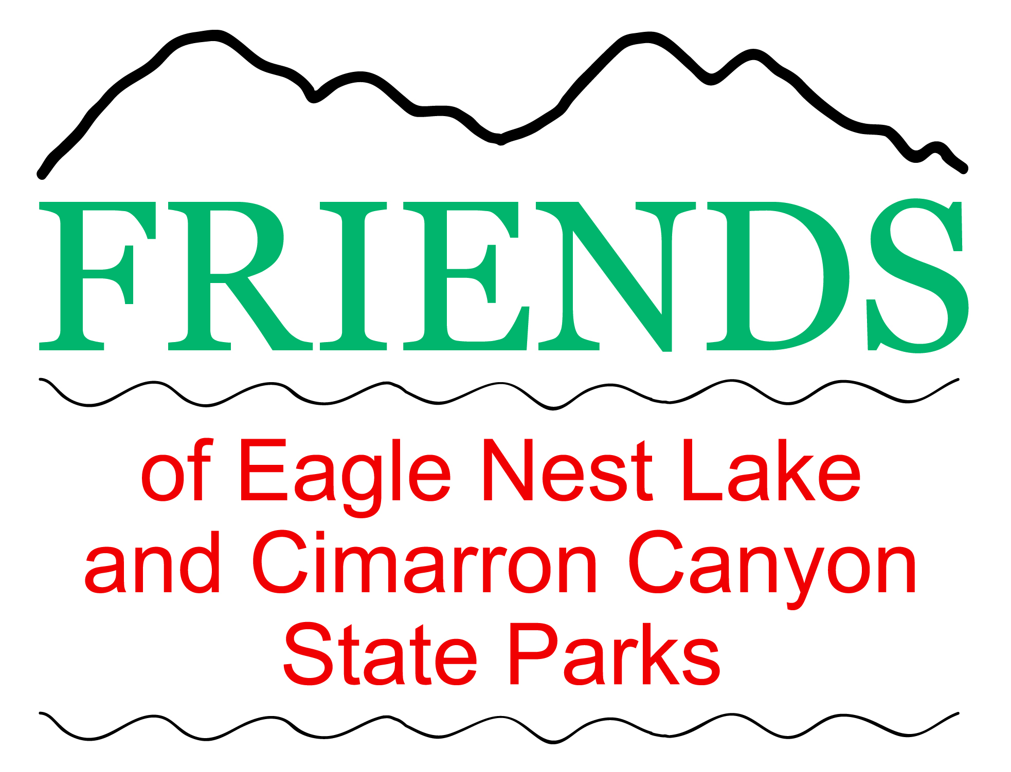 | Annual Friends of  Eagle Nest Lake Eagle Nest Lake  Ice Fishing Tournament  Last Saturday in January  Sponsored by  Friends of Eagle Nest Lake and Cimarron Canyon State Parks  In cooperation with  NM Department of Game and Fish and  New Mexico State Parks
Tournament Rules
New Mexico Game & Fish and State Park
Rules & Regulations will be enforced
ATVs and Snowmobiles that are properly licensed and permitted per NM State regulations are allowed for use by ice fishermen, but must be driven only from the hauling trailer straight down the boat ramp onto the ice. When returning, ATVs and Snowmobiles must be driven direct from the ice onto the trailer, i.e. no circles in the parking lot or other places on State Park grounds.
* State Park Day Use Fees $5 cash per car or valid Annual State Park Pass.
* 6 AM – 11 AM registration in the Eagle Nest Lake State Park Visitor Center.
* 2 PM participants MUST be in line at the measuring station at the Eagle Nest Lake State Park Visitor Center with their Tournament catch to qualify their catch for the Tournament.
* $10 per category registration fee payable in cash only.
* Participants may begin fishing after registration.
* Fish submitted for judging must be caught by participant submitting said fish for judging.
* Misrepresentation by participant in any category disqualifies participant in all categories.
* Participant MUST select ONE fish to be measured for prize in entered species categories 1, 2 and 3.
* Total Fish caught must not exceed NM Game & Fish Rules & Regulations for daily bag limit of each species, i.e.: Trout/Salmon combined limit of 5 per day, Perch 30, Pike unlimited.
* For answers to additional NM Fishing Rules & Regulations refer to NM Fishing Proclamation
PRIZES awarded for BIGGEST fish in each species categories: 1, 2, and 3 determined by:
* The total length of the fish will be measured.
* In case of a tie in length, the girth measurement will take priority.
* If a tie still exists, the prize will be shared by the winners.
1. Trout/Salmon
2. Perch
3. Pike
4. Creel. Prize awarded for the TOTAL fish caught in registered species categories. Participant must register in at least one species category to register in Creel category.
Creel winner will be based on points for the total fish caught in Tournament registered species.
Points for each fish caught in Tournament registered species are:
TROUT/SALMON= 3 PTS. PERCH = 1 PT. PIKE=5 PTS.
FOR EXAMPLE: 3 Trout = 9 pts.
5 Perch = 5pts.
2 Pike = 10 pts.
Total = 24 pts.
In event of a tie, the prize will be shared by the winners.
Cash prizes will consist of 75% of the registration fees collected for each category.

* 1st Place - 40% of the cash prize
* 2nd Place - 30% of the cash prize
* 3rd Place - 20% of the cash prize
* 4th Place - 10% of the cash prize

Raffle Prizes: Winners must be present to claim prize. NO REFUNDS
GOOD LUCK & HAVE FUN! (rev 01-06-2020)

