INSTALLATION DIRECTIONS:
STEP#1 – CHECK THE BOX FOR THE FOLLOWING ITEMS (YOU WILL ALSO FIND A PACK OF 20 INSTALLATION SCREWS)
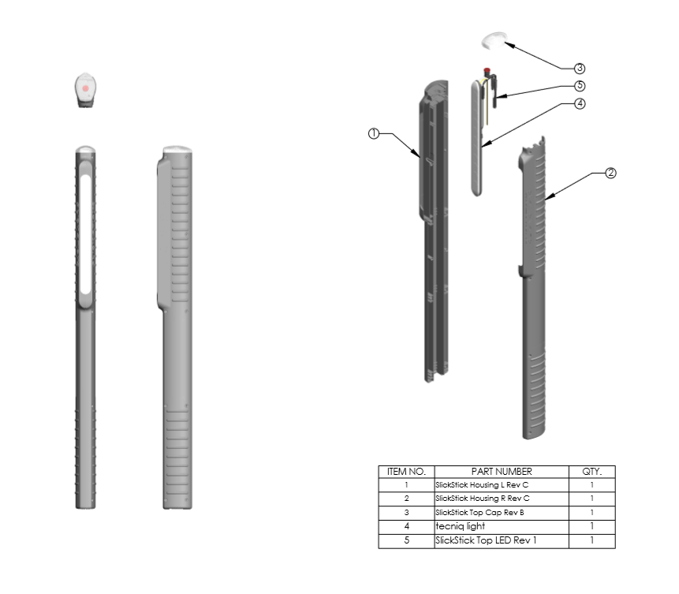
STEP #2 - CHOOSE EITHER OF THE SLICK STICKS THAT YOU ARE READY TO INSTALL
-THERE IS NO LEFT OR RIGHT
STEP #3 - - YOU CAN NOW TRY TO SLIDE THE SLICK STICKS OVER YOUR GUIDE POST
-YOU WILL WANT TO FEED THE LONG CENTER WIRE THROUGH YOUR GUIDEPOST TO HIDE THE WIRE
(THIS IS A COSMETIC DECISION BUT YOU CAN RUN THE WIRE ANY WAY YOU PREFER)
-IF YOUR GUIDE POST IS TOO THICK FOR THE SLICK STICK TO SLIDE OVER DO NOT WORRY THE INSTALLATION PROCESS IS STILL VERY SIMPLE
-IF YOUR GUIDE POST IS TOO THICK YOU WILL NOW WANT TO UNSNAP THE SLICK STICK SO IT APPEARS AS THE PICTURES ABOVE. YOU WILL HAVE THE TWO SIDE PIECES AND THE TOP CAP SEPERTATED.
-YOU CAN UNSNAP THE SLICK STICK BY PULLING THEM APART AT THE BOTTOM AND THEN AT THE MAIN LIGHT ITSELF. DON’T BE AFRAID TO PULL HARD THE SLICK STICKS MATERIAL IS VERY STRONG.
-ONCE YOU HAVE THE SLICK STICKS APART YOU CAN NOW PLACE ONE HALF OF THE SLICK STICKS (I USE THE HALF THAT HAS THE WIRING) ON YOU GUIDE POST THEN ATTACH THE OTHER SIDE. PLACE THE TOP CAP IN ITS DESIGNED SLOT AT THE TOP AND YOU CAN NOW INSERT THE SCREWS AND TIGHTEN THEM DOWN.
STEP#4 - SPLICE THE WIRES INTO YOUR EXISTING TRAILER WIRES
- WHITE WIRE IS THE GROUND (YES THAT IS ODD BUT ON TRAILER WIRES WHITE IS GROUND)
- BLACK WIRE IS YOUR RUNNING LIGHTS
- YELLOW WIRE IS YOUR BRAKES AND TURN SIGNALS

