The Keeper’s Journal
Lighthouse Homeschool Co-op | 2016-2017 | Volume I
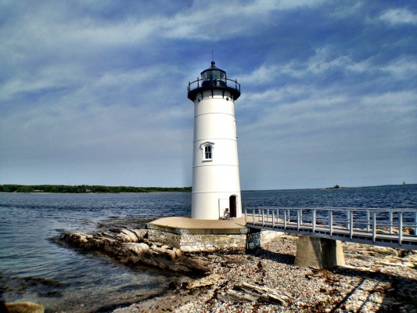
As a student, it is easy to take advantage of the resources here at Lighthouse without considering the people who make our Co-op possible. It starts with teachers who offer their time and dedication each year to bring forth the quality classes for other people’s children. No, they are not paid. This year, there are more classes than ever, occupying every room during the 3rd period, including the nursery! This would not be possible without our willing teachers.
Likewise, without our board members, our well-oiled machine that embodies Lighthouse would be inoperable. As the framework of our fellowship, they are in charge of setting forth our agenda and managing our financial demands. From setting up to closing down, the board is there to expedite the progress of our group.
Finally, without FCBC, we would not be celebrating our 17th semester at this facility that has been so graciously bestowed on us. Through their expansion of the Church a few years ago, we have increased in number of students as well as classes.

Are you new to Lighthouse this year? If so, we would like to welcome you personally into our close-knit community of homeschooled students. We hope you are already getting to know our weekly routine and have adapted to your classes nicely.
Also, we encourage veteran students to find some new friends among the crowd. This year, our number of students has substantially increased, and everyone needs a friend. As we enter the 2nd quarter, it would be wise to keep this in mind.

As fun additions to our future newsletters, we will be requesting drawings from elementary scholars, and content submissions from middle and high school students. Every month, we will also feature what we deem to be the coolest class projects. On a side note to the teachers, keep an eye out for newsletter interviews coming your way!

For corrections/suggestions, please contact the editors:
jcgreenflyguy@gmail.com, joshuaandcody99@hotmail.com.

