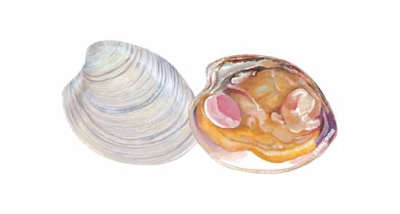
Scientific name: Mercenaria mercenaria
Market name: Clam, Hardshell, quahog
Common names: Hardshell Clam, quahog

These clams are rarely sold by the name “hardshell” or “quahog,” but instead are sold by names reflecting size (1 1/2 to 5 inches), from Littlenecks to Cherrystones, Topnecks and Chowders. On the West Coast, Manila Clams and Washington Steamer Clams are sometimes called Littlenecks, though they aren’t in this hardshell family.

