Nurturing Parenting Program®

Facilitator Training

with

Anneze Barthelemy, MSW
Trainer- Nurturing Parenting Programs®

Learn the philosophy and goals of Nurturing Parenting and how to implement and facilitate the group and home-based Nurturing Parenting Programs®

_________________________________________________________________________________________________________________________________________

Workshop Description

Times: 10:00am Registration
10:30 –1pm Training Session
2 – 5:00pm Training Session

Day 1: Day One will focus on incorporating the philosophy, skills and strategies of nurturing parenting. Participants will learn how to design home-based and group-based parenting programs utilizing the proven lessons of the Nurturing Parenting Programs.

Days 2 & 3: A hands-on approach to conducting home and group-based Nurturing Programs that includes facilitating weekly sessions, how to use program materials, videos and assessment tools, children’s and parents’ program activities, family home practice assignments, icebreakers, personal growth lessons, activities for personal power, alternatives to corporal punishment, building self-esteem, self-concept and empathy in parents and children. Participants will learn how to use the online version of the Adult-Adolescent Parenting Inventory (AAPI-2) to gather pre and post program outcome data.

_________________________________________________________________________________________________________________________________________

The Nurturing Parenting Programs®
The Nurturing Parenting Programs are family-based programs with a proven track record of preventing the recurrence of child abuse and neglect that address the specific needs of different populations:

Dates: June 20, 21 & 22nd, 2019

Cost: $250.00

Location: The Community Empowerment Center
4501 NW 31st Avenue
Oakland Park, FL 33309

Sponsored by…

Rapha Family Services, Inc

- Prenatal Program
- Parents and Their Infants, Toddlers, and Preschoolers
- Parents and Their School-Age Children
- Parents and Adolescents
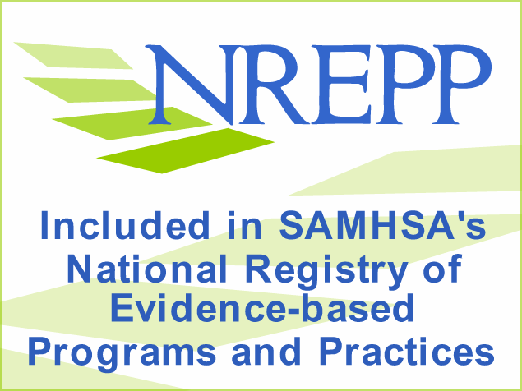
- Teen Parents and Their Families
- Families in Substance Abuse Treatment & Counseling
- ABC’s Program for Parents and Kindergarteners
- Crianza con Cariño
- Parents and Their Children with Health Challenges
- African-American Nurturing Program Supplement
- Hmong Parents and Adolescents
- Christian Families
- Family Nurturing Camp
- Nurturing Skills for Families
- Nurturing Skills for Teen Parents
- Nurturing America’s Military Families

_____________________________________________________________________________________________________________
Adult-Adolescent Parenting Inventory (AAPI-2)
The AAPI-2 has proven invaluable in assessing the parenting attitudes and child-rearing beliefs of parents and adolescents. Founded on five parenting constructs known to lead to abusive parenting, the AAPI provides scores that profile parents at risk for abusing and neglecting children. For more info, visit wwwassessingparenting.com.

Philosophy of Nurturing Parenting

Registration Form

June 20, 21 & 22nd, 2019

Make check payable to Rapha Family Services, Inc.
mail or email your registration to:

Rapha Family Services, Inc.
Attn:
Anneze Barthelemy
1615 S Congress Ave, Suite 103
Delray Beach, FL33445

Phone: 786-267-1964
Email: annezebarthelemy@gmail.com
_________________________________________________________________________________________
Registration Deadline: June 15, 2019 Email or call for availability after deadline.

___________________________________________________________________________
Name of Participant: (As it will appear on your certificate).

___________________________________________________________________________
Agency

___________________________________________________________________________
Address

___________________________________________________________________________
City, State Zip

_______________________________________
Phone

_______________________________________________________________________
Email as it will appear on roster and for receipt.

$250 per registration. Sorry, no refunds after June 18th, 2019; a credit will be provided towards a later training.
Method of Payment:
___ Check enclosed
___ Money order enclosed
____ Pay Pal (send fund to annezebarthelemy@gmail.com)
____Zelle or Cashapp

____________________________________________________________________________

The philosophy of Nurturing Parenting emphasizes the importance of raising children in a warm, trusting and caring household. It is founded on the belief that children who are cared for develop the capacity to trust, care and respect themselves, other people and living creatures and the environment. The philosophy of Nurturing parenting is founded on seven principles:

1. Feelings of Attachment. Attachment means a bond between parents and their children that conveys a deep love that is unconditional. When children feel loved unconditionally, communication, trust and respect naturally follow.

2. Empathy. Empathy is the ability of parents to put themselves in the place of their children in an attempt to feel, think and understand what their children are feeling, thinking and understanding, and responding to them in a loving and respectful way.

3. Nurturing Oneself. Taking time in getting one’s own needs met, as an adult, forms the foundation of understanding and helping children get their needs met. Nurturing parents take care of themselves as well as their children.

4. Gentle Touch. Research has shown that children who experience warm and gentle touch in the form of hugs, pats, and massages develop and maintain healthy relationships throughout their life, as well as a healthy and positive sense of their self.

5. Discipline. Setting limits through family rules, teaching right from wrong through family morals, and teaching respect and worth through family values are all a part of a nurturing family. Discipline cannot be imposed, beaten into or forced on children but rather develops best by the children modeling their parents whose example they admire.

6. Expressing Feelings. Helping children and adults learn appropriate ways to manage and express their feelings is a fundamental characteristic of a nurturing family.

7. Expectations and Self-Worth. Knowing what to expect of children as they develop plays a significant role in their self-worth. When parents have appropriate expectations, children learn that they are competent people, capable of pleasing others important in their lives.

Anneze Barthelemy, D.Min. Cand., MSW, RCSWI
Trainer and Consultant
Anneze Barthelemy is a Social Services Consultant. She has been wholeheartedly impacting the Miami-Dade County through facilitating the Nurturing Parenting Program. She has been a facilitator since 2007 and a Nurturing Parenting Certified Trainer since 2011. In 2007, Ms. Barthelemy founded Rapha Family Services, a non-profit social services agency serving Dade, Broward, and Palm Beach counties. Rapha Family Services, Inc. is a 501- (C) (3), Faith-driven, Private, Non-Profit Social Services agency. The agency is dedicated to improving the lives of families by providing them with the necessary tools needed to succeed; such as Individual and Family Therapy, Nurturing Parenting Classes, family mentoring, Queen Esther’s Mentoring, Referrals, Case Management Services and Humanitarian Aid to Haiti.

