Food Scarcity: Food Deserts in America
Marissa Rollins
George Mason University—GCH 360
Professor Snyder
December 9, 2015

Food Scarcity: Food Deserts in America
Americans tend to think that the people of the country are well fed and have the ability to access nutritious food. Because of this, it was actually quite difficult to research and find information on food shortages within the United States. Most people are not aware of the vast majority of the population in America that spends its days hungry or that intakes heavily processed foods just to keep moving. America grows fields and fields of corn, makes wheels and wheels of cheese, and produces many other different types of food. Despite the large quantity of food produced and the even larger amount that is imported into the country, it may prove shocking that there are many people in America who do not have access to food, let alone proper nutritious food. This subject of a lack of access to healthy food is the main focal point of this paper. Those who cannot afford healthier foods, such as organic apples and bunches of fresh kale, are stuck with the cheaper, highly-processed, and nutrient-deprived foods or simply no food at all. This is unjust. The food-deprived areas that these people live in are known as “food deserts”. People in food deserts do not have the option to pick selectively; they must pick and choose from their small grocery and convenience stores. In order to address this growing problem, changes need to be implemented in order to increase the availability of healthy, nutritious food at a price that is affordable.
What is a Food Desert?
According to the Centers for Disease Control and Prevention (CDC), “Food deserts are areas that lack access to affordable fruits, vegetables, whole grains, lowfat milk, and other foods that make up the full range of a healthy diet” (A Look Inside Food Deserts, 2012, n.p.). For these deserts, access to food is limited. If there are any well-stocked supermarkets, with lush produce and other fresh foods, they are often miles upon miles away. This lack of access is shown in Figure 1, which displays areas of the country in which there is a shortage of supermarkets and a 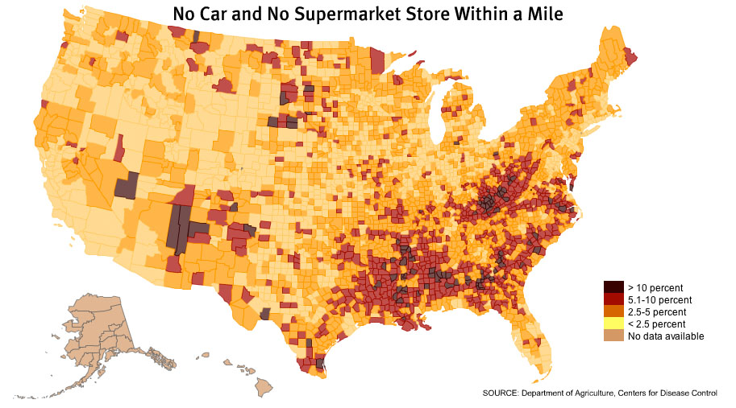lack of reliable transportation to those markets. Many of the citizens that live in these food deserts are stuck eating at fast food restaurants or buying their boxed and canned foods from a convenience store. Because of the lack of healthy, nutritious foods, many of these people are suffering from malnutrition and other food-related illnesses such as diabetes and obesity (Agricultural Marketing, n.d., n.p.).
Figure 1. No car and no supermarket store within a mile. Retrieved from "USDA Defines Food Deserts | American Nutrition Association." USDA Defines Food Deserts | American Nutrition Association. American Nutrition Association. Web. 3 Dec. 2015.
Demographics of a Food Desert
One of the most influential determining factors of a food desert is the socioeconomic status of the people who live there. The Food Empowerment Project (2016) states:
[Food deserts] are most commonly found in communities of color and low-income areas (where many people don’t have cars). Studies have found that wealthy districts have three times as many supermarkets as poor ones do, that white neighborhoods contain an average of four times as many supermarkets as predominantly black ones do, and that grocery stores in African-American communities are usually smaller with less selection (Food Deserts, n.p.).
This disparity between Caucasian neighborhoods and minority-dominated neighborhoods is shocking. A lack of access to nutritious, perishable food leads to an increase in the prevalence of certain diseases within a population, such as diabetes, obesity, and nutrient deficiencies. Examples of such populations include North Tulsa, Oklahoma and in Minnesota.
Food Scarcity in North Tulsa, Oklahoma
The food crisis in North Tulsa, Oklahoma, is one example of a food desert. Over the years, many grocery stores have come and gone from the area, leaving the citizens stuck with either taking the bus for several miles or trading their food stamps for rides to the grocery store (Salass, 2013, n.p.). According to Salass’ article, the existence of this food desert can be partly contributed to the people living within this part of Tulsa. Salass quoted a female resident of North Tulsa:
In the past, only one parent had to work to support a family, which usually left mom at home to cook for everyone. ‘Now both parents have to work, sometimes several jobs, just to make ends meet. Now there's no time for keeping a garden or even cooking. The economy is not set up for the family anymore’ (Salass, 2013, n.p.).
Many of the people living in North Tulsa are low-income workers who must work several jobs in order to get by, all while living in government-provided homes (Salass, 2013, n.p.). Because of the low-income status of the neighborhood, many people cannot afford to buy healthy and organic food, thus decreasing the demand for grocery stores with fresh produce. The people in these communities need a meal that is quick to make and sufficient in calories to get them through their day. Some of the diseases that occur due to this food scarcity are obesity, heart disease, and diabetes.
Diabetes in Tulsa, Oklahoma
There is a high prevalence of type I diabetes in Tulsa. According to the Tulsa County Health Profile, “Diabetes mellitus (commonly known as diabetes) was the seventh leading cause of death in Tulsa” (2015, p. 108). The number of diabetes-related deaths is very concerning. In fact, prevalence of diabetes deaths actually went up from the eighth leading cause of death in 2014 to the seventh leading cause of death in 2015 (Tulsa County Health Profile, 2015, n.p.). Figure 2 displays the prevalence of diabetes mellitus across race and ethnicity and shows that diabetes disproportionately affects the African American and American Indian populations of Tulsa.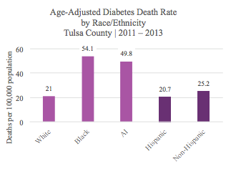 Diabetes is extremely harmful, and not just because of how it impacts the body’s means of using insulin. Diabetes mellitus “lowers life expectancy by up to 15 years, increases the risk of heart disease by two to four times, and is the leading cause of kidney failure, lower limb amputations, and adult-onset blindness” (Tulsa County Health Profile, 2015, p. 108). Figure 2 is congruent with the aforementioned discrepancy in the demographics of food deserts across the nation, where more African American and American Indian people have less access to nutritious food, and therefore are more susceptible to diseases such as diabetes. Considering how seriously diabetes affects the population, an implementation of healthy food practices such as encouraging home gardening and farmers’ markets with fresh produce and healthy foods would be a step in the right direction towards lowering diabetes rates in Tulsa.

Figure 2. Age-adjusted diabetes death rate by race/ethnicity Tulsa county 2011-2013. Retrieved from Tulsa County Health Profile 2015. (2015). Retrieved December 9, 2015, from http://www.tulsa-health.org/sites/default/files/page_attachments/_health-profile-2015-web.pdf

Food Deserts in Minnesota
There is also a prevalence of food deserts in the Twin Cities of Minneapolis and St. Paul, Minnesota. Within these cities there is a lack of healthy food within close proximity and a lack of transportation to get to that food. As stated by Minnesota 2020, “In 2006, food deserts covered about one-half of Minneapolis and nearly one-third of St. Paul. This shortage of stores that offer healthy food choices is so pervasive that many Twin Cities suburbs have 20 times the number of food stores per capita than their urban counterparts” (Knuth, 2010, n.p.).
It is not only the lack of transportation that causes the food desert in this area. It is also a lack of education about healthy food and nutritious options. The professionals who are studying the food deserts in Minnesota state that food deserts and obesity have a strong correlation, citing that “since 1995, Minnesota's rate of obesity has increased from 15 percent to 25 percent, bringing the total to roughly 1.3 million Minnesotans” (Knuth, 2010, n.p.). This drastic increase in obesity rates exemplifies just how much processed food can affect the individuals living in food deserts. The reason why there are food deserts in both urban and rural areas of Minnesota is due to the fact that in “urban neighborhoods, zoning laws and real estate costs contribute to a lack of supermarkets. In rural communities, supermarket chains often find low-population areas unattractive” (Knuth, 2010, n.p.). The difficulty that supermarkets encounter in these areas creates a lack of fresh produce and healthier options that many major grocery stores in well-populated areas carry. The stores’ low chances of continued success in these areas also decreases the number of physical stores found in a food desert. This lack of grocery stores is one of the defining factors of a food desert.
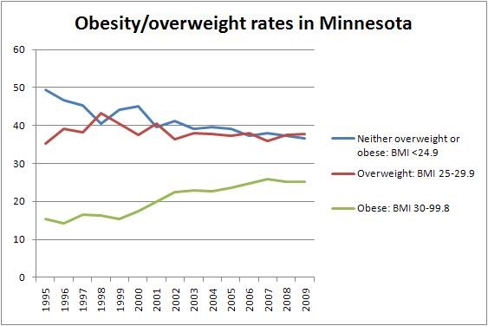In the Twin Cities of Minnesota, nearly one in five residents do not own transportation to take them to a supermarket (Knuth, 2010, n.p.) Since there is a lack of urban stores, many people travel miles and miles away from their homes in order to shop for nutritious food. Although this may not be a problem for those people who do own cars or who have other forms of transportation, the less fortunate are stuck with the small stores that they have, which decreases their chances of obtaining proper nutrition.
Figure 3. Obesity/overweight rates in Minnesota. Displays increasing rates of obesity in Minnesota. Retrieved from Sluppang, N. (2010, June 18). Declining health care investment will let the pack catch up. Retrieved December 6, 2015, from http://www.mn2020hindsight.org/view/declining-health-care-investment-will-let-the-pack-catch-up
Obesity in Minnesota
The lack of nutritious food and healthy options leads many of Minnesota’s citizens living in food deserts down the path towards obesity, as shown in Figure 3. As stated in Minnesota 2020, “In 2005 alone, obesity cost Minnesota about $9.3 billion in direct and indirect health care costs” (Knuth, 2010, n.p.). However, according to research done in Knuth’s study, the lack of fruits and vegetables is not the only contributing factor. The ease with which an individual can locate a fast food restaurant is also problematic (Knuth, 2010, n.p.).
Analysis
Food shortages in the United States present themselves in the way of food deserts. With a lack of nutritious food within close distance, many citizens are forced to live on what they can, which generally ends up being food from a box or a can. In order for them to receive healthy, nutritious fruits, vegetables, and flesh meats, the people that live within the confines of a food desert must go far out of their way to obtain anything nutritious. It is for this reason that new food shortage policies must be implemented. In Minnesota, for example, there is now an abundance of farmers’ markets being held to sell fresh produce, healthy food buying incentives, and an increase in urban gardens in order to combat food deserts and all of the health complications that come along with them (Knuth, 2010, n.p.). Other programs designed to reduce shortages would be beneficial in other areas of the country affected by food deserts.
Conclusion
Food scarcity and food deserts endanger many lives across the country. The United States needs to implement policies in order to make sure that its citizens are fed and given proper nutrition. Policies that provide incentives for farmers’ markets and more cost-effective grocery stores are the key to giving American citizens the nutrition that they need at a price that they are able to. By assisting each other, communities can build a healthier and happier way of living with lower costs, fewer diseases, less suffering, and more food.

References
A Look Inside Food Deserts. (2012, September 24). Retrieved November 28, 2015, from http://www.cdc.gov/features/FoodDeserts/index.html
Agricultural Marketing Service - Creating Access to Healthy, Affordable Food. (n.d.). Retrieved November 28, 2015, from http://apps.ams.usda.gov/fooddeserts/foodDeserts.aspx
Food Deserts. (n.d.). Retrieved December 6, 2015, from http://www.foodispower.org/food-deserts/
Fowler, R. (2012, October 19). Hartford ranks eighth worst nationally on access to healthy food. Retrieved December 6, 2015, from http://articles.courant.com/2012-10-19/news/hc-op-fowler-hartford-a-food-desert-for-residents--20121019_1_healthy-food-food-desert-hartford-food-system
Gallagher, M. (n.d.). USDA Defines Food Deserts. Retrieved December 9, 2015, from http://americannutritionassociation.org/newsletter/usda-defines-food-deserts
Knuth, S. (2010, August 10). Minnesota 2020. Retrieved December 6, 2015, from http://www.mn2020.org/issues-that-matter/economic-development/irrigating-minnesota-s-food-deserts
Salass, N. (2013, August 5). Tulsa's Food Scarcity Takes Toll On Residents' Health And City's Pride. Retrieved October 27, 2015.
Sluppang, N. (2010, June 18). Declining health care investment will let the pack catch up. Retrieved December 6, 2015, from http://www.mn2020hindsight.org/view/declining-health-care-investment-will-let-the-pack-catch-up
Tulsa County Health Profile 2015. (2015). Retrieved December 9, 2015, from http://www.tulsa-health.org/sites/default/files/page_attachments/_health-profile-2015-web.pdf

