The Elk River Chemical Spill

Emily Bremer
August 4, 2014

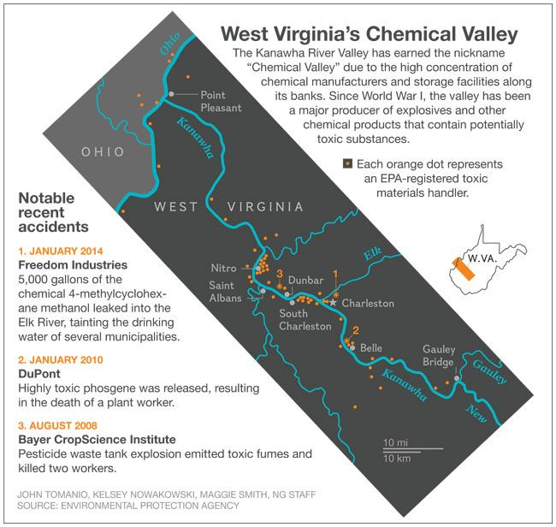On January 9, 2014 a leak in a chemical storage facility at Freedom Industries was discovered to have spilled approximately 10,000 gallons of MCHM into the Elk River in Charleston, West Virginia. The spill affected 300,000 people, costing them both their water supply and health. Unfortunately for Charleston, which is located in the heart of the Kanawha River Valley, occurrences like this are not uncommon. In fact, Kanawha River Valley is more commonly referred to as Chemical Valley and this is the fifth major incident to happen in the last 8 years (Osnos, 2014). The map below shows some the locations of major chemical manufacturers and recent accidents (Parker, 2014).
The mountainous land of West Virginia is full of natural resources, and has led to a booming industrial sector. However, a lack of environmental regulations, and corporate accountability along with the pro-business politics of the state have left the region so vulnerable to environmental disasters like the Elk River Spill, they have become a normal part of everyday life for residents. It doesn’t take more than a walk down near the Elk River to see how polluted it has become and not just due to industrial waste; litter and garbage accumulate on the banks as well (the picture below of the river shows some of the pollution, including a shopping cart- taken July 2014).
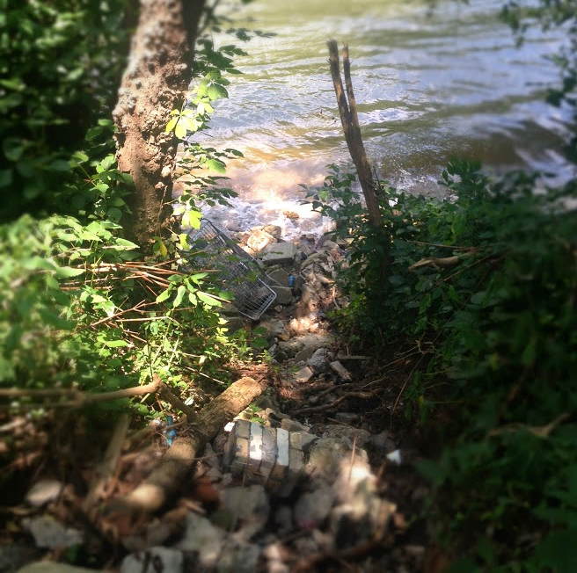

Background
Native Americans were the first to use the land of West Virginia for its resources when they produced sodium chloride. Later in 1797, the first salt furnace was constructed. The mining of salt combined with the abundance of natural resources set the stage for future chemical manufacturing in the region (Cantrell, 2004). According to the West Virginia Historical Society, the region had an abundance of the “big six” main elements that are the bases of all products, carbon (from coal), oxygen, nitrogen, (from the air), chlorine (salt brine) and hydrogen (from the water) (Cantrell, 2004).
The big turning point in the history of the Kanawha River Valley was the outbreak of World War I. Until the war, Germany was the largest producer of chemicals, and when America entered the war, they had one major gunpowder supplier but it was not nearly large enough to support the allied troops. Government officials began to look for other sources of production, and settled on Kanawha Valley because of the natural gases, salt, coal and oil (Cantrell, 2004). This led to construction of a gunpowder plant, mustard gas plant, explosives plant and a naval ordinance plant in the Charleston area. Though The Armistice would stop the construction of some of these plants, the amount of money invested by the government into the industry brought many chemical companies to the region who took advantage of the infrastructure that was now in place. These events were the first major thrust of Charleston and the Kanawha River Valley into its future as a major center for chemical production. In the next decades, the Charleston area experienced continuous industrial growth, producing over 100 new chemicals and being one of the only regions to fair well through the Great Depression (Cantrell, 2004).

Though there were concerns about toxic waste since the 1950’s, it wasn’t until the early 70’s (when the EPA was established) that scientists finally began to study the chemicals being emitted into the environment. In 1984, 52,000 pounds of methyl isocyanate leaked from a Union Carbide plant in Bhopal, India, causing 5,000 deaths (Cantrell, 2004). This led to an outcry from Charleston residents, as there was a Union Carbide plant producing the same chemical nearby. The company countered with a marketing campaign to gain support from citizens, and created 'Support Carbide’ bumper stickers and t-shirts. This tactic would be used repeatedly in the future and most recently is echoed in the ‘Friends of Coal’ movement. Though Friends of Coal is a volunteer organization it was founded by the West Virginia Coal Association (Grandia, 2008). In 1985, despite the push for more regulations and the company’s implementation of additional safety features, 5,000 pounds of aldicarboxime was leaked into the air from the plant (Cantrell, 2004). These incidents pushed citizens to demand more corporate accountability and transparency about the amount of chemicals they were producing and releasing into the environment. While this incident led to numerous reforms, it is believed that tens of thousands of pounds of MIC are still stored in an underground tank at the site to this day (Cantrell, 2004).

Elk River Chemical Spill
On January 9, 2014 Freedom Industries reported that one of their chemical storage tanks had been leaking, the company was not only unsure how much had leaked, they also did not know how long it had been leaking. The chemical leaked was crude MCHM, sold by Freedom Industries and used by coal companies to clean the impurities out of coal. On January 21, it was found that a mixture of propylene glycol phenyl ether (PPH) and dipropylene glycol phenyl ether (DiPPH) also leaked from the same tank into the water supply (CDC). Governor Tomblin declared a state of emergency and people were ordered not to use or drink the water. While some people noticed right away from the smell of the water something was wrong, many citizens did not find out until much later. The automated phone calls warning people about the leak did not come until the evening, in fact when speaking with some locals, most people found out second hand from friends and family. Some had already been using the water all day. Four days after the spill the State declared the water safe to drink but the CDC did not declare the water safe until February 24. Many residents are still uncertain, and continue to find other sources of water 6 months later (Youngren, 2014).
A report by the U.S. Chemical Safety Board has determined that the leak was due to “an egregious lack of oversight at chemical storage company Freedom Industries, which used tanks damaged by corrosion to hold toxic materials”(Prupis, 2014). Additionally, there was no evidence of any inspection of the site prior to the January 9 spill. Environmental investigative reporter, Ken Ward, spoke in a recent NPR interview and reported that the Chemical Safety Board has been to West Virginia several times for industrial accidents, and continuously issued recommendations for more over-sight and accident prevention programs and encouraged them to work with the Kanawha-Charleston Health department. However, the state never followed through with these and Ward notes, “the state has really done absolutely nothing to implement that recommendation. The Kanawha County officials have encouraged the state to work with them ... and the state has just basically ignored the recommendation” (Ward, 2014). Furthermore, industry officials perpetuate an idea that they are overregulated and that the EPA and OSHA are constantly imposing restrictions on manufactures, when in reality lot of these facilities will go for years and years without ever seeing an OSHA inspector ... without ever seeing an EPA inspector” (Ward, 2014).
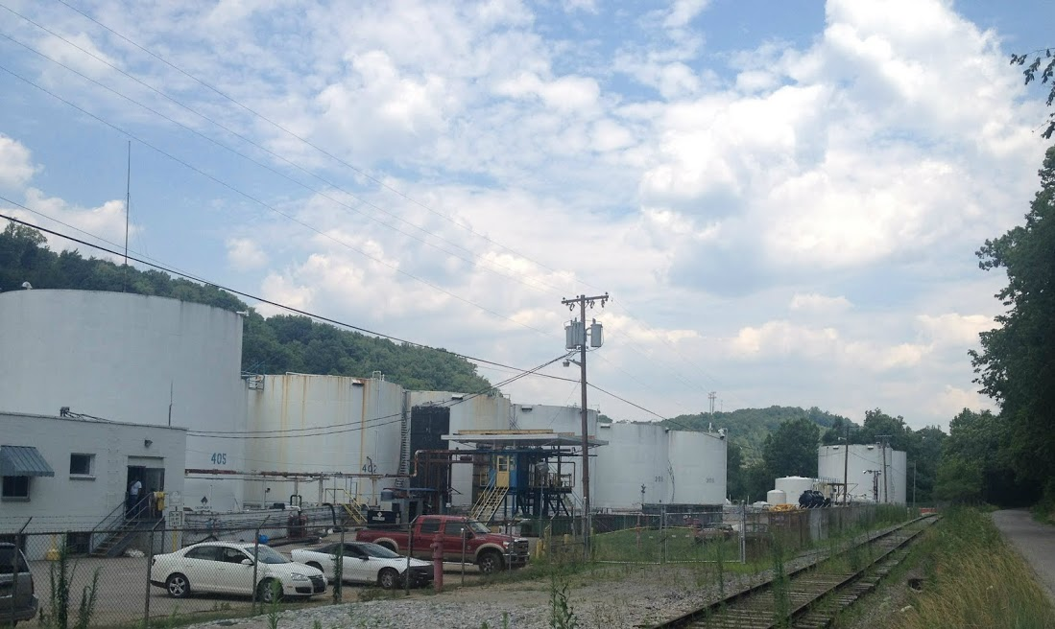Freedom Industries has since declared bankruptcy and over 2,000 people have filed claims against the business, and a $2.5 million dollar settlement has been reached. The money from this will most likely go to health studies, water testing and help to the 300,000 people affected by the spill. Additionally, their storage tanks, including the one containing the leak, were cleaned and demolished on July 16.
(Freedom Industries Storage Tanks- photo taken July 2014)
Health Risks
Overall there are many health risks associated with various chemical industries, to both the workers and the residents living near the plants. A 1975 study showed “excess rates for bladder, lung, liver and certain other cancers among males in 139 counties where the chemical industry is more highly concentrated” (Hoover & Fraumeni, 1975). Additionally, the American Cancer Society reports that “ …there are some industries – such as certain types of chemical manufacturing, mining, coal production, and iron and steel founding – in which cancer risk is higher for certain workers. Research has identified a range of carcinogens that can be hazardous to workers in these industries if they are exposed to them over time” (American Cancer Society, 2014). The biggest problem scientists and researchers have found when studying the effects of a chemical on human health, is that often the long-term effects of exposure cannot always be predicted. This means they often can only be studied retroactively which makes it more difficult to determine if there were underlying factors.
Currently, the long-term health effects of MCHM are not only unknown but widely debated. Many people claim there is little harm, while others have maintained that there is too little information to make a conclusion and that it is not just the chemical itself but also the mixture of chemicals that needs to be studied. The Elk River Spill has promoted many scientists to investigate the risks. The National Science Foundation awarded Rapid Response Research Grants to researchers at 3 universities, Virginia Tech, South Alabama and West Virginia University. In the NSF press release William Cooper, program director, stated “This is one of the largest human-made environmental disasters in this century. In instances such as this, where the situation is still developing and public health is involved, timing is everything" (National Science Foundation, 2014). These grants give the researchers resources to immediately begin investigating. Each team will cover a different part of the investigation including, the absorption into plastic pipes in houses, the extent of the contamination and how MCHM reacts in the environment (National Science Foundation, 2014). While long-term health effects are still unknown, short-term health effects include eye, throat and skin irritation as well as drowsiness and dizziness. According to an investigation done by the West Virginia Bureau for Public and Health and the Agency for Toxic Substances Disease Registry, 369 people went to local emergency departments for symptoms from exposure to the water (WVBPH and ATSDR, 2014). The most common symptoms were headaches, nausea and vomiting. Beyond the physical health implication is a much deeper one, the mental effects. Many residents had to deal with finding clean water sources, especially difficult for those who live in more rural areas or cannot afford to purchase bottled water. Additionally, caring for children and infants in the uncertainty, and trying to make the decision between drinking the water, (with differing reports on whether it was safe or not) or continuing to deal with the expensive, time consuming task of finding safe water. Local resident and activist Crystal Goode worries of how this will affect her children in the future, “I don’t know how you measure the residual effects of mistrust, fear and uncertainty, I don’t know how this is going to affect them growing up” (Goode, 2014). Furthermore, she spoke of how every day after showering she could smell the chemical-licorice sent in her hair, a constant reminder that the spill is real. This may seem trivial in the grand scheme of the crisis, but it these little day-to-day experiences that truly show the psychological effect of living through it. Two months after the incident, in an interview with the New Yorker, Dr. Gupta, head of the local health department, stated that there were still countless questions about the health risks of the chemical, including, “What is the metabolism and excretion of this compound in humans? Does it accumulate? … What is the carcinogenic potential? What is the teratogenic potential? What does it do to home pipes? How does it interact, if at all, with other compounds in water, such as chlorine? Does it form harmful or harmless products?” (Osnos, 2014). The future impact of exposure cannot be known until these questions are answered and more research is conducted about the long-term effects of the chemical.

Political Factors
West Virginian politics have become more and more pro-business at the expense of the environment. For instance, this year West Virginia’s Department of Environmental Protection, took a 7.5% budget cut for the second year in a row, and is at its lowest level of funding since 2008 (Osnos, 2014). While the pro-business trend is not new and can certainly be seen in government decisions across the country both locally and nationally, the consequences of these decisions can be seen more directly in an area high in chemical manufacturing. In West Virginia the coal industry is one the strongest examples of this trend. The coal industry has such a huge political influence, that it is almost impossible to get elected without supporting them and a 2012 study found a strong and positive correlation between the threat of environmental regulations and increased political donations by coal companies (Long, Stretesky, Lynch, & Fenwick, 2012).
In fact, just the day before the spill in his State of the State Address, Governor Tomblin spoke out against environmental regulations saying, “I will never back down from the E.P.A because of its misguided policies on coal” (Osnos, 2014). Furthermore, since the spill, Governor Tomblin again pushed back against, what he believes to be, unreasonable EPA regulations that would hurt the coal industry that is vital to West Virginia life, during meetings discussing the on-going response to the spill with the West Virginia EPA (Gerken, 2014). Coal and chemical industries in West Virginia are a huge employer and use this to their advantage to gain citizens’ support. They often present a choice to people, jobs or the environment (and subsequently, public health). For instance, on I-64 a billboard sits with this statement “Don’t let EPA bureaucrats take away our coal jobs” (Long, Stretesky, Lynch, & Fenwick, 2012). This creates a false impression that environmental safety and public health can only be achieved at the price of the economy and creates a division in the community, instead of allowing for compromise or safe industry standards to be created. No one should have to give up their health for their job, or their job for their health, there are sustainable solutions that can be made without sacrificing one for the other.
Despite the division, more and more citizens are pushing for increased regulations and since the spill 73% of residents believe the government has not done enough to protect air and water quality (Gerken, 2014). Many residents still do not drink the water, or trust that it will be safe any time soon. As well, the general consensus is that the neither Freedom Industries nor the Government did enough to help citizens through the crisis. Goode has said of their response, “The government played into people’s fear and their need for everything to be okay, they were just focusing on reducing panic…they take advantage of this inaccurate West Virginia stereotype that people are ignorant and can’t understand so they should just trust the government” (Goode, 2014). It is not that the people of Charleston are apathetic or ignorant, but when you live in a place called Chemical Valley and your government is more concerned about protecting businesses than your safety, there seems that little can be done, especially when it is so often presented that residents can choose between their jobs and their health. This is not the case and hopefully The Elk River spill will not just spark changes in environmental policy in West Virginia but across the United States. The incident has created a new spark among local people and activism movements. Activism in the area takes on many different forms, from environmental groups, to community forums. Goode is even using poetry to start a conversation. On Saturday, February 8, customers marched to West Virginia American Water Company to protest the continuing billing during the time of contamination, (Youngren, 2014). Though the news crews and media attention are gone, hopefully the momentum created by the incident continues to build to make long-term changes in Charleston.
Conclusion
Various political, historical, and socioeconomic factors produced the conditions for the Kanawha River Valley to develop into Chemical Valley and subsequently for the Elk River chemical spill to occur. We cannot continue to let industries put a price tag on the health of people and the environment, and this incident is a perfect example of what happened when we do. Hopefully this accident serves as a wakeup call to lawmakers, and to citizens to demand corporate accountability, increased regulations, and most importantly the actual enforcement of these regulations. After all, the Elk River Chemical spill is not a random accident, Charleston is not a unique place where these factors have just happen to come together to create problems, it is a sample of what can happen anywhere in the United States. Chemical Valley is not the exception, it is the rule and if nothing changes it will be our future.

References
American Cancer Society. (2014, 02). Occupation and Cancer. Retrieved 2014, from American Cancer Society: http://www.cancer.org/acs/groups/content/@nho/documents/document/occupationandcancerpdf.pdf
Bearden, D. (2014). Oil and Chemical Spills: Federal Emergency Response Framework. Congressional Research Service .
Caldwell, L. A. (2014, January 19). West Virginia: New health hazard, same story? CNN Breaking News .
Cantrell, N. (2004). West Virginia's Chemical Industry. West Virginia Historical Society , XVIII (2).
Day, R. (1992). A Comparative Ecological Study of Selected Cancers in Kanawha County, West Virginia. American Journal of Internal Medicine , 21 (2), 16.
Gerken, J. (2014, 02 25). Earl Ray Tomblin Cautions Against 'Unreasonable' EPA Regulations. Huffington Post .
Goode, C. (2014, July). Telephone Interview. (E. Bremer, Interviewer)
Grandia, K. (2008). Friends of Coal, Friends of Coal Industry. Retrieved 2014, from DESMOGBLOG: http://www.desmogblog.com/friends-of-coal-friends-of-coal-industry
Holusha, J. (1994, June 4). Bracing for the Worst in Chemicals. The New York Times , p. 2.
Hoover, R., & Fraumeni, J. F. (1975). Cancer Mortality in US Counties with Chemical Industries. Bethesda: National Cancer Institute.
Johnson, R. (2014, January 17). This Woman Is Terrified About What Happened To Her Baby After Exposure To Tainted Water In West Virginia. Business Insider , p. 1.
Johnson, R. (January, 16 2014). West Virginia: 'Why Is The Rest Of The Country Fixated On A New Jersey Traffic Jam And We Have No Clean Water?'. Business Insider , p. 1.
Long, M. A., Stretesky, P. B., Lynch, J. M., & Fenwick, E. (2012). Crime in the Coal Industry: Implications for Green Criminology and Treadmill of Production. Organization and Environment .
National Science Foundation. (2014, January 3-). NSF awards rapid response grants to study West Virginia chemical spill. Retrieved 2014, from National Science Foundation: http://www.nsf.gov/news/news_summ.jsp?cntn_id=130304
Osnos, E. (2014, April 7). Letter from West Virginia: Chemical Valley. The New Yorker , p. 19.
Parker, L. (2014, January 16). A Century of Controversy, Accidents in West Virginia’s Chemical Valley in Lead-up to Spill. National Georgraphic: Daily News , p. 8.
Peterson, I. (1985). Toxic Pollutants in 'Chemical Valley'. Science News , 127 (7), 1.
Pickering, M. (Director). (1991). Chemical Valley [Motion Picture].
Prupis, N. (2014, July 28). Lack of Oversight, Damaged Tanks Caused West Virginia Chemical Spill. Common Dreams .
Southall, C. D. (2014, January 12). Critics Say Spill Highlights Lax West Virginia Regulations. The New York Times , p. 4.
Ward, K. (2014, 01 29). How Industrial Chemical Regulation Failed West Virginia. Fresh Air. (D. Davies, Interviewer) National Public Radio.
WVBPH and ATSDR. (2014). Elk River Chemical Spill Health Effects: Findings of Emergency Department Record Review. West Virginia Bureau for Public Health and The Agency for Toxic Substances Disease Registry.
Youngren, P. (2014, July). Personal Interview. (E. Bremer, Interviewer)

