GENTLE STEPPING

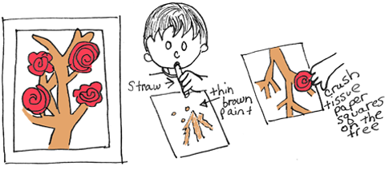
May 2017 Gentle Steps Foundation

  - PARENTING
There really is no learning curve in parenting. As soon as you feel like you have a handle on a situation, it changes. This can be frustrating, exhausting and stressful. Even when people assure you that you will be able to handle things much more efficiently with your next child, lo and behold you realize that every child has an altered temperament that makes them different from their sibling.
Parenting is rewarding and wonderful but it is also a challenge. It is more than a fulltime job because you are never off. When you are at work or out with friends; when your child is at school or at their friend’s; even when they are tucked safely asleep in their beds – you are still a parent and are responsible for the heart, mind and spirit of the precious one who calls you mom or dad.
Yet there is more to this “parenting” then what we might consider. How about the changes we have to make to our own lives? We are now role models and in so being we must watch our words and actions and we must be aware of the environments we allow our children to be part of. This is not easy for sometimes it means confronting friends and family members and asking them to reframe from behaviors you once were actively participating in before the little one arrived. If your friends and family are unwilling to accept these changes you may have to make changes in your relationships.
It goes even deeper for as a parent we must be aware that we are now responsible for this child and do whatever it takes to give our child the opportunities to flourish, to discover and to thrive. We must put our child’s needs first and then ours. I am not saying you should not take care of yourselves because that is a must. But what seems simple in parenting can become complex and even at times leave you wondering what to do.
Parenting classes can help with not only educational techniques and information on parenting but also on the support end. As parents come together and talk about raising children they can share real life ideas that have worked for them and some that have not. It is a give and take process where no one is right or wrong and it is safe to talk about these times. Gentle Steps Foundation offers parenting sessions and groups.
  - SPIN-CYCLE
A spin cycle is what the process of parenting can best be described as or in other words: multitasking plus! Parents often may feel as if they are on the spin cycle. No sooner do we complete one task there is always something else that needs to be done.
It is not unusual for parents to feel helpless or out of control. The need to protect our children from harm (big and small) is a natural response. Accepting the fact that we cannot always be there to do this is difficult but the truth is that we are only one person. Circumstances unfold that are beyond our ability to control the outcomes.
There are ways that we as parents can stay informed by talking with our children, their teachers and friends. We can know where they are and set down limits. We can be consistent and be role models of the behaviors and attitudes we want to see in our children. We can say what we mean and mean what we say. These skills are learned and so they can be developed more as we practice them.
Our words matter and we do not get instant replay or have a remote control to rewind and try again. Once words are spoken they are out there. We can say we are sorry and promise that we will do all we can not to repeat something again. We can own up to the fact that we are human and even parents say and do wrong things. Words are powerful.

  - MANAGING ANGER
Anger is normal for adults and also for children. Often parents will send their children to “time-out” or their room to get control of their anger. They already probably do not feel very “good” about their outburst and being sent away can make them believe they are “bad”. Feelings are normal, including anger.
Parents have asked the following questions or made the following statements over the years:
“Why is my child lashing out like this?”
“I cannot reason with her when she is lashing out!”
“She needs to calm down!”
Children have shared that when their parents send them away because they (the child) is angry they feel or think:
“No one is listening to what is upsetting me?”
“How am I supposed to solve this problem by myself?”
“I am angry and anger is bad. I must be a bad person.”
“My anger scares my parents and they do not know how to help me. I must be really screwed up”
“Next time I am angry I will just stuff these feelings inside me so no one can see them.”
We as parents can help our children to manage anger responsibly.
Help your child define what managing anger really means.
Example: We accept our anger but we do not act on our anger by hurting others or ourselves (emotionally, mentally or physically). We also do not destroy property.
When we look beyond our anger we can see fear, sadness and hurt. These are the feelings that normally make us feel like we need to defend ourselves. As we recognize these feelings and the causes of them we can begin to let go of the anger and start working on the issue.
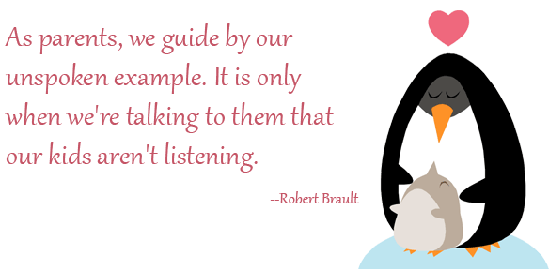
When your child gets angry:
One of the main ways to control anger is to help your child to note what sensations they have when they are becoming angry. Does their face feel flushed, their heart beat becomes faster, their head hurts, their stomach feels sick, or they feel like they cannot breathe? What messages is their brain telling them: “Run; Fight; Stop; React?”
Help your child to learn how to take deep breaths from their stomach, breathing in through their nose and slowly out their mouth. This will help them regulate their emotions.
Be there for your child and listen to what your child is trying to express. Acknowledge that your child is upset. Try and see the issue from their point of view. Hold off on giving advice but let your child suggest ways that he/she may want to handle the situation. Write these ideas down (even ones that you know will not work) and if your child is old enough have them write these down. This process is called brainstorming and is part of problem solving.
Have your child cross out ones that he knows will not work or will hurt him or another person or thing. Now have him pick one from the list that might work. Have him try that one and reassure him that you can come back to the list if needed. Ask if there is anything he needs help with.
Providing our children with the tools they needs to deal with feelings and emotions is an essential task a parent can provide.

  - Mothering Sunday
Mother’s day stems from a festival known as “Mothering Sunday”. This normally was a gathering of families that would attend service at their home (Mother’s) place of worship together on the 4th week of Lent. Over time this celebration became where children would honor their mother with gifts and words of gratitude. It is said that there are more phone calls made on mother’s day than any other day of the year.
Around the 19th century Ann Reeves Jarvis and Julia Ward Howe started work clubs for Mothers in which they offered education and support in parenting. Other endeavors to promote mothers and the impact they have on their children included Mother’s Friendship Day (1868) and Mother’s Day Proclamation (1873).
So what exactly is this holiday and why make it a special day? Mother’s day is a day in which we stop and consider the many sacrifices our mothers make for us. It gives us pause to take a step back and personally celebrate our unique relationship with the woman who raised us. Traditions still flow beautifully from mother to child and child to mother. While it has been capitalized on, it is still a day to know how very loved and cared for most of us have been.
To mother means to love with an unconditional love, to seek what is right and good and to be role model of such behaviors we strive to see in our children.

Programs Gentle Steps Offers:
- Basic Baby Care
- Adult Parenting Classes
- Teen and Teen Pregnancy Parenting Classes
- Parent and child Play Groups
- Family Therapy
- Individual Counseling
- Behavioral Therapy
- Pastoral Leadership Counseling
- Life Skills Counseling

  - Celebrate Freedom
Freedom is a privilege we often take for granted and yet this month we are reminded of the cost of such a gift. As we stop to embrace the sacrifices men and women have paid with their own lives in order that we may live in a country such as ours, may we take the time to give homage to these brave soldiers. May the meaning of freedom not be just a feel good feeling that warms our hearts but let it be a fire that burns deep in our souls. Let us accept diversity and individualism. May we accept the fact that our way does not need to be our neighbor’s way. Let us be creative and imaginative. May we honor the fact that each one of us can choose to worship or not worship in any way that brings peace. May the words of our mouths be ones of recognition and compassion and even more importantly may our actions speak volumes of empathy. May we not build walls but extend our hands and help those in need.
