BENEFITS OF TREATMENT ON THE BIOMAT AMETHYST MAT:
• Receive infrared and negative ion vibratory signals through a high-tech computer-operated system and amethyst quartz crystals (natures' super conductor).
• These natural, beneficial light rays and charged ions radiate energy, penetrating each and every cell.
• This powerful light force increases blood alkalinity and speeds cellular function during a deep state.
• Proven through Kirlian photography, this energetics penetrates 80x more deeply than normal heat (going 6 to 8 inches into the body).
• Reduces swelling and inflammation by improving lymph flow.
• Increases blood flow of the micro-circulatory system.
• Shown to destroy cancer and viral cells without harming surrounding healthy cells.
• Stimulates healthy molecular vibration with long-lasting life-sustaining enzyme activity.
• Removes toxins (Powerful Detoxifier), which are often at the core of many health problems.
• Alleviates allergies, migraines and sinus issues.
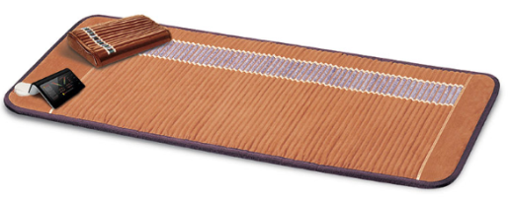
• Helps lungs, respiratory, skin, digestive and cellular disorders.
• Rejuvenates the skin.
• Relieves pain and joint stiffness.
• Decreases hyperactivity.
• Burns calories and controls weight
• Excellent for accelerated healing
• Amethyst is known as the power crystal and has the ability to transform lower energies into higher and acts as a healer at all levels of mind, body and spirit.
Be sure to drink lots of water before and after a treatment on the mat. The benefits continue long after the treatment. You may feel like you need to rest more (due to the detoxifying effect) or may immediately have more energy. Honor whichever way you feel. And as you didn’t create your physical body/ailments overnight, many times it also takes a period of time to get the benefit you want. Healing is like peeling away an onion – it’s a layer at a time! Herbal supplements can help increase the healing response.
810-584-5241 yourpathforwardholistics@gmail.com

