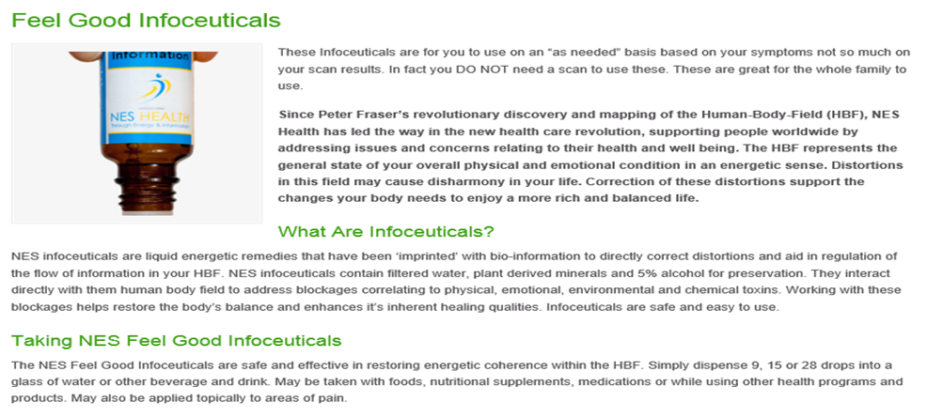
List of Feel Good infoceuticals

CFI (ET-6)-Cold Flu Immunity (ET 6) aids in the body's natural ability to recover from cold & flu symptoms. May provide relief from fatigue, promote drainage, and re-tune cellular function. Supports lung and large intestine meridian.

Chill (ES-8)-Chill encourages a calm mental state, and the releasing of emotional and sensory data. May be helpful when suffering from constant, long-term stress.

EMF-Electromagnetic Field helps correct energetic imbalances from radiation exposure. May help improve your ability to deflect electromagnetic fields. May be used topically on the hands, back of neck, or other exposed areas.

ESR-Emotional Stress Release supports the release of emotional stress, soothes the digestive tract, and may assist in the absorption of nutrients. May be applied topically to areas of physical trauma.

Fat Metabolism-Fat Metabolism helps to correct and normalize liver function, hormonal activity, and metabolism of fat. Supports the nervous system and may encourage appetite regulation.

Female (ES-12)-Female supports female endocrine function to enhance social abilities, attractiveness, sexual function, and charisma. Helps promote confidence, willpower, social warmth, and wellbeing.

Heart Driver (ED6)-Heart Driver helps with decision-making processes, mental clarity and integration, identity and self-esteem. Helps regulate emotions. May have a beneficial effect on skin tone and appearance.

Heart Imprinter (ED2)-Heart Imprinter energetically enhances the heart's ability to imprint nervous system information onto the bloodstream. Helps re-establish the head-heart connection, promoting mental clarity and a positive emotional outlook.

Love-Love promotes feelings of unity and unconditional love for oneself and others. Supports personal transformation, and helps to clear the crown chakra.

Male (ES-11-Male helps support the correct male endocrine function to enhance social abilities, attractiveness, sexual function, and charisma. Helps promote confidence, willpower, social warmth, and wellbeing.

Muscle Driver (ED9-Muscle Driver assists in clearing metabolic waste stored in muscle tissue to help restore flexibility, mobility, and muscle strength. Promotes independence and supports the ability to animate dreams and desires.

Nerve Driver (ED4-Nerve Driver supports nervous system to help your body deal with stress. Helps to shed toxins, calm the system, and aid in your ability to get a restful sleep.

Peace-Peace promotes a calm mental state, mental clarity, and honesty with oneself. Enhances the head-heart connection to resolve conflicts between emotions and logical thought, as well as memories that have caused disharmony.

Polarity-Polarity aids in correcting energetic distortions brought on by air travel, over-exposure to electromagnetic fields, chronic illness and geopathic stress. May assist in physical and emotional detoxification. Particularly useful for jet lag.

Rejuv-Rejuvenation helps rejuvenate the body after sports, strenuous physical activity, physical injury, impact or shock. Aids in tissue regeneration, muscle recovery, muscle tone. May ease muscle strains, swelling, and trauma. May be applied topically in injured areas.

Sleep-Sleep promotes balanced sleep cycles and regulation of your body's natural rhythms. May have a harmonizing affect on the body's entire energetic system. Use 3-4 times throughout the day, with the last dose before bedtime to reset your sleep cycle.

Energy (Source-Energy/Source enhances source energy available for physical activity. May be useful when energetically depleted due to chronic illness, mental exhaustion, stress, toxic exposure, malnutrition, or poor breathing. Use before and during physical activity.mail.com

810-584-5241
yourpathforwardholistics@gmail.com

