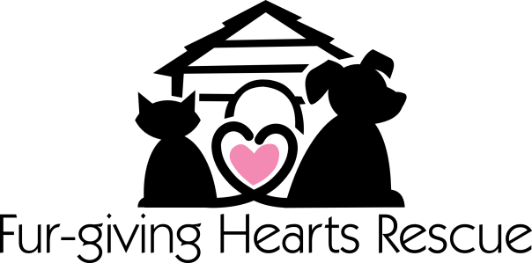
REQUEST FOR RELEASE OF MEDICAL RECORDS

From: ________________________________ (Adopter)
To: __________________________________ (Veterinarian/Clinic)
ADDRESS:_____________________________
______________________________________
PHONE:_______________________________

I request that copies or summaries, as required by state law, of the medical
records, pertaining to my animal(s) named_____________________________
be released to Fur-Giving Hearts Rescue. I hereby authorize and provide my written consent to this transfer of medical information.
Signature of Adopter: ____________________________________
Date_________
Signature of FGHR Representative:_________________________
Date__________

