Weston on the Green  Neighbourhood Plan  November 2016 | 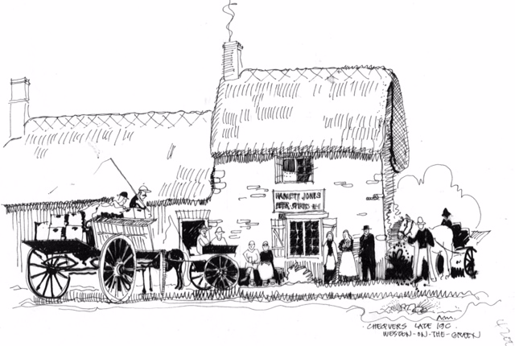

By the time the Village News is published, the Neighbourhood Plan (NP) will have been officially presented to the Parish Council for approval. The PC is the legal body for submitting the Neighbourhood Plan to Cherwell District Council and if they approve the NP they will formally submit the Plan to CDC. As the qualifying body, the PC will be responsible for implementing the objectives put forward in the Plan.

Once the PC has submitted the NP to Cherwell, the Planning body will either agree the Plan and maybe make comments/suggestions or it will be rejected. If agreed with suggested amendments, the Steering Group will make changes as advised by the CDC.

The NP will be formally published for consideration by statutory consultees for a six week period. This is known as the “Formal Consultation Period” and begins once Cherwell have come back with any amendments and we have altered the Plan as suggested by them.

Once the Formal Consultation Period is finished it will be submitted to the External Examiner for review and recommendations and if the External Examiner authorises the Plan it will go to the village to seek approval via a referendum.

We will keep the village informed of all stages via the website at http://www.wotgneighbourhoodplan.co.uk/ or go to Facebook.com, and search for Weston on the Green Neighbourhood Plan.

Dates of the next Steering Group Meetings:

8th December 2016
12th January 2017
9th February 2017

They are all held at 7.30 pm in the Village Hall and open to the public.
Alex Reid

