Nutrition Plus, Inc.
Emily Roark Patti Brenn Susan Morrell
(620) 221-2777 (620) 218-4994 (785) 224-4104
roark2@cox.net pattibrenn@cox.net smorrell12@gmail.com
www.nutritionplusinc.com
June is:
National Fresh Fruit and Vegetables Month
National Country Cooking Month
National Dairy Month
National Papaya Month
National Soul Food Month
National Turkey Lovers Month

Important dates:

June 5 – Firm deadline for claims-end of fiscal year for Kansas, means claims and payday are earlier in month than any other month. Our deadline is the 15th to have everyone processed. Any claims received after the 5th are not guaranteed to be paid at the end of June.

June 19th - Checks and direct deposits go out

“Infant Feeding in the CACFP”

TBD - Topeka Workshop at library 6:30 pm
TBD - Winfield Workshop at Presbyterian church
6:30 pm

What’s New?

Home visits continue during the pandemic so please keep your paperwork up-to-date. We are making accommodations to minimize exposure. So far, this is working out very well.

Dillons Community Rewards Program! We have been approved as a non-profit business to
JUNE 2020
participate in the rewards program. This gives us the required extra income we need to keep functioning. All we need, is for our Dillons shoppers to link their Dillons plus cards to Nutrition Plus. This is a big win for us! Call Emily for details.

Program audit from Child Nutrition and Wellness is complete. As expected, it went well. There were a couple things we need to correct. We got a corrective action plan for no labels at a visit. Providers need to keep labels for whole grains, cereals and yogurt. Two months-worth are required, so basically 2 breads, 2 crackers, 2 cheerios, 2 yogurts, 2 tortillas…
The other findings that counted against us were the attendance sheets where there were no absences, late arrivals or early pick-ups. State considers it “an anomaly”, if there are 4 months-worth of full attendance for each child. Our corrective action plan now requires us to flag an attendance sheet with no absences. We then look back at the previous 3 months looking for similar claims. If all 4 months have no absences, parent audits will be performed or sign-in/out sheets will be required. This is new for all of us, but they were insistent that it is unusual for no one to be sick, leave early or get dropped off late every once in a while.

New Crediting Foods Guides are here! We are having the 2020 books printed for each provider and they will be handed out as soon as we can get together. Product Formulation Statements. We have gotten permission to reimburse for 12 commercially prepared meat items from Tyson and Gorton’s. Using these specific products will eliminate the need for extra meat alternate to be served. These will be handed out asap.
Creditable whole grains and yogurt list now available. Last year, at the whole grain workshop, a provider asked, “what can we buy?” I got permission from Child Nutrition and Wellness, to compile a list of products that met the criteria for the program. There is a list of breads, buns, tortillas, etc. with pictures and the name of the product. We will be distributing these soon. It is not a complete list, with every available brand and item out there, but is a good start. Some products are cleverly marketed to look like they are healthier than they really are. This tool should make it clear which items are whole grain and creditable.

Homemade sidewalk chalk

1/2 cup Cornstarch
2/3 cup Water
Food Coloring

Mix together the water and cornstarch, and stir until the cornstarch dissolves. Other chalk paint recipes call for a 1:1 ratio of cornstarch and water. Since this paint goes on the sidewalk instead of paper, incorporating just a bit more water enables you to paint longer without needing to reload the paintbrush, which is always great for younger kids. Divide the paint mixture into the wells of a muffin tin or similar painting tray, and add food coloring to achieve the desired colors – note that the colors will dry much lighter on the sidewalk than they appear in the tin! The entire batch should cost about $.50 to make so say goodbye to wasting money on expensive chalk purchases!
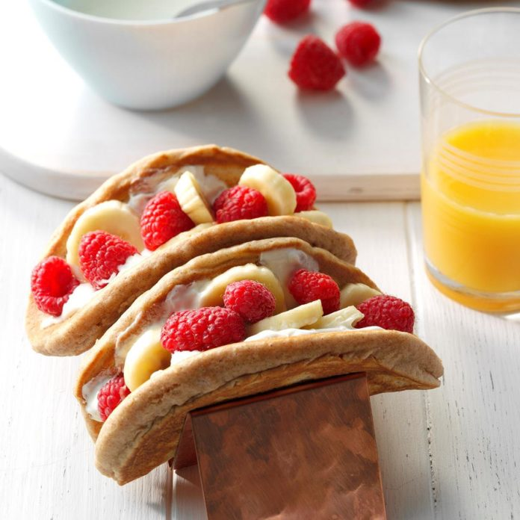
Breakfast Tacos
3/4 cup all-purpose flour
3/4 cup whole wheat flour (this recipe is whole grain-rich)
3 tablespoons sugar
2 teaspoons baking powder
3/4 teaspoon ground cinnamon
1/2 teaspoon salt
1 large egg, room temperature
1 cup milk
2 tablespoons canola oil
1 teaspoon vanilla extract
1/3 cup cream cheese, softened
3 tablespoons vanilla yogurt
1 small banana, sliced
1 cup fresh raspberries
(Any fruit can be substituted in, depending on availability. They’ll be delicious anyway!)

Whisk together flours, sugar, baking powder, cinnamon and salt. Combine egg, milk, canola oil and vanilla; stir into dry ingredients just until moistened.
Preheat a griddle over medium heat.
Lightly grease griddle. Pour batter by 1/2 cupfuls onto griddle; cook until bubbles on top begin to pop and bottoms are golden brown. Turn; cook until second side is golden brown.
Meanwhile, beat together cream cheese and yogurt. Spread over pancakes; top with banana and raspberries. Fold up.

As always, thank you for being the best part of Nutrition Plus. Emily, Patti & Susan

