**[Panini: Summer Fast Food, Italian-style](http://www.kingarthurflour.com/blog/2011/07/14/panini-fast-food-italian-style/" \o "Permanent Link: Panini: fast food, Italian-style)**

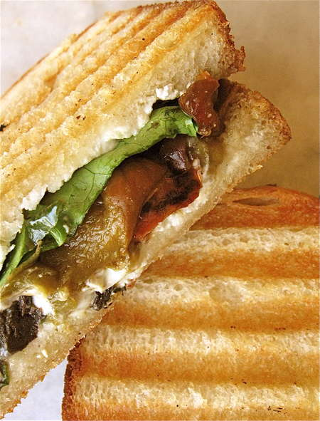

Panini is the Italian version of an American grilled cheese sandwich (or a French croque monsieur): two pieces of bread, filling, grilled or griddled to warm/melt what’s inside…i.e., comfort food at its best.

While we don’t generally think of grilling sandwiches (beyond cheese) in this country, it’s a fairly commonplace practice in Italy, where Panini are offered in versions as basic as tomato, basil, and mozzarella; or as deluxe as yellow fin tuna, olives, artichokes, baby greens, and tapenade.

The panini is Italy’s favorite fast food, available 24/7 in bars, trattorias—even on the Autostrade, Italy’s superhighway…and while panini haven’t caught on in this country to the degree that pizza has, they’re gradually becoming more well-known.

A panini craze several years ago spiked consumer interest in the [Panini grill](http://www.kingarthurflour.com/shop/items/panini-grill), a ridged sandwich press designed to produce Panini’s signature grill marks. While a panini grill makes panini easy, it’s certainly not a necessity; you can grill panini in a frying pan or on a griddle as you would any grilled sandwich.

So now, while farmers’ markets are swinging into gear and beautiful weather (plus long evenings) make quick and easy dinners enticing, consider panini. Once you’ve got your ingredients assembled, panini are faster than burgers—and much more versatile.

OK This recipe should start with a trip to the farm stand, or your favorite produce market. Yesterday I picked up some good-looking bell peppers, and a few Portobellos

.[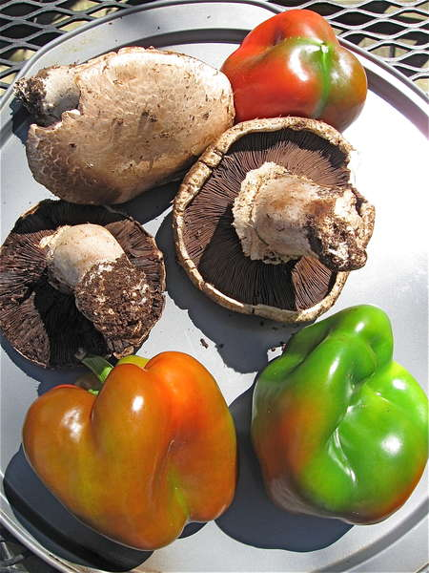](http://www.kingarthurflour.com/blog/files/2009/05/img_6872.JPG)[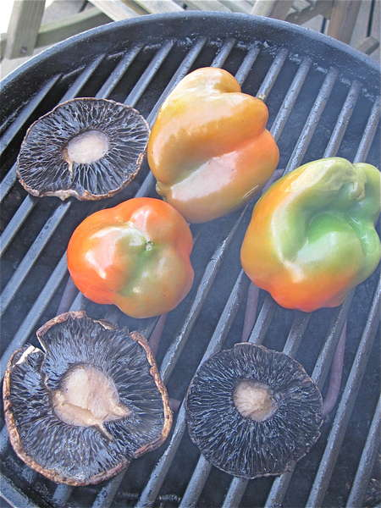](http://www.kingarthurflour.com/blog/files/2009/05/img_6875.JPG)

Next step: light the grill. **Note:** I don’t always bother scraping the gills out of the mushrooms, as most recipes ask you to do. Just spray whatever veggies you’re grilling with olive oil spray, and lay on a hot grill. Any smoke the veggies generate adds extra flavor. Or simply place on a grill pan or fry pan till softened. Turn the vegetables frequently, especially the peppers; you want them to char all over (the peppers, not the mushrooms). These mushrooms are ready to come off the grill…

[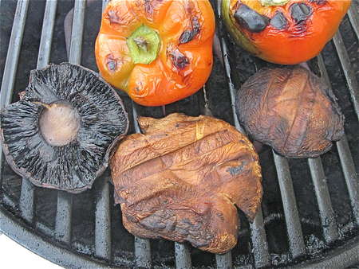](http://www.kingarthurflour.com/blog/files/2009/05/img_6879.JPG)

…but the peppers need a bit longer. Ah! Now they’re ready.

[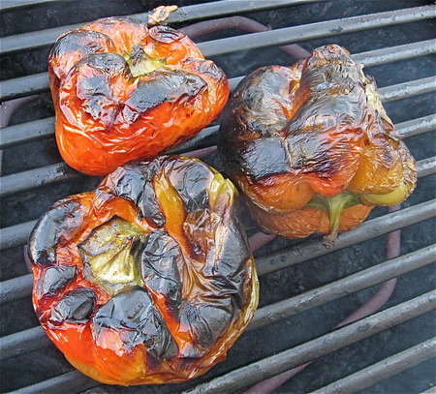](http://www.kingarthurflour.com/blog/files/2009/05/img_6882.JPG)

[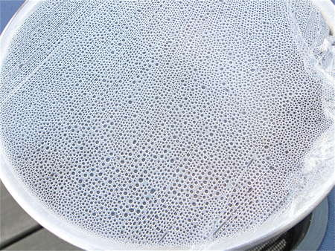](http://www.kingarthurflour.com/blog/files/2009/05/img_6893.JPG)

Remove the peppers from the grill, put them in a bowl, and cover tightly with plastic wrap. They’ll create their own steam bath.

[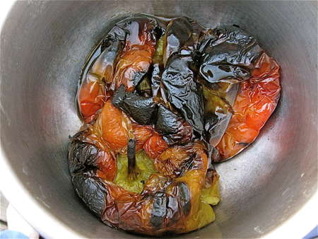](http://www.kingarthurflour.com/blog/files/2009/05/img_6894.JPG)

When they’re cool enough to handle, remove the plastic wrap. The steam will have made their skins loosen up a bit.

[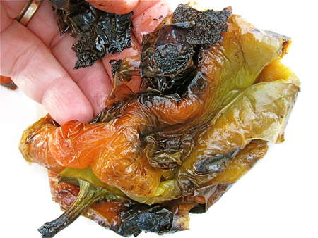](http://www.kingarthurflour.com/blog/files/2009/05/img_6895.JPG)

Skin the peppers; the skin will come off in shreds and, when you’re lucky, in sheets.

[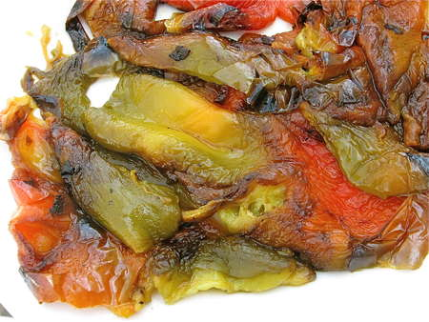](http://www.kingarthurflour.com/blog/files/2009/05/img_6898.JPG)

Discard the skin and seeds. What you have left is tasty roasted pepper.

[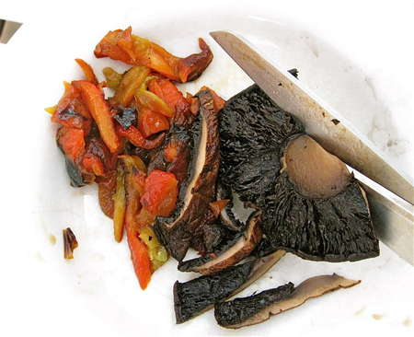](http://www.kingarthurflour.com/blog/files/2009/05/img_6899.JPG)

Slice the roast pepper in strips, and cut the mushrooms in strips, too. A pair of scissors is a handy tool for this.

[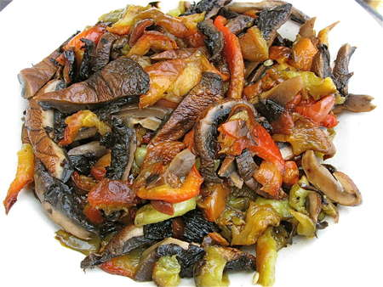](http://www.kingarthurflour.com/blog/files/2009/05/img_6903.JPG)

Now here’s a good-looking mélange of smoke-roasted veggies!!

[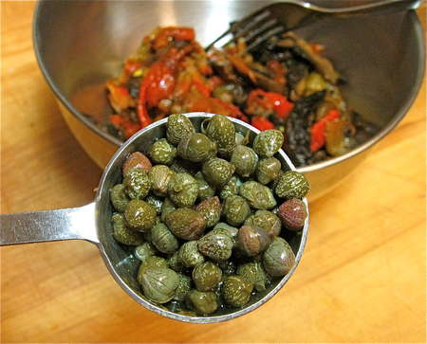](http://www.kingarthurflour.com/blog/files/2009/05/img_7273.JPG) [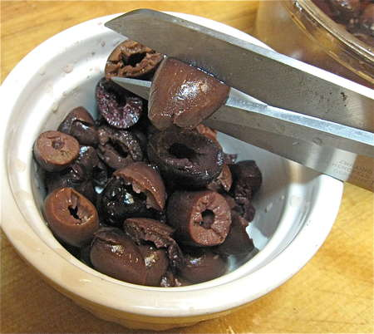](http://www.kingarthurflour.com/blog/files/2009/05/img_7274.JPG)

Add salty capers and pitted Kalamata olives, which you’ve cut into coarse pieces. There’s the scissors again…

[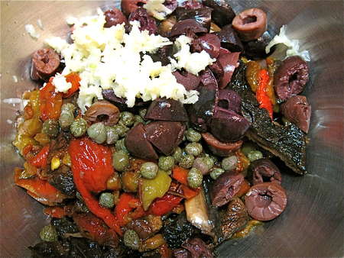](http://www.kingarthurflour.com/blog/files/2009/05/img_7275.JPG)

Toss everything together with chopped garlic… And there’s your sandwich filling. This can be made ahead and refrigerated.

[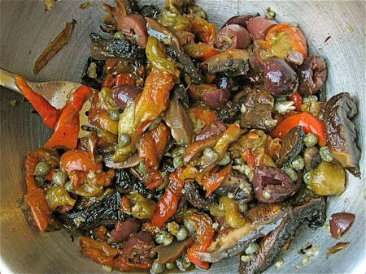](http://www.kingarthurflour.com/blog/files/2009/05/img_7282.JPG)

[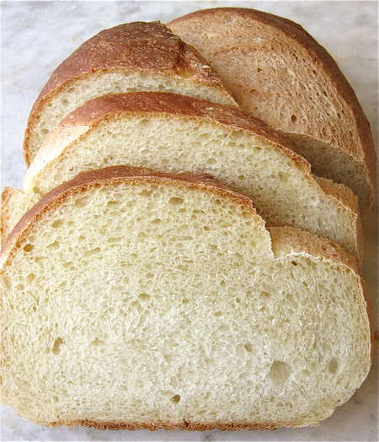](http://www.kingarthurflour.com/blog/files/2009/05/img_7284.JPG)[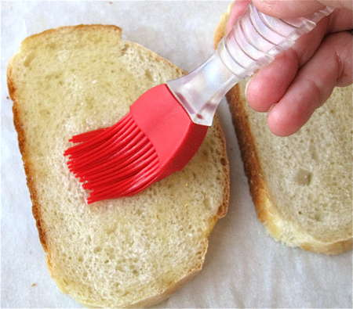](http://www.kingarthurflour.com/blog/files/2009/05/img_7285.JPG)

Next, the bread. I’ve chosen as I thought it was a nice size and shape of loaf for panini. Cut two slices, and brush one side of each slice with olive oil.

[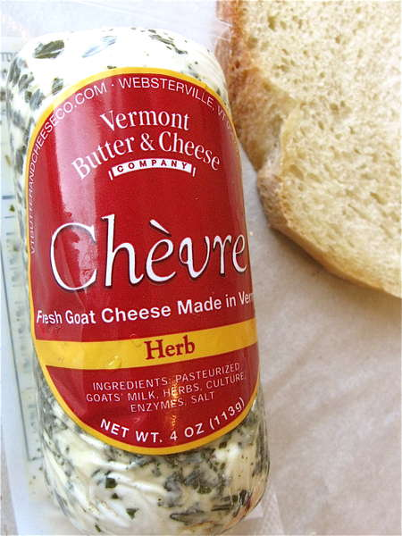](http://www.kingarthurflour.com/blog/files/2009/05/img_7286.JPG)[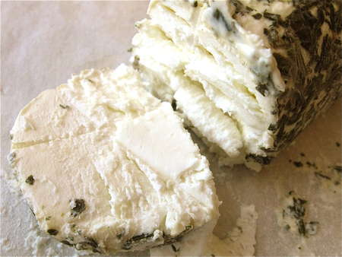](http://www.kingarthurflour.com/blog/files/2009/05/img_7287.JPG) Pick your favorite cheese. I’ve chosen a nice Vermont herbed goat cheese; it just feels right to me, with the sourdough and roasted vegetables. Ok now cut slices …and spread (or layer) on the non-oiled sides of the bread.

Spread roasted vegetables on one slice of bread…

[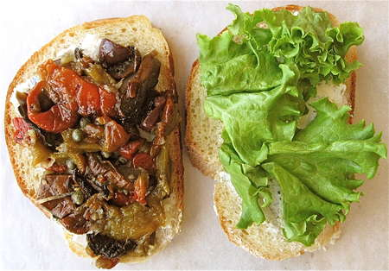](http://www.kingarthurflour.com/blog/files/2009/05/img_7297.JPG)

…and baby spinach, arugala, or your favorite salad greens, on the other.

[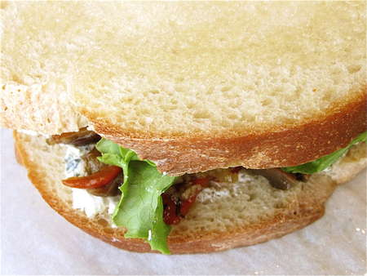](http://www.kingarthurflour.com/blog/files/2009/05/img_7298.JPG)

Sandwich together. Make sure the oiled sides of the bread are on the outside. Repeat the process to make more sandwiches; you’ll get 4 or 5 sandwiches out of this amount of filling and cheese.

Now you’re ready to grill. A panini press generally only takes a few minutes to preheat, so you don’t need to worry about planning too far ahead.

[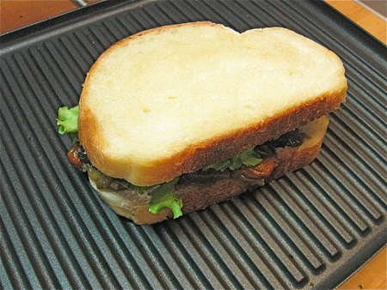](http://www.kingarthurflour.com/blog/files/2009/05/img_7303.JPG)

If you have a [panini grill](http://www.kingarthurflour.com/shop/items/panini-grill) or press, use it. If not, you can accomplish the same thing on a stovetop griddle or in a frying pan; you just won’t get the nice grill marks.

[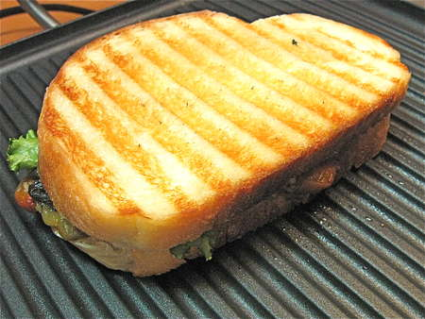](http://www.kingarthurflour.com/blog/files/2009/05/img_7307.JPG)

Close the press, and grill till the interior of the sandwich is hot, the cheese is melting, and the bread is hash-marked and toasty.

[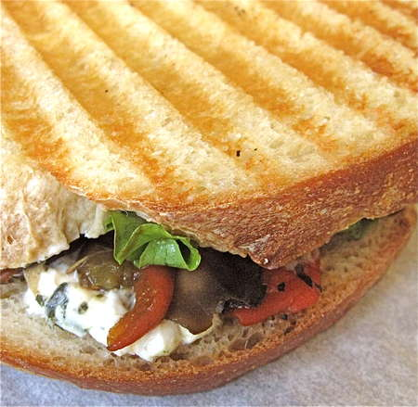](http://www.kingarthurflour.com/blog/files/2009/05/img_7310.JPG)

Like this.

[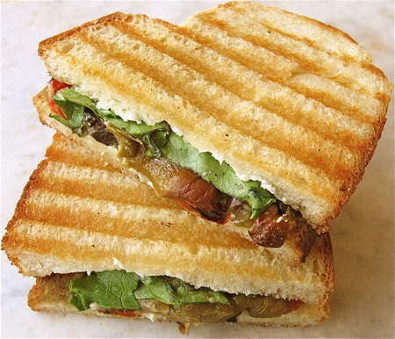](http://www.kingarthurflour.com/blog/files/2009/05/img_7320.JPG)

Cut sandwiches in half to serve.

[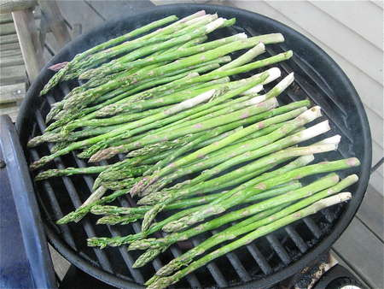](http://www.kingarthurflour.com/blog/files/2009/05/img_6887.JPG)[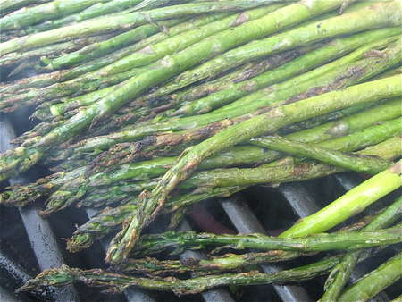](http://www.kingarthurflour.com/blog/files/2009/05/img_6889.JPG)

So, since the grill was on anyway, and I had also bought some fresh asparagus, I decided to throw it on. Drizzle with olive oil first.

Next, place on the grill, spread out as much as possible, so each piece is lying directly on some hot metal. Turn frequently. If your grill has a cover, use it; the asparagus will cook a bit faster.

[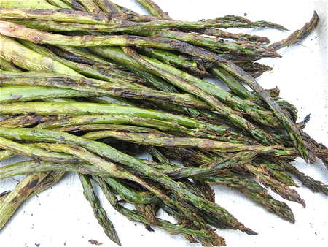](http://www.kingarthurflour.com/blog/files/2009/05/img_6892.JPG)

Remove when limp and beginning to brown. Salt to taste, and enjoy.