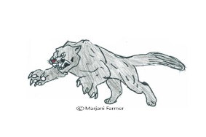**Office of Communications and Media Relations**

P.S. 129M

The John H. Finley Campus School

425 West 130th Street

New York, NY 10027

212-690-5932

52 Chambers Street, New York, NY 10007

Tel: 212.374.5141 Fax: 212.374.5584

# CONSENT TO PHOTOGRAPH, FILM, OR VIDEOTAPE A STUDENT FOR NON-PROFIT USE

(e.g. educational, public service, or health awareness purposes)

Student Name: _________________________ School: P.S.129M John H. Finley

I hereby consent to the participation in interviews, the use of quotes, and the taking of photographs, movies or video tapes of the Student named above by PS129, administration, teachers, support staff, support staff from collaborative educational programs.

I also grant to the technology liaison, PS129 administration, teachers, support staff, and support staff from collaborative educational programs. the right to edit, use, and reuse said products for non-profit purposes including use in print, on the internet, and all other forms of media. I also hereby release the New York City Department of Education and its agents and employees from all claims, demands, and liabilities whatsoever in connection with the above.

Pictures may be used to generate grants and/or other online funds such as, but not limited to: Donor Choose, Adopt a Classroom, pledge cents, ect… Pictures may also be posted on our ClassDojo site, twitter handle @johnhfinley and/or on our website [www.johnhfinley.org](http://www.johnhfinley.org) and for other nonprofit educational purposes at the technology liaison, PS129 administrations, teachers, support staff, and support staff from collaborative educational programs discretion.



Date: ___________

Address of Parent/Guardian: ________________________________________________________________________