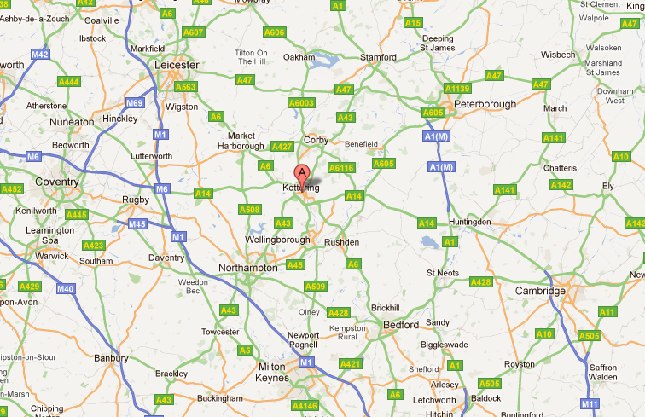

***Buffets – Free delivery within 20 miles***

***Over 20 miles – please call for delivery cost***

***N.B. Delivery radius shown are approximate***