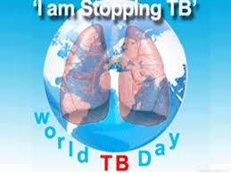

# The elders, children and people with weakened immune systems are at high risks.

*QAAXADA AYAAN JOOJINAYAA INTA AAN NOOLAHAY*

WAXAAN KUUGU BAAQEYNAA INAAD ISKA BAARTO CUDURKA QAAXADA

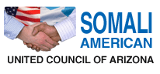

EDUCATES AND ECOURAGE THE REFUGEE COMMUNITY TO GET VOLUNTERELY TESTED FOR TB AS A PREVENTIVE AND/OR CURATIVE MEASURE.

# TB partnership is leading the way to a World without tuberculosis (TB), a disease that is curable but still kills three people every minutes.

*TB*

IN MY LIFETIME

MARCH 24. 2013

Phone: (602) 522-2100

* 2425 E. Thomas Rd, Suite 10,11, & 12 Phoenix, AZ 85016