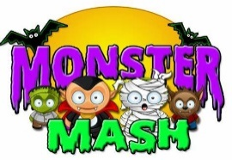  October Holiday  Programme |  |  | The Greenfield Club is a non-profit making charity, set up in 1996 to provide out of school care, for children aged 4-11 years. We are open from 7:45am until 6pm every week day during the school holidays, except for Bank Holidays. We are accepting children who start Reception class in September so please come along and visit us to book your sessions!
 | Monday 28th | Tuesday 29th | Wednesday 30th | Thursday 31st | Friday 1st November
Open 7:45am  9:30am | Shadow Puppets  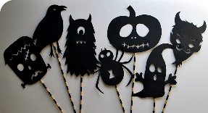 | Bowling Trip  Please arrive by 9am  £7.50 per child | Explorer Dome  NEW Light Show  9.30am-10.30am  £3 per child | 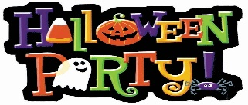  Hallowe’en Fancy Dress &
10:30am | Puppet Shows & Hallowe’en Snack time |  |  | Police Talk @ 10am  “Get your questions ready!” | 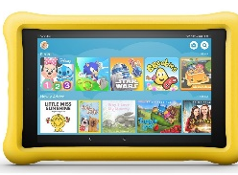  Chill Out Time!
12:00pm | 12pm Lunch Time
 | Pumpkin Carving  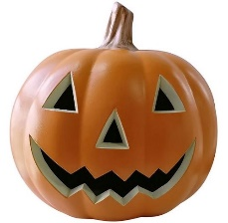 |  | The Doughnut Game  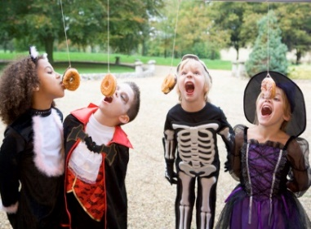
Deadly Desserts
Choose from a selection of ice creams and dessert ingredients to make your own Hallowe’en treat!
1:00pm
 |  |  |  |  | Glow In the Dark Bubble Making
2:30pm | The Chocolate Mummy Game | Balloon Decorating
4:00pm  Close 6pm |  |  | Halloween Games  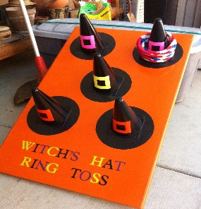 | 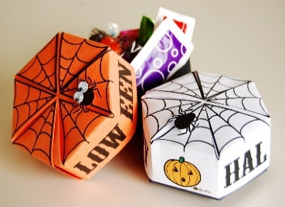  Hallowe’en Gift Boxes | Hallowe’en Movie Time
The booking deadline is Friday 11th October – Don’t miss it!
October Holiday Programme 2019
Date  Please tick your selected sessions | Morning Session  (7:45am-1pm)  £15.00 |  |  | Afternoon Session  (1pm-6m)  £15.00 |  |  | All Day Care  (7:45am-6pm)  £25.00
Mon 28th Oct
Tues 29th | Hollywood Bowl trip +£7.50 |  |  |  |  |  | Hollywood Bowl trip +£7.50
Weds 30th | Space Show +£3 |  |  |  |  |  | Space Show +£3
Thurs 31st
Fri 1st Nov
Mon 4th Nov | Back to School for Elm Park – Breakfast & After School Club begins (St Michael’s Inset Day)
Please note that trips are compulsory and there will not be an option of staying at Club.
We welcome suggestions for competitively priced trips and visitors to continue to keep fees low.

By booking certain dates, you are giving your consent for The Greenfield Club staff to take your child/children off Club premises, to travel by mini-bus/coach, to the stated trip destination or take part in a particular activity.
Name/s of Children: |  |  |  |  | Age/s during the October Holidays:
Name of parent/carer: |  |  |  |  | Telephone number:
Home Address:
(House number & Post-code)
Email address: |  |  |  |  | School:
Please circle payment type: |  | BACS | Childcare Vouchers |  | Cash no longer accepted |  |  | Cheques no longer accepted
Signature: |  |  |  |  | Date:

The Booking Deadline is Friday 11th October – Don’t miss it

Please note that we will be having food & fireworks on Tuesday 5th November between 4 & 6pm for all After School Club attendees – information on payments will be advertised soon!

