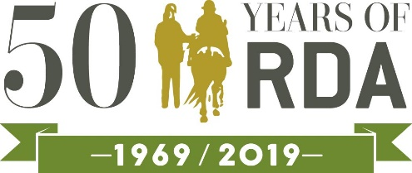

- Agree an Endeavour promise with your riders and try to achieve it together in time for Celebration Week – then celebrate with our special 50th anniversary Endeavour certificates

- Organise games and competitions for your Celebration Week sessions – and present our 50th gold rosettes to everyone who takes part

- Hold a 50th or Gold themed cake sale

- Spell out a giant ‘50’ with poles or cones and challenge riders or drivers to steer their way round

- Endurance groups: join the 50k challenge to earn your 50th Endurance certificate and rosette – contact Lucy Stokes at lstokes@rda.org.uk to find out more

- Make this the year you try something new – start a new activity like Showing and Endurance and by October there’ll be no stopping you

- Enter the Arts & Crafts or Writing competitions – this year there’s a 50th theme and a new category for photography

- Organise a collection of 50ps. If everyone started collecting now you could be ‘quid’s in’ by the end of the year

- Have a party and celebrate with all the people who’ve helped make your group so special - anniversaries are perfect for a bit of nostalgia washed down with tea and cake

- See if you can collect ’50 things we love about RDA’ – you could turn this into a fundraising tool, a publicity poster, a social media campaign, even a video!

Don’t forget to share with us your 50th celebrations and achievements by using the #RDA50 or emailing Beth Randles at brandles@rda.org.uk or Caroline Ward at cward@rda.org.uk

