Best of British Week  Summer Holiday  Programme |  |  | The Greenfield Club is a non-profit making charity, set up in 1996 to provide out of school care, for children aged 4-11 years. We are open from 7:45am until 6pm every week day during the school holidays, except for Bank Holidays. We are accepting children who start Reception class in September so please come along and visit us to book your sessions!
Week 1 | IMPORTANT NOTICE!  We are a Nut Free Zone | Lunch Time  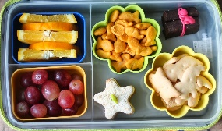  Please remember to pack a healthy lunch box with ice pack | Wednesday 24th | Thursday 25th | Friday 26th
Open 7:45am  9:30am |  |  | Walking Trip to Winterbourne Library  Please bring your library card and ‘Summer Reading Challenge 2019’ from your local library!  Please arrive by 10am as we are due at the library by 11am  (We should return by 1pm)  Union Jack Cupcakes | Wild Place Trip  Please arrive by 9am  £3 treat money recommended  A new and exciting trip to the Wild Place project where the children can see cheetahs, giraffes and endangered animals! | Cricket
10:30am |  |  |  |  | Healthy Fish & Chip Making
12:00pm | Sun Hats & Sun Cream  Please remember sun protection this Summer! | Tuck Money  40p a day or 20p for a  half day!  We provide a selection of snack foods such as fruit, crackers, raisins, toast, croissants etc
1:00pm
 |  |  | Union Jack Cupcakes |  | TIE DYE FUN
2:30pm | Trips  It is essential that your child has sensible shoes, a rain jacket and we do recommend a spare set of clothes and extra socks for our outdoor adventure trips is also recommended! | Summer Special  We are offering our amazing Summer Special deal again for trip days – you only pay £15 for the day and then venue costs. If no venue costs, a small fee may apply. We will cover the coach costs!
4:00pm  Close 6pm |  |  | Three-legged Races | Penalty Shoot Out | British Bulldog Fun
The booking deadline is Friday 12th July – Don’t miss it!

In the Air Week  Summer Holiday  Programme |  |  |  |  |  |  |  | It’s easy to book!  Just email us your form by renaming the document  with your child’s name!  thegreenfieldclub@yahoo.co.uk
Week 2 | Monday 29th July |  |  | Tuesday 30th |  |  |  | Wednesday 31st |  |  |  |  |  | Thursday 1st August |  |  |  | Friday 2nd
9:30am | Giant Rocketship Making |  |  | Animal Encounters  A new visitor this Summer – with reptiles and more!  Please arrive by 8:45am  £3 per child |  |  |  | Trip to Air Hop  Please arrive by 8:45am  Followed by lunch & a trip to  £3 gift shop money recommended. We should return by 4pm latest |  |  |  |  |  | Space Show  Don’t miss out on this galactic experience! Early booking advised! |  |  |  | Launch Rockets
10:30am |  |  |  |  |  |  |  |  |  |  |  |  |  |  |  |  |  | Moon Sand
12:00pm | Lunch Time |  |  |  |  |  |  |  |  |  |  |  |  | Martian Attack  (Parachute game)
1:00pm | 60 seconds Shoot a Hoop Challenge!
2:30pm |  |  |  | Tennis |  |  |  |  |  |  |  |  |  | Fruit & Marshmallow Kebabs  Make your own fruity treat for afternoon snack! |  |  |  | Paper Airplane Making
4:00pm | Helium Balloon Release |  |  | Welly Wanging |  |  |  | Rice Crispie Treat Airplanes |  |  |  |  |  |  |  |  |  | Chill Out Time
Sand Sculptures Week  Summer Holiday Programme |  |  |  |  |  |  | Where are we? – Based at the rear of The Greenfield Centre,  Park Avenue, Winterbourne, BS36 1NJ  Tel: 01454 777604  Please see our website for more information  www.thegreenfieldclub.com
Week 3 |  | Monday 5th August |  | Tuesday 6th August |  |  | Wednesday 7th August |  |  |  |  | Thursday 8th August |  |  |  | Friday 9th August
9:30am |  | Kinetic Sand |  | Watermelon Ice Lollies |  |  | Hengrove Play Park  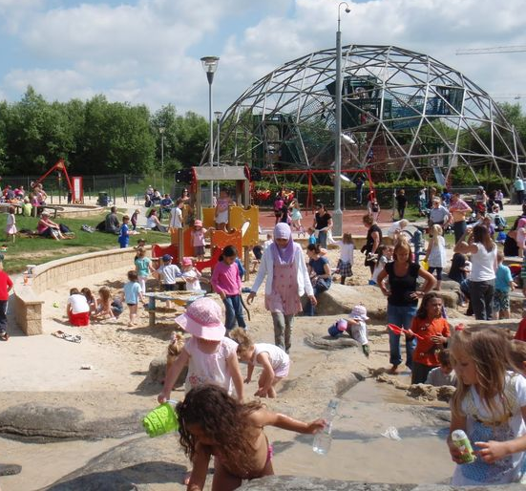  Please arrive by 8:45am  £3 treat money recommended! |  |  |  |  | Hula Hooping Challenge  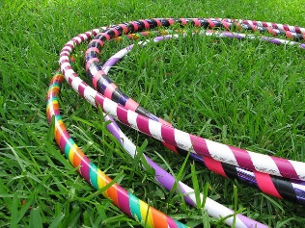  Team up and see what challenges you can achieve! |  |  |  | Sand Art & Giant Beach Ball Fun
10:30am
12:00pm  Lunch time |  | Chocolate Pirate Coins |  | £2.50 per child  Including a Dance Off, Ice Cool Slushies & Campfire Building
1:00pm |  |  |  |  |  |  |  |  |  |  |  | Sand Sculptures Competition
 |  | Volleyball
2:30pm |  | Beach Wear Design Competition |  |  |  |  | Grass Skirt Making |  |  |  |  | Beach Tent Making |  |  |  | Long Jump Challenges
4:00pm

Summer Holiday Programme  Foodie Festival Week |  |  |  |  |  | The Greenfield Club is a non-profit making charity, set up in 1996 to provide out of school care, for children aged 4-11 years. We are open at 7:45am until 6pm every week day during the school holidays, except for Bank Holidays. We are accepting children who start Reception class in September for the Summer Holiday Club so please come along and visit us at Club or view our website to book your sessions!
Week 4 | Monday 12th August |  |  | Tuesday 13th August |  | Wednesday 14th August |  |  |  | Thursday 15th August |  |  |  |  |  | Friday 16th August
9:30am | Italian Pizza Making  Get creative making your very own Italian style pizza! |  |  | Cattle Country Trip  Please arrive by 8:45am  £3 spending money recommended!  We should be back by 4:15pm latest |  | Fromeside Gym Trip  Please arrive by 9am  We will be walking to Fromeside Gym shortly afterwards and will be back for 12pm lunch |  |  |  | Yate Trip  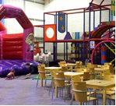  Followed by Foodie Festival Treasure Hunt at Kingsgate Park  Please arrive by 9:15am  £3 recommended |  |  |  |  |  | Equality Workshop  Healthy discussions on human rights and equal opportunities
10:30am |  |  |  |  |  |  |  |  |  |  |  |  |  |  |  | Melon Madness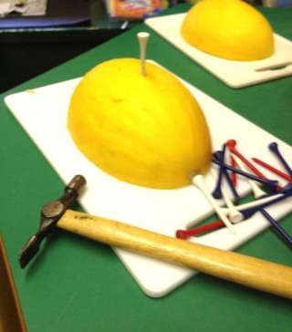
12:00pm | Lunch Time |  |  |  |  | The Smelling Game |  |  |  |  |  |  |  |  |  | Duck Duck Goose  &  Fruit Salad  (Parachute Game)
1:00pm | Foodie Printing
2:30pm | Plate Spinning |  |  | Fruit Penalty Shoot Out |  | Mexican Wrap Making |  |  |  | Fruit Quiz |  |  |  |  |  | Blindfolded Guessing Game
Summer Holiday Programme  Glamping & Nature Week |  |  |  |  |  |  |  |  | Even though there is a structured programme that staff encourage all children to participate in, the children are also free to rest or choose from a wide variety of self-led activities at Club!
Week 5 |  |  | Monday 19th |  | Tuesday 20th |  |  |  | Wednesday 21st |  |  |  | Thursday 22nd |  |  |  | Friday 23rd
9:30am |  |  | Animal Masks |  | Visitor  Independent wildlife educator and owl specialist Ian McGuire will be visiting to talk and show the children some very interesting items! |  |  |  | Bridgehouse Railway  Walking Trip  Please arrive by 8:45am |  |  |  | Drumming Workshop  Lots of fun learning to drum!  Please arrive by 8:45am |  |  |  | Kiddie Cocktails  Create your own amazing juice drink topped with fruit and of course, an umbrella!
10:30am |  |  | Tent Building
12:00pm |  |  | Lunch Time |  | Nature Quiz |  |  |  | Camping Inventions Fun |  |  |  | Leaf Patterns |  |  |  | Limbo Fun
1:00pm |  |  | Saltdough Worms
2:30pm |  |  |  |  | Dodge Ball |  |  |  |  |  |  |  | Clay Tree Faces |  |  |  | The Funny Walk Game
4:00pm |  |  | Butterfly Paintings |  |  |  |  |  | The Drama Game |  |  |  | Frisbee Fun |  |  |  | Perfume Making
Sports & Games Week  Summer Holiday Programme |  |  |  |  |  |  | When we are on trips or at the local play park, you can phone us in an emergency on 07784 48 10 32
Week 6 | Monday 26th August |  |  | Tuesday 27th |  |  | Wednesday 28th |  |  |  | Thursday 29th |  |  |  |  | Friday 30th
9:30am | BANK HOLIDAY  CLUB CLOSED  Bookings and September Allocated Places  Our Manager Sian will be away during the end of August so please phone the Club on (01454) 777604 and ask for the Play Leader in charge to discuss your September requirements.  An allocated places pack can be found online at www.thegreenfieldclub.com and any adhoc bookings can be accepted once a booking form has been received.  If you make a last-minute booking for Holiday Club care or September care you will need to pay in advance or on the day. |  |  | The Shape Game |  |  | Rounders |  |  |  | Walking trip to Newleaze  NERF Battles |  |  |  |  | Cricket
10:30am |  |  |  | Sports Designs
12:00 pm |  |  |  |  |  |  |  |  |  |  | Hand Ball |  |  |  |  | Sports Top Design
1:00pm |  |  |  | Cookie Making |  |  | Cat & Mouse  One of our most popular parachute games!
2:30pm |  |  |  |  |  |  |  |  |  |  | Sports Pom Poms |  |  |  |  | Wink Wink Murder
4:00pm |  |  |  | Football Time |  |  |  |  |  |  | The Key Game |  |  |  |  | Back to School  We are open for Breakfast & After School Club for Elm Park on Tuesday 3rd September and for After School Club collection at St Michael’s on the same day!
7.45am-6pm | Monday 2nd September – Elm Park & St Michael’s Inset Day
 | End of Summer |  |  |  |  |  | Park Play & Chill Out Time
Summer 2019 Newsletter
New September Starters (Before & After School Clubs)  During May an online joining pack for Allocated Places Sept 2019 - July 2020 was added to our website.  Please apply by completing your forms and emailing them back to Sian at our yahoo email address. She will be pleased to answer any questions and arrange any visits. We look forward to having your child start with us!  For existing members please inform us of any changes otherwise your child’s allocated place will continue in September. Membership fees will be invoiced for and then once paid your child will be allocated their place -Thank you |  |  |  |  |  |  |  |  |  |  |  |  |  |  | Is your child starting school in September?  Then you may be pleased to know that they can come & join us during the Summer Holiday Club!  Your Reception Class starter is very welcome to attend our Summer Holiday Club which starts on July Wednesday 24^{th.}  The online booking pack will be online around 4-5 weeks before the Summer Holidays start.  There are a number of ways to pay in advance, please see our website for details.  We look forward to meeting with you and showing your child what we do best - play!
New Trips & Visitors for Your Children
In the last year we introduced new trips such as Fromeside Gym, Newleaze walking trip and we have had Paula Winstone from Abacus providing a first aid workshop for the children. This year we have been thrilled with our Spaceshow experience which everyone thoroughly enjoyed. This year other new experiences have been planned – please see our 2019 Summer Holiday Programme for more details! !
Very Important Information! - Paying your childcare fees  If you are new to us then this information may be useful.  For Holiday Club bookings, your invoice due date will be a week before your care commences. If we can accommodate last minute bookings then your invoice will be due immediately.  For term time care adhoc bookings are due a week in advance and last minute bookings immediately.  For term time allocated places an invoice will be sent out on the 15th of each month and will be due by the end of the month – paying a month’s care in advance at all times. Your monthly invoice must be settled in full by the due date in order for care to resume so childcare vouchers will need to be processed in good time!  Bookings must be made by close of business Friday (6pm) for the following week as our email is not always checked outside of working hours. |  |  |  |  |  |  |  |  |  |  |  |  |  |  | Gift Aid  If you are a UK tax payer, it only takes a signature to support us.  The Greenfield Club can reclaim 25p of tax on every £1 that you give!  Please pick up your form from the desk or print the one below and sign for us asap!  Thank you for your ongoing support!

