Ice Fishing Tournament
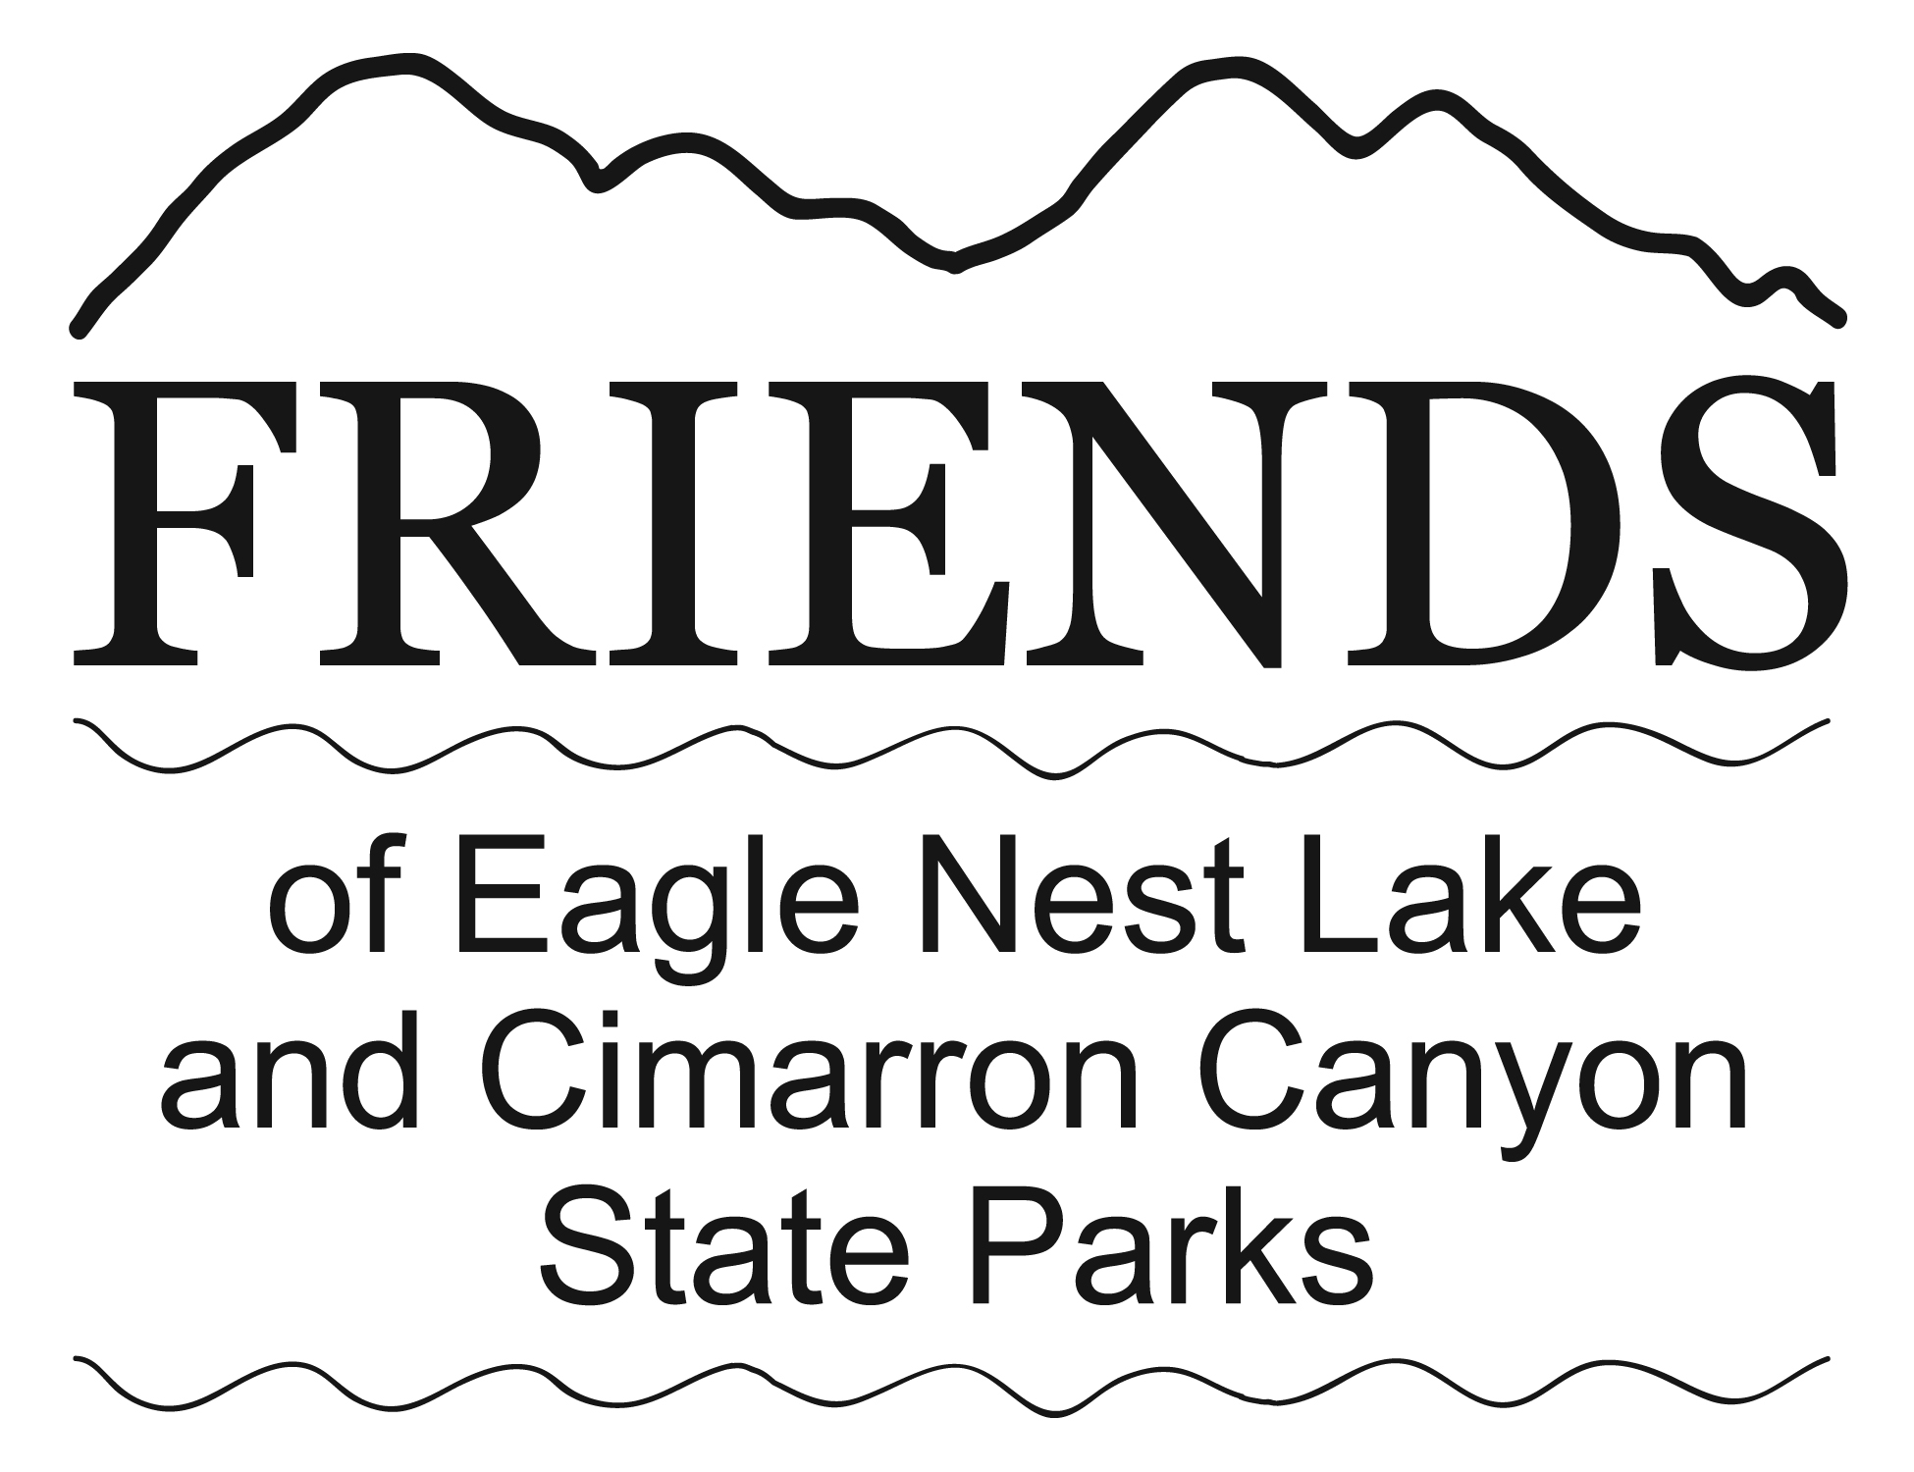
January 30, 2021
Eagle Nest Lake State Park

THERE ARE 4 CATEGORIES:
1. Trout/Salmon. 2. Perch. 3. Pike. 4. Creel. (Points for total fish
in this category are based on entry into one or more of the species categories.)

EVENT PARTICIPATION FEE: A $10 entry fee is required for each category. (To enter Creel category at least one of the species categories must also be entered.) NO REFUNDS!
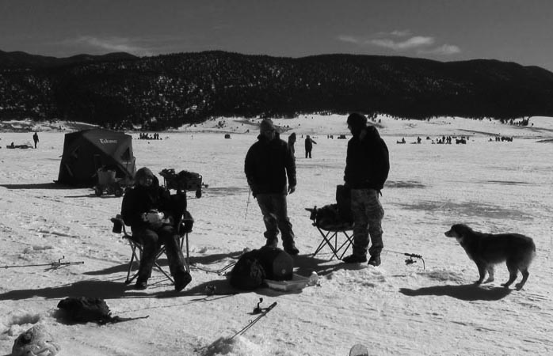
REGISTRATION: 6:00 am – 11:00 am
WHERE: Eagle Nest Lake State Park Visitor Center,
42 Marina Way, CR B-11 in Eagle Nest
END OF TOURNAMENT: Must be in line at measuring station by 2:00 pm
CONTACT INFO: Day: JB at 337-485-3722
Email: info@friendsofeaglenestlake.org or
secretary@friendsofeaglenestlake.org
Website: FriendsofEagleNestLake.org
The tournament will begin any time after you register. Your catch must be
turned into the registration location by 2:00 pm to be included in the contest.

PRIZES will be awarded for “Biggest Fish” in categories 1, 2 and 3. Each contestant will be limited to one fish in each of those categories. The total length of the fish will be measured. In case of a tie, the girth measurement will take priority. If a tie still exists, the prize will be shared by the winners. Creel winner is based on points for total fish caught in registered species categories.

CASH PRIZES: Cash prizes consist of 75% of the registration fees collected for each category.
1st Place: 40% of the cash prize
2nd Place: 30% of the cash prize
3rd Place: 20% of the cash prize
4th Place: 10% of the cash prize
RAFFLE ITEMS ALSO AVAILABLE.
New Mexico Game & Fish and State Park
Regulations will be enforced!
SPECIAL THANKS TO: New Mexico Department of Game and Fish
Eagle Nest Lake State Park and Cimarron Canyon State Park
SPONSORED BY: Friends of Eagle Nest Lake & Cimarron Canyon State Parks

