DIGITAL INSECT SPECIMEN PHOTOGRAPHY OF MICROSCOPIC AND MACROSCOPIC DIAGNOSTIC FEATURES
MIKE TAYLOR, ASSOCIATE, WORLD MUSEUM LIVERPOOL, 16 October 2017.

INTRODUCTION
Previous papers have described progress in developing a photographic work station, initially for use with film cameras. Ref 1, Taylor, 2001. Ref 2. Taylor, 2004. Ref 3, Taylor, 2012. Ref 4, Taylor, 2015.

The later papers described equipment primarily designed for photographing whole specimens using a range of lenses. These lenses being used on a 45⁰ angled stage with an adapted microscope stage positioned to hold the specimen and allow small incremental changes to the specimen to camera distance, ‘Working Distance’, whilst carrying out photographic sequences for subsequent image stacking using Helicon Focus 6 software.

In 1992 I commenced research into the Diptera, Asilidae fauna of the Eastern Mediterranean islands of Chios and Lesvos, with colleagues from the Liverpool Museum and elsewhere. I had then, and still also have now, difficulty in identifying some material due to the scattered sources of keys and descriptions. Study of the Robber Fly website of Fritz Geller-Grimm yielded some patchy help via its photographs of Type Specimens, however much of the material was of poor quality after many years since collection.

I resolved to create a ‘Virtual Reference Collection’ of all the species on our Chios and Lesvos checklist. This collection being in the form of ‘Diagnostic Papers’, one for each species. Each paper would include a diagnosis text based on the best keys available, cross-referenced to high quality photographic images of whole specimens down to detail as small as 2mm. This entailed the development of the 45⁰ angled stage to accommodate a full range of high quality macro lenses and an extended focussing ‘rail’ with fine adjustment and no looseness or ‘backlash’ in operation.

I have now developed the equipment to meet these objectives and have completed 37 Diagnostic Papers of the 63 Asilid taxons on the Chios and Lesvos checklist. See Appendix 1 for this checklist and availability of the Diagnostic Papers freely downloadable from my website miketaylornaturalist.co.uk

EQUIPMENT USED

The improved angled stages have been developed using the following Olympus equipment, with the current ranges of prices obtainable on e-bay.

Olympus E410 Camera £100 to £150.
Olympus E620 Camera £120 to £250.
Olympus Focussing Rail £40 to £100.
Olympus Auto Bellows £90 to £150.
Olympus Telescopic Auto Macro Tube 65-115 £130 to £160.
Olympus 20mm Macro Lens £300 to £400.
Olympus 38mm Macro Lens £350 to £400.
Olympus 50mm Macro Lens £70 to £175.
Olympus 35mm Digital Lens £100
Sets of Extension Tubes £25 to £60.
OM to OM4/3 Adaptor £10 to £20.
Remote Shutter Release £5.

There should be no difficulty in using different cameras to the Olympus used in my arrangements. In these cases a different adaptor e.g. Nikon to OM, Cannon to OM…..would be needed.

Using the Olympus equipment listed and an angled stage with the dimensions detailed later, the ranges of Fields of View ( widths for landscape and heights for portrait orientations ) with the listed lenses are as follows:-

35mm Digital 50mm-85mm
50mm Lens 9mm-60mm
38mm Lens 4mm-13mm
20mm Lens 2mm-5mm

As the 38mm and 20mm Olympus lenses are expensive, a start could be made using just the 50mm Olympus Macro lens, and further lenses purchased as needs and opportunities arise.

If a suitable camera is already available then an initial arrangement using just a 50mm lens could be completed at a cost of less than £300 if limited to the use of stacks of extension tubes. This cost excludes the overhead light source.

SIMPLIFIED ANGLED STAGE DESIGN

The angled stage is made of an operating surface with a prop, both supported on foot plates. The operating surface and the prop are made from 12mm thick 7 Ply wood. The 60mm high footplates raise the whole level of the equipment without excessive distances between them, this ensures maximum availability of rail extension potential within a small ‘footprint’ beneath the light source.

The operating surface is 450mm long overall and 155mm wide, with a 45⁰ angled base where it is attached to the forward footplate. The operating surface has a 60mm by 65mm cut-out at the top to allow access to the camera battery compartment during operation. The prop is 240mm long overall and 155mm wide, with a 45⁰ angled base where it is attached to the rear footplate. These footplates are best glued to the pre-assembled operating surface and prop on a true flat surface to avoid annoying wobbling during operation. See Fig A for completed configuration.

With my equipment there are two ¼ inch diameter clearance holes drilled on the centreline of the operating surface 90mm and 110mm from the base for attaching the Focussing Rail and a single ¼ inch diameter clearance hole 25mm from the top for attaching the camera. I use one inch long socket headed ¼ inch diameter one inch long UTC bolts, obtained from Amazon for £2 a pack.

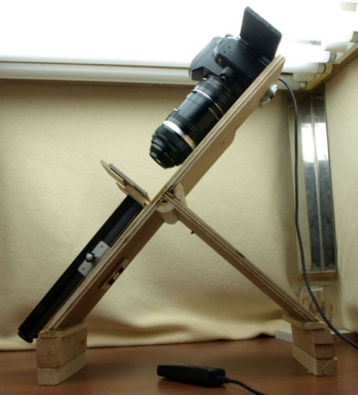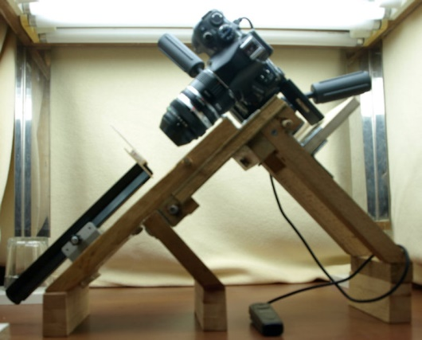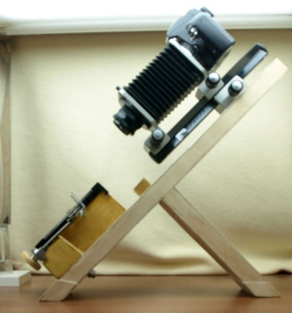
Fig A Fig B Fig C

As I frequently take large numbers of images in a single session requiring changes in orientation and format ( including between landscape and portrait ) for my convenience I have two other set ups based on the same principles. Fig B shows a camera in the portrait position, and Fig C a camera with a bellows unit.

OPERATING METHOD

I use my equipment with the light source described in a previous paper, Ref 3.

For ease and speed of use I have calibrated my equipment and formulated an exposure table showing which shutter speeds to select depending upon choice of lens and extensions. My camera is always set to 100 ASA sensitivity and as I always use Speed Priority (S) the aperture is always manually selected at f8.

EXPOSURE TABLE

EXTENSION LENGTH FIELD WORKING DISTANCE SPEED at f8
mm mm mm
Olympus 35mm Digital Macro Lens
0 50/85 70/160 Auto Exp

Olympus 50mm Macro Lens
7 115 360 1/20 sec
13 70 220 1/20 sec
21 45 145 1/20 sec
31 30 100 1/15 sec 33 27.5 85 1/13 sec 38 24 83 1/10 sec 47 19.5 71 1/8 sec
52 18 66 1/6 sec 59 14.5 57 1/6 sec 78 11.5 45 1/4 sec
92 9 35 1/4 sec

Olympus 38mm Macro Lens
0 13 60 1/15 sec
7 11.5 55 1/10 sec
12 10.5 50 1/5 sec
19 9.5 50 1/4 sec
33 8 45 1/3 sec
38 7 44 1/2.5 sec
78 5 40 1/1.3 sec
109 4 39 1.3 secs

Olympus 20mm Macro Lens
0 5 25 1 sec
52 3 19 1.3 secs
95 2.2 19 6 secs
109 2 20 8 secs
OPERATIONAL SEQUENCE

Selection and preparation of specimens for photography is the same as described in previous papers, see References.

The end of the Focussing Rail has a knurled screw which is used for fixing the retaining plate to which the photographic grey-carded mounted specimens is slotted.

The specimen to be photographed is measured and the Field dimension selected from the list in the Exposure Table.

The indicated Lens and Extension Length is then set up and selected on the camera. The carded specimen is slotted onto the retaining plate and the Working Distance ‘WD’ read from the Exposure Table is adjusted as appropriate by moving the specimen towards or away from the camera using the Focussing Rail knob and a ruler.

Speed priority (S) is selected on the camera, the speed selected is as indicated in the Exposure Table and the sensitivity setting 100 ASA.

Using the camera display adjust the specimen position in the frame. Using the Focussing Rail knob, move the specimen so that it is just too far away from the camera to be in focus. Using the Remote Shutter Release in conjunction with sequential small rotations of the Focussing Rail knob and by observing the progression of the specimen into focus and beyond to out of focus, take the desired sequence of images.

Small shallow features will need very few exposures in the sequence,say 6 or 8. Large specimens with an oblique wing tip to wing tip aspect perhaps several dozen exposures.

Image stacking is then performed on the computer using Helicon or Zerene.

SAMPLE IMAGES Fig D
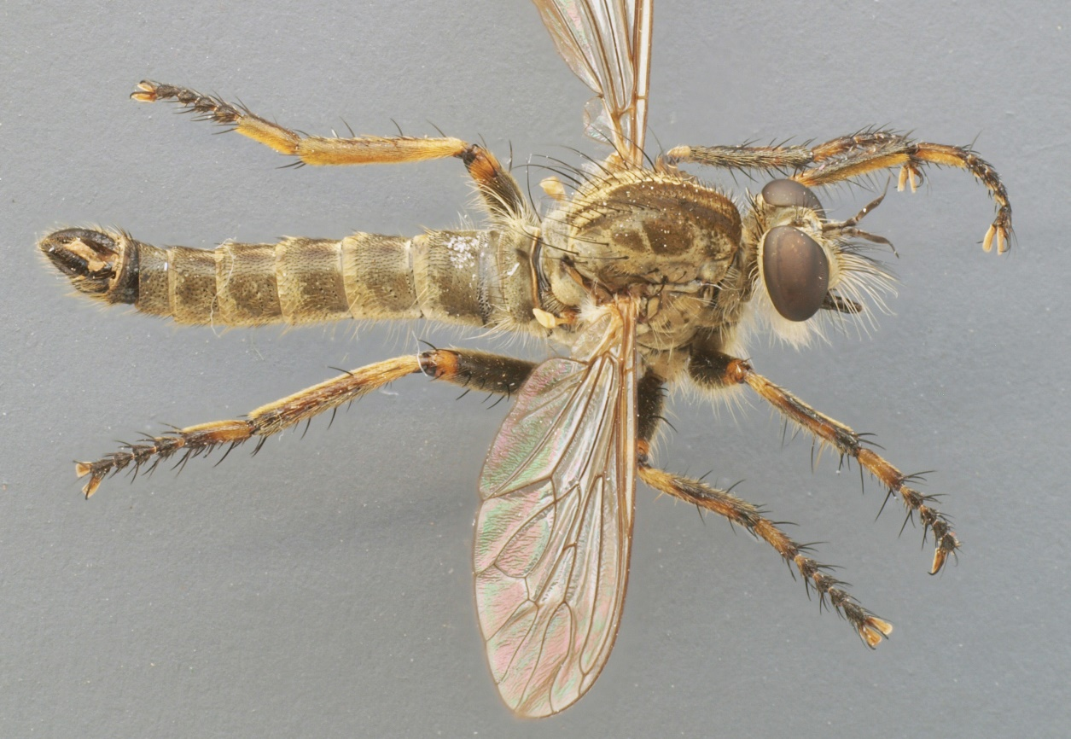
E.cowinii. Sp 18mm, Lg 14mm. West Kimmeragh,IOM.9.VIII.2002.S.M..Crellin.
Fig E Fig F
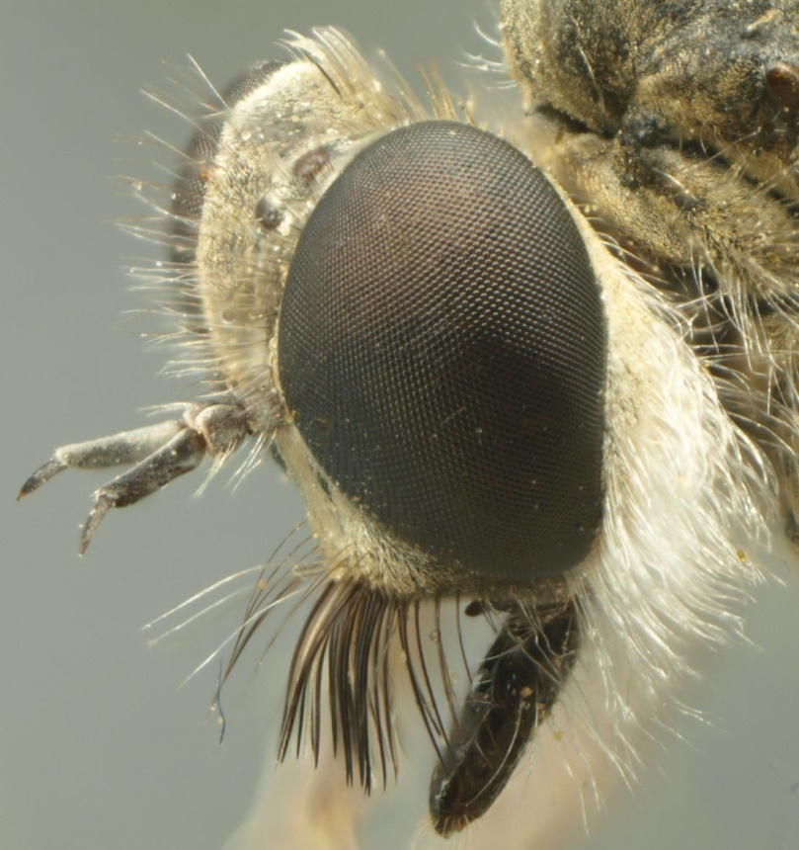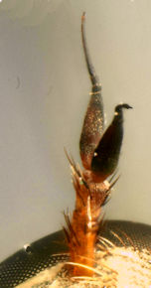
Stichopogon albofasciatus. Sp 16mm, Lg 10mm. Neomochtherus mundus
Kalloni, Lesvos, Greece, 25.IV.2001. Sp 23mm, Lg 16.5mm,
Salagonas, Chios, Gr. 9.VII.97.

Fig G
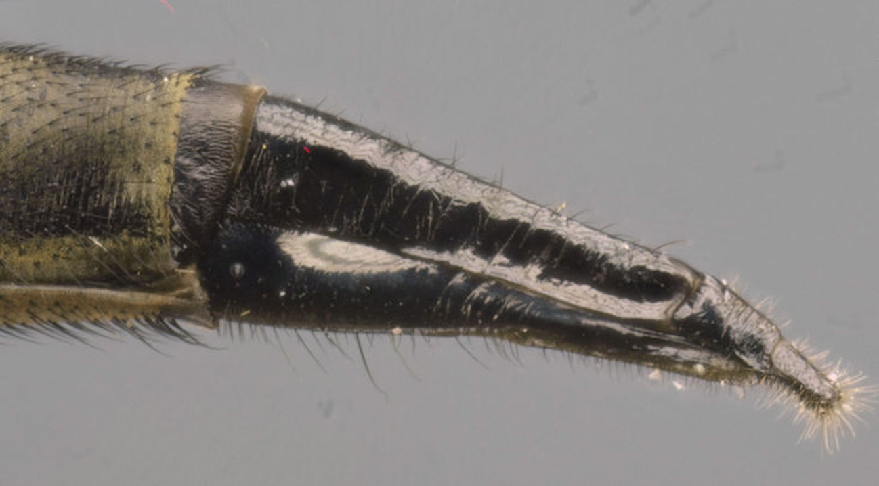
Engelopogon naxia, Sp 32mm, Lg 18mm, Kalimassia, Chios, Greece, 8.V.2016.
Fig H
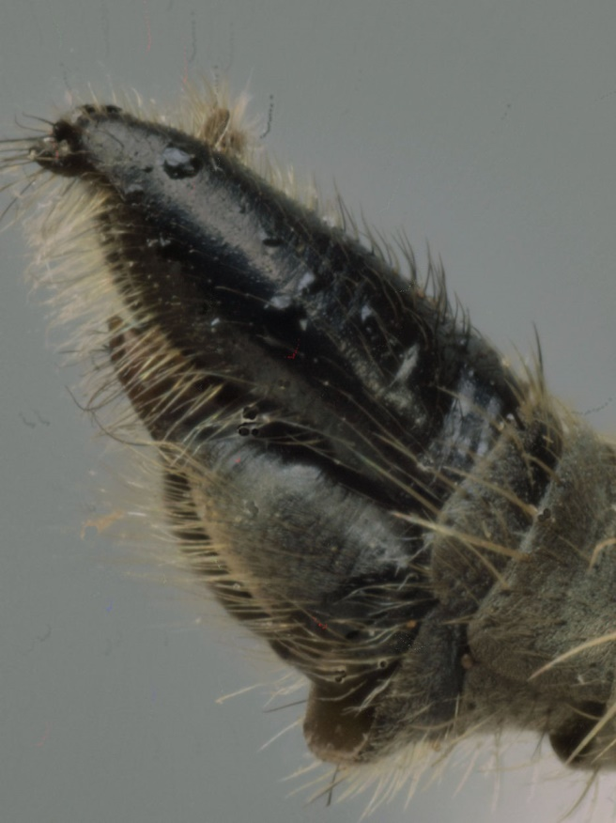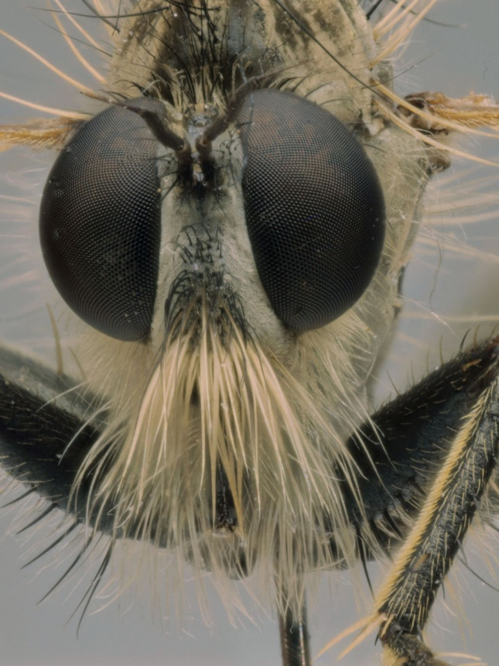
Machimus Species B. Sp 18.5mm Lg 11.5mm, Thimiana, Chios, Greece,30.IV.02.

Camera Settings:-

Fig D. 50mm lens, 52mm XT, 1/6 at f8. Fig E. 38mm lens, 78mm XT, 1/1.3 at f8
Fig F. 20mm lens, 52mm XT, 1.3’ at f8 Fig G. 20mm lens, 0mmXT, 1.0’ at f8.
Fig H. 20mm lens, 45mmXT, 1.6’ at f8. Fig I. 20mm lens, 0mmXT, 1.0’ at f8.

APPENDIX 1

CHECKLIST, ROBBER FLIES (Dipt, Asilidae), OF CHIOS & LESVOS, GREECE.
Mike Taylor, 16th October 2017.
STATUS OF
CHIOS LESVOS FIGURED
DIAGNOSIS
LEPTOGASTRINAE

1. Leptogaster palparis Loew. 1847. X Available
(Leptogaster Species A) Awaiting more specimens and determination.

ASILINAE

2. Erax barbatus Scopoli. 1763 X Available
3. Erax tenuicornis Loew. 1848 X Need specimens
4. Promachus canus
leontochlaenus Loew. 1871 X Available
5. Promachus leoninus Loew. 1848 X Available
6. Polyphonius laevigatus Loew. 1848 X Available
7. Pamponerus choremii
Smart, Taylor & Hull. 2007 X X Available
8. Anripnrisson trifarius Loew. 1849 X X In Prep
9. Engelopogon goedli Loew. 1864 X Available
10. Engelopogon naxia Macquart. 1838 X Available
11. Neomochtherus mundus Loew. 1850 X Available
12. Cerdistus denticulatus Loew. 1849 X X Available
13. Dysmachus fuscipennis Meigen 1820 X Available 14. Dysmachus stylifer Loew. 1854 X Available 15. Eutolmus calopus Loew. 1848 X In Prep
16. Eutolmus fascialis Loew. 1848 X Available
17. Eutolmus haematoscelis Gerst. 1861 X X Available
( Eutolmus mordax Loew. 1848 ) Provisional to be confirmed.
( Eutolmus paricida Loew. 1848 ) Provisional to be confirmed.
18. Machimus annulipes Brullé. 1832 X X Need specimens
19. Machimus caliginosus Meigen. 1820 X In Prep
20. Machimus gonatistes Zeller. 1840 X In Prep ( Machimus mystacinus Becker. 1923) Provisional to be confirmed.
21. Machimus setibarbus Loew. 1848 X Available
(Machimus Species A) Awaiting more specimens and determination.
(Machimus Species B) Awaiting more specimens and determination.
22. Neoepitriptus setosolus Loew. 1840 X Available
( Tolmerus poecilogaster Loew. 1849) Provisional to be confirmed
23. Tolmerus pyragra Zeller. 1840 X X Available

LAPHRIINAE

24. Laphria aurea Fabricius, 1794 X Available
25. Laphria flava Linnaeus. 1776 X Need specimens
26. Choerades loewi Lehr. 1992 X Available
27. Andrenosoma cornuta Oldroyd. 1972. X Available
28. Pogonosoma marrocanum Fabr. 1794 X Need specimens

DASYPOGONINAE

29. Anarolius jubatus Loew. 1844 X Available
30. Stenopogon junceus Wiedemann.1820 X Available
31, Stenopogon sabaudus
harpax Loew. 1868 X Available
32. Ancylorrhynchus glaucius Rossi. 1790 X Need specimens
33. Scylaticus miniatus Becker. 1915 X Available
34. Holopogon nigripennis Meigen. 1820 X In Prep
35. Habropogon longiventris Loew. 1847 X Available
36. Stichopogon albofasciatus Meigen. 1820 X Available
37. Stichopogon scaliger Loew. 1847 X Available
(Stichopogon Species A) Awaiting more specimens and determination
38. Pycnopogon fasciculatus Loew. 1847 X Available
39. Pycnopogon leucostomus Engel. 1930 X Available
40. Pycnopogon pallidipennis Brullé. 1836 X Available
41. Crobilocerus megilliformis Loew. 1847 X Need specimens
42. Heteropogon ornatipes Loew. 1851 X In Prep
43. Heteropogon scoparius Loew. 1847 X Available

ACANTHOCNEMINAE

44. Saropogon dasynotus Loew. 1870 X Available
45. Saropogon eucerus Loew. 1847 X Available
46. Saropogon leucocephalus Meigen. 1820 X Available
47. Saropogon platynotus Loew. 1847 X Available
( Saropogon Species E} Awaiting determination
( Saropogon Species F) Awaiting determination
(Saropogon Species G) Awaiting determination
(Saropogon Species H) Awaiting determination
(Saropogon Species I) Awaiting determination
48. Dasypogon octonotatus Loew. 1869 X Available
49. Molobratia teutonus Linnaeus. 1767 X Available

PRYTANIINAE

50. Scytomedes haemorroidalis Fabr. 1794. X Available

NOTES ON THE CHECKLIST

1. 50 species are identified from the two islands.
2. 4 more Asilinae have been provisionally identified from poor or limited material and require confirmation.
3. 9 further suspected taxa have been grouped and await
determination.

AVAILABILITY OF DIAGNOSIS PAPERS

All ‘Available’ diagnosis papers indicated above are freely downloadable
from my website www.miketaylornaturalist.co.uk
They are found in the Section ‘Insect Specimen Identification’.

USE OF DIAGNOSIS PAPERS

Any of the ‘ xlsx’ Diagnosis papers may be used as ‘Templates’ by workers wishing to create their own. Downloaded papers can be edited with diagnosis texts substituted for different taxons.

My Asilid diagnosis texts are mainly based on my translation of Engel 1930.

The Plates of Images are limited to 140mm widest ‘jpg’ images.

REEFERENCES
Ref 1 Taylor M.J. 2001 BJENH, 14: 193-206
Ref 2 Taylor M.J. 2004 BJENH, 17: 25-33
Ref 3 Taylor M.J. 2012 ‘ Insect Digital Work Station, 11 Feb 2012.
www.miketaylornaturalist.co.uk
Ref 4 Taylor M.J. 2015 ‘ Digital Insect Specimen Photography with ‘Helicon Focus 6’ computer stacking software and Rotating Specimen Stages. 30 June 2015
www.miketaylornaturalist.co.uk

