Thank you for your interest in After the Classroom: Workshop – things that I wished I’d known when I finished in the classroom, I am delighted that this course has been given Quality Checked status by the National Counselling Society
I have included here some basic information that I hope will help you to understand what this course is all about but please do email trainingbyliberty@outlook.com if you have a question that is not covered here.
This course is aimed at trainee counsellors who have just finished or are about to finish a Level 4 Counselling qualification that would like to know how to navigate the terrain ahead. This would also be suitable for any counsellor who is considering working for themselves or wants to ensure they are compliant with accredited body requirements.
This day course will help to pick apart what is needed to work as a counsellor beyond the classroom and will discuss all the things I wish I had known when I finished training such as how to keep records, GDPR requirements, client logs, accredited body requirements. Supervision to client ratios; what might be useful to have in a tool kit as well as basic accounting for self employed.
To register your interest or for any queries please email me on trainingbyliberty@outlook.com or complete and return the registration form that can be found at the bottom of the relevant page on www.trainingbyliberty.com
The cost of the course is £60. You can secure your place by completing the course registration form at www.trainingbyliberty.com and returning along with your £10 deposit to trainingbyliberty@outlook.com or you can contact Liberty Talking Therapy and request a registration form.
As a delegate from this course you are eligible to join the National Counselling Society with a discounted price on production of the certificate of attendance from this course
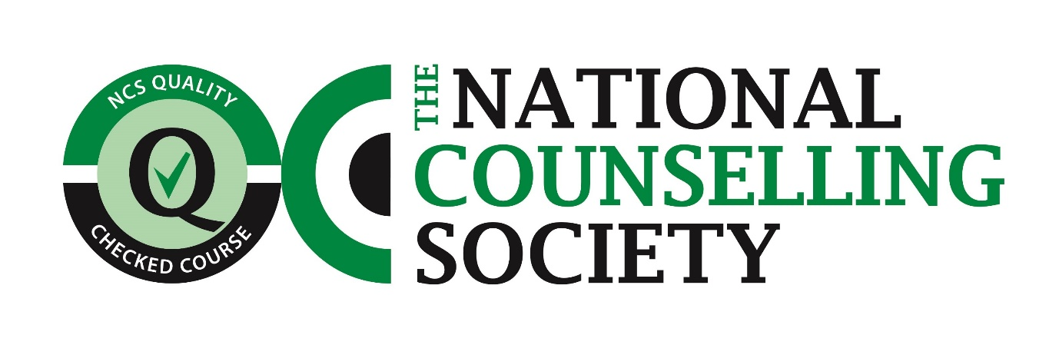
Please note that a minimum of 4 persons are required for a course to run

