Zahra Hamidaddin
GCH 360 - Health and Environment
The Effect of Impoverished Sanitation Systems on the Zika Outbreak
May 8th, 2017

Introduction:
At the start of 2015, we experienced a new outbreak of Zika fever, which is caused by the Zika virus, spreading across Latin America. This virus, which is a mosquito-borne illness spread by the Aedes aegypti mosquito and the Aedes albopictus mosquito, originated from the Ugandan Zika forest where it was first discovered in 1947 (World Health Organization [WHO], 2016). The 2015-16 Zika virus epidemic began in Brazil, but it quickly spread to other nations in both South and North America. The mosquito species that were known to cause the spread of Zika virus are both commonly found in these regions, as the Aedes aegypti mosquito is common in the tropical and subtropical climates of the Americas and the Aedes albopictus mosquito can be found in areas as northern as the Great Lakes region (WHO, 2016). As mosquitoes are known to proliferate in areas with standing water, functioning sanitation systems and water drainage are vital to the prevention of the spread of mosquitoes that could be carrying this virus. The link between weak sanitation systems and the abundance of standing water in Latin America have lead to the outbreak and acceleration of the spread of Zika virus in the region.
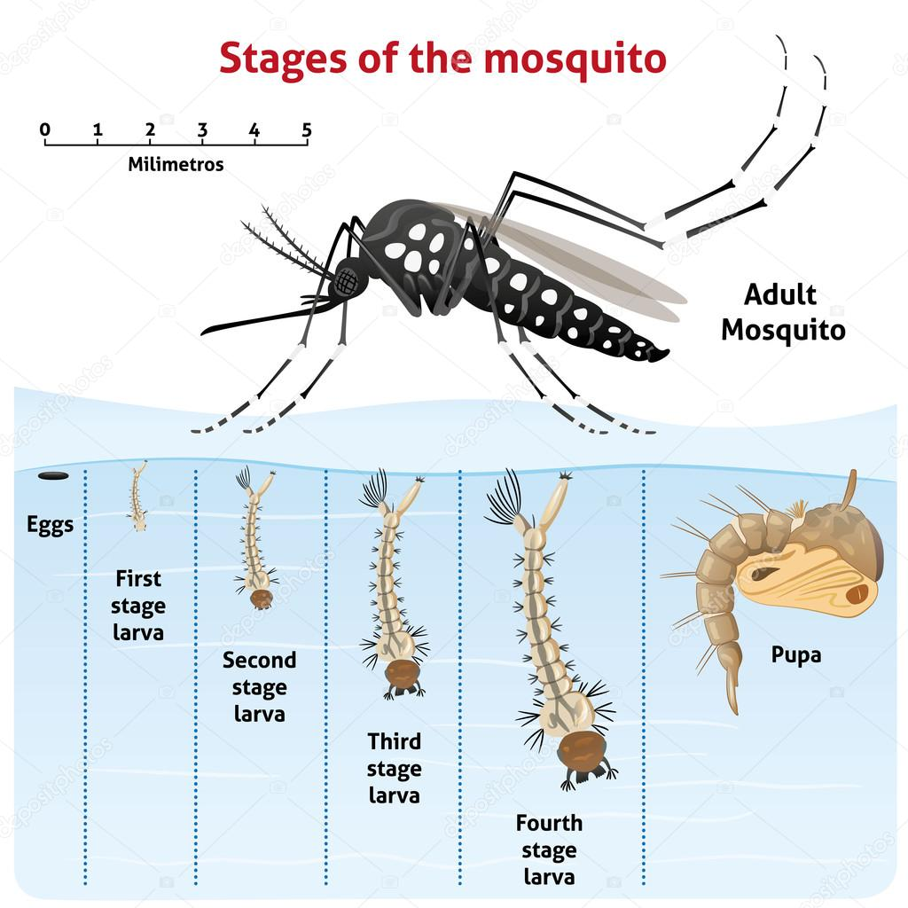
Figure 1. Image showing life cycle of a mosquito, majority of the stages occurring in water.
Background:
Though this virus originated in Uganda and was first isolated in a Macaca monkey from the Zika forest, researchers believe that the disease was brought to Brazil by an infected individual who came from French Polynesia and was exposed to the virus there (CDC, 2015). The strains of the virus commonly found in Latin American cases belonged to the Asian lineage of the virus rather than the African strain, which is how epidemiologists narrowed down the source of the outbreak that emerged in Brazil to conclude that it was introduced from French Polynesia. The specific event that brought the virus to Brazil was unclear at first, but researchers were later able to deduce that the virus came to Brazil during the 2013 Confederation Cup, which included competitors from French Polynesia (CDC, 2015).
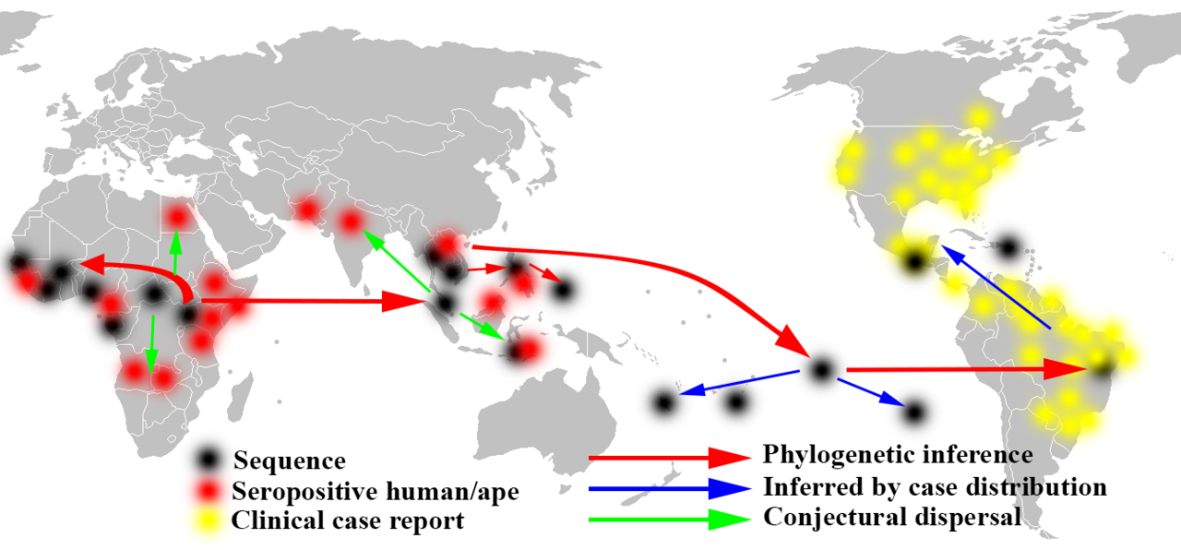
Figure 2. Direction of Spread of the Zika virus
Though the main methods of transmission for Zika virus are mosquito vectors (especially Aedes aegypti), this virus can also be spread via sexual contact, contaminated blood transfusions, and from mother to fetus during pregnancy or birth. Zika virus has been documented to be transmitted sexually from a man to his sex partners in nine different countries, including Argentina, Chile, Peru, and the United States (WHO, 2016). Vertical transmission, or the transmission of a disease from a mother to her fetus, is also widely documented and causes the greatest concern, as this mode has been proven to cause congenital brain anomalies in the infants (CDC, 2016). Of these anomalies, microcephaly is the most widely reported, and it is characterized by a condition that prevents the fetus’s brain from developing properly, resulting in an abnormally small head (Parker & Parker, 2002). This causes intellectual disabilities, seizures, dwarfism, and other serious health implications to the infant. The Zika virus is also linked to the development of Guillain-Barre syndrome in adults, a serious disorder that causes the body’s immune system to attack the peripheral nervous system, which can lead to muscle weakness and even paralysis (WHO, 2016). That being said, the usual symptoms of Zika virus are not as severe; most infected individuals experience joint pain, skin rashes, headaches, and a fever that lasts 2-7 days (WHO, 2016).
Health Implications:
Sanitation systems have been suffering for a long time in Latin America, especially in Brazil, the epicenter of the 2015-16 Zika epidemic. The general assumption in this region was that mosquitoes only proliferate in clean stagnant water, believing that dirty water did not serve as breeding grounds for these mosquitoes (Osava, 2016). Now it is more greatly understood that the Aedes aegypti breeds in all kinds of still water, meaning that effective sanitation methods are even more significant to the elimination of the spread of Zika than what was first assumed (Osava, 2016). The lack of sufficient water drainage, garbage disposal, urban storm systems to prevent flooding and other basic sanitation infrastructures, the Zika crisis continues to expand throughout this region, especially in regions of overcrowding and population pressure. Insecure water supplies have also led to the exacerbation of the epidemic, as many households who are not provided with piped water rely on household water tanks to store their water (these tanks are known as caixa d’agua) (Osava, 2016). The water tanks that can be commonly found in many Brazilian households are often not held to high standards of upkeep and turn into the perfect breeding place for mosquitoes.
As mentioned before, the Zika virus may not have severe effects on most individuals, but it can cause serious, life-threatening implications to the fetuses of pregnant women who become infected. The severe congenital brain anomalies that are associated with this virus, including microcephaly, not only increase morbidity rates of the region, but also affect the economic status of the region (which is already struggling to begin with). As mothers need to stay at home to take care of their child, work productivity of the region decreases greatly. This, along with the expenses that families will now need to spend on health care, has a large impact on economic situations. This feeds into the cycle of the effects of poverty on health, as the decreased socioeconomic status of a family or community makes them more susceptible to other communicable diseases that are known as ‘diseases of the poor’, which in turn continues to detrimentally affect the productivity of the community.
As this virus can also be sexually transmitted, Zika also has great health implications on the development of a stigma surrounding this disease. Just as we have seen with HIV/AIDS and other sexually transmitted diseases, The stigma and shame related to the sexual transmission of Zika virus creates great barriers to testing and prevention of the spread of virus. Those who feel ashamed of finding out they have contracted Zika via sexual transmission (whether this negative association is due to personal feelings or to societal expectations) are less likely to get tested for this virus and are more likely to spread the disease to other via other sexual contacts (Cunningham, Kerrigan, Jennings & Ellen, 2009). If Zika continues to be spread and sexual transmission becomes more common then this stigma will only increase, making it harder for us to control and contain Zika.
As vertical transmission is also a possible mode of transmission of Zika, and because this type of transmission has the greatest health impact on the population (because of the development of microcephaly), there are great reproductive health implications associated with the spread of Zika as well. Limited access to contraceptives and anti-abortion laws are prominent throughout the Latin American region where the Roman Catholic Church is predominant (Partlow, 2016). As the Zika epidemic worsened throughout the years of 2015 and 2016, many Latin American governments recommended and promoted delaying pregnancies. This has caused an outburst of confusion and outcries, as women in this region do not have access to any other recourse once they become pregnant due to the strict reproductive laws and policies in place. In 2012, a study concluded that 56% of pregnancies in Latin America and the Caribbean islands are unplanned, which is a great increase to the comparable worldwide average of a 40% rate of unplanned pregnancies (Sedgh, Singh & Hussein, 2014). This, of course, only stresses the issues of strict reproductive policies in the region. The controversy continued to grow in 2016 as the United Nations High Commissioner for Human Rights claimed that the region’s governments should consider repealing their policies while emphasizing that “upholding human rights is essential to an effective public health response”(Pouilly, 2016). A few days later the Vatican condemned the UNHCR’s statements and claimed that microcephaly should not be seen as an excuse to warrant a death sentence (Zenit, 2016). The issue surrounding strict reproductive health laws is still greatly present in this region, and more action needs to be done to ensure that these policies don’t hinder the progress of disease control and containment during the next possible outbreak or epidemic.
First supporting case:
Since the Zika virus epidemic in Latin America is still relatively new, and because we see great similarities between Zika virus and dengue fever, we can observes past examples of how other mosquito-borne illnesses were impacted by weakened sanitation symptoms to make assumptions of the link between impoverished sanitation and the spread of Zika virus. Dengue is another mosquito-borne illness that is also spread by the Aedes aegypti mosquito and has also been endemic to regions in Latin America. The similarities don’t stop there; contraction of dengue results in similar symptoms as the Zika virus, and is most characteristically known by the presence of dengue fever in the infected individual (Tapia-Conyer, Betancourt-Cravioto, & Méndez-Galván, 2012). The main drivers of disease for dengue are known to be rapid urbanization and lack of mosquito control, that is often characterized by inadequate sanitation services. Duane Gubler, the director of Asia Pacific Institute of Tropical Medicine and Infectious Diseases at the University of Hawaii, has stated that dengue is known to spread more quickly in cities dealing with urban sprawl that have weak public health infrastructures and services, such as potable water, sanitation, and waste-management (Ronaco, 2009). Without improving water and sanitation services to eliminate stagnant water that acts as mosquito breeding grounds, the control of dengue would not have been possible and a dengue epidemic could still be occurring to this day. That being said, as sanitation systems continue to struggle in Latin America, we can still observe high levels of dengue incidence in these populations, further reiterating the importance of strengthening these infrastructures in order to not just decrease spread of mosquito-borne illness, but to also prevent the prevalence of other communicable diseases as well.
Second supporting case:
Of all cities in Brazil, the city of Recife became known as the epicenter of an explosion of microcephaly during the Zika outbreak that is hitting all of Latin America and parts of North America as well. Not only is Recife known as the epicenter of microcephaly incidences, but it also was labeled as the epicenter of the Zika virus outbreak itself. Recife is the fourth largest urban community in Brazil, with a population of 3,995,949 people (The Washington Post, 2016). This city, with it’s large amounts of water sources, such as the various rivers, ports, beaches and shorelines led to its nickname, “the Brazilian Venice” (The Washington Post, 2016). As mentioned before, the presence of stagnant water that is exacerbated by urban sprawl and certain water sources (such as bays and swamps, which are present throughout the city of Recife) is often characterized by weakened water and sanitation systems. The rampant urbanization of the city of Recife has put a great strain on its public health infrastructure, allowing for the proliferation of the Aedes aegypti mosquitoes’ breeding grounds in its plethora of water sources, which in turn has resulted to the atrocious outbreak of the Zika virus in this city and dubbed it as the epicenter of the epidemic.
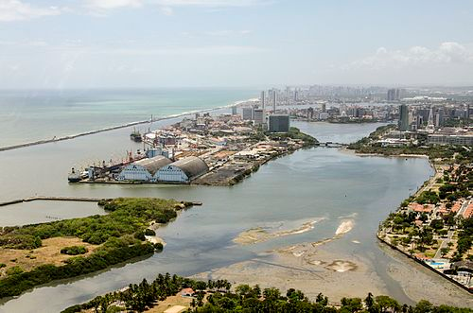
Figure 3. Abundant water sources and vegetation found in Recife, Brazil.
Analysis:
By examining similar cases of the past and by observing the conditions of cities in which we find the Zika virus to be rampant, we can clearly conclude that there is an evident connection between the sanitation of a region and the incidence of mosquito-borne illnesses, such as Zika. Though we are seeing developments in the creation of a Zika vaccine, nothing has been made available to the public yet, nor do we have any cures or treatments for this virus. As it is well known in the public health and medical field, prevention is always easier than treatment. Since preventative vaccines are still not accessible, other prevention methods need to be improved and incorporated into areas where we see a high prevalence of Zika virus and other mosquito-borne illnesses. By refining and enhancing sanitation infrastructure in these regions, we are able to eliminate the breeding grounds of the most common vector of Zika virus, almost ensuring a decrease in the incidence of prevalence of disease. Not only will amended sanitation systems demolish the Zika presence, but it will also improve the overall public health conditions, enhancing clean water availability, diminishing the prevalence of other infectious diseases, and increasing work productivity and life expectancy.
Solutions:
So if the link between sanitation and spread of Zika is evident, what can be done to actually improve the sanitation systems? Changes need to be done to ensure that water drainage is available throughout the community, so that stagnant water is no longer available for the Aedes aegypti mosquitoes to proliferate. Public water systems should be more widely available so that families living in rural areas don’t have to depend on their household caixa d’agua, which are often improperly cleaned and attract mosquitoes and other insects that can cause diseases. Garbage collection and disposal systems need to also be more adequately implemented for better community hygiene and sanitation, which will help decrease the prevalence of all infectious diseases.
Education and health promotion are a vital component of the solutions process, as these changes in sanitation improvements cannot be accomplished without proper awareness that will help push for policy changes that enhance sanitation systems. Education programs and workshops need to be implemented throughout the communities, and should incorporate a variety of different audiences, including young adults, adults, and older generations as well. Awareness through media can also be successful, encouraging people to lobby for better policies via radio, newspapers, televisions and other outlets will help engage a larger portion of the community. Working and collaborating with NGOs that advocate for greater access to water and sanitation would be a great driving factor to create change as well, as they often offer financial support for the improvement of water and sanitation facilities. Examples of NGOs that would benefit from a partnership to establish these solutions are: WaterAid, WASH (water, sanitation, and hygiene) advocates, UNICEF and the Bill and Melinda Gates Foundation.
Conclusion:
The Zika epidemic in Latin America has caused an outcry of panic, which in turn has finally created a sense of urgency in preventing the spread of disease via the improvement and enhancement of the impoverished sanitation systems. Perhaps it is the more threatening symptoms that Zika can lead to (especially since serious conditions can develop in infants, which often creates a more urgent sense of responsibility) that has prompted this change. Greater awareness has caused better promotion of simple sanitation fixes, such as proper drainage and elimination of still water sites. That being said, more needs to be done to create more permanent solutions for sanitation systems, such as improved water access and adequate, supplementary pipelines. The greater global community needs to become more involved in developing these solutions in order to prevent future outbreaks of other diseases from reaching the same levels of morbidity and mortality.

References

CDC Concludes Zika Causes Microcephaly and Other Birth Defects. (2016, April 13). Retrieved May 08, 2017, from https://www.cdc.gov/media/releases/2016/s0413-zika-microcephaly.html
Osava, M. (2016, February 26). Zika Epidemic Offers Sanitation a Chance in Brazil. Retrieved May 08, 2017, from http://www.globalissues.org/news/2016/02/26/21874
Parker, J. N., & Parker, P. M. (2002). The official parent's sourcebook on microcephaly. San Diego CA: Icon Health Publications.
Partlow, J. (2016, January 22). As Zika virus spreads, El Salvador asks women not to get pregnant until 2018. Retrieved May 08, 2017, from https://www.washingtonpost.com/world/the_americas/as-zika-virus-spreads-el-salvador-asks-women-not-to-get-pregnant-until-2018/2016/01/22/1dc2dadc-c11f-11e5-98c8-7fab78677d51_story.html
Pouilly, C. (2016, February 05). Upholding women’s human rights essential to Zika response. Retrieved May 08, 2017, from http://www.ohchr.org/EN/NewsEvents/Pages/DisplayNews.aspx?NewsID=17014&LangID=EN
Ronaco, R. (2009, September 01). Urban sprawl, bad sanitation spread dengue fever. Retrieved May 08, 2017, from http://www.reuters.com/article/us-philippines-dengue-idUSTRE58011M20090901
Sedgh, G., Singh, S., & Hussein, R. (2014, September). 301Intended and Unintended Pregnancies Worldwide in 2012 and Recent Trends. Retrieved May 08, 2017, from http://onlinelibrary.wiley.com/doi/10.1111/j.1728-4465.2014.00393.x/epdf
Staff, Z. (2016, February 17). Holy See on Zika Virus: International Community Should Exercise Due Diligence, But Not Panic. Retrieved May 08, 2017, from https://zenit.org/articles/holy-see-on-zika-virus-international-community-should-exercise-due-diligence-but-not-panic/
The Washington Post. (2016, July 11). The heart of the Zika outbreak. Retrieved May 08, 2017, from https://www.washingtonpost.com/graphics/world/zika/
Zika virus. (2016, September 06). Retrieved May 08, 2017, from http://www.who.int/mediacentre/factsheets/zika/en/
Zika Virus Transmission from French Polynesia to Brazil. (2015, October 06). Retrieved May 08, 2017, from https://wwwnc.cdc.gov/eid/article/21/10/15-1125_article

