STATE OF CALJFORNI A-NI\TURAL RESOURCES AGENCY EDMUND G. BROWN JR., GOVERNOR
CALIFORNIA COASTAL COMMISSION
CENTRAL COAST DISTRICT OFFICE 725 FRONT STREET, SUITE 300 SANTA CRUZ, CA 95060
PHONE: (83 I) 427-4863
FAX: (83 I) 427-4877
WEB: WWW.COASTAL.CA.GOV

June 23, 2016

Carl Holm, Director
Monterey County Resource Management Agency 168 West Alisal Street, 2nd Floor
Salinas, CA 93901

Subject: Vacation Rentals

Dear Mr. Holm:

We understand that the County is grappling with the use of private residences serving at times as visitor-serving overnight accommodations. This practice, commonly referred to as vacation rentals (or short-term rentals) has recently elicited controversy, not just in Monterey County but state and nationwide, over the proper use of private residences within residential areas. Some argue that private residences should remain solely for the exclusive use of those who reside there because this helps to foster neighborhood stability and residential community character. Others argue the opposite approach, in that vacation rentals should be encouraged because using residential properties for visitor accommodations is an efficient use of land and allows the property owner an avenue to use his or her residence as a source of supplemental income. These are not easy debates, and different areas and different contexts will lead to different conclusions in this respect.

We offer the following observations on the vacation rental issue. The Coastal Act describes a hierarchy of encouraged land uses, with agriculture and coastal-dependent industry the highest priority uses to be accommodated within the state's coastal zone, followed by "private lands suitable for visitor-serving commercial recreational facilities designed to enhance public
opportunities for coastal recreation." 1 The lowest priority uses are private residential, general
industrial, and general commercial. Thus, the Coastal Act places a higher priority on the provision of visitor-serving uses, particularly overnight accommodations, over private residential uses because such visitor-serving uses offer a vehicle for the general public to access and
recreate within the state's coastal zone. At the same time, however, the Coastal Act also places a high priority on the protection of sensitive coastal resources, including public views, agricultural lands, environmentally sensitive habitat areas, and wetlands and streams. The Act also protects ce1iain special communities that are popular visitor destination points for recreational uses, including certain coastal residential communities near popular shoreline recreational areas and beaches. Thus, the allowance for visitor overnight accommodations must be balanced with the Act's other requirements, thereby requiring a nuanced approach to their regulation.

- Coastal Act Section 30222.

Carl Holm, Monterey County Vacation Rentals
June 23, 2016
Page 2

Thus, from our perspective, we continue to support allowing short-term vacation rentals within private residences as an important source of visitor accommodations in the coastal zone. These rentals can also offer lower-cost overnight opportunities, especially for larger families and groups. However, we also recognize and understand community concerns associated with the potential impacts of such vacation rentals, including with respect to community character and noise and traffic impacts. We also recognize concerns regarding vacation rentals within certain sensitive coastal resource areas, such as rural agricultural lands, which could result in uses incompatible with their location and surroundings.
At this juncture it is our opinion that vacation rentals are allowable in Monterey County's coastal zone under the LCP, and we highly recommend that instead of attempting to suggest they are prohibited or pursuing such prohibitions, that Monterey County instead work with us to develop regulations that serve to ensure Coastal Act-required protections are in place to address any potential concerns. I note that efforts along these lines were undertaken by the County back in 1997, but those efforts were apparently discontinued. We would suggest that now is an appropriate juncture to restart that effort. Commission staff has experience in working with local governments to draft and implement such regulations, including recent LCP requirements associated with vacation rentals for both Santa Cruz and San Luis Obispo Counties.2 In place of
prohibitions, which the Commission has historically not supported,3 these coastal communities
instead were able to find a balanced middle ground that helps to ensure that vacation rentals are regulated, including for transient occupancy tax and rules and regulations purposes, and limited as necessary to avoid oversaturation of such rentals in any one neighborhood or locale. These programs have proven successful in Santa Cruz and San Luis Obispo Counties, and we would suggest that their approach can serve as a model for Monterey County moving forward. We look forward to working with you on potential LCP language that meets Monterey County's specific needs and coastal contexts consistent with the Coastal Act.
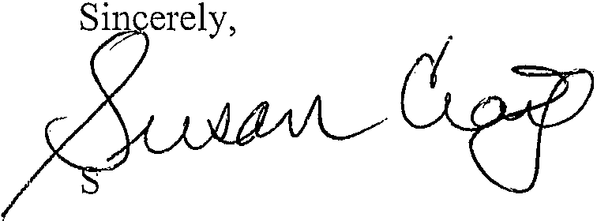Thank you for the oppo1iunity to comment on this important issue. Please feel free to contact me with any questions or concerns.

usan Craig
Central Coast District Manager California Coastal Commission

- See, for example, Santa Cruz County LCP amendments SC0-1-1 1 Part 3 (approved by the Commission on July 13, 201 1) and LCP-3-SC0-15-0008-1 Part A (approved by the Commission on May 14, 2015), and San Luis Obispo County LCP amendment SL0-1-12 (approved by the Commission on November 13, 2013).
- See, for example, City of Pismo Beach LCP amendment PSB-1-10 Part 2 (denied by the Commission on December 8, 2011 ).

