The Effects of Acid Rain on the Environment

Fenio Waum

George Mason University

Introduction
“Acid rain is a short-hand term that covers a set of highly complex and controversial environmental problems. It is a subject in which emotive and political judgements tend to obscure the underlying scientific issues which are fairly easily stated but poorly understood (Basil John Mason,2016).” There are many environmental complications that harm the earth. Acid rain is one factor that mainly impacts large bodies of water. The effects of acid rain also include the destruction of forests and plants, the exposure of toxins to aquatic animals, and the deadly impact on the food chain (Society, 1996).
According to the National Geographic Society, acid rain transfers acid into wetlands, streams, lakes, and other aquatic environments. The acidic water produces condensed soil filled with aluminum, which deposits into lakes and streams. The toxic waters then penetrate the aquatic animals and effect the food chain. The toxins are transmitted into different animals that consume aquatic organisms. Therefore, the food chain is hindered and can result in a dangerous outcome. Some examples of the aquatic animals effected are crayfish, fish, and clams (Society, 1996). As deadly toxins are transmitted from organism to organism, trees and plants deteriorate from the acid infused soil.
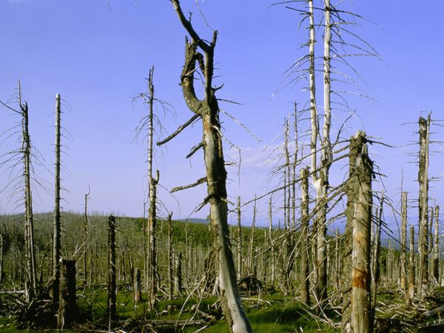
Figure 1: Trees Impacted by Acid Rain
Source: National Geographic Society
“Acid rain also damages forests, especially those at higher elevations. It robs the soil of essential nutrients and releases aluminum in the soil, which makes it hard for trees to take up water. Trees' leaves and needles are also harmed by acids” (Society, 1996). In the picture above, it shows the effect of acid rain on trees. The trees are shown as dry, brittle, and damaged. After impacted by acid rain, trees and plants are not likely to survive.
Background
Acid rain does not just fall out of the sky on its own; there are crucial determinants that provoke this dangerous acidic deposition. Human activity is what sparks the acid rain to form. “When humans burn fossil fuels, sulfur dioxide (SO2) and nitrogen oxides (NOx) are released into the atmosphere. These chemical gases react with water, oxygen, and other substances to form mild solutions of sulfuric and nitric acid. Winds may spread these acidic solutions across the atmosphere and over hundreds of miles. When acid rain reaches Earth, it flows across the surface in runoff water, enters water systems, and sinks into the soil (Society, 1996)”.
Since the fumes of the burned chemicals flow throughout the air, it creates acid rain when combined with water; as claimed by the National Geographic. Once the acid rain is constructed, it begins to spread throughout the earth by the movement of natural winds. Human activity is not the only factor regarding acid rain. As stated by the National Geographic Society, rotting vegetation and erupting volcanoes release chemicals that can cause acid rain. Some chemicals that are given out by rotting vegetation and volcanoes are methane and sulfur dioxide. Acid rain stems from rotting vegetation, erupting volcanoes and mostly human activities.
Health Implications
Humans, crops, and animals are greatly affected by acid rain. For humans, sulfur dioxide (SO2) and nitrogen oxides (NOx) gases can get inhaled and the gases can enter their lungs. The gas particles and heart and lung disorders are shown to have a relationship according to scientific studies (Effects of Acid Rain, 2016). Asthma and bronchitis are both related to the effects of acid rain. Acid rain disrupts the pH levels of organisms in the ecosystem. “The more acid that is introduced to the ecosystem, the more aluminum is released. Some types of plants and animals are able to tolerate acidic waters and moderate amounts of aluminum. Others, however, are acid-sensitive and will be lost as the pH declines. Generally, the young of most species are more sensitive to environmental conditions than adults (Effects of Acid Rain, 2016)”.
Plants and trees that are effected by acid rain result in death and lack of nutrient growth. The aluminum-filled soil is very harmful to plants (Effects of Acid Rain, 2016). Acid rain can cause the removal of nutrients and minerals within the soil (Effects of Acid Rain, 2016). Because of the removal, the plants and trees cannot grow, or are able to withstand freezing temperatures (Effects of Acid Rain, 2016). Not every plant and tree can get effected by acid rain because of its buffer capacity. “Many forests, streams, and lakes that experience acid rain don’t suffer effects because the soil in those areas can buffer the acid rain by neutralizing the acidity in the rainwater flowing through it (Effects of Acid Rain, 2016)”. The buffering capacity of forest helps maintain nutrients in soil.

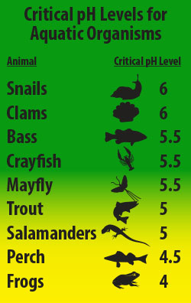
Figure 2: Critical pH Levels for Aquatic Organisms
Source: Effects of Acid Rain
Methodology
There are many different methods to decrease the production of acid rain. Methods have been creating for acid rain through research. According to Sci-tech Connect, the acidic deposition phenomena, when implicated as a factor potentially responsible for crop and forest yield losses and destruction of aquatic life, has gained increasing attention. The widespread fear that acid rain is having or may have devastating effects has prompted international debates and legislative proposals (Irving, 1983). During the methods research, the interactions between plant, soil, soil, microbes, and groundwater were tested (Irving, 1983). In order to establish cause-effect relationships between rain acidity and the response of a receptor, controlled studies are necessary to verify observations in the field since there are many natural processes that produce and consume acidity and because numerous other environmental variables affect ecosystem response (Irving, 1983).
First supporting case/example
The outcome of acid rain on the earth has created damages that cost large amounts of money to fix. A study by the Environmental Resources Limited in 1983 estimated the total damage costs (Newbery, 1990). The total of $0.6 – 4.5 billion dollars per year would have to go towards crops, buildings, and forests. “The costs of reducing SO2 emissions in the year 2000 by 10-27% by adopting FGD and FBC in new boilers might be $1.9 – 6.5 billion per annum, depending on the amount of new capacity installed (Newbery, 1990)”. The study consisted of the cost-effective for base load at current European gas and coal prices (Newbery, 1990). In addition to summing up the cost for coal, the coal was monitored and governmental protectionist policies were produced. Research conducted during this case study included cost of coal and electricity, gas production, and acid rain damage and alternatives.
Second supporting case/example
Many countries are trying to fix their acid rain crisis. Canada has an acid rain program that targets acid rain solutions. The Canadian Acid Rain Program conducted a study of acid rain during a 40-year time span. It started in during the 1960s and it is still ongoing. Some objectives Canada addressed in the case study is aggressively reducing domestic emissions, expanding science, and re-engaging federal, provincial and territorial partners (Acid Rain Case Study, n.d.). The Canadian case study resulted in “Canada has made remarkable progress over four decades in assessing acidification impacts and reducing acidifying emissions: important advances in scientific understanding since the 1960s, broad public support for action from all levels of government, the private sector was key to all parties embracing a policy of emission controls and industries recognized issue and responded with emission reductions & development of new control technology, and demonstration projects that were successfully incorporated into the program without compromising deadlines (Acid Rain Case Study, n.d.)”. In 1980 Canada and the US signed a Memorandum of Intent Concerning Transboundary Air Pollution which resulted in US and Canadian scientists working together to create an agreement for a technical basis of air pollution (Acid Rain Case Study, n.d.).
Analysis
Acid Rain has different forms. Most of acid rain comes from man-made actions. There are two different types of acid rain; wet and dry deposition. For wet deposition, “when the wind blows the acidic chemicals in the air to the areas where the weather is wet, the acids fall to the ground in the form of rain, sleet, fog, snow or mist. It removes acid from the atmosphere and deposit them on the earth’s surface. When this acid flows through the ground, it affects large number of plants, animals and aquatic life. The water from drain flows into rivers and canals which is them mixed up with sea water, thereby affecting marine habitats” (Causes, Effects and Solutions of Acid Rain, 2016). Dry deposition is a little bit different. It reacts differently when the winds blow. “If the wind blows the acidic chemicals in the air to the areas where the weather is dry, the acidic pollutants slip into dust or smoke and fall to the ground as dry particles. These stick to the ground and other surfaces such as cars, houses, trees and buildings. Almost 50% of the acidic pollutants in the atmosphere fall back through dry deposition. These acidic pollutants can be washed away from earth surface by rainstorms (Causes, Effects and Solutions of Acid Rain, 2016)”.
The different climate effects and atmospheric pollution has influence the production of acid rain. “It was discovered way back in 1800s during the Industrial Revolution. A Scottish chemist, Robert Angus Smith, was first to discover this phenomenon in 1852 as a relationship between acid rain and atmospheric pollution in Manchester, England. But it gained public attention mainly in 1960s. The term was coined in 1972 when the NY Times published reports about the climate change effects which started arising due to the occurrence of acid rain in the Hubbard Brook Experimental Forest in New Hampshire (Causes, Effects and Solutions of Acid Rain, 2016)”.
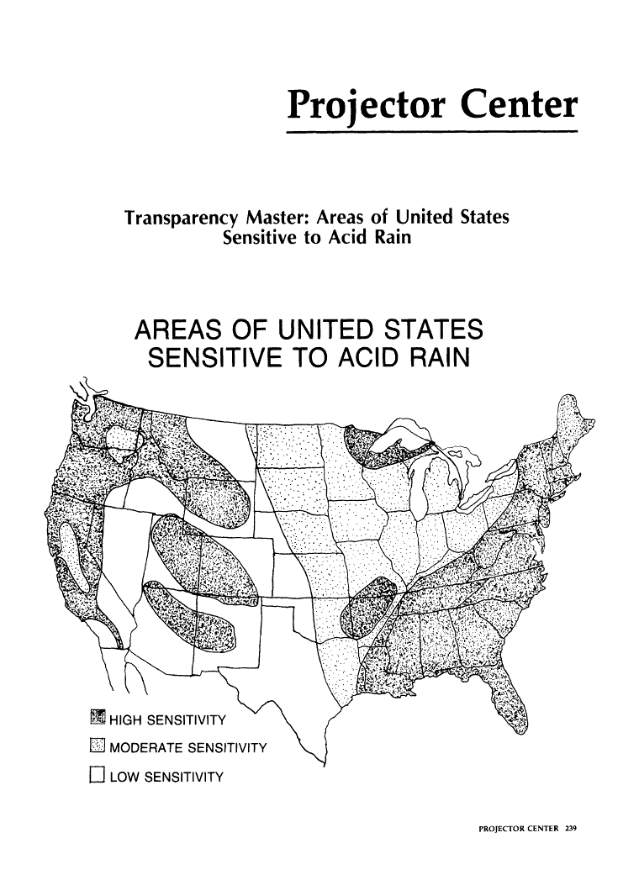
Figure 3: Areas of United States Sensitive to Acid Rain
Source: The American Biology Teacher
Solutions
Cleaning up exhaust pipes and smokestacks, restoring damaged environments, and using alternative energy sources are all great solutions to acid rain (Causes, Effects and Solutions of Acid Rain, 2016). By cleaning up the pipes and smokestacks, it would decrease the amount of chemicals that pollute the air. “Most of the electric power supporting the modern-day energy requirements comes from combusting fossil fuels such as oil, natural gas, and coal that generate nitrogen oxides (NOx) and sulfur dioxide (SO2) as the chief contributors to acid rain. Burning coal largely accounts for SO2 emissions while NOx emissions are mostly from fossil fuel combustions Causes, Effects and Solutions of Acid Rain, 2016).
Restoring damaged environments can help increase better breathable air. It can also help restore trees and plant life so that oxygen could circulate throughout the earth. “Use of limestone or lime, a process called liming, is a practice that people can do to repair the damage caused by acid rain to lakes, rivers and brooks. Adding lime into acidic surface waters balances the acidity. It’s a process that has extensively been used, for instance in Sweden, to keep the water pH at optimum. Even though, liming is an expensive method and has to be done repeatedly (Causes, Effects and Solutions of Acid Rain, 2016). Lastly, using alternative energy sources could reduce acid rain from forming. Acid rain is created by chemicals in the air mixing with water. If humans could use a different source of energy that doesn’t involve chemical gases, then it would make the environment healthy and better.
Conclusion
Acid rain is a problem that impacts the life of humans, crops, and wildlife. Acid rain is created by chemicals of human activity, rotting vegetation, and erupting volcanoes mixing with water. Acid rain is not completely terminated, but it decreases as humans find new scientific methods.
References
Acid Rain Case Study. (n.d.). Retrieved from http://www.un.org/esa/sustdev/csd/casestudies/a5_canada.pdf
Basil John Mason. (n.d.). Retrieved December 06, 2016, from http://izquotes.com/quote/251173
Causes, Effects and Solutions of Acid Rain - Conserve Energy Future. (2016). Retrieved December 06, 2016, from http://www.conserve-energy-future.com/causes-and-effects-of-acid-rain.php
Effects of Acid Rain. (2016, March 31). Retrieved December 06, 2016, from https://www.epa.gov/acidrain/effects-acid-rain
Irving, P. (1983). Acid rain research: A review and analysis of methodology. Retrieved December 06, 2016, from http://www.osti.gov/scitech/biblio/5457080
Newbery, D., Siebert, H., & Vickers, J. (1990). Acid Rain. Economic Policy, 5(11), 297-346. doi:10.2307/1344480
Society, N. G. (1996). Acid Rain Facts, Acid Rain Information, Acid Rain Pictures, Acid Rain Effects - National Geographic. Retrieved December 05, 2016, from http://environment.nationalgeographic.com/environment/global-warming/acid-rain-overview/
Transparency Master: Areas of United States Sensitive to Acid Rain. (1983). The American Biology Teacher, 45(4), 239-239. doi:10.2307/4447685

