Effect of Hand Washing Hygiene Education On Communicable Disease in Children at Schools: A Comparison Between the United States and Kenya

Yasaman Haidarbaigi

George Mason University

**Introduction**

According to MDHHS (2016), schools play a major role in helping reduce or prevent the incident of illness among children in our communities. (pg.2) A communicable disease is one that is spread from one person to another through a variety of ways and the common types are common cold, flu, strep throat, urinary tract infection, and stomach flu. (ACPHD, para.1, 2013) This disease can spread among children in schools through water, sanitation, and mostly not knowing about the disadvantages of hand washing because of lack of hygiene education. However, to stop communicable disease among children in schools, schools have to determine the effectiveness of a comprehensive hand washing hygiene programs. According to ACPHD (2013), reporting of cases of communicable disease is important in the planning and evaluation of disease prevention and control programs. (para. 2)

**Background**

Hand washing is the single most important means of preventing the spread of infection. (Infection Control Today, para.6, 2000) Children are mostly at an increased risk of infectious diseases in schools because they comply less with hygiene. Parents play an important role in educating and encouraging their children about issues in their school. According to Infection Control Today (2000), Education and training of staff has been a central focus of infection control programs with marginal impact. (para.12) Schools have to provide a program about hand washing among children and parents in schools about how many times children have to wash their hands, how they have to wash their hands, and how they have to use water fountains. Education and training of staff has been a central focus of infection control programs with marginal impact. Encouraging good hand hygiene and following cleaning recommendations contribute to a safe and healthy learning environment for children. According to MDHHS (2016), when schools report illness to their local health department (LHD), public health specialists can assist schools with disease prevention and control guidance. (pg. 2) Public schools have to provide schools with safe drinking water, improved sanitation facilities and hygiene education that encourage the development of healthy behaviors for life in children. (UNICEF, pg.3, 2012) The objective of this paper is to determine the effectiveness of a comprehensive hand washing programs among children in schools. To better understand this topic, a comparison between the effect of hand washing hygiene education in children in the United States schools and children in Kenya schools has been completed.

**Health Implications**

According to Infection Control Today (2000), in the infection control arsenal, hand washing is the primary weapon and the purpose of hand washing in the healthcare is to remove microbes from the hands in an effort to decrease the risk of communicable diseases and to prevent their potential transfer. Hand washing with soap improves health and saves lives by preventing infections. (Global Hand Washing, para.1, 2015) According to Global Hand Washing (2015), after using toilet, coughing, sneezing, touching other people’s hands, and touching other contaminated surfaces many infections can start with disease causing bacteria and viruses. Two major illnesses that are transmitted on the hands are diarrhea and pneumonia; they have killed an estimated 1.7 million children every year, however many of these deaths can be prevented by hand washing with soap (Global Hand Washing, para.3, 2015)

Ebola is another deadly disease that results from not washing hands frequently with clean water and soap, or the use of an alcohol based hand sanitizer. Ebola has symptoms of fever, headache, diarrhea, vomiting, and stomach pain. This disease can lead to mortality if it is not detected early and referred to the hospital for further evaluation. As I stated this in the background and pervious paragraph, if children do not wash their hands after using toilet, they will get infected with the waterborne diseases such as diarrhea, pneumonia, Ebola and etc. According to MDHHS (2016), Children with the symptoms listed below should be excluded from the childcare or school setting until symptoms improve: (These are communicable disease symptoms from not washing hands)

* Chicken pox
* Fever
* Vomiting
* Rash with fever or behavior change
* Unusual color of skin, eyes, or Urine

Children are the group that they are most affected to communicable diseases by not washing their hands properly. Children are not well educated and informed on the consequences of not washing their hands properly. The hygiene standards in most developing countries is very poor, especially toilets and non-availability of water and soap for children after using toilets.

**Methodology**

To measure the effect of hand washing, schools can conduct a survey to ensure the procedures, that they introduced was effective and resulted in a positive outcome. The surveys will be given once all the measures such as conducting a mass information campaign on the needs and proper hand washing, introduction of flyers, educate children about communicable diseases, and the dangers that in some occasion may result in their death is completed. In order to find out the positive outcome of the results the schools should conduct a survey by picking a sample of 2,000 students and make them undergo the glo gel test. Glo gel determines the amount of germs on your hands after washing them. This survey can help schools find out if the results are satisfactory or not, this will determine the efficacy of the program as a whole in preventing communicable diseases. The research on this topic has been conducted mainly by UNICEF, WHO, and CDC. The effect of hand washing has been measured by number of deaths in different regions and countries and recommended preventions according to the circumstances of each region and country. They came up with a variety of recommendations based on the availability of resources at each region and each country. In developing countries, the prevention process is more complicated than the developed countries. More recourses and budgeting are required to prevent the spread of communicable diseases, which the countries cannot afford to invest and they have to seek donations from developed countries to invest in these projects, which by itself is a challenge. Because the number of developing countries are enormous and supporting all of these countries is not possible and it will take time.

**First supporting case/example**

Children can become infected with germs by unknowingly touching their eyes, nose, or mouth and hand washing is the first thing they need to do against spread of many illnesses. The ultimate conclusion is that the current status of cleanliness and the resulting health benefits in developed countries shouldn’t be taken for granted. (Handwashing in Schools, pg. 14, 2012) Hand washing in schools is very important because it avoids children form getting sick and spreading germs. The obstacles that prevent children from washing their hands at schools in America are lack of supplies, hand washing in not a cool thing, no having time, violence in the bathrooms, and they don’t wash their hands in the right way or not long enough. (Handwashing in Schools, pg. 18, 2012) According to Hand washing in Schools (2012), the rate of absenteeism from schools in the United States are high owing to children not washing their hands which is costly for the Ministry of Education and schools themselves. School absenteeism is costly because administrations has to pay substitute teachers, teachers are re-teaching students that are absent, students are missing class and activities, parents experience lost work days, and decreased participation in school meals. (Handwashing in Schools, pg.19, 2012)

**Second Supporting Case/example**

According to USAID (2014), over 95% of neonatal death occur in developing countries. In Africa, diarrheal disease is the single largest cause of death among children and one of the risk factors for death from diarrhea in Africa is poor hygiene. (USAID, pg.1, 2014) In Kenya, a Public-Private Partnership for Hand washing forum exists and a National Steering Committee, chaired by the Ministry of Public Health and Sanitation, leads it. (USAID, pg.1, 2014) According to USAID (2014), There is a clear need for hand washing promotion campaigns in Kenya. 44.6% of Kenyan households use appropriate methods of water treatment, with a majority of them boiling water; however, only 5% of caregivers report HWWS at all critical times. (USAID, pg.1, 2014) According to UNICEF(2012), poor sanitation, water scarcity, inferior water quality and inappropriate hygiene behavior as disastrous to the health of school-aged children, who spend long hours in schools. The physical environment and cleanliness of a school facility can significantly affect the health and well being of children. (UNICEF, pg.3, 2012) According to UNICEF (2012), Disease spreads quickly in cramped spaces with limited ventilation, where hand-washing facilities or soap are not available, and where toilets are in disrepair. Too often, schools are places where children become ill. (pg. 3)

**Analysis**

The effect of hand washing hygiene education in the United States compared to the effect of hand washing hygiene education in Kenya is very different because the Unites States is a developed country while Kenya is in the process of developing. In America there are a lot of resources available to prevent the spread of communicable diseases in schools and educate children to wash their hands. There is no budgetary constrains to buy soaps and hand sanitizers, and there are proper toilets for use. Cleaners routinely clean toilets in the U.S. schools. Medical and clinical facilities are available to refer the infected children, and water department controls water sources and they are clean and hygienic. Schools in the U.S. usually conduct mass information campaign on washing hands and hygiene promotions. Based on my researches, a large number of children in schools in Kenya are at high risk for communicable diseases due to overcrowding poor water resources, poor sanitation, and hygiene conditions. In addition to poor or non-chlorination of water sources, water is usually contaminated by feces of infected individuals who contaminate directly or through the contamination of food. There are no proper toilets, there is no tap water for children to wash their hands, and schools cannot provide to buy soap or hand sanitizer. Even if water is available to the people, it is not chlorinated. Water is usually transported and stored; therefore the transported water may be contaminated by microbes. Students are not trained to wash their hands properly and there are lack of information campaign on how important it is for children to wash their hands at schools in addition to lack of resources.

**Solutions**

Schools in the United States promoting hand washing and hygiene should start from households and parents should pay particular attention in teaching their children proper hand washing and periodic use of hand sanitizer on daily basis. Schools should also provide mass information campaign on the importance of proper hand washing and mounting flyers on toilets showing proper hand washing with pictures. Schools can prevent the spread of communicable diseases by providing hand sanitizers and air dryers in toilets, and installing sensor tabs in the restrooms. Schools have to emphasize to children the importance of washing their hands before they eat as well as washing their hands after using the toilet.

In Kenya, schools have to educate the children on modes of transmission and protection, prevent open defecation, and construct more toilets with water tabs. Schools in Kenya should also provide soap and hand sanitizers, but also chlorinate water, and provide mass information campaign to the students on proper hand washing. Developing countries are mainly depending on UN agencies and NGOs to invest in this sector and sometimes these agencies are not able to secure a budget for this purpose to invest and improve the situation because there are so many other dire needs in other sectors to invest than improving and investing in hand washing improvements. Kenya doesn’t even have proper school buildings and classrooms for the children and this by itself requires a huge investment. There are many areas and villages that children are taking classes in open areas with no classrooms, no latrines, no water, and children have to go to open for defecation. UN agencies and NGOs agencies should bring to the attention of donor countries to pay more attention and importance to construction of proper latrines at schools for children to prevent infection diseases.

**Conclusion**

Communicable diseases can easily spread from one person to another. Children play an important role to spread infections in schools by not washing their hands properly or even not washing their hands at all. In East Africa, to prevent the diseases related to hand washing, contaminated water and hygiene, school authority and government should educate the public on modes of transmission and protection, prevent open defecation, increase coverage of clean and fly proof latrines, protect water sources through sanitary upgrading, chlorinate all schools water supplies, prevent contamination of water during transport and storage, increase water quantity, and encourage hand washing with soap and hand sanitizer. In the United States, schools should continue with the mass information campaign, room for improvement in kid’s hand washing behaviors at school, and improvement of toilet facilities. Teachers should refresh student’s memories periodically on the importance of hand washing. The bottom line is that the developed counties like the United States has much less challenges to tackle this issue than developing countries like Kenya in South Africa.

**References**

Alameda County Public Health Department. (2013). Communicable Disease. Retrieved

from <http://www.acphd.org/communicable-disease.aspx>

Infection Control Today. (2013). Preventing Infection Through Handwashing. Retrieved

from <http://www.infectioncontroltoday.com/articles/2000/07/preventing-infection-through-handwashing.aspx>

Michigan Department of Health and Human Services. (2016). Managing Communicable

Diseases in Schools. Retrieved from <http://www.michigan.gov/documents/mdch/Managing_CD_in_Schools_FINAL_469824_7.PDF>

United Nations International Children's Emergency. (2012). Water, Sanitation and

Hygiene (WASH) in Schools. <https://www.unicef.org/publications/files/CFS_WASH_E_web.pdf>

Partnership For Hand Washing. (2015). Why Hand Washing. Retrieved from

<http://globalhandwashing.org/about-handwashing/why-handwashing/health/>

Centers for Disease Control and Prevention. (2013). Water, Sanitation &

Environmentally-related Hygiene. Retrieved from <http://www.cdc.gov/healthywater/hygiene/fast_facts.html>

American Cleaning Institute. (2012). Handwashing in Schools. Retrieved from

<http://www.cleanlink.com/webcasts/20120628_Handwashing/062812_handwashing.pdf>

**Appendixes #1**

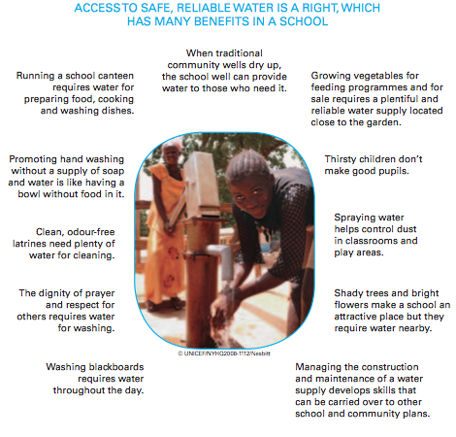

Figure. 1 UNICEF (United Nations International Children's Emergency)

This picture illustrates water sources used at schools in East Africa.

**Citation**

United Nations International Children's Emergency. (2012). Water, Sanitation and

Hygiene (WASH) in Schools. <https://www.unicef.org/publications/files/CFS_WASH_E_web.pdf>

**Appendix #2**

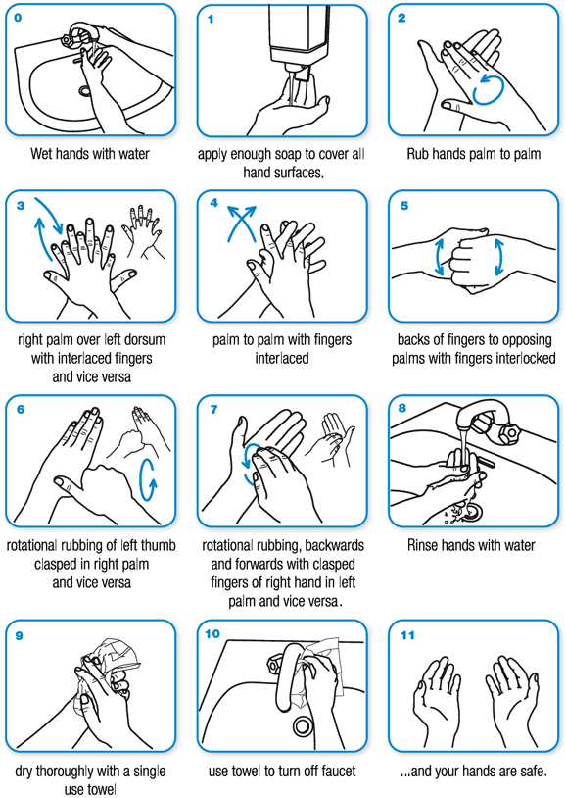

Figure. 2 WHO (World Health Organization)

This photograph shows the right procedures of washing hands with pictures for children in schools.

**Citation**

World Health Organization. (2016). Clean Care Is Safe Care. Retrieved from

<http://www.who.int/gpsc/clean_hands_protection/en/>

**Appendix #3**

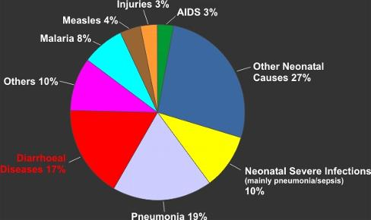

Figure. 3 Eloes Project (Kenya, East Africa)

This Graph shows that Access to clean, safe water and sanitation have been shown to reduce infant and child death rates by 20-30%.

**Citation**

Eloes Project. (2013). Water and Children. Retrieved from

<http://www.eleosproject.org/12.html>