Ahoy!

The list below is a compilation of service providers assembled from a “Who would you suggest?” request to RE/MAX agents in the Santa Clarita Valley. This is not a recommendation or endorsement, simply an offering of folks who may be of help for your round-the-house needs.



Handy Man:
Don Grant~805 813-0775
Mike Maricle 661 210-6757
Howard Pointer 661 291-1532
John Rozelle 661 407-5004
Tim Shannon 661 714-0811
Jim Wallace 661 816-9042
Westin Goudey 661 406-6091
Mike Gill~661 470-9360
Jason Duffy, 661-524-5040


Contractors:
Martin Lynn 661 254-5475
Top construction Greg 661 775-9945
Carl Reese 661 877-1499

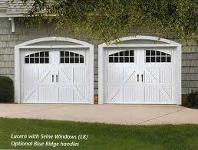

Garage doors:
Mark at Lift Right (repairs +) 661 257-4285



Painters:
Lloyd~~661 714-4263
Lio 661 993-1849
Dave Van Oden 661 251-5356 of VO Painting
Jim Uhl 661-510-6292 – cell
Andreas 661.433.4468
Able 661.254.5114
Jose at 818-322-5505
Jason Duffy, 661-524-5040



Carpet & flooring:
Marty's Flooring 661.252.2522
The Carpet Sore Mitch 818 362-3534
E G Carpet - Owner is Edgar - Cell - 818-822-5423


Locksmith:
Joe @ Universal Lock 818 764-4077
Newhall-Valencia lock & key 661 251-4830

Roofing Repairs:
Roofing Repair plus Kurt Blumberg 661 644-2838
Karl Brown KB Roofing cell: 818-896-4224

