Natural Disaster Environmental Conditions in the U.S. - Floods
George Iskandar
George Mason University
GCH 360 – 002

Abstract
The United States is the fourth largest country in world with an area of 9,147,420 square kilometers. In addition to this huge area, the United States is surrounded by water from two sides. Both being a peninsula and the physical size introduce several diverse weather patterns and expose the country to a higher risk of natural disasters. This paper will examine natural disaster environmental conditions in the United States, specifically floods, and their effects on both people and the environment. In addition, two case studies will be analyzed to examine their causes and what could have been done to prevent those disasters. Factors including health effects, response techniques, and government intervention will be used to evaluate the aftermaths. Being the most common type of natural disasters, floods are one of the leading causes of death from natural disasters in the United States. Although floods commonly occur as after effects of other natural disasters, floods should be scrutinized as they can be devastating if not managed properly. Floods can vary greatly in size and duration, therefore emergency preparedness and education is a crucial part of avoiding catastrophic outcomes. Natural disasters are inevitable and cannot be prevented entirely, and our duty is to actions for minimizing the extent of their outcome as much as possible and ensuring quick recovery.
Introduction
Floods are defined as “a general and temporary condition where two or more acres of normally dry land or two or more properties are inundated by water or mudflow.” Floods are always a result of another natural event or disaster, or poor infrastructure. Natural events that may cause flooding include storms, hurricanes, and rapid accumulation of rainfall. Poor infrastructure like breached levees, dams with insufficient load support, and clogged drainage systems may also be causes of flooding. In some of the cases, floods occur due to a combination of natural events/disasters and poor infrastructure, which most of the time, leads to catastrophic aftermaths. Moreover, floods are classified into four different types depending on their cause, overbank flooding, coastal flooding, ice jam flooding, and flash flooding. Commonly observed in the Midwest, overbank floods occur in rivers when water overflows the banks of the river due to heavy rain. Coastal flooding refers to flooding at the coast or shoreline of the ocean which is caused by hurricanes and tsunamis. Ice jam flooding occurs mostly in areas with cold temperatures when large bodies of ice block the flow of water. Flash floods, which are the most dangerous type of floods, occur very quickly in which fast-moving water rises rapidly and can be destructive.
Floods are the number one natural disaster in the United States, they are very dangerous as they can cause many fatalities and be highly destructive if severe. Unlike hurricanes, the severity of floods are measured based on damages rather than a quantitative scale. Statistics in the United States show that on average, floods kill around 140 people each year and cause six billion dollars in damages. In the United States, there were 183 instances of major flooding 2005 to 2014 which caused 292 fatalities and approximately 30 billion dollars in losses. In the first half of 2015 (January to June), there were 10 instances of major flooding causing 4 fatalities and about 50 million in losses. States with the most risk of flooding have been identified as Louisiana, Florida, and California, as they are objected to areas in the ocean known for severe weather patterns and storms. Shown below is an image from the United States Geological Survey (USGS) showing a presidential disaster declarations from flooding in the United States.
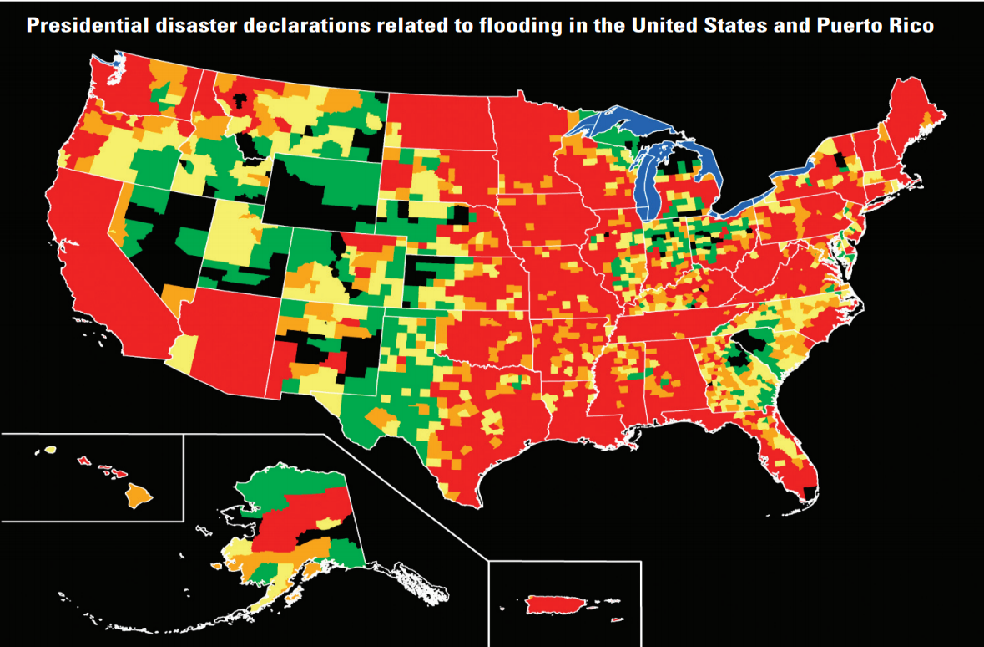
“Green areas represent one declaration; yellow areas represent two declarations; orange areas represent three declarations; red areas represent four or more declarations between June 1, 1965, and June 1, 2003.” (USGS)
Floods may have severe impacts on the human health affecting both physical health and psychological/emotional health. Floods may have direct and indirect effects on physical health. Direct physical health consequences include drowning, injuries, hypothermia, animal bites, and as mentioned in the article by Du, FitzGerald, Clark, and Hou, “health risks also are associated with the evacuation of patients, loss of health workers, and loss of health infrastructure including essential drugs and supplies.” Indirect physical impacts include “infected wounds, complications of injury, poisoning, poor mental health, communicable diseases, and starvation.” Additionally, floods may cause ignition in flammable areas leading to burns or possibly explosions. Floods may result in psychological and emotional health due to loss of homes, loved ones, or jobs (no money would entail no supply of water and food).

Case study 1: Hurricane Katrina, 2005
Hurricane Katrina was one of the worst hurricanes that ever hit the United States. The hurricane hit the New Orleans, Louisiana, during hurricane season in 2005 and caused 1833 death because of the floods and left millions of people homeless. Although storms in New Orleans are common, the hurricane was unexpected as it re-intensified into a category 5 hurricane after it was thought to be weakening. Due to poor infrastructure, the waves smashing into the levees caused them to collapse which resulted in extensive flooding. 80 percent of the city was flooded and the water took several weeks to recede. Thousands of people died and millions of people lost their homes and jobs, and were forced to move. This caused severe physical and psychological health effects as many of the people that lost their houses or had to be relocated were bonded to their homes.
Government response to the disaster was somewhat inefficient as the damages were extreme and millions of people needed support and relocation. In addition, federal, state, and local officials were blaming each other for the disaster which was unnecessary given a time of crisis. The National Guard helped with evacuations out of the city, but with so many people left homeless, thousands had to stay at the New Orleans Convention Center and the Superdome until relocation. Michael D. Brown, the director of the Federal Emergency Management Agency (FEMA), was forced to resign after the disaster. After the crisis was contained, the government was forced to implement better environmental and evacuation policies in order to prevent the same thing from happening again. The Army Corps of Engineers rebuilt the levee system after the hurricane, “making the barriers higher and supporting them with steel beams that extend as far as 65 feet (19.8 meters) below sea level.” (LiveScience) In addition, congress passed an act in 2006 that helped many cities improve and revise their evacuation plans in case of another severe emergency.
Case Study 2: Flood in Texas
A recent case of severe flooding, occurred in Northern Texas, Kansas, Oklahoma, and Arkansas. The states were severely affected especially Texas which has a total of ten deaths and Kansas with a total of six deaths. The floods were brought on by heavy rains during Thanksgiving on Thursday, 26 November 2015. “In Oklahoma, around 70,000 homes and businesses were without power at one point over the weekend. Oklahoma Governor, Mary Fallin, has declared a state of emergency in all 77 counties of the state.” (Floodlist) This incident also had the same physical effects as most severe floods causing deaths and spread of disease. Psychological effects were amplified by the fact that it was thanksgiving and many people lost their families during that time which can be devastating for the rest of their lives. Government response was not clear and has not been completely made public as the disaster was very recent. The National Weather service released warnings about extended flooding in some areas in Kansas and Oklahoma.
Analysis
Government response in both cases was not efficient in both cases. Although there was not enough information to determine the efficacy in the second case study, taking into account the number of deaths and the severity of the disaster leads to the conclusion that the response was not efficient and caused the disaster to keep worsening. The first case study clearly showed failure to manage the situation by both the federal and local governments. Handling these kinds of natural disasters in a timely manner is a critical part of emergency management that must be improved by the government. Such disasters may have severe health consequences on the people affected and slow responses are unacceptable by the government since they are obligated to protect its citizens. States at most risk of inland or overbank flooding have been identified as South Dakota, Missouri, Kentucky, and Arkansas. States at most risk of coastal flooding are Mississippi, Florida, and Alabama. Therefore, these states should take immediate action into revising and improving their infrastructure and emergency planning as they are faced with a great danger of natural disasters.
Conclusion
In conclusion, floods pose a threat to the well-being of many people in the United States and should be taken into account more seriously. In order to avoid or lessen catastrophic repercussions of such natural events, environmental policies must be reformed and infrastructure should be examined according to the risk. In addition, new emerging technologies should be tested and considered for primary prevention methods as more advanced technology may offer better protection. Communities known for higher risk of disasters should be insured against natural disasters to decrease the aftermaths of any crisis that might happen. Natural disasters are inevitable and impossible to prevent completely. Therefore, it is our job to raise awareness and ensure maximum protection to prevent severe repercussions.

References
Flooding & Flood Risks. (2015, November 30). Retrieved December 9, 2015, from https://www.floodsmart.gov/floodsmart/pages/flooding_flood_risks/ffr_overview.jsp
2014 NATURAL CATASTROPHES. (n.d.). Retrieved October 28, 2015, from http://www.iii.org/fact-statistic/catastrophes-us
Flood Hazards—A National Threat. (2013, June 25). Retrieved October 28, 2015, from http://pubs.usgs.gov/fs/2006/3026/
Redd, N. (2012, October 11). Flood facts, types of flooding, floods in history. Retrieved October 28, 2015, from http://www.livescience.com/23913-flood-facts.html
Koebler, J. (2012, March 14). 10 States Most at Risk of Flooding. Retrieved December 9, 2015, from http://www.usnews.com/news/slideshows/10-states-most-at-risk-of-flooding/10
Du, W., FitzGerald, G., Clark, M., & Hou, X. (2010, May 1). Health impacts of floods. Retrieved December 9, 2015, from http://www.ncbi.nlm.nih.gov/pubmed/20586021
Zimmermann, B. (2015, August 27). Hurricane Katrina: Facts, Damage & Aftermath. Retrieved December 9, 2015, from http://www.livescience.com/22522-hurricane-katrina-facts.html
Thanksgiving Floods and Storms Leave 14 Dead in Texas and Kansas; Oklahoma Declares Disaster - FloodList. (2015, November 29). Retrieved December 9, 2015, from http://floodlist.com/america/usa/thanksgiving-floods-14-dead-texas-kansas-oklahoma
States at Risk: Which US States are Least Prepared for Potential Flooding - FloodList. (2015, November 24). Retrieved December 9, 2015, from http://floodlist.com/america/usa/which-us-states-not-prepared-floods

