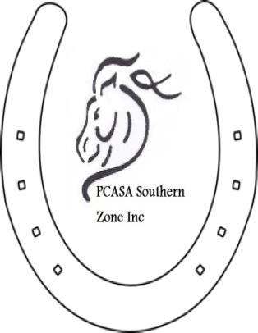

MONARTO EQUESTRIAN CENTRE BOOKING FORM
for PCASA & EA Financial members
P.C.A.S.A. SOUTHERN ZONE INC.

C/- BOOKING OFFICER, Tricia Skewes
PO Box 34, Goolwa S.A. 5214
Or email to monartoequestriancentre124@gmail.com
PH: 0428 554028

CONDITIONS OF USE:
- A responsible adult must be present with riders at all times.
- Access to a telephone must be arranged.
- In case of emergency the road number for Monarto is 214 Peach Rd
- The cost to repair any damage to equipment or property (including jumps) is to be borne by the hirer.
- All equipment is to be returned to the correct storage area.
- Stables and yards are to be left in a clean and tidy state.
- Manure is to be removed from around building and house paddock.
- All buildings, including house, dormitories, toilet block etc are to be left clean and tidy.
- All gates must be shut at all times.
- Road doubles are out of bounds.
- Park on water jump side & access house side jumps from gate by road crossing

PLEASE NOTE: dates will not be booked unless booking form, financial status (membership card) or text of them is accompanied by receipt of $25/ horse fee & dates have been approved by
Deb Cook 0457 699 049 or Trish Skewes 0428 554 028
BSB: 085 921 Acct: 794913855

Bookings are required

MONARTO EQUESTRIAN CENTRE REQUEST FOR BOOKING FORM.

NAME OF HIRER:.....................................................................................

POSTAL ADDRESS:.........................
.............................................................................................
............................P/C.........................
PIC #.............................................................

PCASA #....................................
Club................................................... Southern Zone members no charge except for training days

EA #..............................................................

PHONE NUMBER:..............................................

MOBILE:.................................................

EMAIL:..............................................................................

DATE/S REQUESTED:............................................

Cross Country:............

The hirer acknowledges that the Pony Club Association of South Australia Southern Zone Inc. will not accept any liability or be responsible for any accident, damage, injury or illness to any horse, rider, spectator, instructor, organizer, hirer or any other persons present during the hire period.
The hirer accepts responsibility for informing all participants of the aforementioned requirements.
Has read the above conditions of use and agrees to abide by these conditions.

SIGNED:...............................................
PRINT NAME:..............................................................
ON BEHALF OF:.........................................................
DATE:.............................

After receiving this form you will be sent a confirmation.

