Voice- Well-being
- We believe that children learn best in an atmosphere of fun, challenge and high expectation.
- We provide a wide range of exciting learning opportunities to encourage every child to achieve their best possible outcomes and prepare them for life ahead.
- Working in partnership with parents and carers, the dedicated and inspirational staff support each child to solve problems and lead their own play and learning in our safe and inclusive environment.
- All transitions are supported
- We use meaningful praise to
Instil confidence
- The embedded key person
approach supports well-being
and relationships
- All children’s well-being is
Monitored 3 times a year
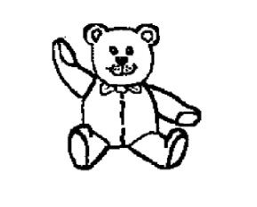
Our Vision and Values
Voice- Pupil learning
- Our planning reflects children’s interests
- Independence is encouraged and celebrated
- Children learn through play and first hand experiences
- Strategies are used to support children’s individual needs
Voice- Respect
- All children and adults will be heard
- We appreciate and value differences
- Manners are valued
Within the pre-school
- Everyone is welcomed
Voice- Professional learning
- All staff embrace CPD
- All staff are open to new ideas and theories
- Staff keep up to date with new thinking
- We seek knowledge and advice from other professionals

