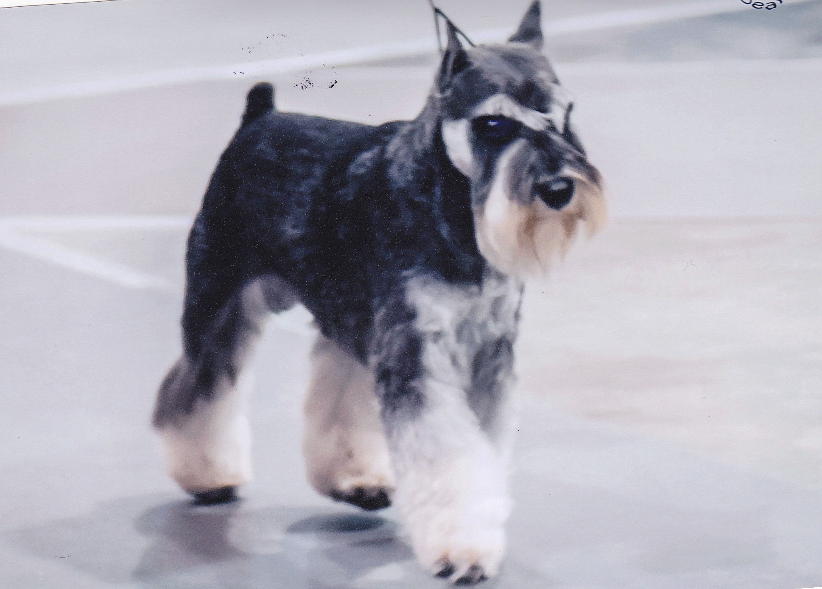
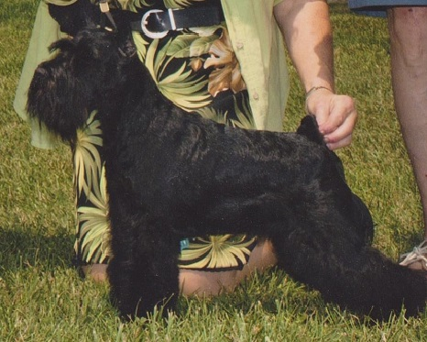
Dream Mtn. Kennel
141 Grisham Rd.
Royal, AR 71968
(501)701-8676
www.dreammtn.com
dreammtn@live.com Sire Dam

Please Print
Name: _________________________________________________
Address: _______________________________________________
City: _______________________ State: ______ Zip:____________
Home Phone: _______________ Work Phone:_______________ Cell Phone:_______________
Email__________________________________________________________
Place of employment: _____________________________________________
Place of spouse’s employment: ______________________________________

Name of pet you are interested in purchasing: _____________________________ _________
Why do you want to buy a mini schnauzer? _________________________________________
How long have you been looking for a pet? __________________________________________
What is it about this pet that appeals to you? _________________________________________
Who will be the primary care giver for this pet? _______________________________________
Does anyone in your home have allergies (pets)? ______________________________________
Number of people in your household (including children’s ages): ______________________________________________________________________________
Is everyone in the family in agreement with the pet you want to adopt? ____________________
Are you aware of the financial obligation involved in having a pet? _______________________
If your pet becomes sick, how much would you be willing to spend? ______________________
Are you aware that this pet will require routine vet care including (but not limited to) annual examinations and vaccinations? ______________________________________________
Please DO NOT over vaccine my puppy!!!!!
Do you agree to obtain required needed vaccinations? ________________________________
If the pet you are purchasing is not house trained, what method will you use to help the pet succeed? _____________________________________________________________________
Are you prepared for this pet to have accidents in your home? ___________________________
As an adult have you ever been a pet owner? ________________________________________
Do you have any dogs and/or cats at home now? ____________________________
- Age____ Breed______________ Sex_____ Licensed________ Vaccinated_____
Temperament_______________________________________________________
- Age____ Breed______________ Sex_____ Licensed________ Vaccinated _____
Temperament_______________________________________________________
- Age____ Breed______________ Sex_____ Licensed________ Vaccinated_____
Temperament_______________________________________________________

Are your pets spayed or neutered? _____________________________________________
**Some cities may require a city license for two or more animals**

Name of vet and phone number ________________________________________________

Additional pets should be listed after “Additional Comments” section.

Have you had other pets in the past five years? ______________
- Age____ Breed_________________________________
- Age____ Breed__________________________________
What happened to them? __________________________________________________

Do you: rent/lease______ or own______.
If you rent, is your lease monthly________ or yearly_______.
Name of complex and/or association: _________________________________________
PET POLICY: please attach a copy___________________________________________
How long have you been at this address? ______________________________________
Name of Landlord and phone number: ________________________________________
If you had to move, what would you do with your pet? ___________________________

Do you intend to keep this pet inside? _______________________________________________

Do you have a fenced in yard? ___________________________________________________
If yes, please explain what type and is the whole yard fenced in?

If there is no fence, please explain how you plan to contain, allow for bathroom breaks, exercise, etc. the pet you are purchasing ____________________________________________________
Where will this pet sleep at night? _________________________________________________
How many hours per day on average will this pet be left alone? _______________________
Where will this pet stay while you are gone to work, weekend trips, holiday/vacation? _____________________________________________________________________________

Are you familiar with animal regulations in your city? _________________________________

Are you willing to make a commitment to provide for this pet for its entire life span? ______

If you are unable to keep this pet for any reason during its lifetime, we require that you return this pet to Dream Mtn. Kennel. (see contract)

References
(a non-relative)

Name: ______________________________________ Phone:___________________________
Name: ______________________________________ Phone____________________________

I, ____________________________, understand that a home visit may be conducted prior to placement of this pet.

Signature(s): __________________________________________________
Date: ________________________________________________________

Seller Signature: ________________________________________________

Additional Comments:

