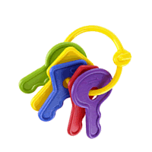FABULOSO BUNNY TOYS!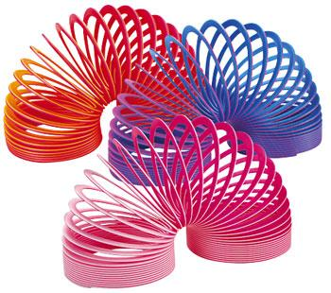

**Remember Bunnies need to play & chew**

- Small cardboard boxes
- Small willow and wicker baskets
- Dead sticks from the yard
- Old books, Magazines or Phone Books
- Shredded Paper in a litter box
- Raffia (Tie bows on boxes or on the side of the pen)
- Grass or Maize Mats
- Bare Wood (Without Paint or Varnish)
- Empty Toilet paper rolls
- Litter box of plain potting soil (no fertilizer)
- Scarf or towel to scooch and smooth
- Leather shoe to chew on
- Apple branches/twigs
- Grapevine Wreaths, Balls, & Baskets
- Bird & Cat Toys – like a ball with a bell inside
- Junk Mail (fold in half for grabbing)
- Notebook paper, Craft paper, Newspaper
- Cardboard castles (busybunny.com)
- Baby key rings
- Small wood blocks
- Small plastic teacup to throw
- Small plastic “slinkies”

