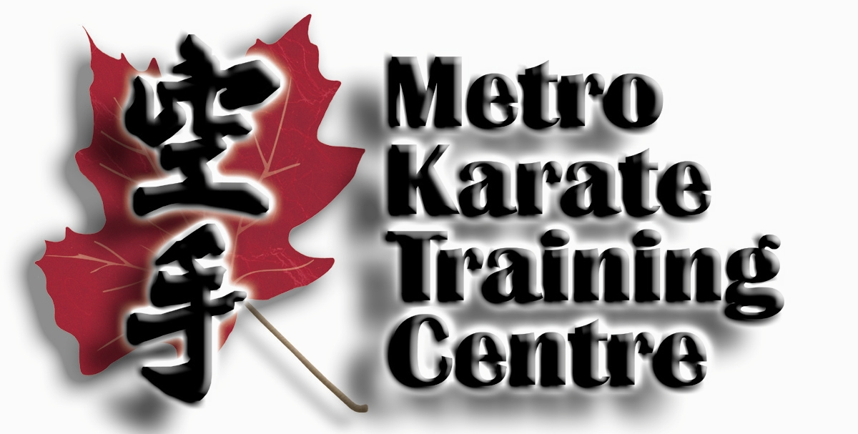

Sensei Ron V. Fagan

Sichidan (7th Degree)

Chief Technical Advisor, IKA

Head Instructor, Metro Karate Training Centre
211 Main Street, Dartmouth, NS, B2X 1S7
Dojo: 902-461-0808 Home: 902-466-4154

2005 – Present
Chief Technical Director: International Karate Alliance of Canada
- Dojos across Canada and the USA fall under Sensei Fagan’s Technical supervision
- Chief Technical Advisor to the New England Uechi-Ryu Team

1995 – 2005
Chief Technical Advisor to O’Sensei M. Tsuruoka, Tsuruoka-Do
- Mr. M. Tsuruoka, 9th Dan, Opened the 1st Dojo in Canada in 1956
- O’Sensei is recognized by the Canadian Government as the “Father of Canadian Karate”

Training Qualifications (All Belts Graded and Awarded By O’Sensei M. Tsuruoka)
2005 Black Belt 7th Degree – Sichidan International Karate Alliance of Canada
Endorsed By O’Sensei M. Tsuruoka
1997 Black Belt 6th Degree - Rokudan Awarded By O’Sensei M. Tsuruoka
1993 Black Belt 5th Degree - Godan Awarded By O’Sensei M. Tsuruoka
1989 Black Belt 4th Degree - Yodan Awarded By O’Sensei M. Tsuruoka
1985 Black Belt 3rd Degree - Sandan Awarded By O’Sensei M. Tsuruoka
1980 Black Belt 2nd Degree - Nidan Awarded By O’Sensei M. Tsuruoka
1974 Black Belt 1st Degree - Shodan Awarded By O’Sensei M. Tsuruoka

Highlights of Major Career Achievements:
Sensei Fagan has facilitated a wide range of Karate related development in the Province of Nova Scotia, Canada and Internationally. The following represents only highlights of his career achievements:

2004 Head Official, USA Uechi-Ryu Championships hosted by George Mattson

- Developed and Implemented the Junior Teaching Accreditation Program, Phase 1©

2002 Developed and Implemented the Teaching Accreditation Program, Phase 2©

2001 Tsuruoka National Championship, Calgary, AB — 1st Place Masters Division, Kumite & Kata
World Okinawan Championships, Atlanta, GA — 1st Place, Masters Kumite Division
Coached the USA Uechi-Ryu Team to 9 Medals: Officiated Finals at Center Ring

2000 Developed and Implemented the Teaching Accreditation Program, Phase 1©
International Karate Championships, Bermuda — 1st Place Masters Division, Kumite & Kata

1999 Tsuruoka National Championship, Kingston, ON — 1st Place Masters Division, Kumite & Kata

- Appointed Technical Advisor to Federation Ecuadorian De Karate
Organized and hosted Tsuruoka National Championship, Dartmouth, NS

1996 Appointed to the Referee Council of Canada

1995 Appointed by Lieutenant Governor in Council as the Martial Arts Coordinator for the Province on
November 4th, to the Nova Scotia Boxing Authority

1994 Appointed Chief Technical Advisor, by M. Tsuruoka, for the Tsuruoka-Do in North America
Was also asked to form the National Tsuruoka Federation

1987 Coached the Provincial NS Karate Team to a National Title in Halifax, NS

1986 Coached the Provincial NS Karate Team to 3rd Place

1981 Regina, Sask. — 2nd Place Black Belt Division, Kumite

1979 1st Atlantic Canadian to compete at Pan American Games, Etobicoke, ON — 4th Place Black Belt

1978 – 1984 Maritime Karate Champion, Black Belt Division, Kumite

1984 – 1986 Coach of Provincial NS Karate Team

1979 – 1981 Member: Team Canada Karate

1976 – 1986 Member: Nova Scotia Provincial Karate

Sensei Ron V. Fagan

Sichidan (7th Degree)

Chief Technical Advisor, IKAC

Head Instructor, Metro Karate Training Centre
211 Main Street, Dartmouth, NS, B2X 1S7
Dojo: 902-461-0808 Home: 902-466-4154

Highlights of Career Refereeing Experience
Pan American Union of Karate Organization (PUKO)
  - PUKO Junior Championships, Margarita Island, Venezuela,
    - September 1996 – Scored 95% on Refereeing Exam
  - PUKO Technical Seminar, Medellin, Columbia, May 28, 2000
    - PUKO Pan American Continental Kumite Referee

National Karate Association
      - Class “A” National Referee
      - World Union of Karate Organization, International
      - Class “B” International Referee
      - Founded Nova Scotia Karate Officials Association – 1994
      - Developed Officials Training Seminar and Materials widely used today
    - First two graduates scored highest marks in Canada in 1995 Nationals written tests
    - Program adopted by PEI, NB, ON, BC and implemented across Canada
      - Implemented Officials Training Program in New England State, 2003
      - Implemented Officials Training Program in Bermuda, 1999 – 2000

Overview of Career Associations and Affiliations:
          - Technical Director for Sport Nova Scotia
        - Regional Director for the National Karate Association
        - Nova Scotia Karate Officials Association
        - World Karate Federation (WKF)
        - International Traditional Karate Federation
        - Canadian Olympic Association

Other:

Sensei Fagan has designed dozens of technical Karate training methods to further the understating of Karate among students and works from a personal belief that every student should be seen as a future teacher. His superior technical understanding and ability attracts National and International attention.

Sensei Fagan is the originator of PK Kata as well as the Teaching Accreditation Program©. Both are recognized and taught widely throughout the Karate world.

On an International basis, Ron Fagan has been hosted in Hollywood, CA to professionally facilitate several celebrities training in Traditional Karate for movie roles.

Mr. Fagan actively pursues the design, development and implementation of Women’s Rape Awareness Training Programs and has appeared in several TV, Newspaper and Black Belt magazine spots.

He is well known and highly respected with regard to his past work with Community Based Programs such as the “Kids Against Drugs” Initiative and the “Victory Team” Program with celebrities such as David Winfield.

Ron Fagan continues to be a regularly sought speaker.

References Available Upon Request

