Nutrition Plus, Inc.
Emily Roark Patti Brenn Susan Morrell
(620) 221-2777 (620) 218-4994 (785) 224-4104
roark2@cox.net pattibrenn@cox.net smorrell12@gmail.com
October is:
- American cheese month
- Eat better, eat together month
- National apple month
- National chili month
- National dessert month
- National pasta month
- National pizza month
- National pretzel month
Important reminder:
Anyone without a new pink enrollment form on file will not be reimbursed for September. The old blue forms were ok for August, but the new pink ones are required for every child claimed in the month of September thru next August, 2020.

Provider resources available soon!
Nutrition Plus, Inc. is in the process of developing ways to help your participation in the Child and Adult Care Food Program (CACFP) become even easier!
Calendars are coming very soon and will be distributed at home visits for those of you that want to use them.
Binders are coming soon and will keep all of your food program paperwork in one place and will be big enough to hold all of your papers for the 4 years that are required.
Magnetic clips will be available for your refridgerators to hold menus and attendance right where you prepare and serve meals!
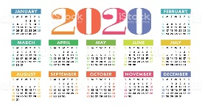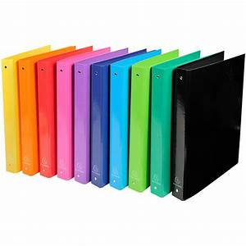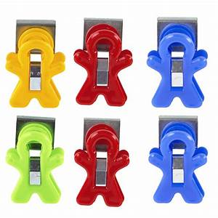
October 2019
New mailing address:
Nutrition Plus, Inc.
121 Mays Rd.
Winfield, KS. 67156

Fall Color Fun

The month of October brings a change of season. Leaves fall from the trees, and vibrant fall colors of gold, orange, yellow, purple, green, deep red, and magenta display mother nature’s fine work of art. Looking at the beautiful and different colors of leaves, think about bringing some into the classroom and teaching how colors of certain foods, like pumpkin and squash, can connect to a change in season. Other foods that represent fall colors are carrots, apricots, sweet potatoes; and in season foods like beets, pears, and Brussels sprouts.
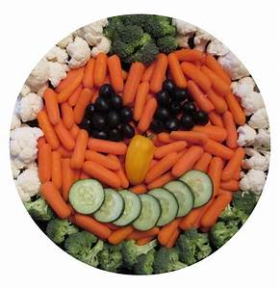
Nutrients and Vitamins
Nutrients provided by foods, like apples and Brussels sprouts are sources of vitamins A and C. Vitamin A contributes to healthy skin, vision, bone, and tooth growth. Vitamin C aids in iron absorption, protein breakdown, and immune system health. Talk to the children about how their body needs different vitamins in order to grow and develop properly. Sources of vitamin A include sweet potatoes and winter squash. Sources of vitamin C include citrus fruits, tomatoes and 100% tomato juice, and potatoes.

Fun Time Activity
Celebrate the season by having a fall picnic at your facility or home. Have chairs, mats, blankets, or other safe items for children to sit on indoors or outdoors. Use pictures of the foods mentioned earlier to place throughout the center, home, and outdoors. You may also take pictures of fall foods that you have made at mealtime, and place the pictures in obvious places. Include an activity on making binoculars. Plan to have children make binoculars the day before the fall celebration. For fun, have them look through the binoculars and find the pictures of some of the foods we have just mentioned. You can put pictures of the foods inside or outside, whatever works best for your child care facility. They will love looking through binoculars to find different foods. Toilet paper tube binoculars are inexpensive, easy and fun for all. They can be easily assembled by taping together 2 toilet paper tubes and tying a string at both ends.
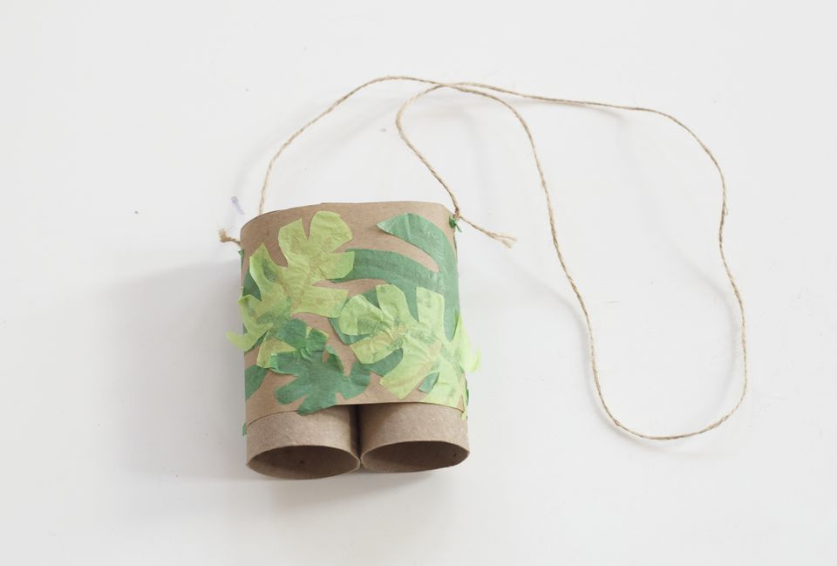
Don’t forget about the website:
www.nutritionplusinc.com
It has many helpful pages like a calendar of important dates, WIC link, printable forms, newsletters & reimbursement rates.

Apple Pizza Snack
1 lb. fresh, thinly slices apples (about 3)
¾ cup peanut butter
1 tablespoon raisins
1 tablespoon shredded coconut
1 tablespoon mini chocolate chips
1 tablespoon crispy rice cereal
- Prepare the base of the pizza by cutting the apples horizontally into circular slices. Try to get 8 complete slices per apple. Carefully remove any core and seeds. You can do this step ahead of time and store slices in the refrigerator sprinkles with a few drips of lemon juice to prevent browning.
- Fill small cups with a choice of toppings for each child.
- Spread ½ tablespoon peanut butter on each apple slice. Allow children to top their own “Pizza”.
Serving size: 2 pizza slices. Each serving provides ¼ cup fruit; ½ oz. meat/meat alternative.
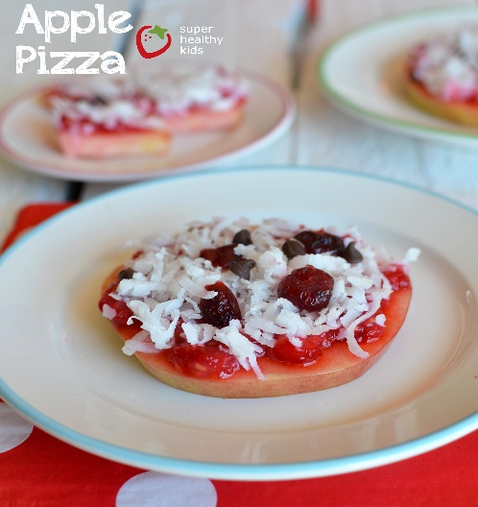

Thanks for being the best part of Nutrition Plus, Inc.
Emily, Patti & Susan

