“The rantings of mad players”; behind the scenes of the Wyrd Sisters

One month to go…

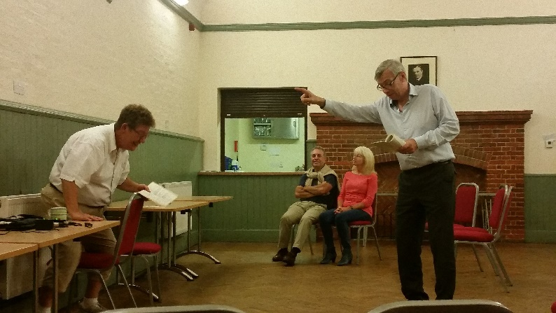
As the cast once again collapse into laughter, another Wyrd Sisters rehearsal grinds to a halt. This time, it was Paul’s high-pitched and timid approach to playing Death, last time it was the trio of “secret black and midnight hags”, and no doubt we will find more ways of making each other laugh as opening night draws closer. A rehearsal with the Winslow Players is never boring, and with the combination of Terry Pratchett’s wonderful words and the cast gradually building on their portrayal of the Disc World characters, it is inevitable…Director Derry pulls the cast (and herself!) back on track, and the rehearsal continues. With a month to go, the cast is running through the second half. Scripts are starting to be put down, and the Players’ regular prompt Carol finds herself very busy correcting our “best guess” at the next line. Terry Pratchett is a master with words, and having chosen his work as part of our 50 year anniversary year, it is important to get it right. If only it was slightly easier to take them all in…

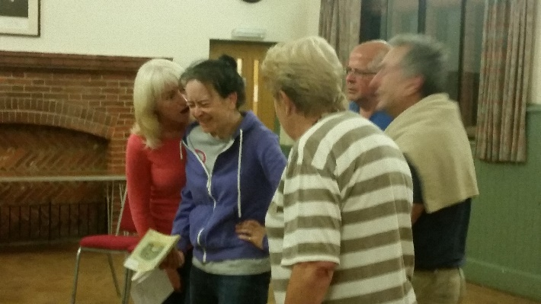
Rehearsing in the St Lawrence Room, a little imagination is needed to picture the end result, but it is coming together. The cast are gradually honing their performances. The climax of the production includes Chris as the Duke lose the remainder of his marbles whilst watching a “play within a play”. His protracted death scene grows in each rehearsal, making everyone laugh by continuing to “die” long after he’s left the stage. That stays in - and once performed, gets a laugh from the audience every night!

The three witches take to the “stage” and close off the rehearsal with the final scene of the play. It has been successful, and is really starting to pull together. The cast can say their words, frequently in the correct order and occasionally at the right time, and the movement is gradually pulling together. If only they get through a rehearsal without collapsing into giggles…

Three days to go…

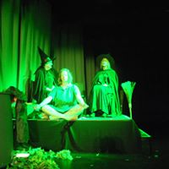
It is suddenly October. The lights are up, and stage blocks are in place. The rehearsals have moved over into the Public Hall, and with the cast in costume it is really possible to see how it will all start to come together. The new lights, installed just before the last pantomime, look great separating the different sections of stage; it is just a case of not wandering off and ending up in darkness. Inevitably, a few of us do this continually, meaning that more masking tape appears on the stage in an effort to remind us to stay where we can be seen. Special effects are tried out, and lightning, explosions, and earthquakes are all really effectively put together and operated by Phil and Roger, timed to perfection to keep the magic going. Also new for the year are our curtains, looking fantastic as they frame the stage. It doesn’t take much to make us happy, and new equipment definitely ticks the boxes!

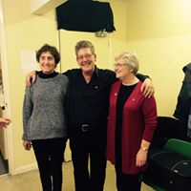
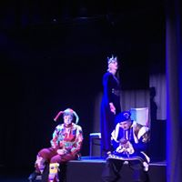
The cast have finally perfected their poker faces, and all those not on the stage are in the dressing room, meaning that it is down to director Derry to keep laughing in the right places. And boy does she laugh! So close to the first performance, nerves are far more in evidence. Forgotten lines, previously a minor annoyance, start to become a far scarier prospect, and everyone is glad to have Carol on standby to put us back on track. Final touches are being added, whether it be planning out how two of the witches will fly around the kingdom (to the tune of Ride of the Valkyries is the answer to that one) or adding mystified looks from the cast when a dramatic sound effect is played. It’s these small touches that really bring it together when the audiences are in.

Our final rehearsal is the dress rehearsal, where other members of the Players are invited to be our first audience. It’s our first chance to see how it fairs with those not involved… and it goes well! Hearing them laugh at all the parts we found funny, and some of those we had forgotten were funny, gives a real boost. Opening night is here, and we are ready to go..!

The performances…

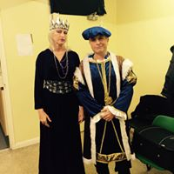
Among the general chaos that accompanies the opening night, there is a quiet confidence in the cast. The performance has sold well, and with more people buying tickets on the door the hall is swiftly full. It is a great feeling to have so many people coming to see the play, and to finally be able to share the fun we had in rehearsal! Paul and Chris are working hard on the make-up, and everyone looks fantastic, including Ian as the late king in a very ghostly shade of green and white.

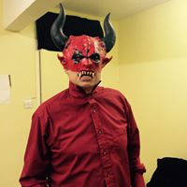
The cue soon comes round, with the opening chords of Danse Macabre being the cue for the three witches to take to the stage. As Derry welcomes the audience to the first of our 50th season’s productions, behind the curtains Margaret starts to knit, and Theresa and Kyrsty take up their positions ready to start. Sue lines up by the curtains, waiting for the lights to go down and to get the show on the road…

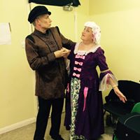
All three audiences are great, laughing right from the start as Granny Weatherwax digs out her diary to work out exactly when the three witches will “meet again”. They keep laughing with us as we hear about Roger and his “trouble”, as the Demon, visually brilliant, makes his appearance, and as the Duke and Duchess get their comeuppance. A visit from a Terry Pratchett fan group is met with some nerves on the Friday night, especially when we discover they have brought their own props (which are brought backstage for us to see in the interval). The nerves turn out to be for nothing; a 5* review from them on Facebook results in a lot of smiles among the cast and crew.

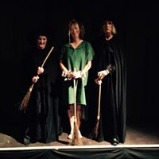
There are, of course, some mishaps along the way. The combination of stage blocks and blackouts catches some cast members out, seeing some bumps and bruises being picked up, and some lines disappear never to be seen or heard again. But the show, as they say, must go on, and if the audience notice, it doesn’t dent their enthusiasm! All too soon, the final bows are taken and the curtain closes on the production. It has been a fantastic success, playing to full houses, and being all we could have hoped for to start our 50th year celebrations. All credit needs to go to the cast and crew who have worked really hard to bring the play to life over the past few months, and who now have a well-deserved break…

…well, at least until panto rehearsals start!

