MARYWOOD UNIVERSITY
Ph.D. in Human Development

SELF-EFFICACY AMONG STUDENTS OF COLOR AT PREDOMINANTLY WHITE INSTITUTIONS OF HIGHER EDUCATION IN NORTHEASTERN PENNSYLVANIA

by
Leon John, Jr.

Submitted in Partial Fulfillment of the Requirements for the Degree of Ph.D. in Human Development

February, 2019
ACKNOWLEDGEMENTS
Firstly, I would like to thank my committee, especially my committee chair, Maria Montoro Edwards, Ph.D. who acted as both a motivator and mentor for the duration of my research and preparation of material. Other members of my committee, Amy Paciej-Woodruff, Ph.D., whose advice and guidance helped to make the journey easier among rocky times, and Lia Richards-Palmiter, Ph.D. who was the constant voice in my ear, and encouraged me to keep going, and who helped me tremendously by giving me direction.
Along the way, there were other people who served as motivators, and were tremendous influencers for me to cross the finish line. The names are too numerous to mention, but for anyone who helped me and offered insight to make me think outside of the box, I thank you.
Finally, none of this would be possible without the support and encouragement of my family. For my parents who constantly kept asking me if my work was finished, and constantly reminded me that the end was near. For my son, Kian, whose future is the reason why I chose this topic so that he and others like him can have an easier path than those who have preceded him.
Lastly, and most importantly, my wife, Luciana. Her encouragement and words were the foundation of which this research was built. None of this would have been possible without her. I am forever grateful and blessed to have such a great support system in her. She helped me to realize that this research is important and is needed to start a conversation among institutions of higher education.

TABLE OF CONTENTS
LIST OF TABLES ..…………………………………………………………………………… 5
LIST OF FIGURES ………………………………………………………………….………… 6
Abstract ………………………………………………………………………………………… 7
CHAPTER 1: INTRODUCTION ……………………………………………………………… 8
Statement of the Problem ………………………………………………………………. 8
Theoretical Framework ………………………………………………………………… 15
Conceptual Framework ………………………………………………………………… 16
Purpose Statement ……………………………………………………………………… 17
Research Question ………………………………………………………………………17
Sub Problems ……………………………………………………………………17
Hypotheses ……………………………………………………………………………... 17
Definition of Terms …………………………………………………………………….. 18
Delimitations …………………………………………………………………………… 23
Limitations ………………………………………………………………………………24
Assumptions ……………………………………………………………………………. 24
Rationale and Significance of Study …………………………………………………… 24
CHAPTER II: REVIEW OF THE LITERATURE ……………………………………………. 27
Introduction …………………………………………………………………………….. 27
Conceptual Framework of Academic Achievement …………………………………… 28
Conceptual Framework of Personal Identity …………………………………………... 31
Conceptual Framework of Campus Climate …………………………………………… 34
Conceptual Framework of Campus Resources ………………………………………… 37
CHAPTER III: RESEARCH METHODOLOGY ……………………………………………... 42
Research Design ……………………………………………………………………….. 42
Participants …………………………………………………………………………….. 42
Instrument ……………………………………………………………………………… 42
Procedure ………………………………………………………………………………. 45
Analysis of the Data …………………………………………………………………… 46
CHAPTER IV: RESULTS/FINDINGS ……………………………………………………….. 48
Sub Problem 1 …………………………………………………………………………. 50
Sub Problem 2 ………………………………………………………………………….. 51
Sub Problem 3 ………………………………………………………………………….. 53
Sub Problem 4 ………………………………………………………………………….. 54
Conclusion ………………………………………………………………………………58
CHAPTER V: DISCUSSION ………………………………………………………………….. 59
Summary of Results ……………………………………………………………………. 59
Interpretation of Results ………………………………………………………………... 61
Social Identity Theory ………………………………………………………………….. 63
Implications …………………………………………………………………………….. 63
Limitations and Recommendations for Future Research ………………………………. 66
Conclusion ……………………………………………………………………………... 68
Bibliography …………………………………………………………………………………… 70
APPENDIX A ………………………………………………………………………………….. 77
APPENDIX B ………………………………………………………………………………….. 81
APPENDIX C ………………………………………………………………………………….. 82
APPENDIX D ………………………………………………………………………………….. 83

LIST OF TABLES
Table 1: PWI Population Information ………………………………………………………….. 43
Table 2: Analyze Ethnicity/Race Responses ………………………………………………….. 49
Table 3: Analyze Mean Responses for IV1 ……………………………………………………. 51
Table 4: Compare Mean Responses for IV2 …………………………………………………… 52
Table 5: Reliability Test for IV2 ……………………………………………………………….. 53
Table 6: Compare Mean Responses for IV3 …………………………………………………… 54
Table 7: Reliability Test for IV3 ……………………………………………………………….. 54
Table 8: Compare Mean responses for IV4 ……………………………………………………. 55
Table 9: Reliability Test for IV4 ……………………………………………………………….. 56
Table 10: Pearson Correlation for DV and Ethnicity/Race, IV 1-4 ……………………………. 56
Table 11: Reliability Test of IV’s 1-4 ………………………………………………………….. 57

LIST OF FIGURES
Figure 1: Theoretical Framework of Social Identity Theory ………………………………….. 15
Figure 2: Conceptual Framework ……………………………………………………………… 16

ABSTRACT
This study measured self-efficacy (DV) as it related to academic achievement, personal identity, campus climate and campus resources (IVs) among 1,156 students of color (SOC) at three predominantly white institutions of education (PWI) in Northeastern Pennsylvania (NEPA). Social Identity Theory was used as the conceptual framework to examine the predictors of self-efficacy. The Student Satisfactory Inventory (SSI) administered by Noel Levitz was used as the instrumentation to gather responses of SOC and assess their self-efficacy. Responses to the question of overall satisfaction on the SSI were used to measure self-efficacy. The results yielded significant correlations among academic achievement, personal identity, campus climate and campus resources as it related to self-efficacy among SOC. Multiple questions were analyzed that related to each of the independent variables. Supplemental analyses were used to test the reliability and validity of the relationship of each question as it related to each of the IVs. Analysis showed that each of the IVs were important for SOC to have a positive relationship with the PWI they were enrolled. In an effort to recruit and retain SOC, and ensure their success, PWI need to closely examine the data from SOC from surveys like the SSI.

CHAPTER I: INTRODUCTION
Statement of the Problem
According to the United States Census Bureau, in 2010 the population in Pennsylvania was 81.9% white and 18.1% people of color, up from 14.6% from the previous census (www.census.gov). People of color are defined as Black or African American, American Indian and Alaskan Native and its subgroups, Asian and its subgroups, Native Hawaiian and Other Pacific Islander and its subgroups, some other race and its subgroups, or two or more races and its subgroups. As demographics continue to change, the children of these growing ethnic groups are enrolling at institutions of higher education in Pennsylvania that are predominantly white institutions (PWI).
Colleges and Universities nationwide are becoming more diverse ethnically and culturally but are not making any changes to accommodate the influx of different cultures to their campuses (Harwood, Huntt, Mendenhall, and Lewis, 2012). In research conducted by Stacy A. Harwood and others, students of color (SOC) face both subtle and outward forms of racism at PWI (2012). Even though SOC benefitted from their experiences at an institution of higher education, they were treated differently by their white peers, staff, and administration of PWI. Some felt that there was no one from the staff or administration to whom they could depend on for support (Harwood et al., 2012). SOC who were involved with campus life cited experiences that ranged from jokes that were racially motivated, to racial slurs from their peers and from others who worked on campus. Even though some of these experiences were unconscious, Harwood et al. (2012), suggested that administration needs to implement more conversation and diversity training for the entire campus community to avoid such instances. They also suggested that PWI should employ more faculty and staff to whom SOC can relate, and to whom they can lean on for support (Harwood, et al 2012), if they intend to increase their number of SOC as a means to diversify the student body. PWI enroll diverse student populations but have not done much to change or enhance the culture by offering student support for SOC. As a result, SOC do not feel that the institutions make an integrated effort to change the overall culture on campus that would make them feel welcome, and it deters them from being successful academically and acclimating to the campus (Harwood et al., 2012).
In The Agony of Education: Black Students at White Colleges and Universities written by Vera Feagin and H. Imani (1996), PWI choose to encourage SOC from underrepresented populations to enroll (Feagin & Imani, 1996). This occurs so that PWI can diversify their population by adding SOC. SOC who are encouraged to attend PWI are already aware that they are going to be part of a population where they are the minority, because they feel that that is representative of the workforce they will experience upon graduation (Feagin & Imani, 1996). The authors suggest that due to SOC experiences at PWI, SOC felt unequal to their white peers and that affected them as it related to SOC fitting into the campus climate. PWI who increased their efforts to attract SOC to enroll offered attractive financial aid packages, or promised academic programs that were unattainable at other institutions created opportunities for SOC to feel welcome.
PWI rely on campus resources such as added student programming, campus clubs and organizations, as well as co-curricular activities that include athletics. PWI also suggest that faculty change their courses to include more politically correct material as an attempt for SOC to feel more comfortable with their surroundings. As Feagin & Imani (1996) state, these efforts did not work as SOC still felt very disconnected with the campus community. Even though student programming, student clubs, and student organizations offered opportunities for SOC to socialize with similar students, the programs were run by faculty and administration who had been there prior to the enrollment efforts for a more diverse population. The same can be said for co-curricular activities (can include athletics) and the in-class lesson plans by tenured faculty (Feagin & Imani, 1996).
The three PWI that this author chooses to examine all include messages of diversity in the body of their respective Mission Statements. PWI A states that it “challenges individuals of all backgrounds to achieve their full potential and make choices based on spiritual and ethical values,” (2018). PWI B in one of their Value statements, states that it embraces “differences and uniqueness through sincerity, awareness, inclusion and sensitivity,” (2018). PWI C states that it “creates an environment that fosters intellectual curiosity, critical thinking, and respect for persons in an environment where all are welcome,” (2018). In each of these examples, SOC would be encouraged to enroll with the expectation that the PWI will create a campus environment where they will not feel excluded.
Students also consider other factors beyond academic programming, such as smaller classroom size, availability of campus resources, and campus climate before they decide to enroll at a small to mid-size PWI (Welton & Martinez, 2014). Even though parents and family members try to prepare theses students for college enrollment (Wells et al., 2009), SOC are faced with very difficult tasks of assimilation once enrolled at a PWI. The factors that attracted them and their parents to enroll are secondary to the issues they face socially from their white peers (Welton & Martinez, 2014).
According to research conducted by Anjale Welton and Melissa Martinez in 2014, SOC who are prepared to enroll at PWI are ready for a rigorous academic challenge and recognize that smaller to mid-size PWI will provide them with easier access and interaction with faculty and administration and support services. However once enrolled at the PWI, SOC felt that they did not belong. One reason was due to the SOC’s belief of social identity and how it relates to them as people (Hurtado, Alvarado, Gulliermo-Wann, 2015). As much as they were prepared for the academic rigors, if SOC felt that they did not belong, it led to problems such as failure to fit in, bad academic standing, and decreased interest in continuing their educational experience (Hurtado et al., 2015). Campus expectations among SOC not being met include support services that relate directly to them, availability of co-curricular activities, and personal attention from faculty. Their feelings of self-efficacy were challenged, and made them feel as though they are not part of the larger campus community because of their personal categorization of being a minority (Welton & Martinez, 2014).
A feeling of not belonging to the larger campus community along with the lack of self-efficacy becomes the root of the problem for SOC. These issues can result in SOC not being able to fulfill their academic goals and PWI will not be able to retain SOC. Without the support services and opportunities that they need, SOC encounter issues and problems in the campus environment that are compounded by the rigors of academic achievement (Welton & Martinez, 2014).
Self-efficacy is directly related to overall satisfaction among college students (DeWitz & Walsh, 2002). In a study conducted among 312 college students, a regression analysis was used to show a significant relationship between self-efficacy and overall satisfaction among college students. Students were administered a survey and indicated that they were satisfied with social interactions and classroom interactions at their college campus. This question addressed their feelings of self-efficacy and the results revealed that there was a significant association between overall satisfaction and self-efficacy.
The researcher in this study will use overall satisfaction as a means to measure SOC self-efficacy as it relates to academic achievement, personal identity, campus climate, and campus resources.
Social Identity Theory

PWI recruit more SOC in an effort to maintain a diverse climate on their campuses. In doing so, they have not added any services or introduced an overhaul of their campus life structure to accommodate the influx of SOC. Once enrolled, SOC feel like they do not belong to the campus culture (Harwood et al., 2012). This can be attributed to a number of issues, but the major reason is that SOC feel as though they do not belong because of the color of their skin and cultural background, and thus feel discriminated against as a group.
According to Tajfel and Turner (1979), social identity theory is defined as one population’s feeling of self-belonging to a certain group because of their own background. These individuals choose to identify with a group because of shared interests, affiliations, gender, age or race. This allows individuals to define who they are and what group they belong to in society. It also helps individuals to define others by recognizing them as belonging to the same group as they do, or belonging to a different group altogether. By placing themselves in one group, they can systemically view others as belonging to other groups (Ashforth & Mael, 1989). This theory can be applied to SOC and their feelings about belonging while enrolled at PWI in Northeastern Pennsylvania. Social Identity Theory can be applied to how SOC feel that they belong to the same cultural group as other SOC.
Regardless of differences in academics, socioeconomics, and personal interests, Ashforth & Mael (1989) suggested social identity theory forces SOC to place themselves in a group with each other because of their physical similarities; that is, they are not white while the majority of their peers, staff, and administration are white. Based on how SOC perceived how the campus community views them, as well as their feelings of self-efficacy, they viewed themselves as being a part of an in-group or out-group.
SOC believe that their experience at a PWI would be different from students who are white. Perceptions of the racial climate on campus are due to how SOC feel they are being viewed by the campus administration and their white peers, as well as the availability of social spaces and interactions they experience on campus (Lowe, Byron, Mennicke, 2014). They stated that classroom interaction with faculty leads to microagressions that set them apart from their white peers (Lowe et al., 2014). Faculty expect SOC to speak to their personal experiences in class and assume SOC will inject diversity into the curriculum. This sets SOC apart from their white counterparts and contributes to their feelings of being part of a separate group.
Social Identity Theory suggests that individuals who feel that they belong to a certain group would want that group to fit in or be the in-group. Tajfel and Turner (1979), referred to this as social categorization. Because SOC believe that they do not belong in a campus climate that is predominantly white, or a campus climate that offers no additional resources to them as SOC, they believe they belong to the out-group. This immediately places SOC at a disadvantage because Social Identity Theory suggests that no group wants to be the out-group (Tajfel and Turner, 1979). Even though SOC view themselves as belonging to the same group because of their backgrounds and cultures, regardless of their interaction with each other or their shared likes and/or dislikes, their primary similarity that defines them as belonging to the same group would be that they are not white.
Tajfel and Turner (1979) also state that everyone places a label on groups to help cognitively identify who they are. For example, the labels of “hipsters” and “geeks” are distinctions given to groups. When these labels are mentioned, an immediate reaction or physical characterization is formulated in one’s brain. SOC do not feel that they belong to the larger community, and may feel negatively toward their social group status. As a result, they formulate the presumption that they are the out-group. In an article written by Rankin and Reason (2005), SOC are more likely to be harassed, to be discriminated against, and to feel that they do not have a peaceful learning environment as compared to their white peers at PWI, and are victims of racial microagressions.
Faculty and staff may unconsciously single out SOC in the classroom, or SOC may feel that there are stereotypical views when they choose to participate in activities such as clubs or organizations and/or athletics. This plays a part of the social standing that the SOC may feel that they have on a campus that is a PWI (Johnson, Wasserman, Yildirim, ad Tonai., 2014). SOC view racial biases and discrimination at PWI differently than their white peers. SOC also view the campus racial climate as an integral part of how the campus community views them. Lack of response from the PWI as it deals with issues of racial diversity, stereotypical prejudices, and lack of education are all indicators of how SOC feel that they do not fit into the campus environment. This also contributes to how SOC feel they are perceived by their white peers and staff and administration as an out-group (Johnson et al., 2014).
Figure 1: Theoretical Framework 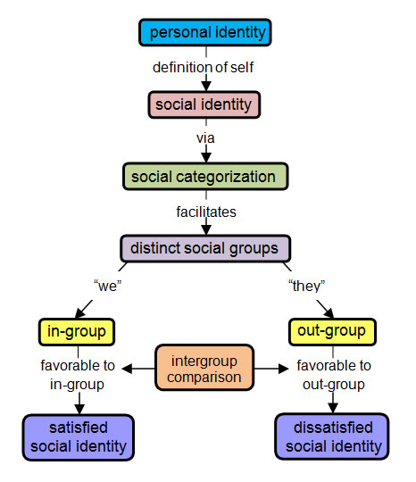
Each branch of the model above displays the stages SOC have to go through before they feel that they are part of either the in-group or out-group. When SOC enroll at PWI their personal identity is already defined. SOC already know who they are. In order to realize where they fit into the social setting of the campus, SOC develop a social identity. Based on how they feel at PWI, their social identity forces them to feel categorized and then to realize that they are part of a social group which can be defined as either an in-group or an out-group. The in-group typically has the favorable outcome, as they have found a place of belonging in the overall campus community. The out-group, however, has a harder time in successful outcomes (socially and academically), as they feel as though they are not part of the larger community. Each stage progresses from one to the other as SOC come to a realization of their place in PWI. The basis of this study is to examine the reason why SOC believe that they are part of the out-group.

Figure 2: Conceptual Framework

The middle block represents the dependent variable (DV), self-efficacy among SOC and is measured by SOC overall satisfaction of the PWI. The first independent variable (IV) would be academic achievement that is defined by how SOC perceive academic success in their current environment. The second IV, personal identity, is the root of how SOC view themselves as fitting into a larger group of which they are the minority. The third IV is campus climate and is defined by SOC perceptions of campus life from a social aspect, as well as how they feel they are viewed as a population. The fourth, and final IV would be campus resources that SOC feel that they have available to them such as access to student services, educational programs that offer SOC opportunities to connect with each other and their white peers, and opportunities to participate in co-curricular activities that would interest them.
Purpose Statement
The purpose of this study is to explore the self-efficacy of SOC (DV) at three mid-size, private institutions of higher education in Northeastern Pennsylvania (NEPA) which are also PWI. Academic achievement, personal identity, campus climate, and resources on campus, of SOC (IVs) are the values that will be examined as to how they relate to self-efficacy.
Research Question
How does Self-Efficacy among College Students of Color (SOC) Affect their Perception of Overall Satisfaction at Three Mid-Size Colleges in Northeastern Pennsylvania (NEPA)?
Sub Problems
- Does academic achievement relate to how SOC feel about self-efficacy at PWI in NEPA?
- Do SOC feel that personal identity is important to them at PWI in NEPA where they are enrolled?
- Do SOC feel a sense of belonging once enrolled at a PWI in NEPA?
- How do SOC feel that the campus community supports them at their PWI in NEPA?
Hypotheses
- (Hn01) Academic achievement is not important for SOC as it relates to self-efficacy at PWI in NEPA.
- (H01) Academic achievement is important for SOC as it relates to self-efficacy at PWI in NEPA.
- (Hn02) SOC do not feel that the campus community is integral as it relates to self-efficacy at PWI in NEPA.
- (H02) SOC feel that the campus community is integral as it relates to self-efficacy at PWI in NEPA.
- (Hn03) The Student Satisfaction Inventory (SSI) will not show that SOC are satisfied with their overall experience of campus climate at institutions of higher education in NEPA.
- (H03) The SSI will show that SOC are not satisfied with their overall experience of campus climate at institutions of higher education in NEPA.
- (Hn04) SOC do not feel that campus resources are important as it relates to self-efficacy at PWI in NEPA.
- (H04) SOC feel that campus resources are important as it relates to self-efficacy at PWI in NEPA.
Definition of Terms
Students of Color (SOC)
Undergraduate students who are not white and who self-identify as not being white. The self-identification will be based on responses that students gave on the instrument that was used for this study. Students define themselves as American Indian/Alaskan, Asian, Black, Hawaiian/Pacific Islander, Hispanic, Non-Resident Alien, two or more races, or other/unidentified.
Mid-Size College/University
An institution of higher education that has between 3,000 and 8,000 enrolled students (according to The Carnegie Classification of Institutions of Higher Education ®).
Northeastern Pennsylvania (NEPA)
The metropolitan statistical area in Pennsylvania that includes the counties of Bradford, Carbon, Columbia, Lackawanna, Luzerne, Monroe, Montour, Northumberland, Pike, Schuylkill, Sullivan, Susquehanna, Wayne and Wyoming County (U.S. Census Bureau, 2017). This study will reference colleges/universities in Lackawanna and Luzerne counties.
PWI
Predominantly White Institutions. This is defined as institutions of higher education that have at least 50% of students who are white (Hurtado et al., 2015). Each of the mid-size, private institutions of higher education used in this study qualifies as such.
Student Satisfaction Inventory (SSI)
Instrument used to determine student satisfaction as measured by the quality of campus life and living (Noel Levitz, 2017) using a Likert Scale and administered to college students.
Self-Efficacy
The confidence that allows one to execute behaviors necessary for self-attainment, and to control the social environment and one’s own motivation (American Psychological Association, 2010). Self-efficacy is directly related to overall satisfaction (Dewitz & Walsh, 2002). SOC’s responses to their overall satisfaction will be used to measure self-efficacy. The numbered statement as it appears on the SSI is:
100. Rate your overall satisfaction with here thus far:
(1) Not satisfied at all
(2) Not very satisfied
(3) Somewhat dissatisfied
(4) Neutral
(5) Somewhat satisfied
(6) Satisfied
(7) Very satisfied
Academic Achievement
A measure of one’s standing in an academic setting at a college/university as it relates to their achievement academically (University of Waterloo, 2015). This is measured on the SSI by asking participants to choose what their GPA is at the time of the administration of the survey. The six-point scale is measured from No credits earned to 3.5 or above. The numbered statement as it appears on the SSI is:
108. Current GPA:
(1) No credits
(2) 1.99 or below
(3) 2.0 - 2.49
(4) 2.5 - 2.99
(5) 3.0 - 3.49
(6) 3.5 or above
Personal Identity
A sense of identity one has with a group that makes them feel comfortable and that they and members of the group matter to each other. It can also be a belief that their needs will be met through their commitment to each other (McMillan and Chavis, 1986). It is used in this study to measure self-efficacy among SOC based on questions addressed in the SSI. The numbered statements as it appeared on the SSI are:
1. Most students feel a sense of belonging here.
25. Faculty are fair and unbiased in their treatment of individual students.
37. I feel a sense of pride about my campus.
45. Students are made to feel welcome on campus.
62. There is a strong commitment to racial harmony on this campus.
The questions were selected based on research conducted by Rodgers & Summers (2008) and Sue, Capodilupo, Torino, Bucceri, Holder, Nadal, and Esquilin (2007).
Campus Climate
Atmosphere by which students feel safe, connected to the campus community, and feel a sense of belonging. A positive campus climate yields friendly interactions with all members of the campus, and students feel a sense of belonging in the classroom and in a campus social setting (Harwood, Huntt, Mendenhall, and Lewis, 2012). It is used in this study to measure self-efficacy among SOC based on questions addressed in the SSI. The numbered statements as it appeared on the SSI are:
45. Students are made to feel welcome on campus.
25. Faculty are fair and unbiased in their treatment of individual students.
59. The faculty shows concern for students as individuals.
The questions were selected from the SSI based on research conducted by Watkins, LaBarrie, and Appio (2010), and Sandoval-Lucero, Blasius, Klingsmith, and Waite (2012).
Campus Resources
Campus spaces, opportunities on campus, and faculty/administration that provide opportunities for SOC to be themselves and to interact with others like them (Museus and Saelua, 2017). It is used in this study to measure self-efficacy among SOC based on questions addressed in the SSI. The numbered statements as it appears on the SSI are:
46. I can easily get involved with campus organizations.
52. The student center is a comfortable place for students to spend their time.
65. Faculty are available during after class and during office hours.
71. Channels for expressing student complaints are readily available.
Administration
Staff that are within the student life/affairs division who encourage students to get involved with the development of social, leadership and student life based activities. They also can include staff who are dedicated to the acclimation of students to the college/university campus.
Diversity
The inclusion of different types of people as it relates to different races and cultures in a group or organization (Merriam-Webster, 1963).
Perception
The way one thinks of or understands something about their current situation (Merriam Webster, 1963).
Carnegie Classification
Framework whereby institutions of higher education are rated and classified by the Carnegie Commission of Higher Education. Classifications are based on data received by the Integrated Postsecondary Education Data System (Carnegie Classification of Institutions of Higher Education, 2017).
Delimitations
- This study is delimited to SOC at three anonymous private, mid-size institutions of higher education in NEPA.
- Delimited to SOC from all years of matriculation at three anonymous private, mid-size institutions of higher education in NEPA.
- Delimited to SOC who have taken the Form A of the Noel-Levitz Student Satisfaction Inventory (SSI) during the 2015-2016 academic year.
- Delimited to SOC of all socioeconomic and demographic backgrounds.

Limitations
- SOC from different years of matriculation may respond to the questions differently.
- SOC gender roles may also play a part in how they respond to the questions.
- Due to the lack of diversity in NEPA in general, SOC may respond differently than if they were enrolled at another institution of higher education elsewhere in the state where there is a more diverse population.
- SOC may not reflect their proper ethnicity due to confusion or misinterpretation.
Assumptions
- Private institutions of higher education in NEPA are not equipped to provide SOC with the adequate support services that they need.
- SOC will respond to the survey truthfully which will not affect the integrity of the data received.
- The SSI is a thorough survey, and it measures student satisfaction without bias.
Rationale and Significance of Study
Student satisfaction surveys are conducted at institutions of higher education to address the way that students feel on college campuses (Senior, Moores and Burgess, 2017). Institutions of higher education have moved towards the consumer model which suggests that incoming freshmen have an expectation of resources and facilities in addition to the education that they will receive from that institution of higher education (Senior et al., 2017).
This study is looking more closely at three private mid-size institutions of higher education in NEPA. This specific geographic region was chosen because of the proximity of the institutions of higher education from major cities in the Northeast region of the United States, and the increasing diverse demographic of the region that is presently predominantly white. SOC are being recruited to increase the diverse populations on campus without the hiring of new staff, or realigning of duties for existing staff to help support SOC (Hurtado et al., 2015). The support to engage SOC at their enrolled PWI and help them acclimate is not as strong as it needs to be at institutions of higher education in NEPA. Without proper support, SOC will not be able to succeed academically or socially at a PWI (Hurtado et al., 2015).
Social Identity Theory (Tajfel & Turner, 1979) suggests that SOC at the three institutions of higher education in NEPA are going to feel self-conscious regarding their race and will feel that they do not belong. Tajfel & Turner suggest that SOC will also be more aware of their racial identity, and their feelings of the lack of similarity with their white classmates because of the color of their skin, or cultural beliefs (1979). This can lead to SOC not enjoying their college experience because of their belief that they have to try harder to fit in. It can also lead to a negative perception of the campus climate as they feel that administration will not do a good job in helping them to acclimate (Lowe, et al, 2014). This will ultimately lead to SOC not having as much academic success in the classroom as their white classmates.
The Student Satisfaction Inventory, a student survey conducted by Ruffalo Noel Levitz, “strengthens the quality of the student experience through precise, comprehensive student assessment (2017).” The survey is administered to all enrolled undergraduate students to expose areas that need improving at institutions of higher education. The survey aids with retention efforts as administration is expected to improve areas that are lacking resources as reported by students who take the survey. In 2013, the reliability of the survey was tested against the College Student Satisfaction Questionnaire, and using Cronbach’s Alpha, validity was proven with all values measuring .70 and above. The three institutions of higher education in NEPA which are used in this study were identified based on their similarities and classification according to the Carnegie Classification index (2015). Each of the three institutions of higher education in NEPA are classified as mid-size, four year or above, private-not-for-profit institutions of higher education.
This study will help to identify how SOC at institutions of higher education in NEPA feel, and it can help administrators realize what changes are needed for SOC to become more comfortable with the campus climate. Students’ identity is governed by their academic success and their involvement with extra- curricular activities and campus life (Hurtado et al., 2015). If SOC feel like they do not belong, or that they are being ignored by the administration, their lack of success in and out of the classroom will contribute to their wanting to transfer, drop out of college altogether, or have negative feelings about their own identity as a SOC. If administration makes changes to help SOC feel more connected to the campus climate, it can increase retention rates and aid with recruitment efforts that focus on diversity. This will also give SOC an opportunity to succeed in the classroom and participate in campus life and extra-curricular activities.

CHAPTER II: REVIEW OF THE LITERATURE
Introduction

In their book published in 2013, Identity development of college students: Advancing frameworks for multiple dimensions of identity, Susan Jones, Elisa Abes, and Marcia Baxter Magolda defined identity as “socially constructed and located in larger structures of privilege and oppression,” (p. xxi). The authors also stated that within one’s personal identity exists multiple social identities such as race, gender, sexuality, and social. Regardless of class Jones, Abes and Magolda (2013) suggest that social identity is related to what one is experiencing in a larger community. For SOC enrolled at a PWI, the lack of self-belonging as it relates to the campus community will correlate to how they identify themselves.
Many PWI are increasing their enrollment of SOC through increased outreach to diverse populations while some are not. This is as the nation’s population is becoming more diverse (Hurtado et al., 2015; Garces, Liliana, and Cogburn, 2015). SOC enrolled at PWI that are not increasing their efforts to diversify their campus community encounter fewer feelings of self-belonging, and feel that PWI are not providing them with the ample support they need to succeed academically and socially (Garces et al., 2015). Researchers suggest that when students enrolled at institutions of higher education regardless of their race have perceptions that administration and faculty do not respond to their needs, whether it be academic or social, that they are being treated unfairly and that they are not part of the campus community. Some PWI are not increasing their diversity programs despite the fact that the population in the United States of America continues to become more diverse (Harwood et al., 2015), and SOC are presented with additional struggles to assimilate to a campus environment which they will not experience in the same way as their white peers (Museus, Yi and Saelua, 2017).
Conceptual Framework as it Relates to Academic Achievement
SOC who successfully matriculate from PWI have an easier time adapting to environments that are predominantly white (Harper & Hurtado, 2007). Their experiences at PWI that have environments that are nurturing to them through faculty/staff/administration equipped them to have a higher chance of being successful in the classroom, and also had a positive effect on the development of their cognitive, psychological, interpersonal and communication skills (Turner, Hewstone, Voci, and Vonofakou., 2008; Harper & Hurtado, 2007). The classroom is an important space for SOC who felt that they are already at a disadvantage of being singled out at PWI. Faculty who lead classes play a very important role in the academic achievement of SOC and can help or deter them from having a positive college experience (Harper & Hurtado, 2007).
As has been indicated by the research in the prior section, SOC relate to faculty/staff/administrators who look like them (Luedeke, 2017; Museus & Saelua, 2017; Sandoval-Lucero et al., 2012). Even though this is clearly stated in literature and other research, there are still inequalities in the make-up of faculty/staff/administration of color at PWI. This acts as a roadblock to SOC who feel as though they cannot relate to the campus environment because of the lack of diversity (Hurtado et al., 2015; Turner, Myers & Creswell, 1999). In a study conducted by Levester Gardner, Jr.. in 2014, fourteen faculty/staff and administrators of color at several PWI participated in a study that focused on their role with SOC success in the classroom. One of the issues they faced was that they felt as though they were stretched thin because they believe they themselves are not being supported by administration at PWI. (Gardner, Jr. et al., 2014). Their dual responsibilities presented an issue for faculty/staff/administrators of color and SOC because the faculty/staff/administration stated that they knew that they were not giving their full attention to their SOC mentees, not because they didn’t want to, but because they didn’t have enough time to do so. As a result, some of the SOC who came to them were not able to maintain GPAs that would allow them to continue their academic career at the respective PWI (Gardner, Jr. et al., 2014).
Even though faculty/staff/administrators of color admitted to not being able to provide enough support for SOC at PWI, there were positive findings in the research conducted by Gardner, Jr. et al. (2014). SOC were successful in the classroom after receiving messages of healthy self-image and motivation, encouragement to speak with family members and friends at home, and participation in student affairs in leadership roles. As has also been mentioned in the research in prior sections of this chapter, self-image is directly related to personal racial identity (Rodgers & Summers, 2008; Johnson et al. 2014; Fryer, Jr. & Torelli, 2005; Hurtado et al., 2015). SOC who have been able to have a positive outlook with their personal identity are more successful academically (Rodgers & Summers, 2008). Faculty/staff/administration of color indicated that they encouraged SOC mentees to feel confident about themselves and what they represent culturally. SOC were also encouraged to maintain contact with their family members and friends they grew up with, as well as to get involved with student affairs as suggested by faculty/staff/administrators of color in the study (Gardner, Jr. et al., 2014), persist in the classroom and maintain successful GPAs. The faculty/staff/administration of color cite that these connections that SOC have with family and other students help to establish their personal identity and motivate them to be successful and persist until graduation.
Graduation rates are on the rise across the nation but continue to lag for SOC at PWI (Hurtado et al., 2015). A study conducted by Lorenzo Baber in 2012, indicated that for SOC to persist at PWI, they needed to succeed immediately in their first year (Baber, 2012). SOC who enroll at PWI are already faced with many issues that include all-encompassing issues that all students face such as going to a new place, such as acclimating to a new environment and making new acquaintances and friends. However, they face additional issues such as bicultural stress, which is a feeling of moving back and forth between the dominant white culture and their own culture (Gardner, Jr., Barrett and Pearson, 2014). Being misplaced in an environment that is unfamiliar to them more than their white counterparts during their first year will affect SOC during their first year academically (Baber, 2012).
Baber (2012) indicated that SOC already have established dispositions of their own cultures. Even though some are positive, they were aware that some are negative as perceived by their white peers and faculty/staff/administration at PWI. SOC in this study indicated that this deterred them from concentrating fully in the classroom and was very distracting. They felt as though they needed to act certain ways and try harder for their white peers and faculty/staff/administration to understand them (Baber, 2012). SOC therefore felt by doing this, they had to adapt a different type of personality so that they could be understood. This challenged their personal racial identity (Baber, 2012).
SOC felt they had the added pressure of achieving a high GPA because the spotlight was on them to do so (Baber, 2012). They felt like they were expected to be unsuccessful in the classroom, and therefore had to try harder than their white counterparts. SOC in the study all indicated that their awareness of this did not deter them from trying harder, as they knew that being successful in the classroom was more important than fitting in outside of the classroom, and if they were successful, they would be able to have more in common with their white counterparts (Baber, 2012).

Conceptual Framework of Personal Identity
SOC personal identity is directly related to their academic success at PWI (Harwood, Huntt, Mendenhall, and Lewis, 2012). SOC attending PWI have a lower academic GPA than SOC attending HBCU. This is attributed to the lack of belonging they felt with the campus climate. SOC have reported that PWI have not been proactive in retaining them by helping them feel like they are part of the campus community. Their sense of identity is challenged as they feel that the reasons why they do not get to reap benefits of support from PWI is because of who they are as SOC (Rodgers & Summers, 2008). SOC who have difficulty in the classroom, or who are having a hard time acclimating to campus life, do not believe they have the proper resources and support from faculty and staff. Instead, they feel singled out. In the study conducted by Kelly Rodgers and Jessica Summers (2008), SOC indicate that when they approach faculty for help with understanding course work assignments, they leave their offices feeling more confused and helpless than they were when they arrived. SOC feel this way because they believe that faculty are not genuine or helpful to them because they are not white. This is not deliberate, as SOC attribute this to faculty not being able to relate to them (Rodgers & Summers, 2008).
SOC also felt that they cannot relate to administration as it pertains to campus life (Rodgers & Summers, 2008). SOC who try to get involved with campus life are not comfortable with the responses and support that they are given. They also feel if they attended an Historically Black College or University (HBCU), or a school with more diversity, they would feel more supported and have the ability to become more involved with campus life. Rodgers & Summers (2008), use the example of Greek life as a system that makes SOC feel left out because of their identity. Greek organizations at PWI contain mostly white students. Any attempt to achieve equal treatment and standards as the members of the Greek organization will be met with challenges because they are not white. SOC in this study felt that HBCU are more proactive in providing them with experiences and social standing that would make them feel equal with their peers. Feelings of equality with their white peers would provide them with the proper self-efficacy to succeed in the classroom and within the campus community (Rodgers & Summers, 2008).
In Identity development of college students: Advancing frameworks for multiple dimensions of identity, Jones and Abes (2013) cite social identity theory as being applicable for growth as it relates to both personal identity and the capacity to feel connected to a college/university campus among SOC. Negative personal identity among SOC is a result of being a member of underrepresented groups that have been oppressed for long periods of time. SOC enrolled at PWI already have a preconceived notion that because of their difference in ethnicity, they are already at a disadvantage and would therefore not be able to successfully matriculate (Johnson, et al 2014).
Another obstacle as it relates to personal identity and fitting into a campus community that SOC face is a phenomenon called “acting white.” This phenomenon is associated with students who raise their hand when a question is asked, achieve an above average GPA, and have an interest in activities that are not defined with their culture, such as band, chorus, or ballet (Fryer, Jr. & Torelli, 2009). Peers and social groups that SOC belong to are responsible for these labels placed on SOC, which causes SOC to question their personal identities as associated with attending a PWI. Whiteness, based on the “acting white” phenomenon makes SOC equate high academic achievement with being white because PWI are constructed for their white peers (Fryer, Jr. & Torelli, 2009). This comes from a feeling that SOC feel outnumbered in a classroom, as they recognize there are more white students in the classrooms being instructed by white professors. This construct leads to SOC feeling as though the education they are receiving is part of a system that does not take their cultural and ethnic differences into consideration. In addition to peer pressure from their social circles that include family and outside community friends at home, they may feel like their personal identity is lost (Fryer, Jr. & Torelli, 2005).
SOC are not initially faced with questioning their personal identity while being enrolled at PWI. The challenge begins from as early as eighth grade (Bergin & Cooks, 2002). Being enrolled at PWI only acts to enhance that feeling. A qualitative study conducted among thirty-eight (38) high school SOC helped to define how they felt about their personal identity and what would deter them from identifying with their own race. These high school students were part of a scholarship incentive program named EXCEL. The purpose of the study was to determine whether academic achievement correlated with the feelings among SOC of “acting white” with academic achievement (Bergin & Cooks, 2002).
Bergin & Cooks (2002), found that high school SOC believed that the more time they spent with white students, the more they would lose some of their own personal and ethnic identity. The study showed that SOC’s peers played a great part in helping them identify with their ethnicity. If they were to attend an institution with white students and shared classes and social interaction with them, SOC felt like they would be in danger of “losing” their identity. On the other hand, this experience helped them to be able to understand their white peers, and enrolling at a PWI would help them prepare for the world. This is not based on achieving a successful GPA but on maintaining identity while also successfully assimilating into future college life. This was ascertained by asking students the question “Did students perceive that they had given up on ethnic identity in order to do well in school?” (Bergin & Cooks, 2002).
Personal identity is significant when SOC define their own racial identity. The two are inextricably connected (Hurtado et al., 2015). At PWI, SOC think more about race and their own personal identity than their white peers. SOC are constantly reminded that they are different from their white peers, due to their racial identity and status as a minority at PWI. They are treated differently, feel like they are not supported by the campus administration, and not given opportunities to express themselves and their racial identities in the classroom because their teachers do not look like them (Hurtado et al., 2015). SOC feel like the campus climate at PWI do not support them and therefore, their perception is that they are outsiders and do not belong.
Conceptual Framework of Campus Climate
Microagression as it relates to race has become one of the main reasons that SOC feel like the campus climate at PWI does not make them feel welcome (Sue et al., 2007). Racial microagressions include a number of factors that SOC feel they experience at a PWI. They include microassaults, defined as stereotypical insults aimed at them as a population because they are different from their white peers; microinsults, defined as exchanges between two people that do not take SOC’s cultural heritage into consideration; and microinvalidations, defined as interactions between two or more people that nullify SOC and their feelings about a particular subject or subjects. All of these exchanges can be among SOC and their white peers, SOC and campus administration, or SOC and faculty. It can also be a combination of all three (Sue et al., 2007). In a study conducted by Kevin L. Nadal, Y. Wong, K. Griffin, K. Davidoff, and J. Sriken (2014), racial microaggressions caused low self-esteem among SOC. A major component of these racial microagressions occurred as part of campus life at PWI which make SOC feel distressed and had a negative effect on their academic and social standing within the campus community (Nadal et al., 2014).
SOC stated that faculty, staff, administration who do not look like them, as well as their white peers, have all at least once made them feel uncomfortable through jokes and comments (Watkins et al., 2010). They also stated that their treatment in the classroom is uncomfortable when there are discussions about topics as it relates to non-white culture. There are instances where SOC are called upon to answer questions or comment on situations that faculty feel they can relate to because they are not white (Nadal et al., 2014). SOC feel like these perceptions of them are negative and make them feel inferior to their white peers, and can lead to feelings of isolation from their white peers (Nadal et al., 2014). This all contributes to their negative feelings of the campus climate.
Interracial interaction amongst students’ influences SOC feelings toward campus climate (Lowe et al., 2014). Opportunities for students of all backgrounds to have face time with each other outside of the classroom can help to alleviate the negative perception that SOC have of themselves and of the campus climate because of their cultural differences. Lowe, et al, in their mixed-methods study (2014) at a southern PWI, examined the habits of approximately 300 students of all ethnic backgrounds and their dining experiences in the school dining room. Even though it was reported that segregation among races did occur in this setting, students did not feel like it was purposeful. SOC stated that it was the one place that they felt they had more equality with everyone else. The study (2014) attributed this to the camaraderie and easy-going nature of the dining experience for students. SOC felt comfortable because they were with their peers who look like them, and they had the ability to be themselves and relax. Interracial interaction was more commonplace, as SOC and their white peers were all there for a similar goal. SOC felt like racial difference among students was not an issue in the dining room setting (Lowe et al., 2014).
However, once SOC left the dining room and went to their residence halls or to their classrooms, they continued to feel like outsiders and referred to themselves in the study as “guests,” and “intruders,” (Lowe et al., 2014). The white students in this study indicated that there were no issues among racial interactions and did not feel like the campus climate was exclusive to them. Despite the findings among SOC, white students felt that diversity was supported on campus, and that the institution was doing a good enough job in supporting SOC. Meanwhile SOC felt like they were not given enough support by the administration at their PWI, which included diversity education for the campus community and training for faculty in regards to classroom etiquette. SOC also felt that racial microagressions were rampant on campus (Lowe et al., 2014). This was a major predictor of how SOC felt about campus climate at their PWI.
Perceptions of racial microgressions were used in a study conducted by Stacy A. Harwood et al. in 2012, to discuss the experience of SOC living in residence halls at a PWI with approximately 81 SOC. The researchers chose residence halls because it is an area where the student population experienced real life conflicts but could also celebrate growth. It was a place that was a natural setting for students to speak about their campus climate opinions. Other research conducted has shown that students who lived on campus tended to have higher grades and assimilated into the campus climate more so than those who did not (Pascarella & Terenzini, 1991, 2005). As with the study above, SOC felt that racial microagressions were rampant, and that they were regarded by administration, faculty and staff, and their white peers as outsiders.
In several instances of the study conducted by Harwood, et al (2012), SOC stated that many examples of racial microagressions were experienced through jokes from their peers that were racist in nature. In these instances, their peers did not acknowledge their jokes as being racist. Several responses from SOC indicated that their white peers felt it was okay to use racial terms or tell racist jokes because they were friends with SOC. Even though these micoragressions were unconscious in nature, SOC felt that it made them feel like outsiders. In instances when SOC told their white peers that their comments and jokes were hurtful, the comments and jokes stopped temporarily (Harwood et al., 2012). SOC also reported experiences where shared spaces in the residence halls had racial pictures or slurs written on stationary objects that were visible. When reported to residence hall staff, the directors in charge did not attend to the matter immediately (Harwood et al., 2012).
These experiences create a very unfriendly environment for SOC at PWI, and SOC are left feeling that they are on the outside looking in (Harwood et al., 2012). These feelings are issues SOC believe they cannot discuss with anyone on campus because of the lack of campus resources related to diversity and cultural differences (Nadal et al., 2014; Lowe et al., 2013; Harwood et al., 2012).
Conceptual Framework of Campus Resources
When SOC are recruited to come to a PWI with the promise of programs that will support them and resources available to help them acclimate, such as offices of multicultural affairs, there are several factors the PWI need to take into consideration. One of the factors include the learning needs of SOC because they feel they have to work around their differences while enrolled at PWI (Ingram & Gonzalez-Matthews, 2013). In a study conducted by Dr. Elena Sandoval-Lucero, and others (2012), SOC were asked about what made them want to continue their academic career at the PWI where they were enrolled. They indicated that increased relationships with faculty, family support, and more campus engagement and support were among the main reasons.
The study led by Sandoval-Lucero et al. (2012) was conducted amongst SOC who were both part-time and full-time students. They defined campus engagement and support as services that were specifically geared toward them as SOC. Being involved with campus clubs and organizations that are focused on them as SOC and being advised by faculty and staff that understood their culture, helped with their feelings of belonging and connectedness to their classmates (Sandoval-Lucero et al., 2012). SOC perceived that offerings at PWI were few, and that this took away some feelings of comfort on campus. However, what PWI lacked in clubs and organizations, they could made up for with faculty of color in the classroom (Sanoval-Lucero et al., 2012).
SOC had the perception that faculty who looked like them in the classroom would make them feel more comfortable. In this particular study (Sandoval-Lucero et al., 2012), SOC indicated that they felt they were part of a family, because faculty of color who were at their PWI could relate to them. Even though some SOC were not full-time, their part-time status was not a disadvantage, and they felt they were truly embraced by the environment because their diverse faculty understood their needs as students. It motivated them to also contribute more in the classroom and be successful among their white peers (Sandoval-Lucero, et al, 2012).
Sense of belonging as it relates to SOC in PWI is an important aspect of their social growth and academic success. Among the factors that create a sense of belonging for SOC are positive campus climates, faculty/staff/administration who are invested in students, and positive multi-racial relationships amongst the student body (Museus & Saelua, 2017). Positive campus climates include resources that are available specifically for SOC, such as staff availability, clubs and organizations that are formed with SOC in mind, and diversity programming and training on campus. The more culturally engaging a PWI is, the more SOC feel positive about the campus environment, and the more they feel like their white peers (Museus & Saelua, 2017).
In the study conducted by S. Museus and N. Saelua (2017), the correlation between satisfaction with the campus environment and persistence among all students were positive because of the PWI’s resources. When looking specifically at SOC, the researchers indicated that campus cultural engagement sponsored by PWI were similarly viewed among all students regardless of cultural differences. Even though the researchers’ general hypothesis is that SOC and white students perceive cultural engagement as different at PWI (Johnson, 2000; Rankin & Reason, 2005), SOC and white students both believed that their positive attitudes of campus were directly related to the campus environment and diversity education that the PWI offered (Museus & Saelua, 2017). SOC had the perception that the education offered on their campus promoted cultural familiarity that allowed them to be validated and respected by the campus community and their white peers. Educational programs acted as a means of helping all students, faculty/staff, and administration understand each other’s differences and focused on lessons of respect and acceptance. These programs occurred regularly throughout the academic year and were promoted utilizing faculty’s curriculum (Museus & Saelua, 2017).
Among practices that Museus & Saelua (2017) have indicated that help SOC are culturally familiar spaces that would help them connect with others from their background. These physical spaces should be all inclusive, acting as a space to educate white students and other faculty/staff/administration. Having these spaces open to the campus community promoted inclusivity. Ethnic studies were also built into the curriculum taught by faculty who look like them, so that SOC did not feel that they were being singled out by professors who relied on them for their cultural influence on certain topics. Clubs/organizations are also part of the campus environment and have grown because they were nurtured and supported by the campus administration of PWI (Museus & Saelua, 2017).
Museus and Saelua’s study (2017) also suggested that education beyond the campus community and inclusive of the surrounding community is also integral to how a SOC perceived a part of their campus environment. Lecture series that invite speakers on topics that pertain to SOC, workshops offered for anyone who would like to participate that are specific to issues faced by people of color, and conferences on campus that bring people of all ethnicities to campus can all help to ensure that the campus community and the community at large understand and support SOC. This will provide a campus environment that is not only positive for SOC, but will also build a collectivist culture at PWI. As a result, PWI will persist, and be successful academically and socially (Museus & Saelua, 2017).
Emphasis is placed on the student-faculty relationship as it relates to a student’s academic achievement (Lee, 1999). The reality is that students feel that they spend less time with faculty, as they do with staff or administrators. Students are also not dependent on a grade from staff/administration, so their relationships are different (Lee, 1999). In addition to SOC already feeling out of place at PWI that do not offer what they feel are ample resources for them includes: clubs/organizations, faculty/staff/administration who look like them, and campus spaces dedicated for educating the community on diversity issues. They would also be less than likely than their white peers to reach out to a staff/administrator for assistance if needed (Luedke, 2017).
Student success is mostly defined by academic achievement among students, and while students feel that they need to maintain a positive relationship with their faculty to be successful, much of their success can be attributed to mentoring (Lee, 1999; Crisp & Cruz, 2009). SOC tend to rely on mentors for more than academic support. They feel that they need a mentor for broader types of support that include emotional and psychological, and may look to a mentor as a role model (Luedke, 2017). They gravitate to staff/administration who look like them because they feel comfortable. At PWI that do not have a high number of diverse staff/administration, it becomes more difficult for SOC to find someone they can utilize as a mentor. Findings indicate that SOC who have positive relationships with mentors persist at their institution, have higher grade point averages, and become leaders on their campus (Luedke, 2017).
White staff and administrators are less likely to play a positive mentorship role to SOC than staff and administrators that are of color at PWI (Luedke, 2017). SOC felt like white staff and administrators could not relate to their personal or familial issues, which to them were integral to helping them persist in the classroom and the campus environment. As a result, they felt like the relationships they built with white staff and administrators were not genuine (Luedke, 2017). SOC felt like staff and administrators of color would relate to them on a cultural level and allow them to be themselves. Resources in the form of staff and administrators of color are important to have if PWI continue recruiting SOC to ensure a diverse population (Luedke, 2017).

CHAPTER III: RESEARCH METHODOLOGY
Research Design
This quantitative cross-sectional study is designed to answer the question, “How does Self-Efficacy among College Students of Color (SOC) Affect their Perception of Overall Satisfaction at Three Mid-Size Institutions of Higher Education that are Predominantly White Institutions (PWI) in Northeastern Pennsylvania (NEPA)?” In this study the independent variables (IVs) are academic achievement, personal identity, campus climate, and campus resources. The dependent or outcome variable (DV) is self-efficacy. This study is designed to understand how self-efficacy among SOC is defined by the SOC’s experience at a PWI as it relates to their academic achievement, personal identity, campus climate, and campus resources.
Participants
The participants in this study are all enrolled students of color (SOC) who attended three mid-size PWI in NEPA, inclusive of freshman through senior years, and who participated in the Student Satisfaction Inventory (SSI) designed by Noel Levitz during the academic years 2014-2015, and 2015-2016. This study was conducted amongst SOC between the ages of 17 – 34 during the academic years that started and included January 2015 through May 2016, and SOC who would have lived on and off campus. The SOC from these particular PWI were chosen because of accessibility of the campuses for the researcher, and the profile of each PWI with regard to size as it was classified by the Carnegie Mellon Classification Index. Excluded from this study are students who were enrolled at other PWI in NEPA and students who were not classified as SOC.
Students participating in this study will be selected from 2,087 students from three PWI in NEPA who participated in the Student Satisfaction Inventory (SSI) that is given to the student body to measure student satisfaction. The goal of this study is to collect data from as many SOC as possible that are enrolled at PWI in NEPA. The PWI selected are three, private institutions of higher education in the metropolitan statistical area of the Northeastern part of Pennsylvania located in Lackawanna and Luzerne counties. They each have a similar classification as defined by the Carnegie Commission of Higher Education. At each of these PWI population size and demographics among the student body are similar. Participation among the student body was voluntary without any incentive. The Student Satisfaction Inventory (SSI) was given as part of curriculum in specific liberal arts classes so that a cross-section of students from all majors could be captured. Students were between the ages of 17-34. Students who did not identify themselves as Caucasian/White or who did not respond to the Ethnicity question on the SSI will be excluded from this study.
PWI Population Information
The table below contains information from each of the three PWI that were utilized for this study. The table does not name each PWI, but defines them as PWI A, PWI B, and PWI C. Information for each of the PWI is from the latest, published fact books of each institution. Each of the PWI has the same classification from the Carnegie Classification Index. It shows the total number of students, and the total number of SOC. Each column represents the population for the academic year with which the SSI was administered. For PWI A, the population was from the 2015-2016 academic year. For PWI B, the population was from the 2014-2015 academic year. For PWI C, the population was from 2015-2016.
Table 1
Table 1: PWI Population Information
PWI | Total # of Students | Total # of SOC
PWI A | 3,008 | 794
PWI B | 7,053 | 2,051
PWI C | 3,065 | 225

Instrument
In order to capture quantitative data from SOC at PWI, data retrieved from the Student Satisfaction Inventory (SSI), Form A created by Ruffalo Noel Levitz and administered by the PWI was used. The data included race, gender, age range, and class year. The data also included general satisfaction of student services from the participating PWI. Current GPA and educational goal was also among the data that was collected; however, as this is a self-reporting instrument, there will be no way to confirm the validity of that specific data.
The SSI by Ruffalo Noel Levitz is a study administered at institutions of higher education. It is used to assess student satisfaction, identify issues that students face and help to improve student life on campuses. Data collected also aids with student retention initiatives, helps campuses with developing a strategic plan, and aids with identification of academic and campus initiatives as it relates to accreditation. The SSI is administered to all students, graduate and undergraduate, and helps to measure their level of satisfaction. Freshman to sophomore retention is an issue with college campuses, and the SSI is a key tool that is used to measure student satisfaction with results that aid in student retention (Schreiner & Nelson, 2013).
The SSI was developed by Drs. Laurie Schreiner and Stephanie Juillerat with assistance from Noel Levitz, LLC. Each of the PWI uses the SSI Form A which measures student expectations and level of satisfaction on several scales including: (a) academic advising effectiveness, (b) campus climate, (c) campus support services, (d) concern for the individual, (e) instructional effectiveness, (f) admissions and financial aid effectiveness, (g) registration effectiveness, (h) responsiveness to diverse populations, (i) safety and security, (j) student centeredness, and (k) campus life. The survey had 106 questions that utilized a seven-point Likert scale with 1 meaning not satisfied at all, and 7 meaning very satisfied. Ten of the 16 questions are separate questions that instructors can ask their students that is relevant to their specific classes (retrieved from www.ruffalonl.com). Those questions are not relevant for this study.
A reliability study was conducted in 2013 by Ruffalo Noel Levitz to test the validity, reliability, and feasibility of the SSI. Cronbach’s Alpha was used, and all values were above .70 which indicated that items within the scale used for the inventory were measuring like concepts. It was tested against the College Student Satisfaction Questionnaire which is another survey used by colleges and universities to measure satisfaction among the student body (retrieved from www.ruffalonl.com).
Procedure
Prior to submission of an application for data from each of the participating PWI to the Institutional Review Board (IRB), communication was sent to each of the three PWI offices of Institutional Research. PWI B and C sent the data without the necessity of the IRB, and PWI A required that an application be submitted. No parental consent was needed as the SSI was already administered to the student body.
The SSI was administered at the respective PWI as part of their own requirements to measure student satisfaction and to identify areas that need improving. The SSI was administered in classrooms as part of specific classes during one class session. Even though there is no time limit that is suggested for the administration of the SSI according to each PWI, instructors are encouraged to dedicate a part of their class to the administration of the SSI. The SSI was a requirement for students who were in the class at that time. However, students were not required to answer all of the questions, but were encouraged to be honest with their responses. There were no incentives, and instructors were also encouraged to not influence their students in any way. Instructors did have an opportunity to provide ten questions that were relevant to their class that would be measured according to the Likert scale if they chose to.
As previously mentioned, a total of 2,087 students were administered the SSI not including exclusions. Outliers would be from students who did not answer the question about their race/ethnicity. These will not be included within the analysis. No open-ended responses are expected because of the nature of the SSI which only allows answers based on the 7-point Likert scale. The SSI was administered between Fall 2015 and Winter 2016. SPSS was used to analyze and conduct research for the data.
Analysis of the Data
Quantitative measures using descriptive statistics and inferential analyses will be utilized. For all statistical analyses, alpha (α) will be set a priori at p <0.05. To measure how self-efficacy measures against each of the IV, analysis utilizing Pearson’s correlation coefficient will be used to test the significance of SOC’s self-efficacy (DV) as it relates to personal identity, campus resources, campus climate, and academic achievement (IV). This analysis is used to test if there is a positive correlation between self-efficacy and the IV. The following sub-problems will be analyzed:
- Does academic achievement relate to how SOC feel about self-efficacy at PWI in NEPA?
- What are the factors that SOC feel are important to them at the PWI in NEPA in which they are enrolled?
- Do SOC feel a sense of belonging once enrolled at a PWI in NEPA?
- How do SOC feel that administrators at the colleges/universities support them at their PWI in NEPA?

CHAPTER IV: RESULTS/FINDINGS
The purpose of this cross-sectional study is to measure self-efficacy among SOC at three, institutions of higher education that are predominantly white institutions (PWI) in Northeastern Pennsylvania (NEPA). Self-Efficacy (DV) was measured by the level of overall satisfaction that SOC indicated and was predicted by independent variables (IV), academic achievement (IV1), personal identity (IV2), campus climate (IV3) and campus resources (IV4).
For IV 2, 3 and 4, responses were weighted and based on a series of statements that related to each of the IV. Statements were selected by the researcher based on prior research as it related to each respective IV. Once statements were identified for each of the IV, a mean response was found for each so that a score could be calculated and be representative of each of the IV. For IV2, five statements were measured. For IV3, three statements were measured. For IV4, four statements were measured.
The participants in this study were students who identified themselves as being a SOC, i.e. students who were not white. The students attended three PWI in Northeastern Pennsylvania and were representative of all enrolled students. Participants were not younger than 18 years of age. The Student Satisfaction Inventory (SSI) survey was administered during the academic years that started and included January 2015 through May 2016 to SOC who would have lived on and off campus. Excluded from this study were students who identified themselves as white, and students who preferred not to respond to the question on the survey that asked for Ethnicity/Race.
A total of 2,087 students had taken the survey with 1,156 students identifying themselves as SOC. The targeted goal of this study was to measure self-efficacy among all SOC who had participated in the SSI survey. The SSI survey was administered to all students in the classroom during a specific day and time chosen by faculty. The SSI survey was not mandatory, but all students were expected to complete it. Once administered, the SSI survey was returned to each of the three PWI Offices of Institutional Research. The collected surveys were sent to Noel Levitz that analyzed and reported the results to the respective PWI. Data that were missing demographic information were not included in this study.
Student Ethnicity Information
Information as it pertains to Ethnicity/Race is provided in Table 2. As the table illustrates the total number of SOC responses analyzed were 1,156. This is based on student responses to their ethnicity and is inclusive of both male and female. Each of the numbers represent the ethnicity/race that each student identified with:
1 = African American
2= American Indian/Alaskan Native
3= Asian or Pacific Islander
5 = Hispanic
6= Other
Numbers 4 and 7 represented Caucasian/White and Prefer Not to respond respectively. The table indicates that American Indian/Alaskan Native was the least number of respondents, and Asian or Pacific Islander contained the most number of respondents. The total number of respondents who are SOC are represented in Table 2.
Table 2: Analyze Ethnicity/Race Responses
Ethnicity/ Race
 |  | Frequency | Percent | Valid Percent | Cumulative Percent
Valid | African American | 243 | 21.0 | 21.0 | 21.0
 | American Indian/  Alaskan Native | 18 | 1.6 | 1.6 | 73.7
 | Asian or Pacific Islander | 314 | 27.2 | 27.2 | 72.1
 | Hispanic | 277 | 24.0 | 24.0 | 45.0
 | Other | 304 | 26.3 | 26.3 | 100.0
 | Total | 1156 | 100.0 | 100.0

The entire analysis is based on descriptive statistics that can be found in Table 2. The SSI survey responses are measured using a Likert scale. The mean is 3.16 and standard deviation is 1.867 indicating that responses are close to the mean of the study and the data is therefore valid. Self-efficacy (DV) was measured and scored based on the SOC’s response to their overall satisfaction of the PWI where they are enrolled.
Out of 1,156 SOC who were administered the SSI, some did not respond to all of the questions as it related to each of the IV’s.
Sub Problem 1
Does academic achievement relate to how SOC feel about self-efficacy at PWI in NEPA?
This relates to academic achievement (IV1) of SOC at PWI. In order to address this question, the response for academic achievement was calculated. The numbered statement as it appeared on the SSI was:
108. Current GPA:
(1) No credits
(2) 1.99 or below
(3) 2.0 - 2.49
(4) 2.5 - 2.99
(5) 3.0 - 3.49
(6) 3.5 or above

As displayed in Table 4, the mean response was 3.10 (s.d.= 1.730) indicating that SOC were reporting in the higher GPA range of 2.0 and higher (N=1,145) as it relates to the relationship between academic achievement and self-efficacy (range was 1-6).
A Pearson correlation coefficient was conducted for the relationship between SOC’s self-
efficacy and academic achievement. A positive correlation was found (r=1094)=.008. p=<.001)
indicating a significant linear relationship between the two variables. SOC relate academic achievement to higher self-efficacy.
Table 3: Analyze Mean Responses for IV1

Ethnicity/ Race | Mean | N | Std. Deviation
African American | 2.51 | 241 | 1.882
American Indian/ Alaskan Native | 4.72 | 18 | .958
Asian/ Pacific Islander | 2.43 | 276 | 1.821
Hispanic | 3.21 | 309 | 1.668
Other | 2.43 | 276 | 1.821
Total | 3.98 | 301 | 1.003
 | 3.10 | 1145 | 1.730

Sub Problem 2
What are the factors that SOC feel are important to them at the PWI in Northeastern Pennsylvania (NEPA) they are enrolled? This relates to the personal identity (IV2) of SOC at PWI. In order to answer this statement, responses from the SSI survey were calculated to include a mean score for IV2. Five statements from the SSI survey were used to measure SOC’s feelings of personal identity as it related to self-efficacy (DV). The statements that students responded to on the survey were measured on a Likert Scale (1-7). A mean was taken from the questions and used to measure the self-efficacy (DV) score using the Enter method. The numbered statements as it appeared on the SSI were:
- Most students feel a sense of belonging here.
- Faculty are fair and unbiased in their treatment of individual students.
- I feel a sense of pride about my campus.
- Students are made to feel welcome on campus.
- There is a strong commitment to racial harmony on this campus.
Based on SOC responses (n=1,047) the mean for these responses was 5.07 (s.d. 1.492). Data were screened for missing data and outliers were examined for test assumptions.
Table 4: Compare Mean Responses for IV2

Rate your overall satisfaction with your experience here thus far. IV2
IV2: Personal Identity | Mean | N | Std. Deviation
Total | 5.07 | 1047 | 1.492

A reliability study was conducted to test the validity, reliability, and feasibility of the statements. Cronbach’s Alpha was used, and the values measured .748 which indicated that items within the scale used were measuring like concepts.

Table 5: Reliability Test for IV2
Reliability Statistics
Cronbach's Alpha | N of Items
.748 | 5

A Pearson correlation coefficient was conducted for the relationship between SOC’s self-efficacy and personal identity. A strong positive correlation was found (r=(1,094)=.130, p=<.001), indicating a significant linear relationship between the two variables. Those SOC with a higher personal identity tend to have a higher self-efficacy.
Sub Problem 3
Do SOC feel a sense of belonging once enrolled at a PWI in Northeastern Pennsylvania (NEPA)? This relates to the perception of campus climate (IV3) of SOC at PWI. In order to answer this question, responses from the SSI survey were calculated to include a mean score for IV3. Three statements from the SSI survey were used to measure SOC’s perception of campus climate as it related to self-efficacy (DV). The statements that students had to answer on the survey were measured on a Likert Scale (1-7). A mean was taken from the statements and used to measure the self-efficacy (DV) score using the Enter method. The numbered statements as it appeared on the SSI were:
45. Students are made to feel welcome on campus
25. Faculty are fair and unbiased in their treatment of individual students.
59. The faculty shows concern for students as individuals.
Based on SOC responses (n= 1,072) the mean for these responses was 5.2 (s.d.= 1.507). Data were screened for missing data and outliers were examined for test assumptions.
Table 6: Compare Mean Responses for IV3
Rate your overall satisfaction with your experience here thus far. IV3
IV3: Campus Climate | Mean | N | Std. Deviation
Total | 5.06 | 1072 | 1.507

A reliability study was conducted to test the validity, reliability, and feasibility of the statements. Cronbach’s Alpha was used, and the values measured .782 which indicated that items within the scale used were measuring like concepts.
Table 7: Reliability Test for IV3
Reliability Statistics
Cronbach's Alpha | N of Items
.782 | 3

A Pearson correlation coefficient was conducted for the relationship between SOC’s self-efficacy and campus climate. A strong positive correlation was found (r=(1,094)=.104, p=<.01), indicating a significant linear relationship between the two variables. Those SOC that perceive a better campus climate tend to have a higher self-efficacy.
Sub Problem 4
How do SOC feel that administrators at the colleges/universities support them at their PWI in NEPA? This relates to the perception of campus resources (IV) that SOC feel are available to them at PWI. In order to answer this question, responses from the SSI survey were calculated to include a mean score for IV4. Four statements from the SSI survey were used to measure SOC’s perception of campus climate as it related to self-efficacy (DV). The statements that students had to respond to on the survey were measured on a Likert Scale (1-7). A mean was taken from the questions and used to measure the self-efficacy (DV) score using the Enter method. The numbered statements as it appeared on the SSI were:
- I can easily get involved with campus organizations.
- The student center is a comfortable place for students to spend their time.
- Faculty are available during after class and during office hours.
- Channels for expressing student complaints are readily available.
Based on SOC responses (n=1,032) the mean for these responses was 5.06 (s.d. =1.503). Data was screened for missing data and outliers were examined for test assumptions.
Table 8: Compare Mean responses for IV4
Rate your overall satisfaction with your experience here thus far. IV4
IV4: Campus Resources | Mean | N | Std. Deviation
Total | 5.06 | 1032 | 1.503

A reliability study was conducted to test the validity, reliability, and feasibility of the statements. Cronbach’s Alpha was used, and the values measured .724 which indicated that items within the scale used were measuring like concepts.

Table 9: Reliability Test for IV4
Reliability Statistics
Cronbach's Alpha | N of Items
.724 | 4

A Pearson correlation coefficient was conducted for the relationship between SOC’s self-efficacy and campus resources. A strong positive correlation was found (r=(1,094)=.100, p=<.01), indicating a significant linear relationship between the two variables. Those SOC with higher perceived campus resources tend to have a higher self-efficacy.
Table 10: Pearson Correlation for DV and Ethnicity/Race, IV 1-4 (correlation-bivariate)
Correlations
 |  | Rate your overall satisfaction with your experience here thus far. | Ethnicity/ Race | IV1 | IV2 | IV3 | IV4
Rate your overall satisfaction with your experience here thus far. | Pearson Correlation | 1 | .005 | .008 | .130** | .104** | .100**
 | Sig. (2-tailed) |  | .879 | .786 | .000 | .001 | .001
 | N | 1096 | 1096 | 1087 | 1047 | 1072 | 1032
Ethnicity/ Race | Pearson Correlation | .005 | 1 | .356** | -.035 | -.013 | -.176**
 | Sig. (2-tailed) | .879 |  | .000 | .249 | .670 | .000
 | N | 1096 | 1156 | 1145 | 1098 | 1123 | 1082
IV1: CurrGPA | Pearson Correlation | .008 | .356** | 1 | -.003 | .020 | -.045
 | Sig. (2-tailed) | .786 | .000 |  | .911 | .506 | .142
 | N | 1087 | 1145 | 1145 | 1087 | 1112 | 1072
IV2: Personal Identity | Pearson Correlation | .130** | -.035 | -.003 | 1 | .877** | .740**
 | Sig. (2-tailed) | .000 | .249 | .911 |  | .000 | .000
 | N | 1047 | 1098 | 1087 | 1098 | 1093 | 1060
IV3: Campus Climate | Pearson Correlation | .104** | -.013 | .020 | .877** | 1 | .680**
 | Sig. (2-tailed) | .001 | .670 | .506 | .000 |  | .000
 | N | 1072 | 1123 | 1112 | 1093 | 1123 | 1074
IV4: Campus Resources | Pearson Correlation | .100** | -.176** | -.045 | .740** | .680** | 1
 | Sig. (2-tailed) | .001 | .000 | .142 | .000 | .000
 | N | 1032 | 1082 | 1072 | 1060 | 1074 | 1082
**. Correlation is significant at the 0.01 level (2-tailed).

A reliability study was conducted to test the validity, reliability, and feasibility of each of the values of IVs 1-4. Cronbach’s Alpha was used, and the values measured .621 which indicated that items within the scale used were measuring like concepts. It must be noted that IV1 used a 6-point scale while IVs 2-4 used a 7-point scale. This affected the outcome of the reliability statistics, but still measured closer to the value of 1.
Table 11: Reliability Test of IVs 1-4

Reliability Statistics
Cronbach's Alpha | N of Items
.621 | 4

Conclusion
The findings suggest a positive linear correlation between SOC’s sense of self-efficacy as it relates to their overall satisfaction at PWI, and their responses to academic achievement, personal identity, campus climate and campus resources. As a result, each of the null hypotheses are rejected. Correlations were stronger for IV 2 (personal identity), 3 (campus climate) and 4 (campus resources) than it was for IV1 (academic achievement). The following chapter will discuss opportunities these findings can provide, and areas for future research.

CHAPTER V: DISCUSSION
The purpose of this study is to explore the self-efficacy of SOC (DV) at three mid-size, private institutions of higher education in Northeastern Pennsylvania (NEPA) which are PWI. Academic achievement, personal identity, campus resources, and campus climate, (IV) are the values that will be examined as to how they relate to self-efficacy among SOC. This chapter includes a summary and discussion of the research findings as well as implications, limitations, and suggestions for future research. The discussion is organized around the research question, “How does Self-Efficacy Among College Students of Color (SOC) Affect their Perception of Overall Satisfaction at Three Mid-Size Colleges in Northeastern Pennsylvania (NEPA)?”
Summary of Results
For the current study, a multiple linear regression utilizing Pearson’s correlation coefficient was used to predict self-efficacy by measuring overall satisfaction of SOC at three private institutions of higher education in NEPA by analyzing responses based on academic achievement, personal identity, campus climate and campus resources. The full regression model containing all IV values was statistically significant in predicting SOC’s self-efficacy. All of the measured variables contained correlations that were statistically close. This indicates that all SOC feel similarly as it relates to each of the variables at their respective PWI. This shows that all of the hypotheses were supported for this study.
For each of the IV as related to the DV, the researcher used the multiple regression model, and Pearson’s correlation coefficient to support each of the hypotheses. The first analysis measured SOC’s self-efficacy against questions related to their belief on successful academic achievement. The mean response was 5.07 (n=1,087) indicating that SOC were reporting in the higher GPA range of 3.0 and higher. Using Pearson’s coefficient, a positive correlation was found (r=1,094)=.08. p=<.001) indicating a significant linear relationship between the two variables. Those SOC with an expectation of academic achievement tend to have a higher self-efficacy. The null hypothesis was therefore rejected.
The second analysis measured SOC’s self-efficacy against questions related to their belief of personal identity. The mean for these responses was 5.07 (n=1,047), and using Pearson’s correlation coefficient, a strong positive correlation was found (r=(1,094)=.130, p=<.001), indicating a significant linear relationship between the two variables. Those SOC with a higher personal identity tend to have a higher self-efficacy. The null hypothesis was therefore rejected.
The third analysis measured SOC’s self-efficacy against questions related to their belief on campus climate. The mean for these responses was 5.2 (n=1,072), and using Pearson’s correlation coefficient a strong positive correlation was found (r=(1,094)=.104, p=<.01), indicating a significant linear relationship between the two variables. Those SOC that perceive a better campus climate tend to have a higher self-efficacy. The null hypothesis was therefore rejected.
The fourth, and final analysis measured SOC’s self-efficacy against questions related to their belief on campus resources. The mean for these responses was 5.06 (n=1,032), and using Pearson’s correlation coefficient a strong positive correlation was found (r=(1,094)=.100, p=<.01), indicating a significant linear relationship between the two variables. Those SOC with higher perceived campus resources tend to have a higher self-efficacy. The null hypothesis was therefore rejected.

Interpretation of Results
There has been previous research that has explored SOC and their propensity to have high academic achievement at PWI (Harper & Hurtado, 2007; Baber, 2012). In each of these studies, SOC all have the same overall belief that in order to have a successful experience at a PWI they need to have a successful academic experience which is defined by their academic achievement.
According to the study conducted by Harper and Hurtado (2007), the classroom experience is what SOC feel is key to their academic success. Even though SOC realize that this is important, they acknowledge that faculty also have the ability to make them feel uncomfortable in the classroom by singling them out because of their cultural difference. SOC also report that they are not able to relate to faculty, and cite that as a hindrance to their learning process. Among the SOC responses from the SSI conducted for this study, faculty treatment of SOC in the classroom as individuals, and SOC sense of belonging was examined.
In his study, Lorenzo Baber (2012), states that SOC feel that there is a disconnect between SOC and faculty at PWI because SOC felt that because faculty do not look like them, they do not understand their cultural differences. As a result, faculty would not be able to understand the issues they have in the classroom, which would in turn affect the way SOC perform in the class. Examining the results of the SSI against self-efficacy among SOC as it relates to academic achievement, there was a significant relationship between SOC’s responses on academic achievement and their feelings of overall satisfaction as related to self-efficacy. The responses were based on questions that included feelings of belonging that SOC felt in the classroom and feelings that SOC had on faculty having an unbiased outlook on the classroom. This study helps to support the hypotheses conducted by Baber (2012), and Harper and Hurtado (2007).
Previous findings for research as it relates to perceptions of personal identity, campus climate and campus resources among SOC have also been explored (Rodgers & Summers, 2008; Hurtado et al., 2015; Sue et al., 2007; Watkins et al., 2010; Sandoval-Lucero et al., 2012). In each of these studies SOC indicated that they felt like they were not a part of the campus because of the lack of cultural diversity among the faculty and administration among their respective PWI. Additionally, in a study by Museus & Saelua (2017), SOC felt that culturally safe spaces that were available for all students were lacking at their PWI.
SOC feel like they cannot relate to faculty and administration inside and outside of the classroom, and as a result they feel unwelcome on campus (Rodgers & Summers, 2008; Sue et al., 2007). Because of this, their performance in the classroom and interactions with their white peers on campus suffer. The SSI addresses SOC feelings of bias among faculty members, SOC sense of belonging they feel on campus, and the sense of concerns for students as individuals. This helps to score their feelings of self-efficacy and overall satisfaction of the PWI in which they are enrolled.
Faculty/administration singling out of SOC in specific situations such as classroom interaction and campus social life (Watkins, et al, 2010; Sandoval-Lucero, et al, 2012) can affect their persistence and success on campus. According to the findings of Watkins, et al (2010) and Sandoval-Lucero (2012), these are two issues that SOC face at PWI. The findings of Museus & Saelua (2017) indicate that SOC feel that PWI need spaces on campus where they can be themselves and share with others who are similar to them. It can also provide an opportunity for education among the campus community.
A significant relationship was found among SOC self-efficacy and their feelings of personal identity, campus climate and campus resources. This study helps to support the hypotheses of studies conducted by Rodgers & Summers (2008), Hurtado et al., (2015), Sue et al., (2007), Watkins et al., (2010), Sandoval-Lucero et al., (2012), and Museus & Saelua (2017).
Social Identity Theory
The research for this study supports the role of Social Identity theory as it relates to self-efficacy amongst SOC at PWI in Northeastern Pennsylvania. SOC are able to separate themselves from their white peers. SOC view themselves as belonging to a group that are treated differently by faculty, administrators and their white peers because of their cultural difference (Lowe et al., 2014). SOC identify themselves as being different. The results of this study are consistent with Lowe, et al (2013) which states that SOC feel that more diversity needs to be a part of the campus community in order for them to feel more connected. SOC who are more likely to feel an overall sense of satisfaction by having higher self-efficacy are more likely to succeed academically. They are also able to relate to members of the PWI and feel a part of that campus community. Their group will not be identified as being part of a group of students who are different, but would identify themselves as part of the overall student population. Further research by Johnson et al., (2014), indicates that if SOC are unable to feel as a member of the overall campus community, their perception would be that they felt like members of an “out group,” and would therefore have a more difficult time succeeding academically.
Implications
Based on the findings of this study, there is a direct correlation between SOC feeling of self-efficacy as it relates to overall campus satisfaction and academic achievement, personal identity, campus climate and campus resources at three institutions of higher education in Northeastern Pennsylvania. Each of these institutions is a PWI. As academic achievement remains a primary focus at institutions of higher education, it is the responsibility of each of the institutions to provide an environment in which all students have the opportunity to succeed. If there is any indication that students are having a difficult time, faculty and administration need to identify the problems and try their best to address them. In this study, the SSI indicates the importance of these issues for SOC. If institutions similar to the PWI examined in this study continue to recruit SOC and diversify their campus environment, the issues that this study discusses need to be realized so that SOC can display satisfaction and self-efficacy that will help them to successfully matriculate.
Academic achievement remains important to SOC at PWI. This study shows that SOC’s self-efficacy is directly related to their academic achievement. SOC feel that one of the major issues that they face are faculty and administration that do not look like them, or understand their cultural differences (Harper & Hurtado, 2007). Based on the findings of this study, it is important for SOC to feel welcome on campus which would allow them to succeed academically. It can therefore be surmised that if SOC already have a negative feeling when they sit in a classroom, they will be at a disadvantage from their white peers, and it will make it harder for them to succeed.
This study shows that SOC need to feel like every other member of the classroom in order for them to succeed. Hurtado et al., (2015) conclude that students who feel that they are singled out, and made to feel different in the classroom due to faculty interaction, would be more likely to drop the class and it could affect them in other classes, and their feelings of identity as related to the campus community. This study indicates the importance that SOC feel as a part of the campus community and how it relates to their self-efficacy. Hurtado et al. (2015) suggest that SOC need to see more faculty and administration of color as part of the campus community. This may not be immediately achievable. It can however be addressed as part of a campus master or strategic plan with the input of students. Immediate remediation can occur through mandatory on-campus training and education from professionals outside of the PWI.
Campus climate at PWI also contributes to how SOC feel about their self-efficacy. In relation to how SOC feel about their personal identity, campus climate relates to how SOC succeed on campus. According to Sandoval-Lucero et al. (2012), SOC have all types of experiences that make them have a negative perception of the campus climate. The experiences include macroaggressions from their peers and from faculty and administration. SOC are placed in situations where they feel like a part of an out group. SOC encounter situations where they feel as though they are being excluded from the campus community by virtue of their difference. This is especially applicable during recruitment when SOC are encouraged to join the campus community with the expectation that there are a larger number of SOC than are indicated. The promise of clubs, organizations, athletics and other aspects of campus social life will allow them to freely express their differences and be with others like them. Even though this is important to ensure SOC feelings on how the campus climate is at PWI, research has shown that this does not happen, and SOC experience negative feelings toward the PWI (Sandoval-Lucero et al., 2012). The results of this study show results of significant relationship between how SOC feel about the campus climate at PWI and overall satisfaction, and display the importance of how SOC views the importance of campus climate to high self-efficacy.
How SOC feel about the importance of campus resources and how it relates to their self-efficacy is the final part of this study. The lack of spaces at PWI that are culturally familiar, and the lack of student clubs and organizations advised by faculty/staff of color are issues that are cited in a study by Museus & Saelua (2017). According to this researcher’s study, this is an issue that can be addressed immediately. If PWI develop a plan for culturally relevant spaces for all students on campus, where both SOC and their white peers have access, it can improve SOC’s perception of PWI campus resources. This can be achieved with the support of educational training and information conducted by faculty/administration of color and SOC with their white peers’ input. Development of student clubs and organizations that are driven by the mission of diversity can also be an allocation of the Student Affairs division. This could give SOC an opportunity to express themselves, have a space that is dedicated to diversity, and help with their overall perception of their experience at a PWI, which would contribute to their overall success.
Limitations and Recommendations for Future Research
Based on the findings for this research study, there are enough listed reasons to use this as a springboard for future research. However, there are limitations that would have to be addressed. An example of future research is the recruitment process that Offices of Enrollment Management use at their PWI. Creating a diverse campus does not occur overnight. Admissions professionals should not use lack of diversity at PWI as a recruitment tactic. A diversity plan should be built into recruitment efforts that would address the campus diversity and provide transparency for the prospective SOC.
Training faculty and administration to work with SOC from a different perspective can also be a challenge. Many faculty members are tenured and have been at their respective PWI for a number of years. Their historical perspective with their PWI may indicate that they are addressing the subject material that they need to in order to successfully instruct their classes. To ask faculty to change their method of teaching to accommodate specific students would be a challenge. The same could be said for administration who have been at the PWI for a number of years. Asking these individuals to change their methods after a number of years could be a difficult task. PWI should approach diversity training and education as a means of creating awareness among the faculty and administration, soliciting them for input. PWI also have an opportunity to work with SOC from their campus in developing programs. By starting the conversation, progress could be made and training and educational programs can be introduced to the campus utilizing professionals from outside of the organization.
Hiring faculty and administration of color is something that also cannot be achieved in the immediacy. A campus master plan is necessary for PWI to indicate goals that ensure faculty and administration need to be representative of the campus body. Of course, this is a very delicate area as faculty and staff should be hired based on qualifications and not on the virtue of their cultural background. As indicated in the research, SOC responded that they feel more comfortable with individuals from the campus community who look like them and understand their cultural differences. As turnover occurs at PWI, progress can be made in the hiring practices and future SOC populations will benefit from having faculty and administration that look like them, and understand them.
Establishing culturally familiar places and clubs/organizations that are advised by faculty and administration of color are measures that can be taken by PWI, and can be achieved quicker than any of the prior recommendations. However, advisers should be chosen by qualification and not because of the virtue of their race or ethnic background. Student affairs professionals at PWI should be tasked with establishing areas and spaces where educational seminars and exercises can be held, and are open to the entire campus community. The major limitation on this would be the budgeting and funding that would be needed to host programs for the campus community such as speakers and cultural programs. A budgeting plan will also have to be presented and utilized. PWI should make this is a priority.
The researcher’s recommendation for future research is strong. This study focuses on all SOC. There is an opportunity to seek SOC response as it relates to SOC who live on campus versus SOC who live off campus. Feelings of self-efficacy may be different as SOC who live off campus may have the opportunity to go home at the end of the day to family members and a community who look like them, and would therefore choose not to immerse themselves in the campus community. Another area that future research could look to is the responses of male SOC versus female SOC. Persistence among male SOC could be different from persistence among female SOC. Self-efficacy could also be defined differently among male SOC than female SOC. This is a topic that should be researched and explored.
Finally, when analyzing the responses for each of the IVs there were some responses that indicated a stronger significance than others. Concentrating on specific IV used in this study such as personal identity, campus climate, academic achievement or campus resources, future research can be conducted to indicate which is more important to SOC and could therefore become a working goal toward the retention of SOC. PWI could focus on improving these areas and set up criteria to monitor and make changes where possible.
Conclusion
The achievement gap between SOC and white students is present from the time SOC step foot into the college classroom (Doan, 2015). It is the responsibility of PWI to help SOC feel equal and continue to persist to be academically successful, and to address the needs of its students. By conducting surveys similar to the SSI and other various forms of student research, PWI have the opportunity to address the needs of their student bodies, including SOC. Through this study, a significant relationship is realized on how SOC perceive self-efficacy based on their overall satisfaction of the PWI they were enrolled at in Northeastern Pennsylvania. By identifying key areas that would affect SOC self-efficacy such as academic achievement, personal identity, campus climate and campus resources, there is an opportunity for PWI similar to the three PWI used in this study to use these findings as a way to recruit and retain SOC and create an environment that is welcoming and diverse for all students.

BIBLIOGRAPHY
Academic standing - Understanding your unofficial transcript | Arts. (2017, November 13). Retrieved from https://uwaterloo.ca/arts/undergraduate/student-support/academic- standing-understanding-your-unofficial-transcript
Ashforth, Blake & Mael, Fred. (1989). Social Identity Theory and the Organization. Academic of Management. Review. 14. 20-39. 10.2307/258189.
Baber, L. D. (2012). A Qualitative Inquiry on the Multidimensional Racial Development among First-Year African American College Students Attending a Predominately White Institution. The Journal of Negro Education,81(1), 67. doi:10.7709/jnegroeducation.81.1.0067.
Bergin, D., Cooks, H. (2002). High School Students of Color Talk About Accusations of “Acting White.” The Urban Review. Vol. 34, No. 2, 113-134. doi: 0042-0972/02/0600-0223/0.
Crisp, G., & Cruz, I. (2009). Mentoring college students: A critical review of the literature between 1990 and 2007. Research in Higher Education. 50, 525-545.
Data Access and Dissemination Systems (DADS). (2010, October 05). Results. Retrieved from https://factfinder.census.gov/faces/tableservices/jsf/pages/productview.xhtml?src=bkmk
DeWitz, S. J., & Walsh, W. B. (2002). Self-Efficacy and College Student Satisfaction. Journal of Career Assessment, 10(3), 315–326. https://doi.org/10.1177/10672702010003003
Doan, Jimmy (2015) "The Impact of Campus Climate and Student Involvement on Students
of Color," The Vermont Connection: Vol. 32, Article 4.
Feagin, J.R., Vera, H., Imani, N. (1996). The agony of education: Black Students at White colleges and universities. New York, NY: Routledge.
Fryer, R., & Torelli, P. (2005). An Empirical Analysis of Acting White. doi:10.3386/w11334.
Garces, Liliana M., Cogburn, Courtney D. (2015). Beyond Declines in Student Body Diversity: How Campus-Level Administrators Understand a Prohibition on Race-Conscious Postsecondary Admissions Policies. American Educational Research Journal. Vol 52, Issue 5, pp. 828 – 860.
Gardner, L., Jr., Barrett, T. G., & Pearson, L. C. (2014). African American administrators at PWIs: Enablers of and barriers to career success. Journal of Diversity in Higher Education, 7(4), 235-251. http://dx.doi.org/10.1037/a0038317
Harper, S. R., & Hurtado, S. (2007). Nine themes in campus racial climates and implications for institutional transformation. New Directions for Student Services,2007(120), 7-24. doi:10.1002/ss.254
Harwood, S.A., Huntt, M.B., Mendenhall, R., Lewis, J.A. (2012). Racial Microagressions in the Residence Halls: Experiences of Students of Color at a Predominantly White University. Journal of Diversity in Higher Edcuation. Vol. 5, No. 3, 159-173. doi:10.1037/a0028956
.Hurtado, S., Alvarado, A.R., Guillermo-Wann, C. (2015). Thinking About Race: The Salience of Racial Identity at Two- and Four-Year Colleges and the Climate for Diversity. The Journal of Higher Education. Vol. 86, No., 127-155.
Hurtado, S., Alvarez, C.L., Guillermo-Wann, C., Cuellar, M., & Arellano, L. (2015). A Model for Diverse Learning Environments The Scholarship on Creating and Assessing Conditions for Student Success.
Ingram, T. N., & Gonzalcz-Matthcws, M. (2013). Moving towards engagement: Promoting persistence among Latino male undergraduates at an urban community college. Community College Journal Of Research & Practice, 37(8), 636-648.
Intergroup Theories (Integrated Threat, Social Identity, and Social Dominance) - PSYCH 484: Work Attitudes and Job Motivation - Confluence. (n.d.). Retrieved from https://wikispaces.psu.edu/pages/viewpage.action?pageId=41095610
Johnson, A G. (2000). Privilege, power, and difference. New York: McGraw-Hill.
Johnson, D. R., Wasserman, T. H., Yildirim, N., & Yonai, B. A. (2014). Examining the Effects of Stress and Campus Climate on the Persistence of Students of Color and White Students: An Application of Bean and Eaton's Psychological Model of Retention. Research in Higher Education, 55(1), 75-100. DOI: 10.1007/s11162-013-9304-9.
Jones, S. R., & Abes, E. S. (2013). Identity development of college students: Advancing frameworks for multiple dimensions of identity. Hoboken, NJ: Wiley.
Lee, W. Y. (1999). Striving toward effective retention: The effect of race on mentoring African American students. Peabody Journal of Education, 74(2), 27-43.
Lowe, M. R., Byron, R. A., & Mennicke, S. (2014). The Racialized Impact of Study Abroad on US Students’ Subsequent Interracial Interactions. Education Research International,2014, 1-9. doi:10.1155/2014/232687.
Lowe, Maria R., Byron, Reginald A., Ferry, Griffin & Garcia, Melissa. (2016) Food for Thought: Frequent Interracial Dining Experiences as a Predictor of Students' Racial Climate Perceptions. The Journal of Higher Education. 84:4, 569-600, DOI: 10.1080/00221546.2013.11777302.
Luedke, C. L. (2017). Person First, Student Second: Staff and Administrators of Color Supporting Students of Color Authentically in Higher Education. Journal of College Student Development,58(1), 37-52. doi:10.1353/csd.2017.0002.
Mcmillan, David & Chavis, David. (1986). Sense of Community: A Definition and Theory. Journal of Community Psychology. 14. 6-23. 10.1002/1520-6629(198601)14:13.0.CO;2I.
Museus, S. D., Yi, V., & Saelua, N. (2017). How Culturally Engaging Campus Environments Influence Sense of Belonging in College: An Examination of Differences Between White Students and Students of Color. Journal of Diversity in Higher Education. Advance online publication. http://dx.doi.org/10.1037/dhe0000069.
Nadal, K. L. & Wong, Y. & Griffin, K. E. & Davidoff, K. & Sriken, J. (2014). The Adverse Impact of Racial Microaggressions on College Students’ Self-Esteem. Journal of College Student Development, 55(5), 461-474. Johns Hopkins University Press. Retrieved May 15, 2018, from Project MUSE database.
Pascarella, E. T., & Terenzini, P. T. (1991). How college affects students: Findings and insights from twenty years of research. San Francisco: Jossey-Bass.
Pascarella, E. T., & Terenzini, P. T. (2005). How College Affects Students. a Third Decade of Research. San Francisco: Jossey-Bass.
Publication manual of the American Psychological Association. (2010). Washington, DC: American Psychological Association.
Rankin, S. R. & Reason, R. D. (2005). Differing Perceptions: How Students of Color and White Students Perceive Campus Climate for Underrepresented Groups. Journal of College Student Development 46(1), 43-61. Johns Hopkins University Press. Retrieved May 14, 2018, from Project MUSE database.
Rodgers, K. A., & Summers, J. J. (2008). African American Students at Predominantly White Institutions: A Motivational and Self-Systems Approach to Understanding Retention. Educational Psychology Review,20(2), 171-190. doi:10.1007/s10648-008- 9072-9.
Sandoval-Lucero, E., Blasius, E., Klingsmith, L., & Waite, C. (2012). Student-Initiated Study Groups for STEM Classes in Community College Settings. Higher Education Studies, 2(2). doi:10.5539/hes.v2n2p31.
School connectedness and academic achievement. (2015, August 10). Retrieved from
https://uwaterloo.ca/compass-system/compass-system-projects/compass-study/school-connectedness-and-academic-achievement
Schreiner, L. A., & Nelson, D. D. (2013). The Contribution of Student Satisfaction to Persistence. Journal of College Student Retention: Research, Theory & Practice,15(1), 73-111. doi:10.2190/cs.15.1.f.
Senior, C., Moores, E., & Burgess, A. P. (2017). “I Can’t Get No Satisfaction”: Measuring Student Satisfaction in the Age of a Consumerist Higher Education. Frontiers in Psychology, 8, 980. http://doi.org/10.3389/fpsyg.2017.00980.
Student Satisfaction Inventory™ (SSI). (n.d.). Retrieved from https://www.ruffalonl.com/complete-enrollment-management/student-success/student- satisfaction-assessment/student-satisfaction-inventory
Sue, D. W., Capodilupo, C. M., Torino, G. C., Bucceri, J. M., Holder, A. M. B., Nadal, K. L., & Esquilin, M. (2007). Racial microaggressions in everyday life: Implications for clinical practice. American Psychologist, 62(4), 271-286.
Tajfel, H. & Turner, J. C. (1979). An Integrative Theory of Intergroup Conflict. In W. G. Austin
& S. Worchel (Eds.), The Social Psychology of Intergroup Relations. Monterey, CA: Brooks-Cole.
The Carnegie Classification of Institutions of Higher Education ®. (n.d.). Retrieved from http://carnegieclassifications.iu.edu/
Turner, C. S., Myers, S. L., & Creswell, J. W. (1999). Exploring Underrepresentation: The Case of Faculty of Color in the Midwest. The Journal of Higher Education,70(1), 27. doi:10.2307/2649117.
Turner, R. N., Hewstone, M., Voci, A., & Vonofakou, C. (2008). A test of the extended intergroup contact hypothesis: The mediating role of intergroup anxiety, perceived ingroup and outgroup norms, and inclusion of the outgroup in the self. Journal of Personality and Social Psychology,95(4), 843-860. doi:10.1037/a0011434.
Watkins, N. L., LaBarrie, T. L., & Appio, L. M. (2010). Black undergraduates’ experience with perceived racial microaggressions in predominantly White colleges and universities. In D. W. Sue (Ed.), Microaggressions and marginality: Manifestation, dynamics, and impact (pp. 25-58). New York, NY: John Wiley.
Webster, N. (1963). New collegiate dictionary. A Merriam-Webster. Springfield, MA: G. & C. Merriam.
Website Services & Coordination Staff. (2011, May 05). 2010 Census Interactive Population Map (Text Version) - U.S. Census Bureau. Retrieved from https://www.census.gov/2010census/popmap/ipmtext.php?fl=42
Wells, A. S., Baldridge, B., Duran, J., Grzesikowsk, C., Lofton, R., Roda, A., . . . White, T. (2009, November). BOUNDARY CROSSING FOR DIVERSITY, EQUITY AND ACHIEVEMENT: INTER DISTRICT SCHOOL DESEGREGATION AND EDUCATIONAL OPPORTUNITY. Retrieved from https://www.sheffmovement.org/wpcontent/uploads/2014/04/Wells_BoundaryCrossing.p df CHARLES HAMILTON HOUSTON INSTITUTE FOR RACE AND JUSTICE
Welton, Anjalé & Martinez, Melissa. (2014). Coloring the College Pathway: A More Culturally
Responsive Approach to College Readiness and Access for Students of Color in Secondary Schools. The Urban Review. 46. 10.1007/s11256-013-0252-7.

APPENDIX A
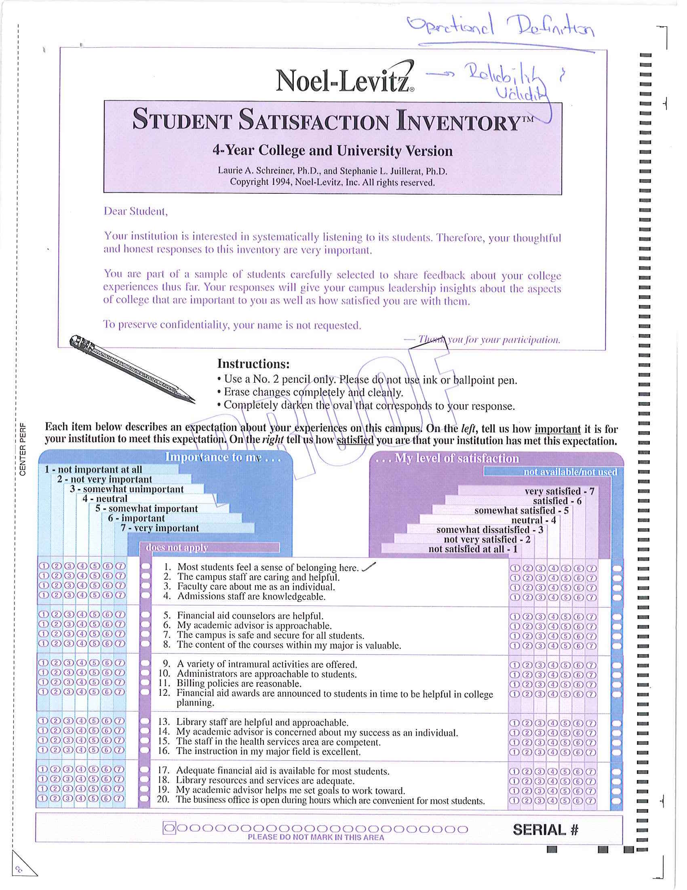
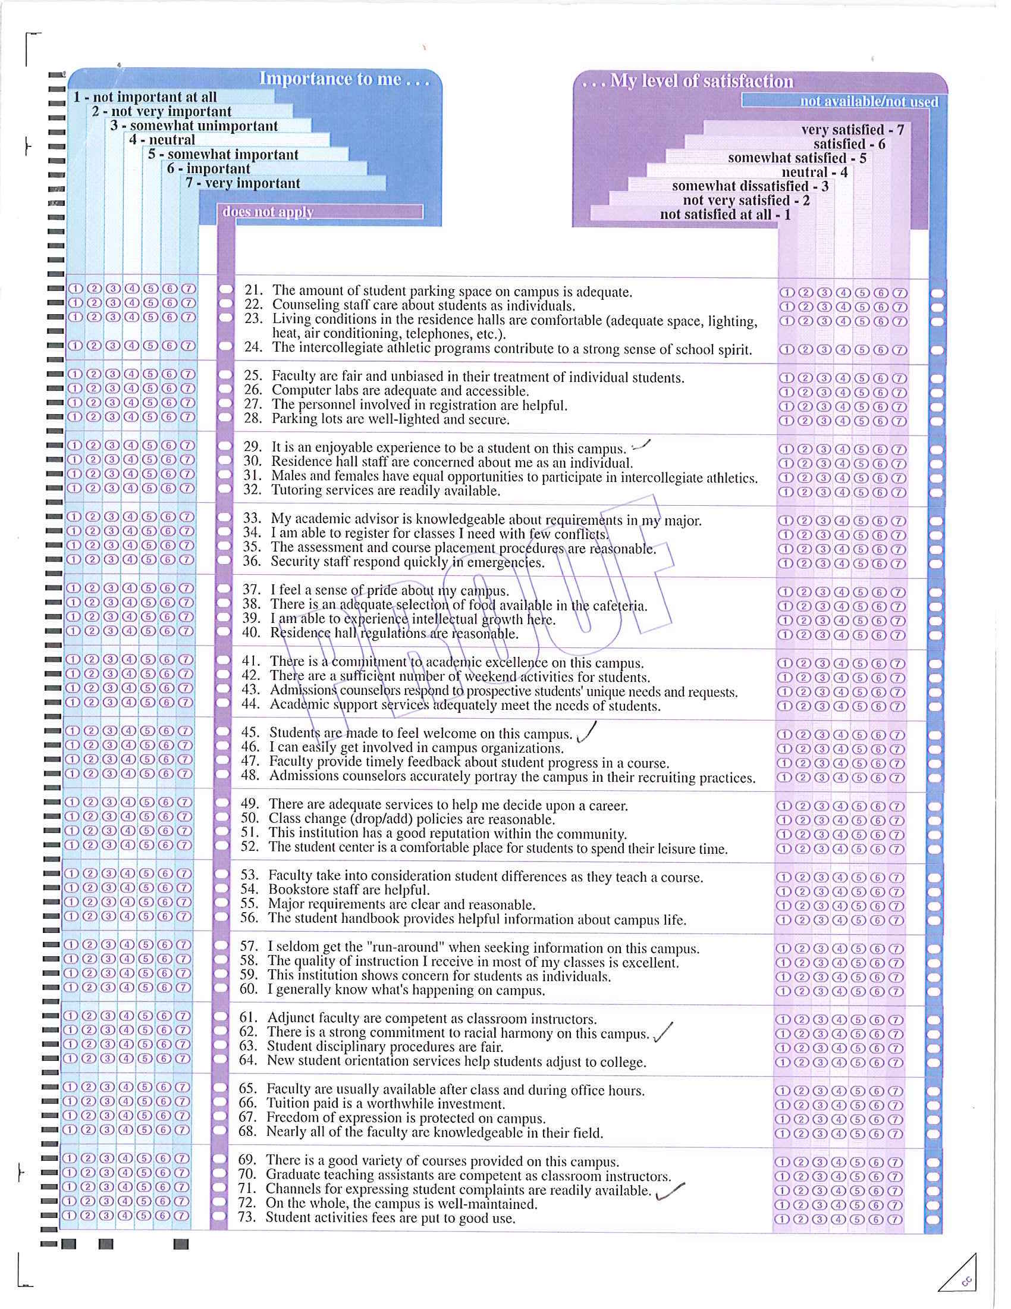

APPENDIX B
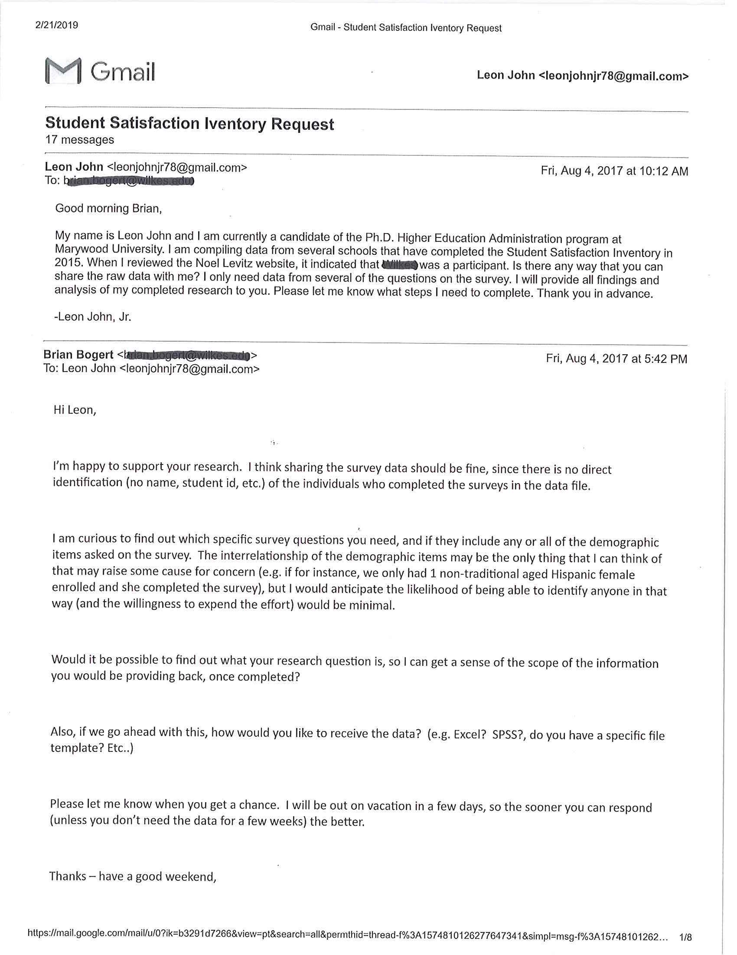
APPENDIX C
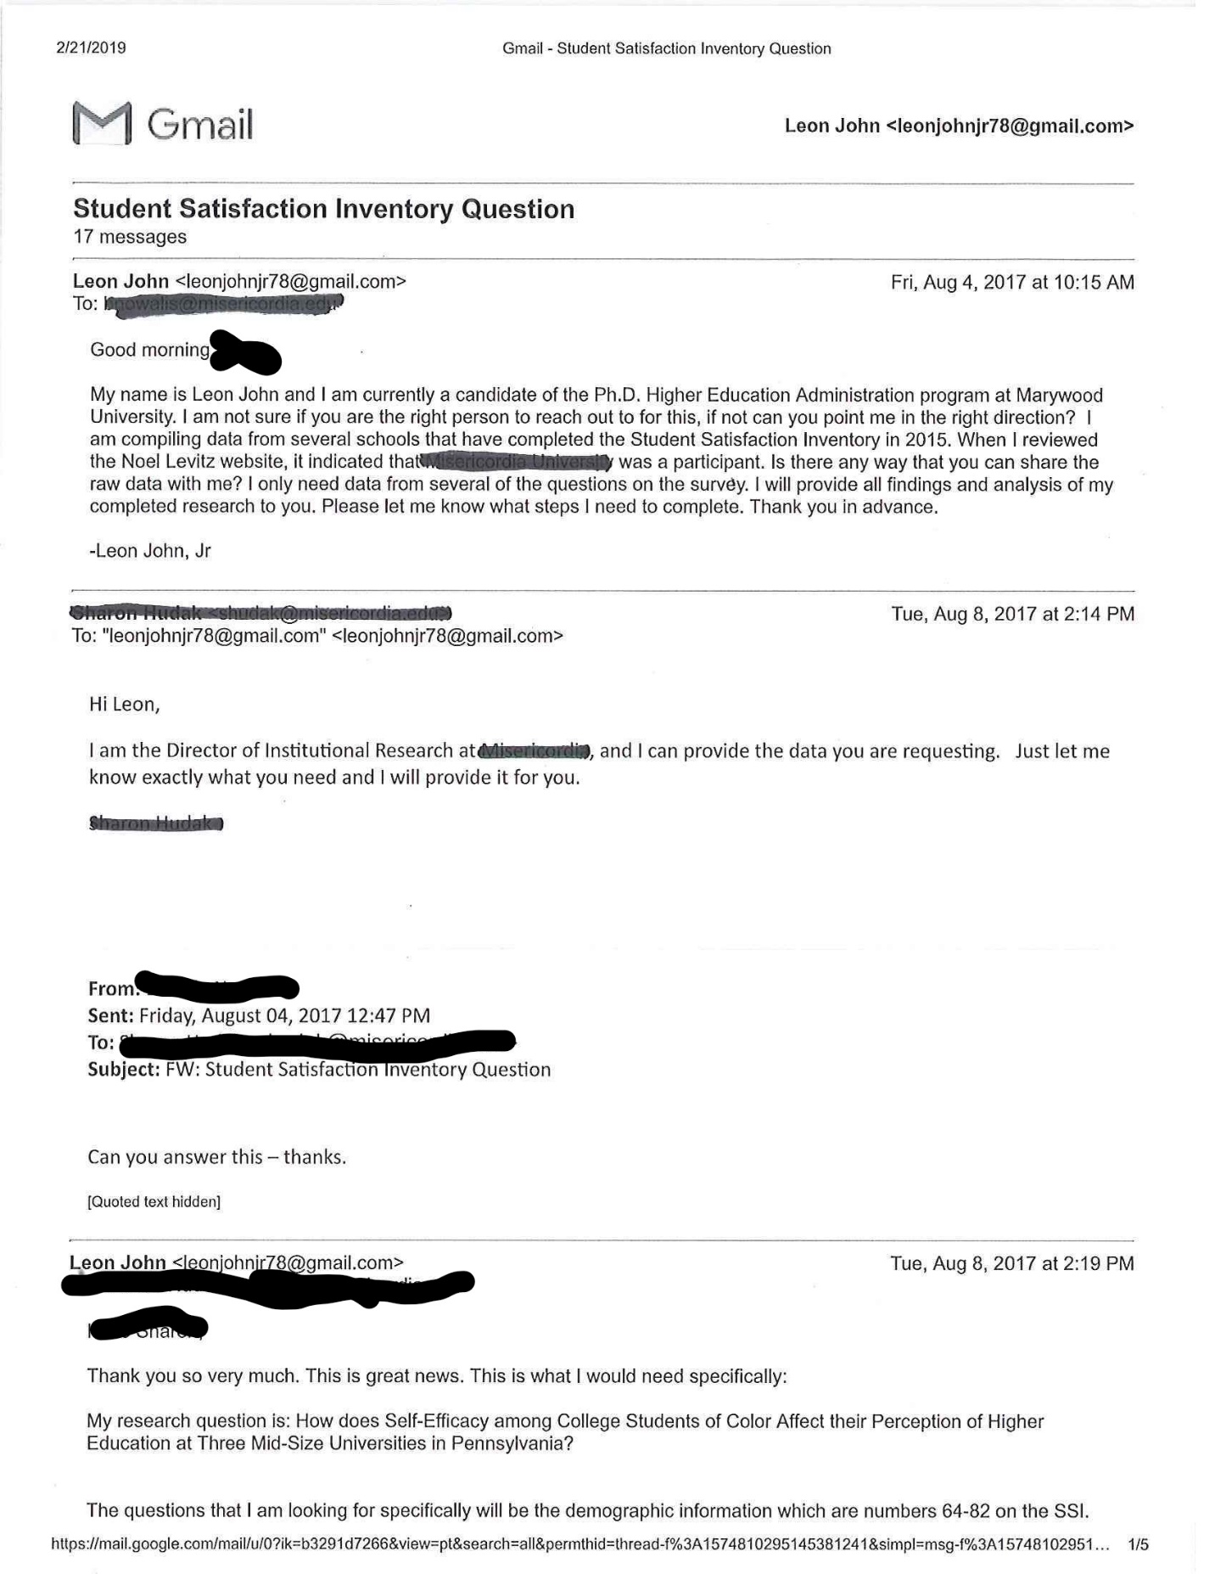
APPENDIX D
