Feel Vibrant with Signature® Far Infrared Saunas
Signature Far Infrared Saunas from Sun lighten™ are the most effective far infrared saunas available. Using Solo carbon heat as the active ingredient, Signature offers the maximum therapeutic results. Solo carbon is the only heater on the market clinically shown to raise core temperature, lower blood pressure and aid in weight loss. This is one of the reasons more doctors recommend Sun lighten over any other sauna brand.

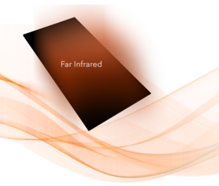
Solo carbon® Far Infrared Therapy
Our active ingredient: Solo carbon far infrared technology proven effective & safe.
The most important element in an infrared sauna is the heater emissivity rating, which determines how efficiently the infrared heat is emitted. High infrared emissivity is the key to the infrared benefits! With generic carbon blend heaters, you’ll get an emissivity rating that’s significantly lower than Solo carbon heaters, making ours the most effective far infrared heater on the market.

Ultra-Low EMF Technology
For the safest infrared heater on the market, look no further than our very own Solo carbon heaters. Our proprietary design creates almost zero EMF, or electromagnetic fields. Click for EMF testing data.
What make Solo carbon so safe are the panels. They contain a blend of materials that are each 100 percent quality-controlled by Sun lighten. So we can promise you safety and effectiveness with each individual heater, unlike any other sauna on the market! Even better, the Solo carbon panels are heat-sealed so no wires or glues are used. When the panels heat up, they won’t be emitting any unhealthy gases. The clinically-tested technology in our infrared saunas makes us the most trusted sauna source around.

Beautiful Craftsmanship & Simple Assembly
With 100 percent quality-controlled manufacturing, you will not find another far infrared sauna as beautiful. Our Signature saunas have solid tongue and groove construction, 33 percent thicker wood than the industry standard and are commercial grade for extra durability. Sun lighten saunas are made from PEFC-Certified wood that is sustainable, adaptable to high temperatures and extremely durable – effect for high traffic use. They’re also available in hypoallergenic basswood and western Canadian cedar.
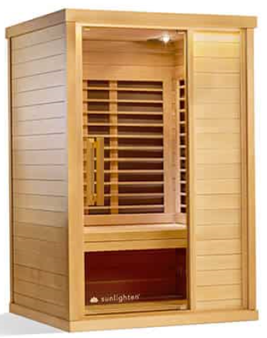
Signature II
Sunlight’s Signature II home sauna offers clinically proven backed infrared sauna benefits like lowered blood pressure, weight loss, detoxification and more – all from the comfort of your home. Nine heaters provide the most effective highest quality and quantity of far infrared heat available, and our proprietary design produces virtually no EMF. The Signature II far infrared sauna seats up to two people, and a removable bench allows for full use of floor space for yoga or stretching. Optional premium add-ons include acoustic resonance therapy, chromo therapy lighting, natural sauna cleaners and more.
Solo carbon® heaters deliver the highest concentration of far infrared heat available, proven 95% effective
Ultra low EMF technology ensures ultimate safety
Patented Magne-Seal™ assembly process for easy set up
Programmable timer & continuous use options for convenience for full use of floor space for stretching or yoga poses.
810-584-5241 yourpathforwardholistics@gmail.com

